TERM 3 HOLIDAY ASSIGNMENT 2026
FORM THREE
AGRICULTURE PAPER 2
Section | Question Numbers | Maximum Score | Candidate's Score
Section A | 1 – 18 | 30 Marks
Section B | 19 – 22 | 20 Marks
Section C | 23 – 25 (Answer any 2) | 40 Marks
TOTAL |  | 90 Marks

SECTION A (30 MARKS)
1. State four roles of worker bees in a bee colony. (2 marks)
________________________________________________________________________________
________________________________________________________________________________
2. Name a tool used for each of the following: (1 mark)
a) Tightening barbed wire. (½ mark)
________________________________________________________________________________
b) Digging and collecting manure. (½ mark)
________________________________________________________________________________
3. List four routes through which pathogens can enter the body of an animal. (2 marks)
________________________________________________________________________________
________________________________________________________________________________
4. What is the term used when the hind legs of a foetus come out first during parturition? (½ mark)
________________________________________________________________________________
5. Give four reasons for maintaining farm tools. (2 marks)
________________________________________________________________________________
________________________________________________________________________________
6. Name a breed of pigs with the following characteristics: (1 mark)
i) Black body with a white patch on the shoulder and foreleg. (½ mark)
________________________________________________________________________________
ii) White body with blue/black spots. (½ mark)
________________________________________________________________________________
7. Mention two tools used for cutting mature horns in cattle. (1 mark)
________________________________________________________________________________
8. Name the other component or tool commonly used together with each of the following: (2 marks)
a) Canula. (½ mark)
________________________________________________________________________________
b) Brace. (½ mark)
________________________________________________________________________________
c) Elastrator. (½ mark)
________________________________________________________________________________
d) Wood chisel. (½ mark)
________________________________________________________________________________
9. Name the four stages that ticks go through in their life cycle. (2 marks)
________________________________________________________________________________
________________________________________________________________________________
10. State two reasons why a wire loop hanging in a Kenya Top Bar Hive (KTBH) is recommended. (1 mark)
________________________________________________________________________________
11. State four reasons for castration in pig production. (2 marks)
________________________________________________________________________________
________________________________________________________________________________
12. Distinguish between the following practices in livestock production: (4 marks)
a) Crutching and ringing in sheep production. (2 marks)
________________________________________________________________________________
________________________________________________________________________________
b) Cropping and harvesting in fish farming. (2 marks)
________________________________________________________________________________
________________________________________________________________________________
13. Name three methods used in the selection of breeding stock in livestock production. (1½ marks)
________________________________________________________________________________
________________________________________________________________________________
14. State two reasons for treating timber. (2 marks)
________________________________________________________________________________
________________________________________________________________________________
15. State three cultural uses of livestock. (1½ marks)
________________________________________________________________________________
________________________________________________________________________________
16. Name the intermediate host of each of the following endoparasites: (2 marks)
a) Fasciola hepatica. (1 mark)
________________________________________________________________________________
b) Taenia saginata. (1 mark)
________________________________________________________________________________
17. Give three signs of heat in rabbits. (1½ marks)
________________________________________________________________________________
________________________________________________________________________________
18. Give two reasons for hoof trimming. (1 mark)
________________________________________________________________________________

SECTION B (20 MARKS)
Answer ALL questions in this section.
19. a) Define the term digestible crude protein (DCP). (1 mark)
________________________________________________________________________________
________________________________________________________________________________
b) A farmer wants to prepare 240 kg of calf-rearing ration containing 18% DCP using Pearson's Square method. Calculate the amount of maize containing 9% DCP and sunflower meal containing 30% DCP required to prepare the ration. Show your working. (5 marks)
________________________________________________________________________________
________________________________________________________________________________
________________________________________________________________________________
________________________________________________________________________________
________________________________________________________________________________
20. The diagram below illustrates an instrument used in cattle breeding. Study it and answer the questions that follow.
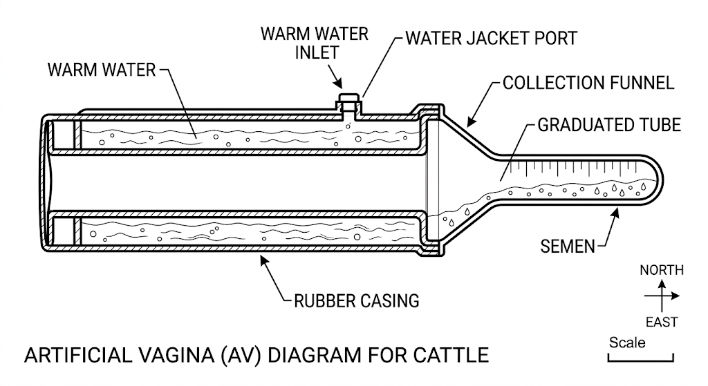
a) Identify the instrument. (1 mark)
________________________________________________________________________________
b) State the role of the instrument in cattle breeding. (1 mark)
________________________________________________________________________________
c) When would it be appropriate to serve a cow after the onset of heat? (1 mark)
________________________________________________________________________________
d) Apart from the method involving the instrument shown, name two other methods of serving a cow. (2 marks)
________________________________________________________________________________
________________________________________________________________________________
21. The diagram below illustrates a livestock handling structure. Study it and answer the questions that follow.
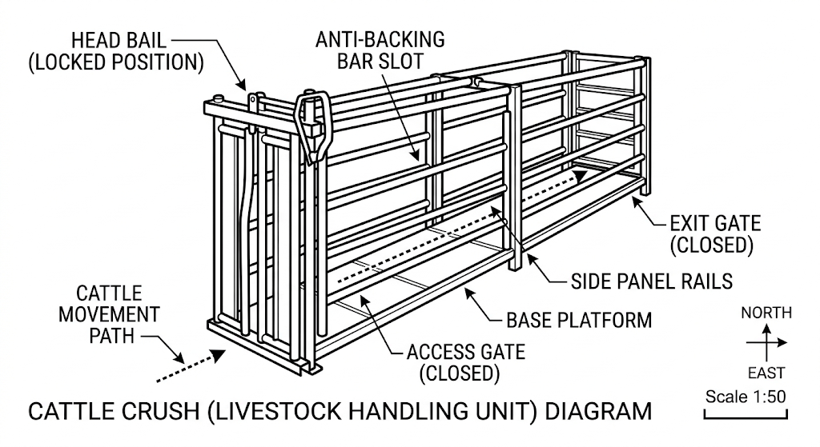
i) Identify the structure. (1 mark)
________________________________________________________________________________
ii) Name any three practices that a farmer can carry out in the structure. (3 marks)
________________________________________________________________________________
________________________________________________________________________________
________________________________________________________________________________
22. The diagram below illustrates the stages of the life cycle of a tick. Study it and answer the questions that follow.
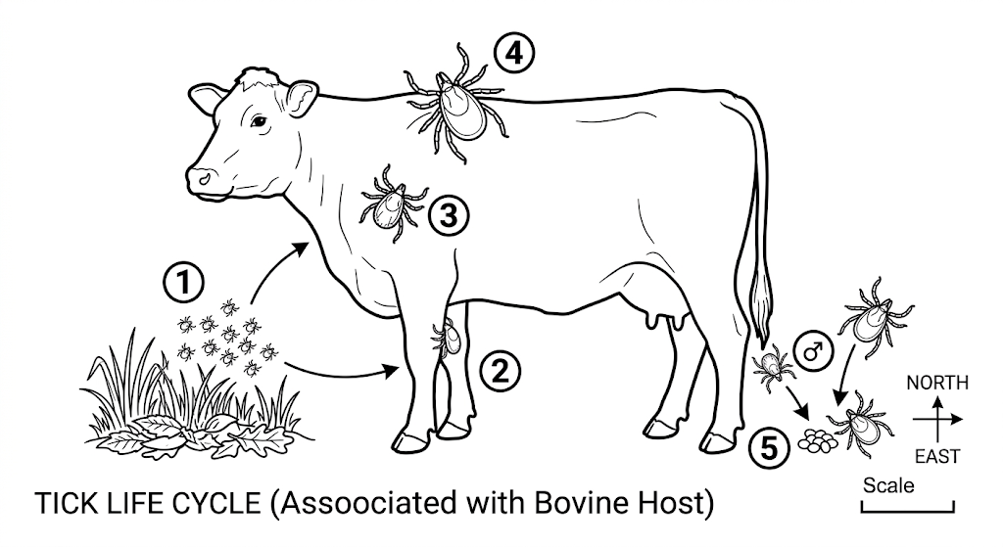
a) Describe the development of ticks at positions 1, 2, 3 and 4. (4 marks)
________________________________________________________________________________
________________________________________________________________________________
________________________________________________________________________________
________________________________________________________________________________
b) Classify the tick on the basis of its life cycle. (1 mark)
________________________________________________________________________________

SECTION C (40 MARKS)
Answer ANY TWO questions in this section.
23. a) Explain five factors that a farmer should consider when siting an apiary. (5 marks)
________________________________________________________________________________
________________________________________________________________________________
________________________________________________________________________________
________________________________________________________________________________
________________________________________________________________________________
b) Explain the importance of steaming up in dairy cattle. (5 marks)
________________________________________________________________________________
________________________________________________________________________________
________________________________________________________________________________
________________________________________________________________________________
________________________________________________________________________________
c) Explain the importance of a hedge on a farm. (10 marks)
________________________________________________________________________________
________________________________________________________________________________
________________________________________________________________________________
________________________________________________________________________________
________________________________________________________________________________
________________________________________________________________________________
________________________________________________________________________________
________________________________________________________________________________
________________________________________________________________________________
________________________________________________________________________________
24. a) Outline the factors to consider when selecting livestock for breeding. (10 marks)
________________________________________________________________________________
________________________________________________________________________________
________________________________________________________________________________
________________________________________________________________________________
________________________________________________________________________________
________________________________________________________________________________
________________________________________________________________________________
________________________________________________________________________________
________________________________________________________________________________
________________________________________________________________________________
b) State four signs of heat in pigs. (2 marks)
________________________________________________________________________________
________________________________________________________________________________
c) State the disadvantages of natural mating in livestock breeding. (8 marks)
________________________________________________________________________________
________________________________________________________________________________
________________________________________________________________________________
________________________________________________________________________________
________________________________________________________________________________
________________________________________________________________________________
________________________________________________________________________________
________________________________________________________________________________
25. a) What factors should be considered when siting farm structures? (10 marks)
________________________________________________________________________________
________________________________________________________________________________
________________________________________________________________________________
________________________________________________________________________________
________________________________________________________________________________
________________________________________________________________________________
________________________________________________________________________________
________________________________________________________________________________
________________________________________________________________________________
________________________________________________________________________________
b) Describe seven requirements of an ideal calf pen. (7 marks)
________________________________________________________________________________
________________________________________________________________________________
________________________________________________________________________________
________________________________________________________________________________
________________________________________________________________________________
________________________________________________________________________________
________________________________________________________________________________
c) Name three materials a farmer requires in order to construct a barbed-wire fence. (3 marks)
________________________________________________________________________________
________________________________________________________________________________
________________________________________________________________________________

