***GROUP 3***

***PROJECT TITLE: JIELIMISHE LIBRARY MANAGENENT INFORMATION SYSTEM***

***GROUP MEMBERS AND SPECIFIC TASK***

|  |  |  |  |  |
| --- | --- | --- | --- | --- |
| **S/N** | **NAME** | **ADMISION NUMBER** | **TASK ASSINGED** | **PROGRESS** |
| **1.** | **VINCENT NGENO** | **SCII/O5817P/2016** | **CODING AND DEPLOYMENT** | **50% DONE** |
| **2.** | **JEPCHIRCHIR RONO** | **SCII/3492P/2016** | **PROJECT CORDINATOR** | **CONTINUOUS** |
| **3.** | **DAVID KABUCHO** | **SCIJ/04388P/2016** | **SYSTEM DESIGN** | **60% DONE** |
| **4.** | **KENEDY MUKIRY** | **SCIJ/03210P/2016** | **CODING AND TESTING** | **60% DONE** |

***PROJECT PHASES***

|  |  |  |
| --- | --- | --- |
| S/N | PHASE | EFFORT |
| 1. | **RESEARCH AND REQUIREMENT GATHARING** | **10%** |
| 2. | **PROJECT PLANNING AND SYSTEM ANALYSIS** | **10%** |
| 3. | **SYSTEM DESIGN** | **20%** |
| 4. | **SYSTEM DEVELOPMENT AND CODING** | **30%** |
| 5. | **TESTING** | **10%** |
| 6. | **PRODUCT AND DEPLOYMENT** | **10%** |
| 7. | **PROJECT REVIEW AND MAINTANACE** | **10%** |
| 8. | **TOTAL** | **100%** |

**JIELIMISHE LIBRARY MANAGEMENT INFORMATION SYSTEM NARRATIVE**

Jielimishe library in and initiative of a Non- Governmental Organization established in the year 2007 based on kibera and mathare to help communities in slum areas to access basic knowledge by providing books (both study and reference), audio visual materials (CDs and DVDs) newspapers and magazines and other research materials. Jielimishe also provides children’s section where they can study and even relax and do there story telling film show while they are on there holidays.

Jielimishe library does not have automated system and all process are done manually. Once an individual want to borrow any book he/she needs to be a member of jielimishe library, In order to be a member one needs to provide the following information:

* National identity card
* Pay a total of ksh.100 monthly fee and ksh.100 yearly subscription
* He/she is a resident of specific slum all be known by referred friend.
* School identity card for pupils/students
* Individual functional number/parent/guardian number.

Once an individual has provided the above information, it takes a week for librarian to process membership card for the individual and he/she is allowed to borrow a maximum of 2 books and return the within a span of 4 days for study books and 8 days for research and novels. Incase he/she does not return the book within the given period the individual incur a penalty of ksh.20 a day and once settle the penalty he/she will be blacklisted for a period of 1 month and will be allowed to borrow the again.

In case the individual does not provide all information required for registration, the registration is suspended until he/she provides full information and they are just allowed to study within the library.

|  |  |  |  |  |  |  |
| --- | --- | --- | --- | --- | --- | --- |
| **S/No** | **Use case name** | **purpose** | **input** | **Source of input** | **output** | **Output recipient** |
| **1.** | Receive member application | Allows individual to apply for membership | National Id and other documents | Individual applicant | Received application | librarian |
| **2.** | Check application details | To ensure Genuity of applicant | Received application | librarian | Complete documents | Director in charge |
| **3.** | Request for application fee | To ensure that application pay for subscription | Bank slip/mpesa message | Director in charge | Additional information | applicant |
| **4.** | Process /decline membership application | To process membership card if decision is made | Print/reject | Director in charge | Print/decline membership card | librarian |
| **5.** | Request for membership collection card | Inform the applicant on the readiness of membership card | Membership card | Director in charge | Membership card | librarian |

**USE CASE SUMMARY**

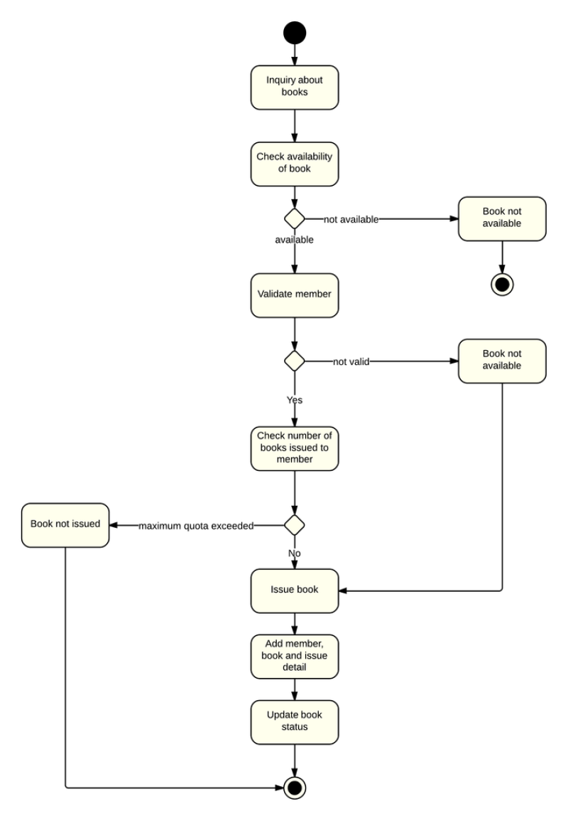

***Activity Diagram***

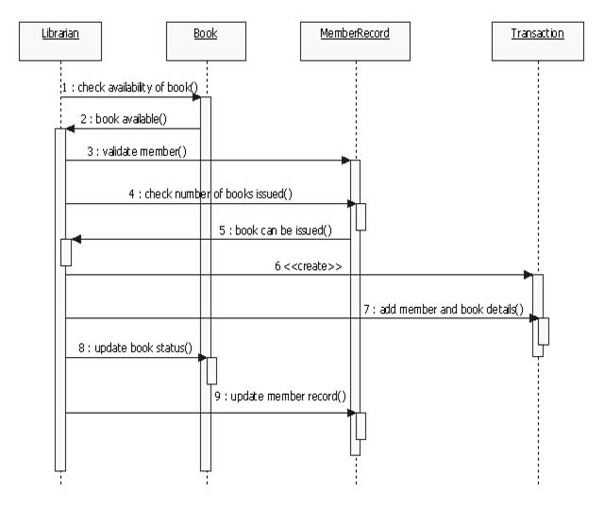

**Swimlane Diagram**