Technical Architecture Document
05_technical_architecture.docx
RetailFlow - Enterprise Data Engineering Platform | Phase 2

1. Architecture Objective
RetailFlow uses a layered, production-style data architecture that separates source ingestion, raw preservation, validation, transformation, analytical modelling and data consumption. The first implementation runs locally using open-source technologies while preserving a clear path to a later Microsoft Azure implementation.

2. Architectural Principles
- Separate operational source systems from analytical workloads.
- Preserve raw source data before transformation so downstream datasets can be rebuilt.
- Use Bronze, Silver and Gold layers to separate raw, technically trusted and business-ready data.
- Prefer incremental processing over unnecessary full reloads.
- Design pipeline operations to be rerunnable and idempotent.
- Treat data quality, security, observability and recovery as platform capabilities rather than afterthoughts.
- Keep transformations modular, testable and version controlled.
- Separate orchestration from transformation logic.

3. Core Components
Component | Technology | Responsibility
Source databases | PostgreSQL | Simulate e-commerce and inventory transactional systems.
File/API sources | CSV, JSON, REST | Represent POS, supplier, return, payment and product feeds.
Ingestion | Python | Extract batch/incremental data and attach ingestion metadata.
Bronze | Filesystem + Parquet/raw formats | Preserve source-aligned immutable data.
Quality gate | Python validation + reconciliation | Validate schemas, records and batch-level controls.
Quarantine | Filesystem/tables | Retain rejected records and failure reasons.
Silver | Parquet / structured datasets | Clean, standardise and deduplicate data.
Transformation | dbt Core | Build modular transformations, tests and documentation.
Gold | Curated datasets | Represent business-ready data products.
Warehouse | PostgreSQL | Store facts, dimensions and analytical marts.
Orchestration | Apache Airflow | Schedule dependencies, retries, backfills and pipeline runs.
Serving | Power BI + FastAPI | Provide authorised analytical and application access.
Engineering | Docker, pytest, GitHub Actions | Reproducibility, testing and CI/CD.

4. Architecture Diagram
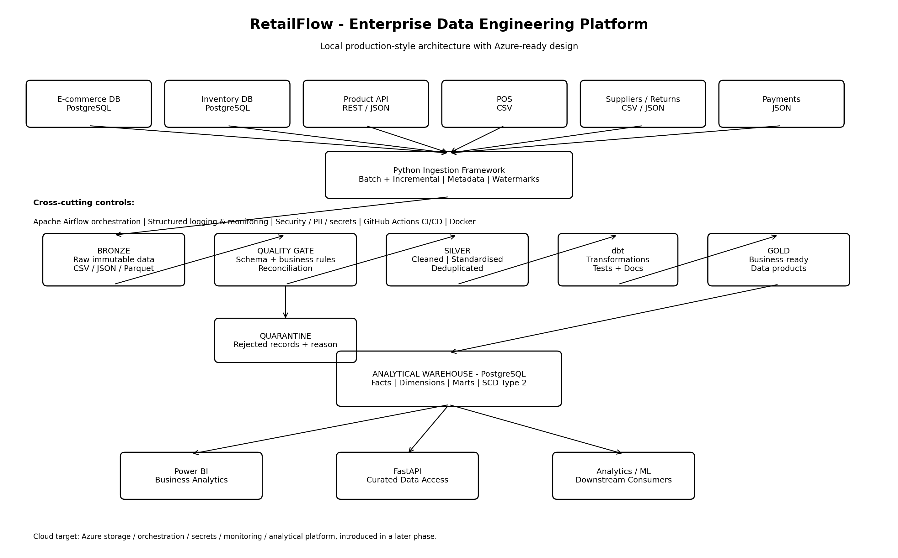

5. Data Layer Responsibilities
Layer | Purpose | Examples
Bronze | Raw preservation and auditability | Source extracts, API responses, files, ingestion metadata.
Silver | Technically trusted data | Typed, standardised, deduplicated, validated entities.
Gold | Business-ready products | daily_sales, customer_sales, product_performance, inventory_position.
Warehouse | Analytical modelling | fact_sales, fact_inventory, fact_payments, fact_returns and dimensions.

6. Warehouse Pattern
The analytical warehouse will use a star-schema-oriented dimensional model. Core facts will include sales, inventory, payments and returns. Core dimensions will include customer, product, store, supplier, date and channel. Historical attributes that require point-in-time analysis will use Slowly Changing Dimension techniques, including SCD Type 2 where appropriate.

7. Cloud Readiness
The local implementation is intentionally cloud-ready but not presented as a one-to-one Azure deployment. A later phase will select Azure services for storage, orchestration, secrets, monitoring and analytics based on the completed local architecture and project constraints.

