SMART WATER FOUNTAIN (PHASE 2)

**DESIGN:**

The block diagram below is a general design of our solution. We divide our design into four modules, including Power Supply, Control Unit, External Control, and Mechanical Unit.

**Figure 1- Block Diagram of Smart Water Fountain**

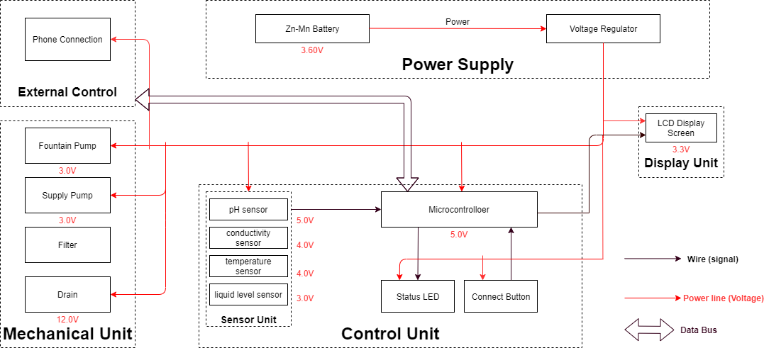

**Steps to Create the Smart Water Fountain IoT Project:**

1. Set up Raspberry Pi: Install the operating system, configure network settings, and ensure your Raspberry Pi is up and running.
2. Connect Hardware: Connect the water pump, water level sensor, relay module, and any other sensors or components you're using to the Raspberry Pi's GPIO pins.

**Raspberry Pi 3:**

* The central component that will control and manage the fountain's IoT functionality.
* Raspberry Pi is used for IoT projects, such as monitoring sensors, controlling home appliances, and collecting data from various sources.

**Sensor Unit:**

* This block contains the four sensors. The data acquired from the sensors will be transmitted to the control unit. Control unit will then have some logic designed to send corresponding signals to control other blocks of the water fountain. At the same time, the display screen on the water fountain will display the readings along with the determined water quality level and remaining water quantity.
* For the PH-value sensor, temperature sensor and conductivity sensor, values will be retrieved and calculated to determine the overall water quality level. When poor water quality is determined, the water replacement procedures will take place. The weight sensor readings will be used to determine the amount of fresh water left in the water tank.
  1. **Temperature Sensor:**

A water-proof temperature sensor is going to be used. Part number from spark fun is: DS18B20. This temperature sensor is compatible with a relatively wide range of power supply from 3.0V to 5.5V. The measured temperature ranges from -55 to +125 Celsius degrees. Between -10 to + 85 degrees, the accuracy is up to +-0.5 degrees. This sensor can fulfill all requirements needed for this project.

* 1. **PH-sensor:**

PH value is a valued indicator of water quality. This PH-sensor works with 5V voltage, which is also compatible with the temperature sensor. It can 6measure the PH value from 0 to 14 with an accuracy of +- 0.1 at the temperature of 25 degrees.

* 1. **Conductivity sensor:**

Conductivity sensor is also part of the water quality assessment. The input voltage is from 3.0 to 5.0V. The error is small, +-5%F.S. The measurement value ranges from 0 to 20 ms/cm which is enough for water quality monitoring.

* 1. **Liquid Level Sensor:**

This sensor is responsible for reflecting how much freshwater is left in the water tank. When the water level is low, fresh water will be pumped to the water tank to ensure the water fountain keeps running with freshwater. This sensor is 0.5 Watts. For water level from 0 to 9 inches, the corresponding sensor outputs readings from 0 to 1.6. From that, the quantity of freshwater left can be determined.

1. Write Code: Write Python code to control the water pump based on the water level readings. Use MQTT to send data to your IoT platform and receive remote commands.
2. Set Up IoT Platform: Create an account on your chosen IoT platform, configure device settings, and obtain necessary authentication keys and credentials.
3. Integrate IoT Platform: Modify your Python code to send and receive data from the IoT platform using MQTT.
4. Optional Web Interface: If you want remote control, set up a web server on the Raspberry Pi. Create a web interface that allows you to start/stop the fountain, change settings, and view data.
5. Database (optional): If you want to store and analyze historical data, set up a database and modify your code to log relevant information.
6. Testing and Debugging: Test your system thoroughly, ensuring that the water pump operates correctly based on the water level sensor readings and that communication with the IoT platform is reliable.
7. Finalize and Secure: Once everything is working as expected, finalize your project, secure the hardware in a waterproof enclosure, and ensure it's safe for outdoor use.
8. Monitor and Maintain: Continuously monitor your IoT smart water fountain and make any necessary adjustments or updates to keep it running smoothly.

Remember to take safety precautions when working with water and electricity, and follow the manufacturer's instructions for the components you use.

**FEATURES OF SMART WATER FOUNTAIN:**

1. Water Filtration: Smart water fountains often include advanced filtration systems to ensure the water is clean and safe to drink. These filters can remove impurities and improve taste.
2. Bottle Filling Stations: Many smart fountains have bottle-filling stations with automatic sensors that dispense water when a bottle or container is placed under the spout. This feature encourages the use of reusable bottles and reduces single-use plastic waste.
3. Temperature Control: Some smart fountains allow users to adjust the temperature of the water, providing options for cold, room temperature, or hot water. This feature is convenient for users with specific preferences.
4. Touchless Operation: To promote hygiene and reduce the spread of germs, smart water fountains often have touchless operation through sensors that detect when a user is approaching and dispense water without physical contact.
5. Water Quality Monitoring: Smart fountains may include sensors to monitor water quality in real-time. If water quality deteriorates or falls below certain standards, the fountain can provide alerts for maintenance.
6. IoT Integration: Internet of Things (IoT) technology is frequently used to enable remote monitoring and control of smart fountains. This allows facility managers to track usage, receive maintenance notifications, and adjust settings remotely.
7. Data Collection: Smart fountains can collect data on water usage patterns, filter status, and maintenance needs. This data can be valuable for resource management and conservation efforts.
8. LED Displays: Some smart fountains feature LED displays that can show water quality information, usage statistics, promotional content, or educational messages related to water conservation.
9. Emergency Preparedness: In some cases, smart fountains are designed to operate during emergencies or power outages. They may include backup power sources and water purification systems.
10. Accessibility Features: Smart fountains often include features to make them accessible to individuals with disabilities, such as wheelchair-accessible spouts and audio guidance.
11. Promotional and Branding Opportunities: The digital displays on smart fountains can be used for advertising, branding, or displaying messages from sponsors, creating revenue opportunities for public spaces.
12. User Interaction: These fountains can offer user-friendly interfaces, such as touchscreens or mobile apps, for customization and control of water dispensing options.

Smart water fountains are commonly found in public places like parks, schools, universities, office buildings, airports, healthcare facilities, and transportation hubs. They aim to provide a convenient and sustainable source of clean drinking water while offering additional features that promote water conservation, hygiene, and user convenience.

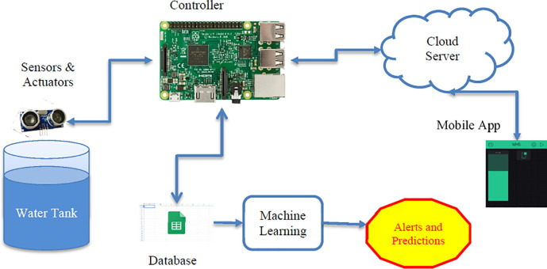

**Figure 2- Hardware setup of smart water fountain**