1. **Create one vpc in N.virginia region.**
2. **Create two subnets.**

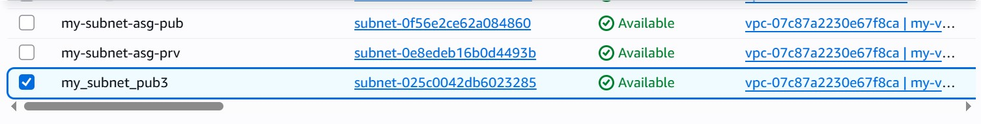

1. **Provide the IGW to the vpc.**
2. **Create One public RT and one private RT.**
3. **Deploy NAT gateway on public subnet and attach the NAT Gateway to private subnet.**

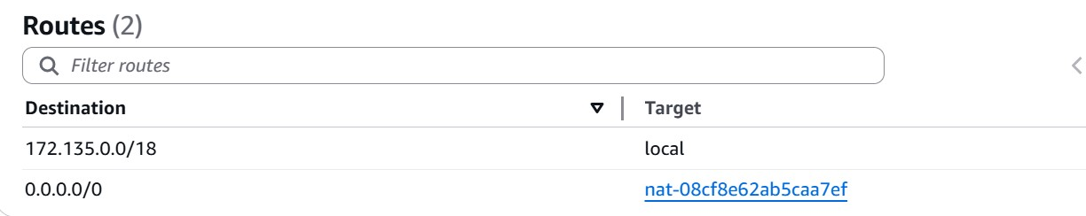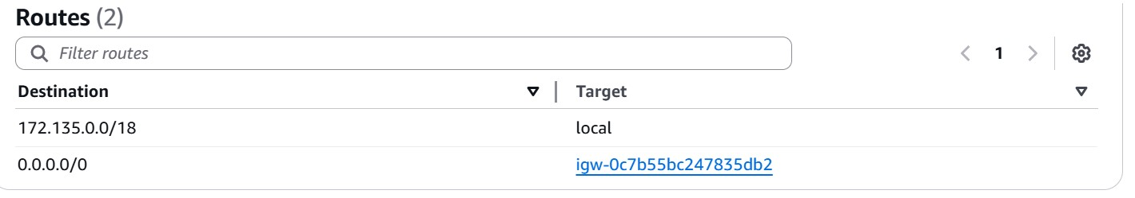

1. **Created Two instances,one in public subnet and one in private subnet.**
2. **Deployed Apache server on both the ec2 instances with sample index.html file.**
3. **Create one application load balancer and attach the load balancer to both the ec2 instances.**

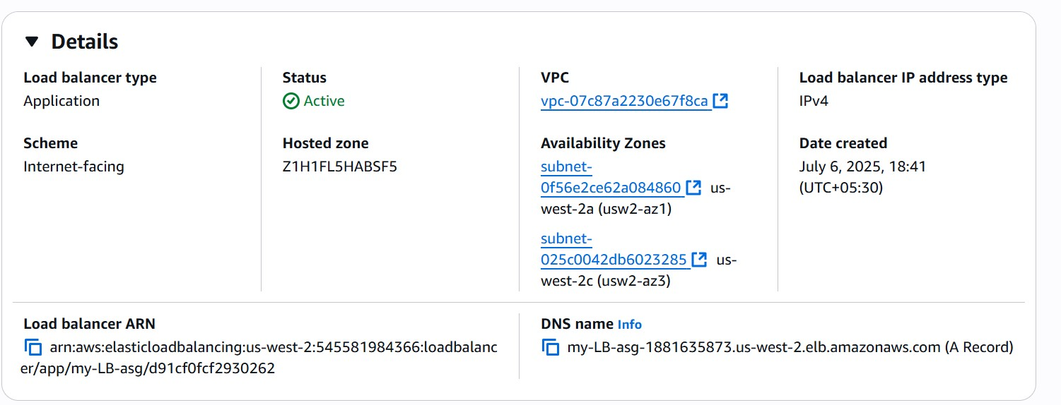

1. **store Application load balancer logs to s3.**

**--> create a s3 bucket in same reegion where LB is present.**

**--> create a bucket policy**

**--> got to loadbalancer -> attributes -> edit -> enable monitoring logs -> attach s3**

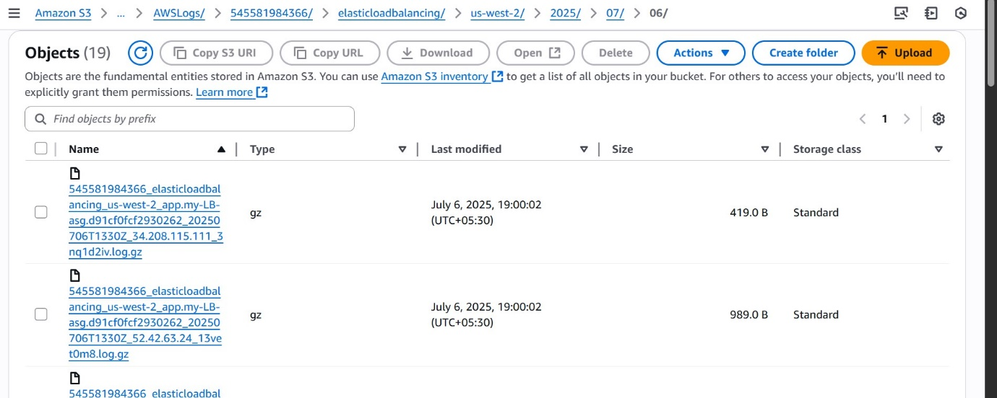

1. **Store the vpc flow logs to cloudwtach group.**

**--> vpc -> flow_logs**

**--> create a role for cloudwtach -> CloudWatchLogsFullAccess**

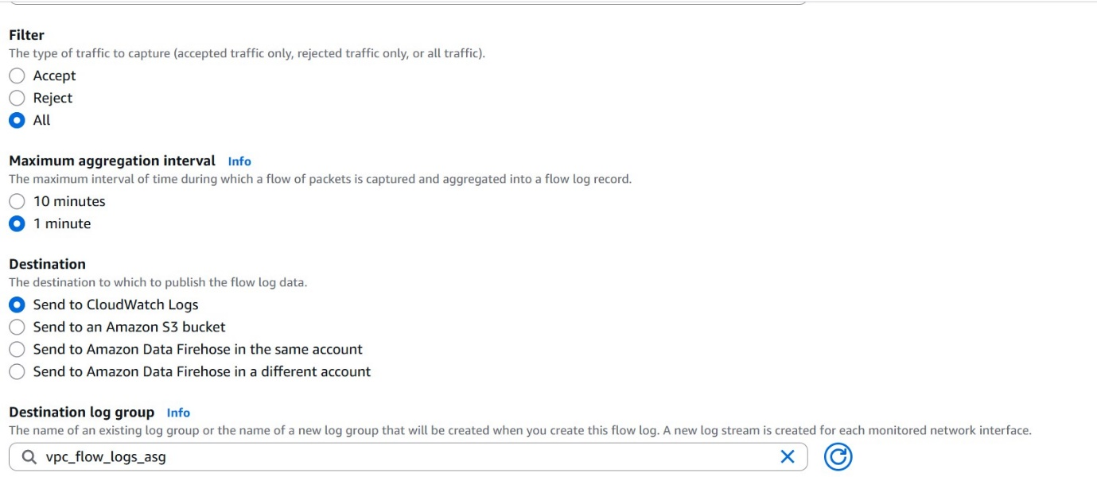

1. **Create Monitoring Dashboards to monitor cpu utilization and to monitor apache service.**

**Go to CloudWatch -> create dashboard -> select widget -> select -> ec2 -> search your instance id -> cpu utilization -> save**

1. **CPU utilizations more than 70% then it should trigger Autoscaling and launch new instance.**
2. **Launch a template**
3. **Create a Autoscaling group**

