1. **Executed small tasks**

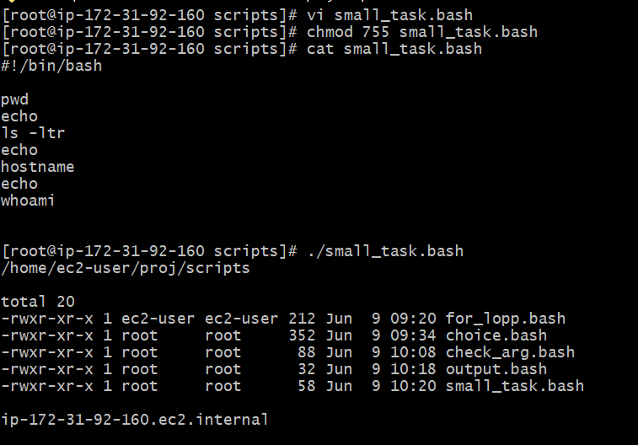

1. **Created Multiple DIR**

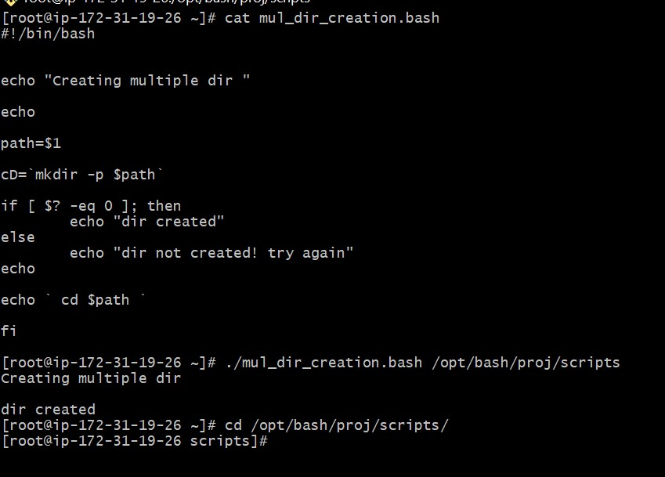

1. **While-do task for starting process**

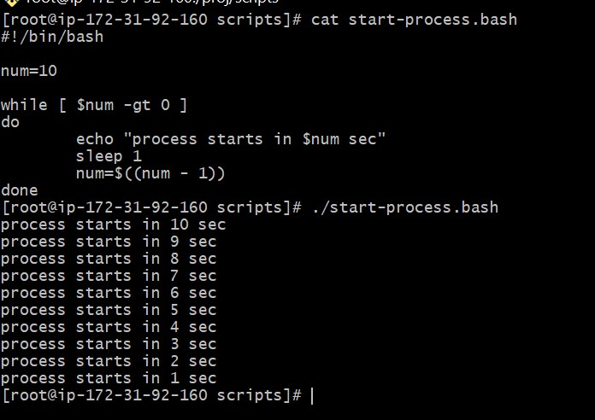

1. **File exist task using if_else**

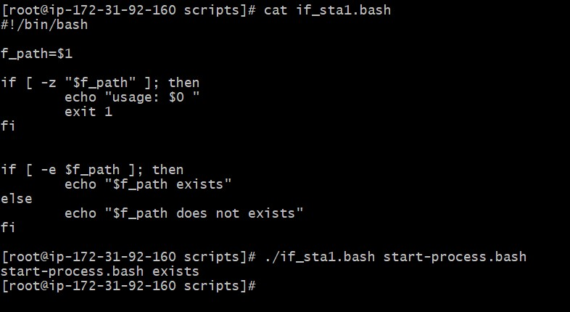

1. **Checking greater num using if-else** 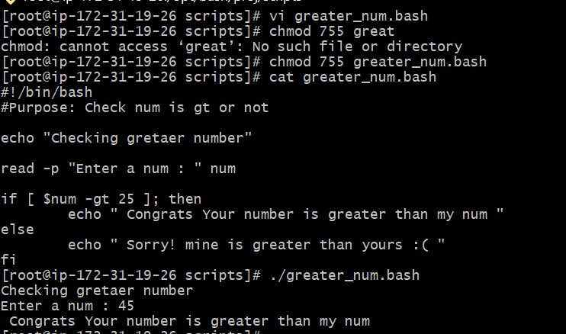
2. **Exist status**

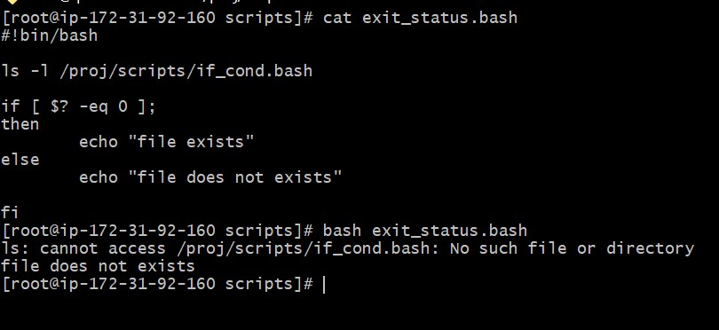

1. **Add 2 num**

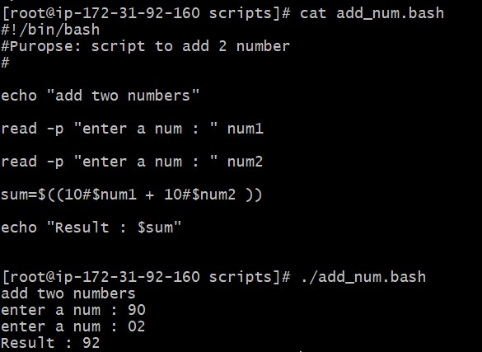

1. **Created DIR & checking whether created or not**

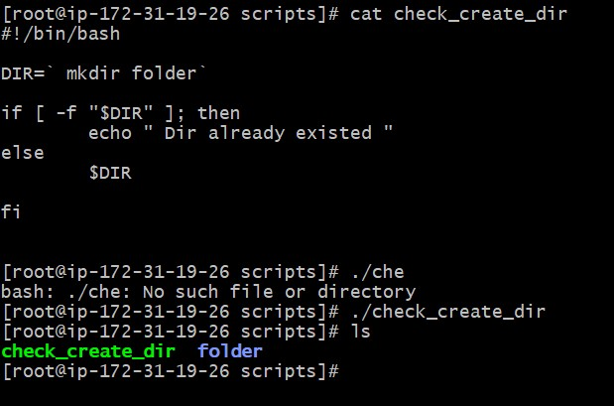

1. **Created Multiple DIR**



1. **Greater number**



1. **Checking free space**

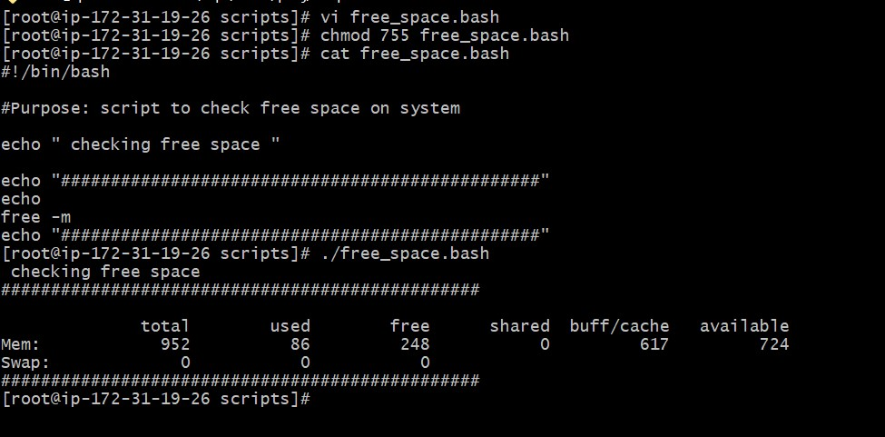

1. **Present working dir**

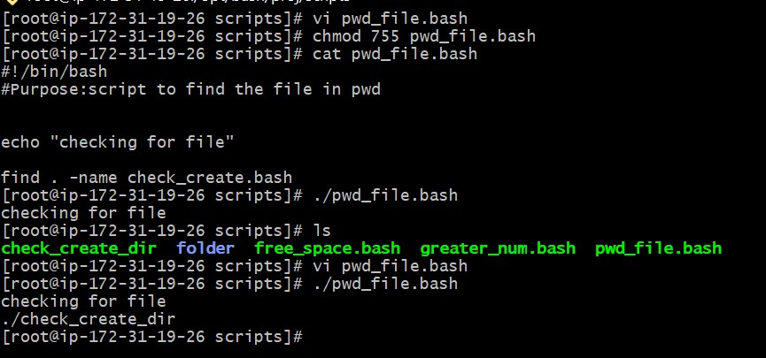

1. **Taking Backup**

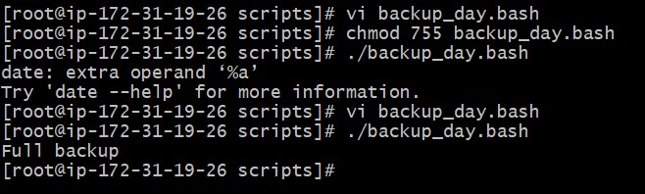

1. **script to install Nginx on an EC2 server.**

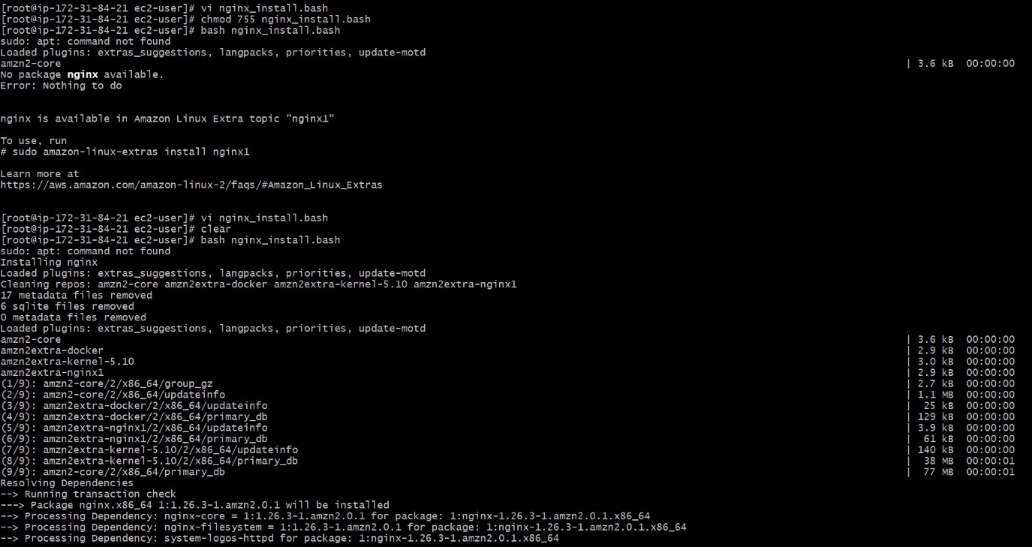

1. **Script checking Nginx service is running, and start it if not.**

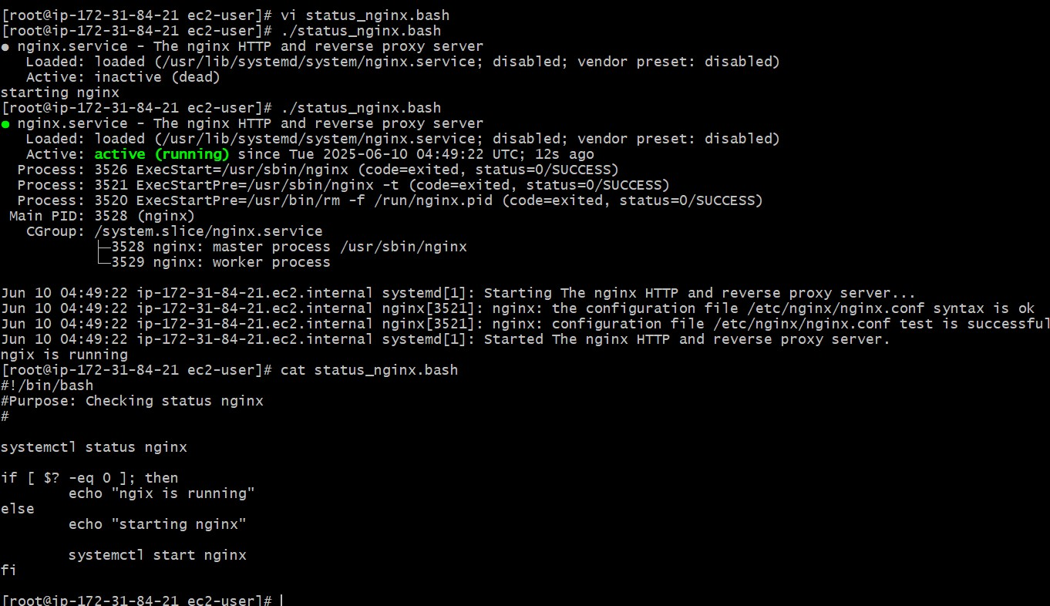

1. **Calculator**

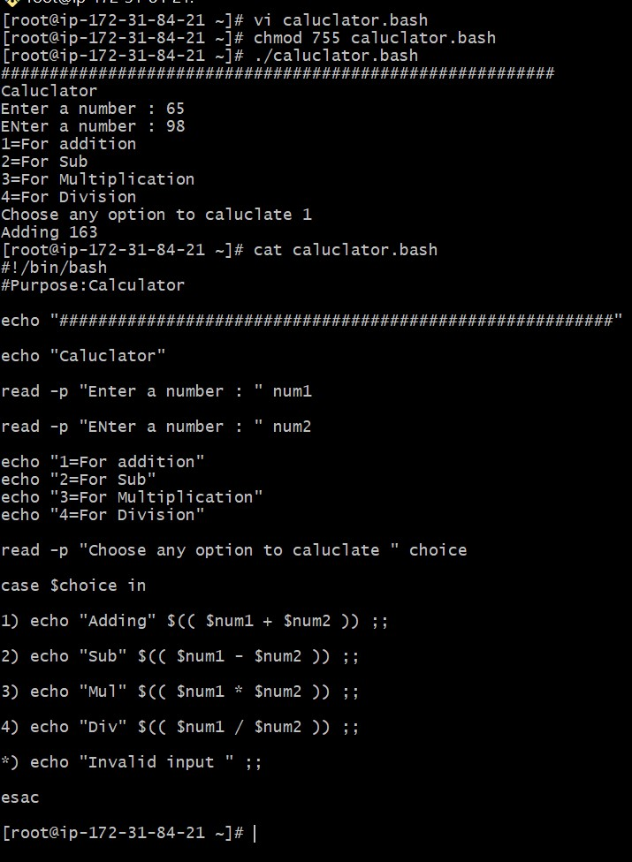

1. **Script to install Apache Tomcat on an EC2 server.**

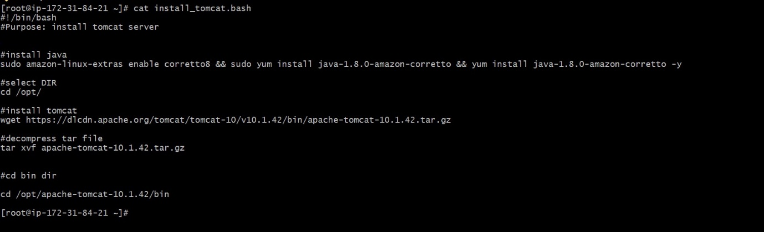

1. **Crontab entry’s**

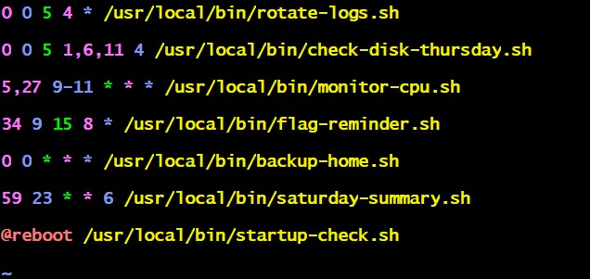

1. **Example on Case**

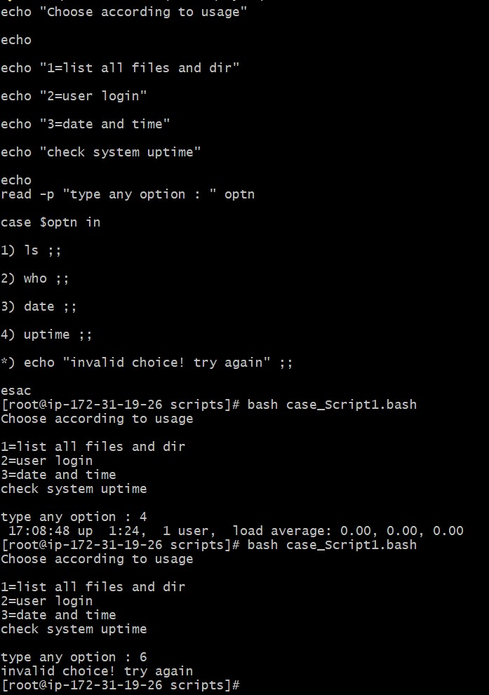

1. **Reading input**

