1. **Configure VPC peering in cross regions.**
2. **Purchase one domain from GoDaddy.**

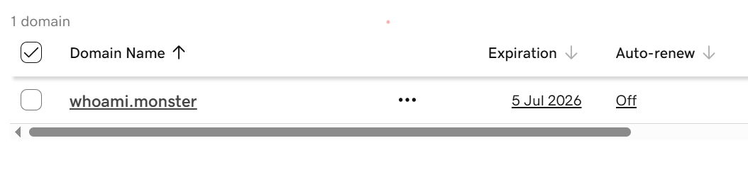

1. **Deploy static webiste in s3.**

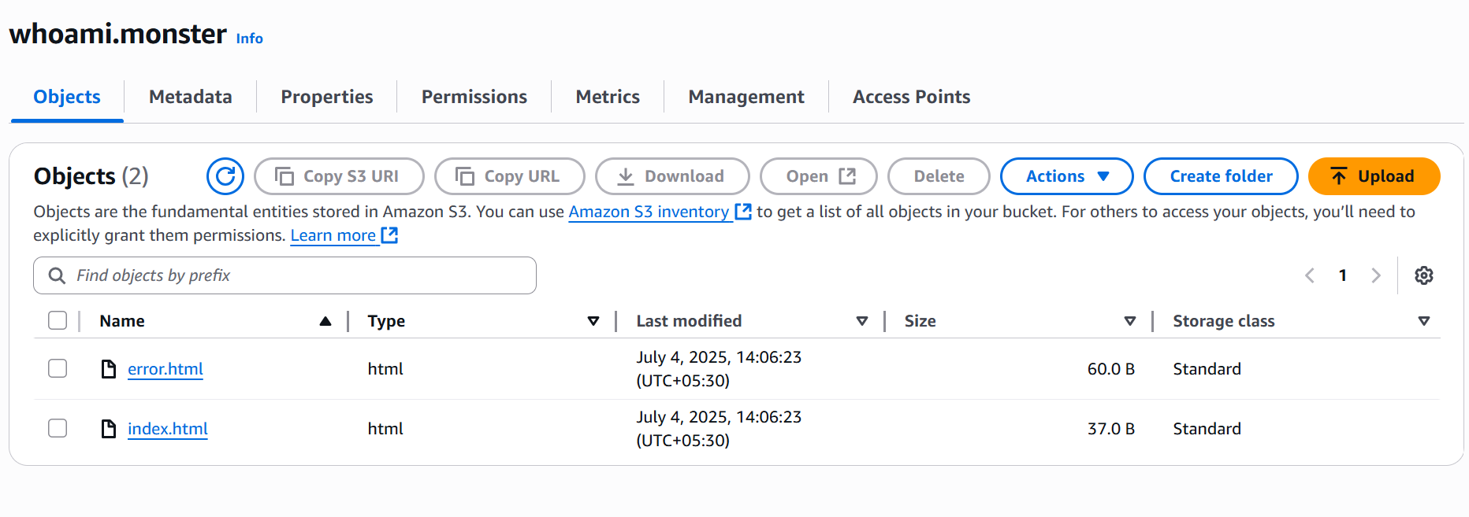

1. **Create CDN and attach one SSL certificate.**

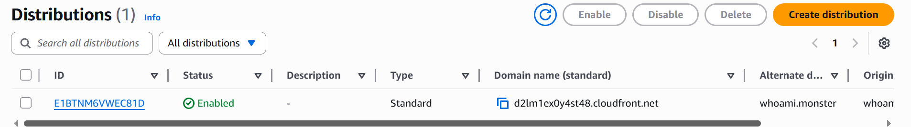

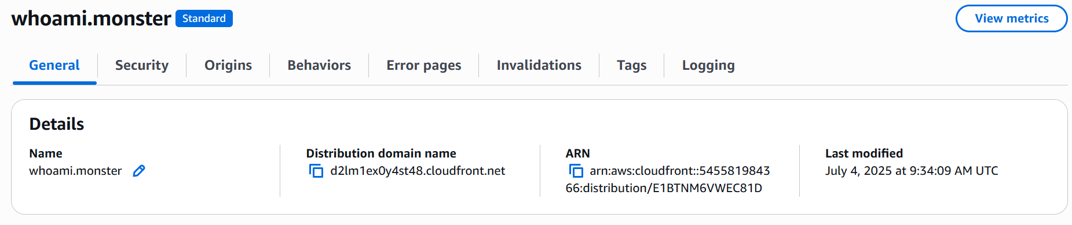

**Created origin**

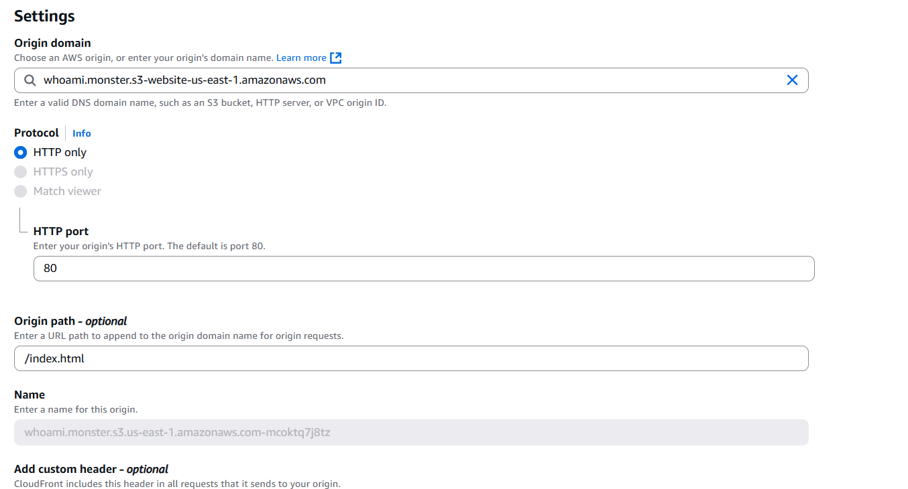

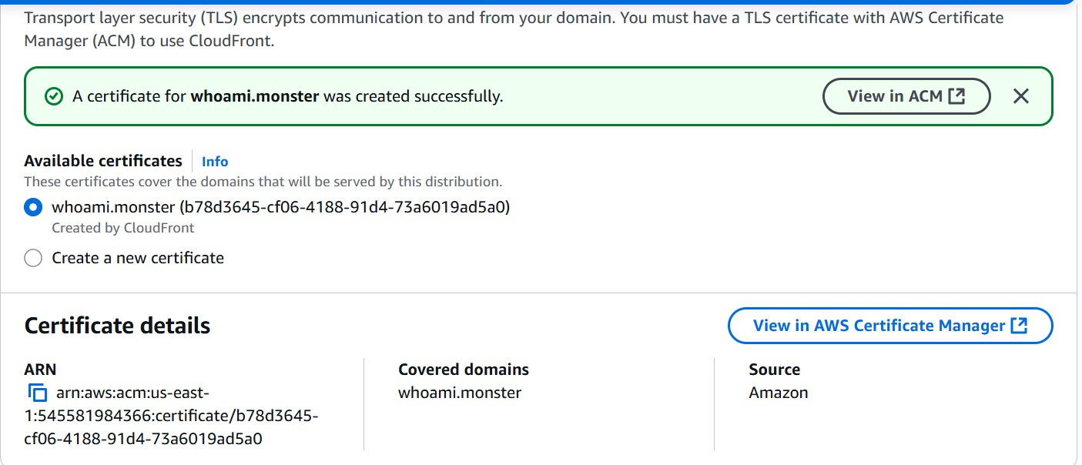

1. **Create Route53 hosted zone and MAP the domain with CDN.**

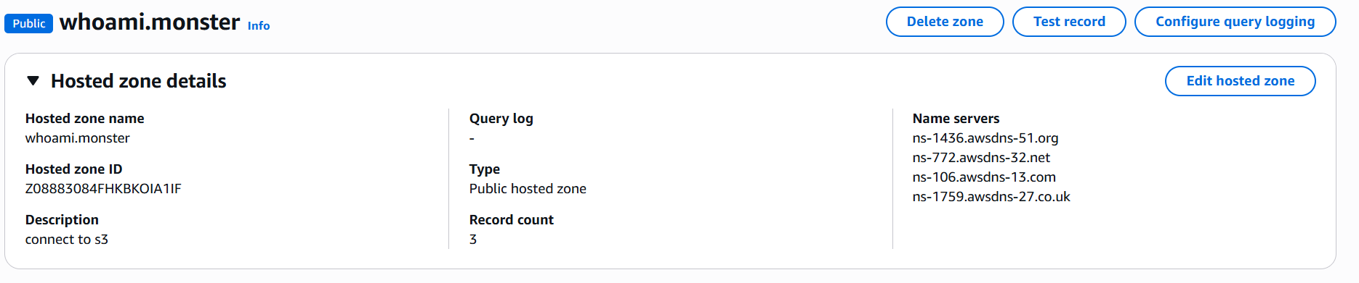

**Mapped domain with CDN**

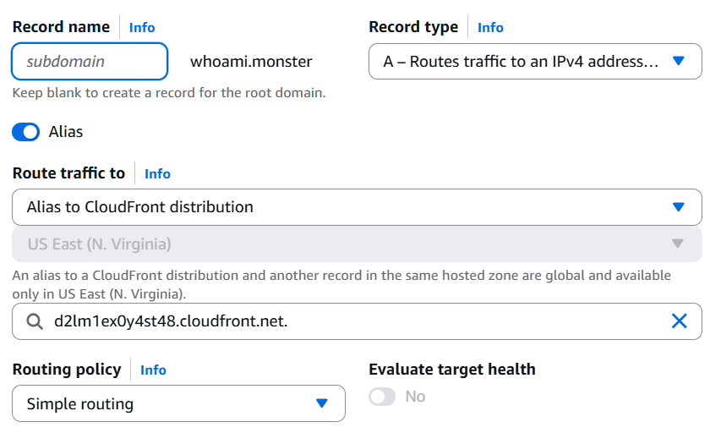

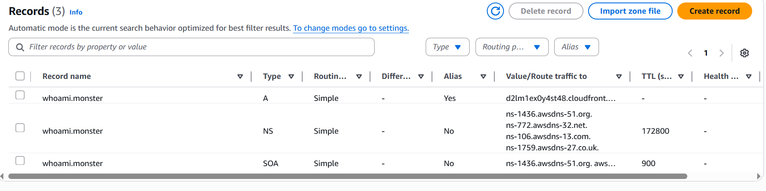

1. **Update the index.html in s3 bucket and the updated file should be accessible by using domain name.**

