1. **Enable CloudTrail monitoring and store the events in s3 and CloudWatch log events.**

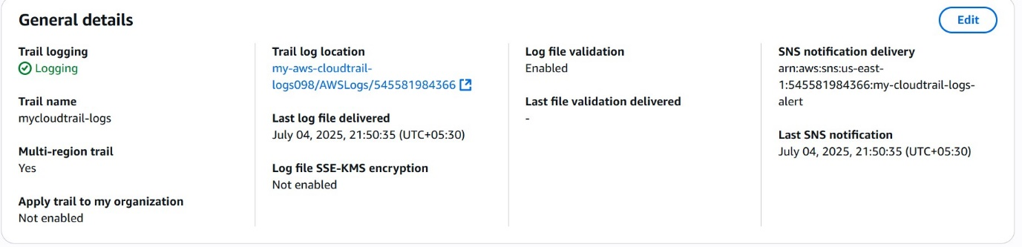

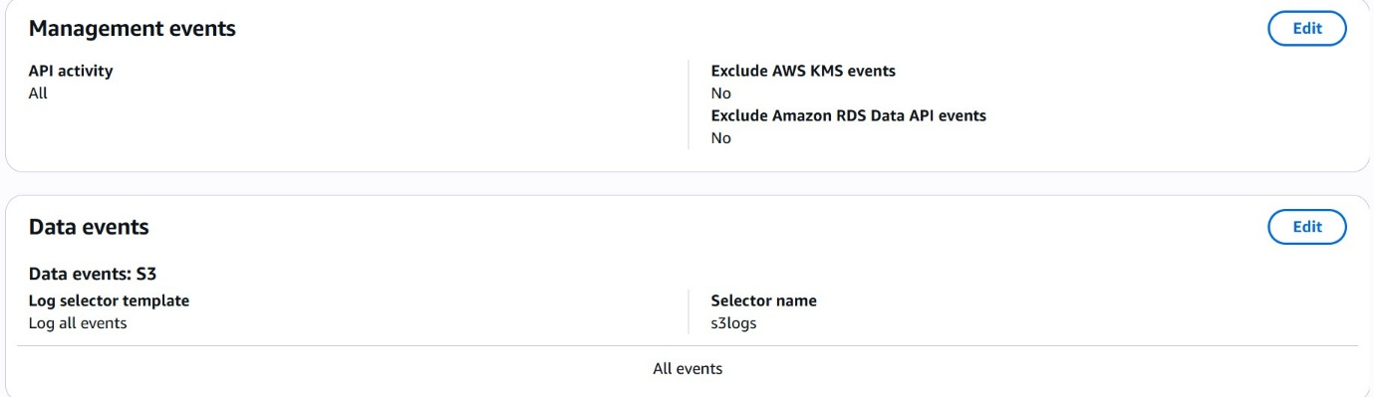

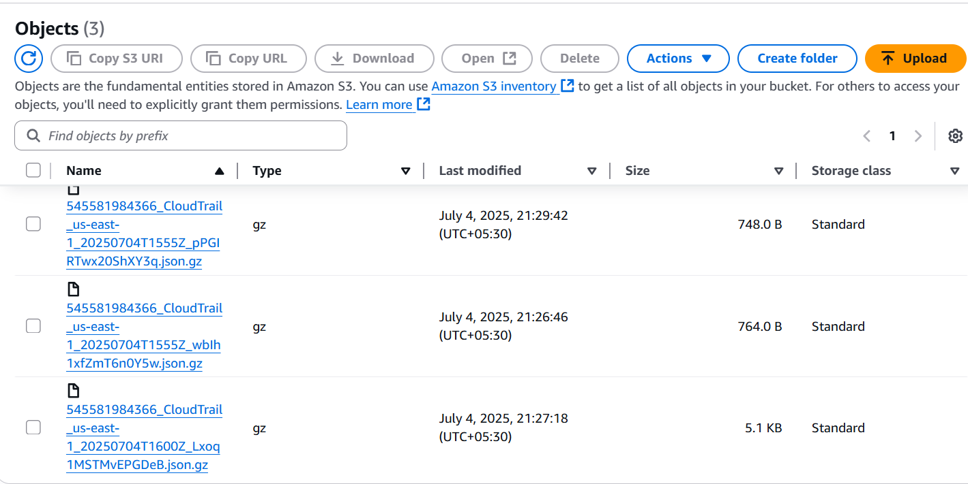

1. **Enable SNS for cloudtrial to send alert on email.**

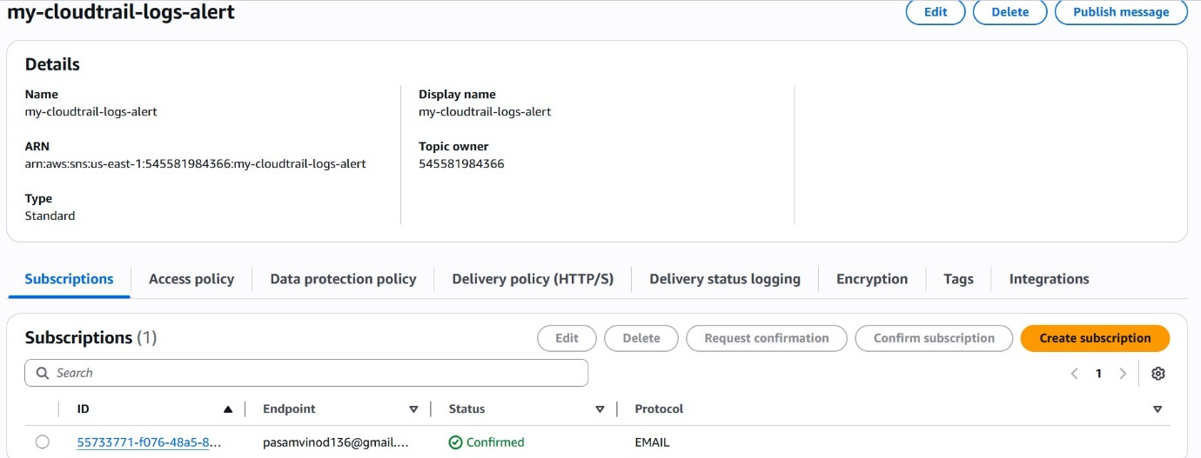

1. **Configure cloud watch monitoring and record the CPU utilization and other metrics of ec2.**
2. **Created instance**
3. **Gave load to instance**
4. **CloudWatch -> create dashboard -> add widget -> select ec2 -> paste instance id -> CPU utilization -> save**

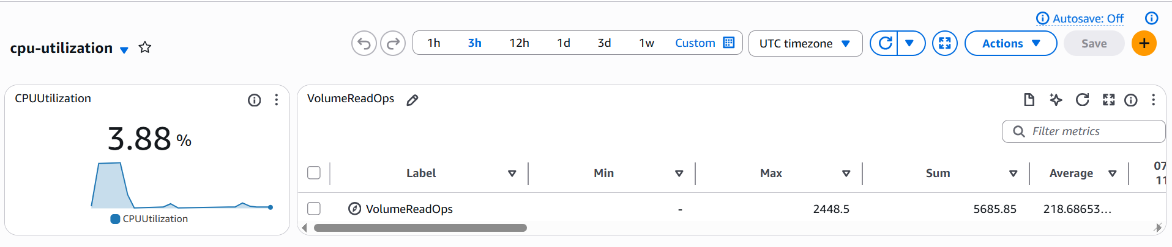

1. **Create one alarm to send alert to email if the CPU utilization is more than 70 percent.**
2. **Cloud watch -> alarm ->select metric -> threshold type -> alarm state trigger -> SNS topic -> alarm name -> create**

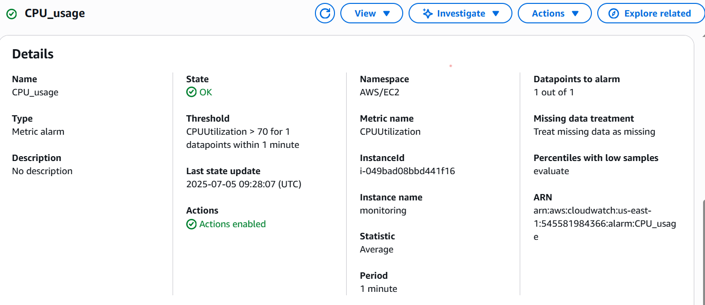

1. **Create Dashboard and monitor tomcat service whether it is running or not and send the alert.**
2. **Create instance**
3. **Install java**
4. **Create bash script that pushes tomcat metrics to CloudWatch**
5. 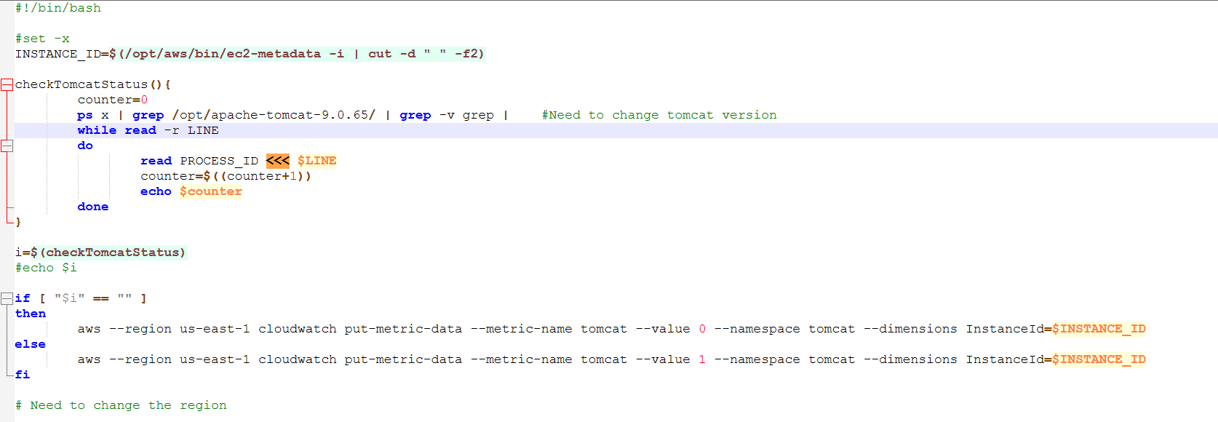
6. **Create a IAM role -> ec2 -> attach CloudWatchAgentServerPolicy**
7. **Create dashboard for tomcat in cloudwatch**
8. **Create alarm for tomcat to email.**

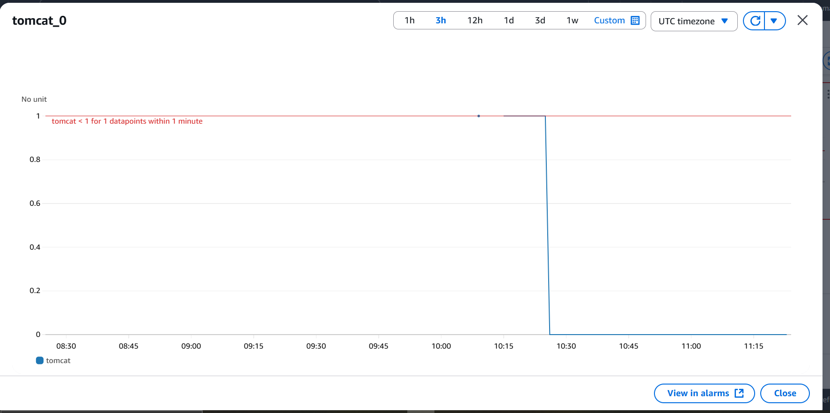

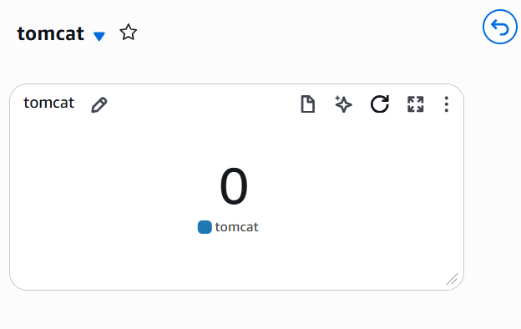

1. **Create Dashboard and monitor nginx service to send the alert if nginx is not running.**
2. **Created a instance**
3. **Created a bash script to install nginx and push metrics to CloudWatch**
4. 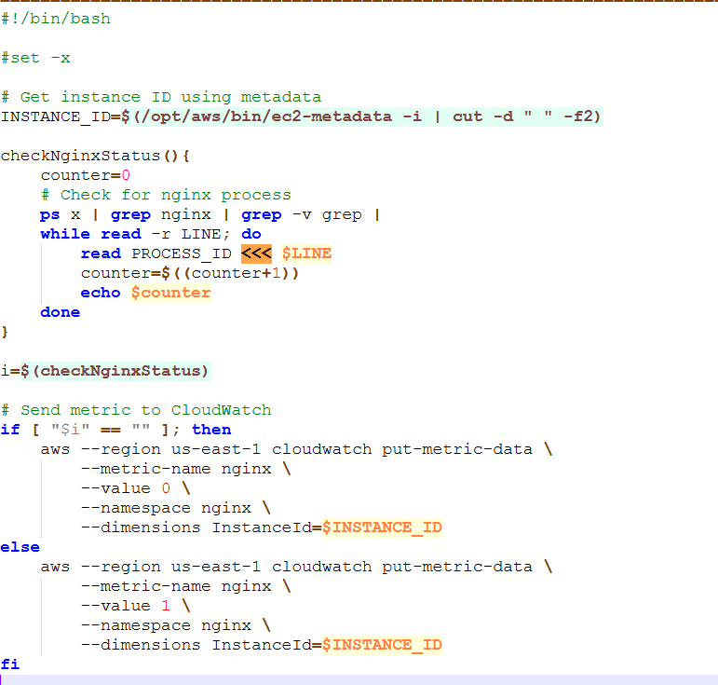
5. 