1. **Configure Classic Load balancer.**

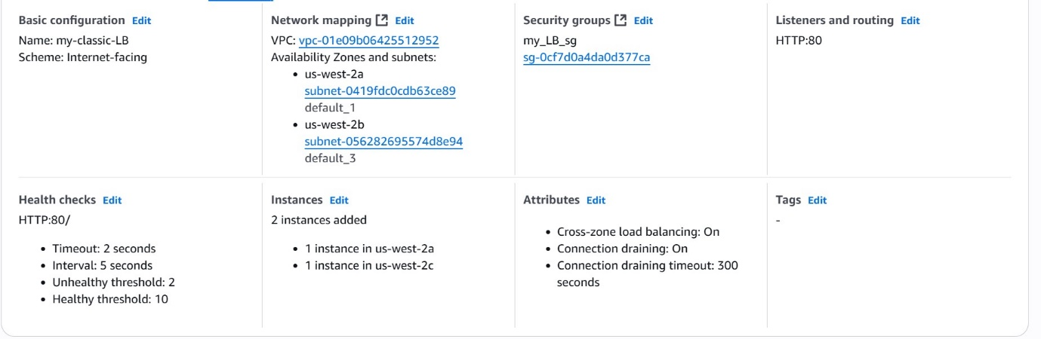

1. **Configure Application Load balancer.**

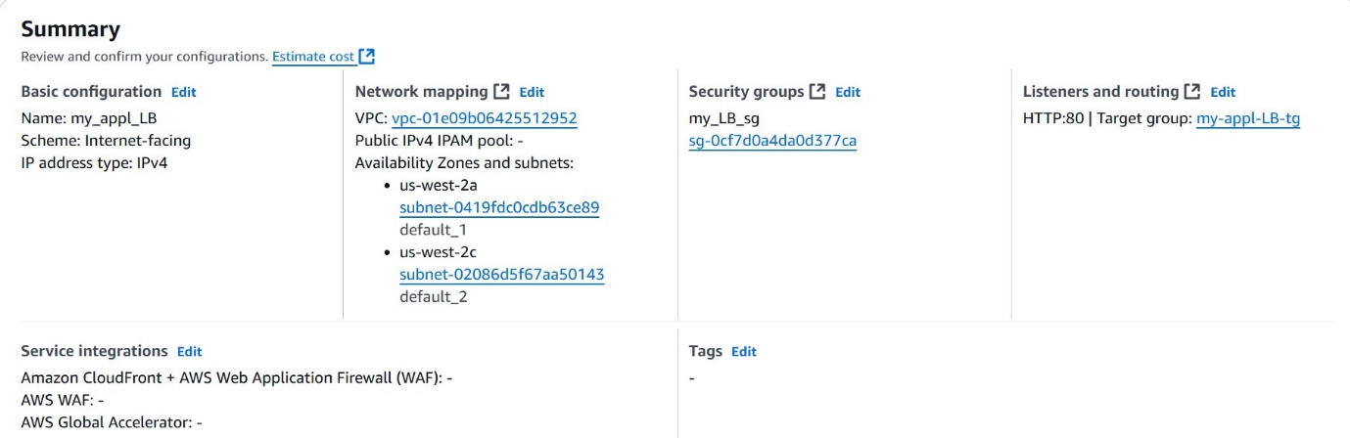

1. **Configure Network Load balancer.**

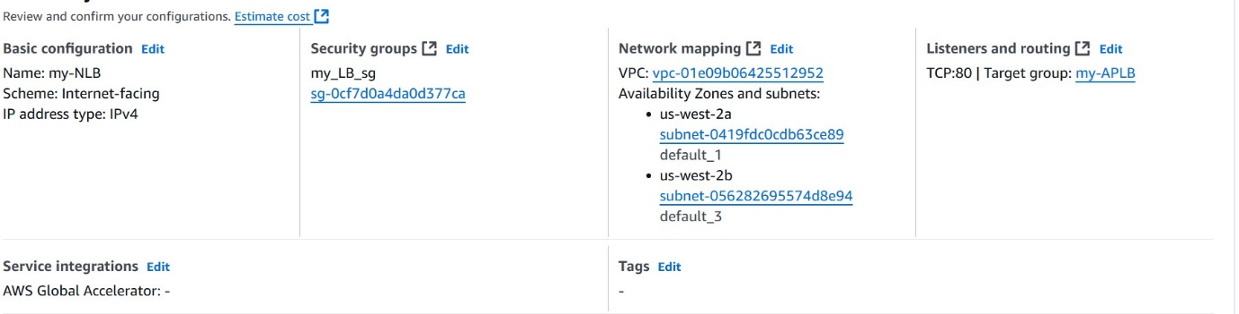

1. **Attach SSL for application load balancer.**

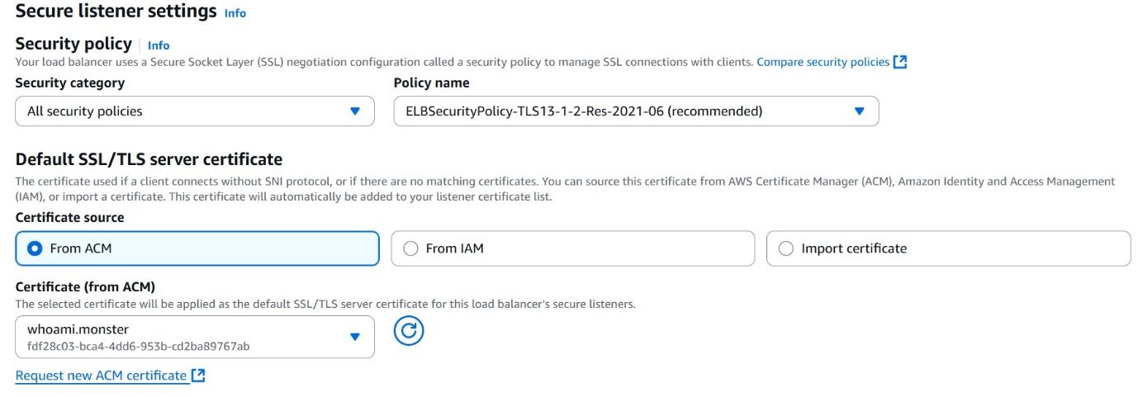

1. **Map Applciation load balancer to R53.**

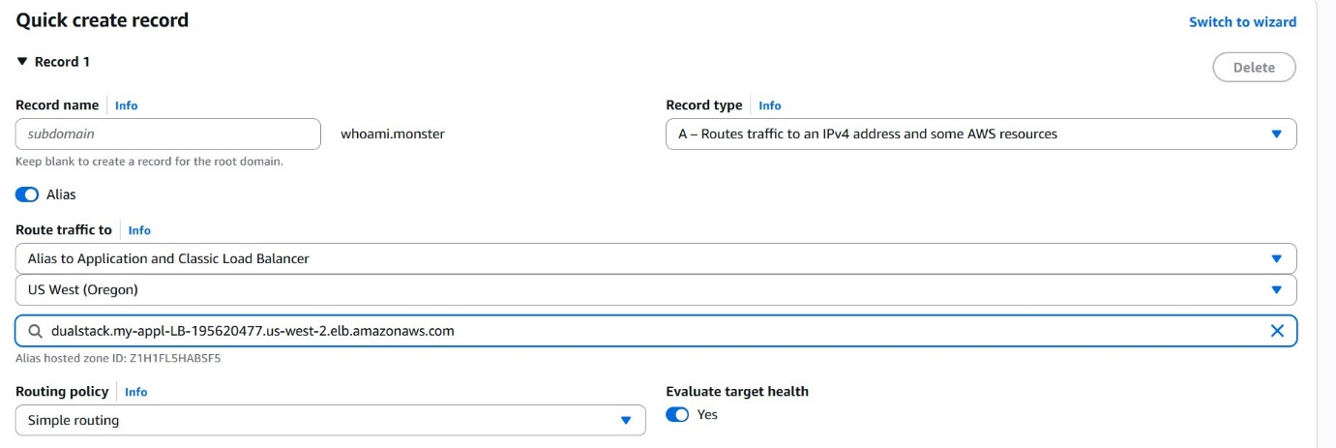

1. **Push the application load balancer logs to s3.**
2. **Go to Load Balancer**
3. **Select created Application load balancer.**
4. **Attributes**
5. **Enable monitoring**
6. **Select S3 bucket**
7. **Attach bucket name**