1. **Steps to Install git**

* **Go to official website:** [**https://git-scm.com/downloads/win**](https://git-scm.com/downloads/win)
* **Select your O.S and install .exe file in your system.**
* **Create env variable to git**
* **Configure git using following command :**

1. **Git config –global user.name your_name**
2. **Git config – global user. email your_github_email**

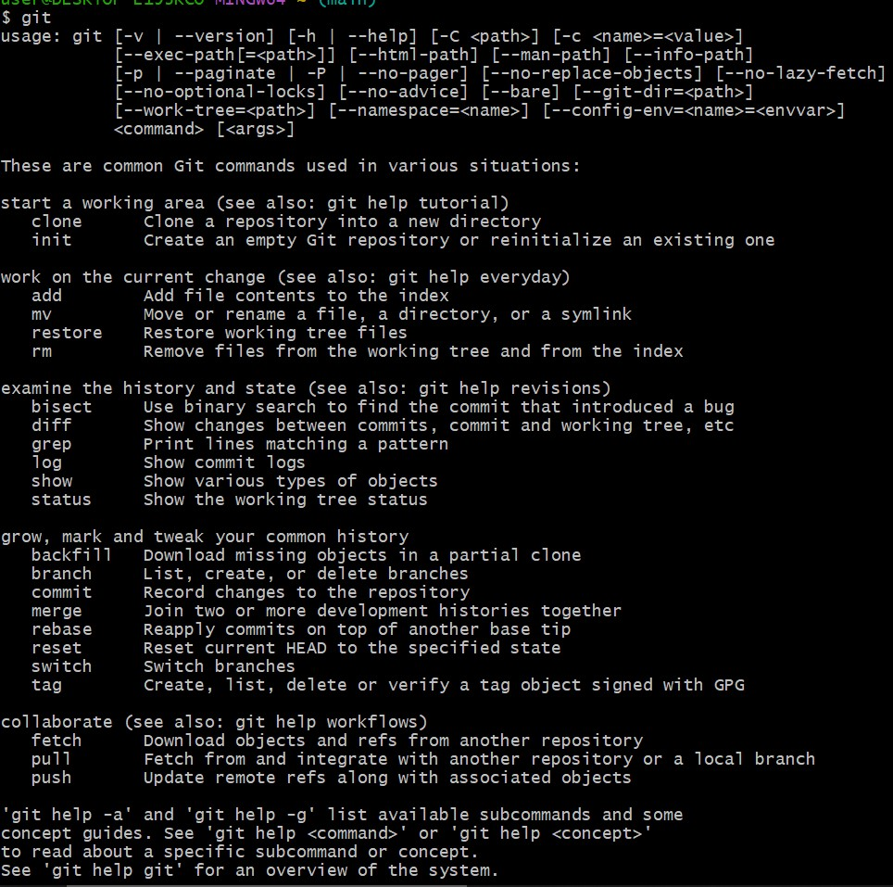

1. **Created a repo in github with README.md and .ignore file.**

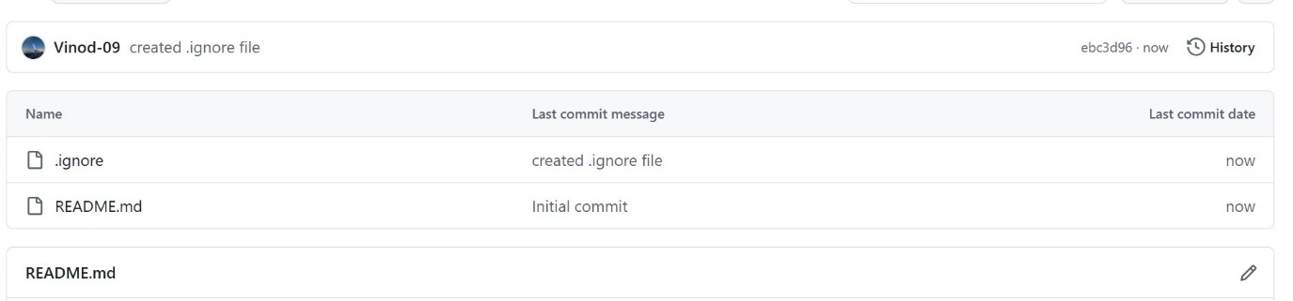

1. **Cloned created repo to local.**

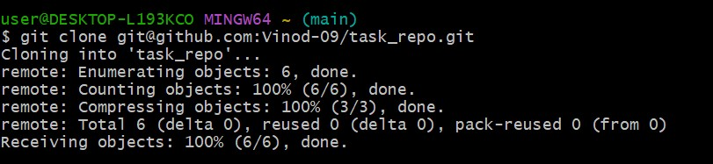

1. **Create two files in local repo. &**
2. **Committed two files and pushed to central Repository.**

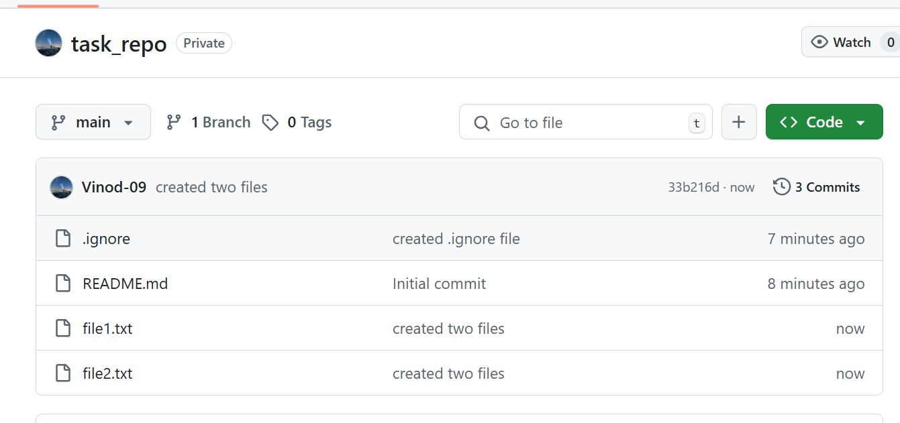

1. **Create a branch in local and create a sample file and push to central.**

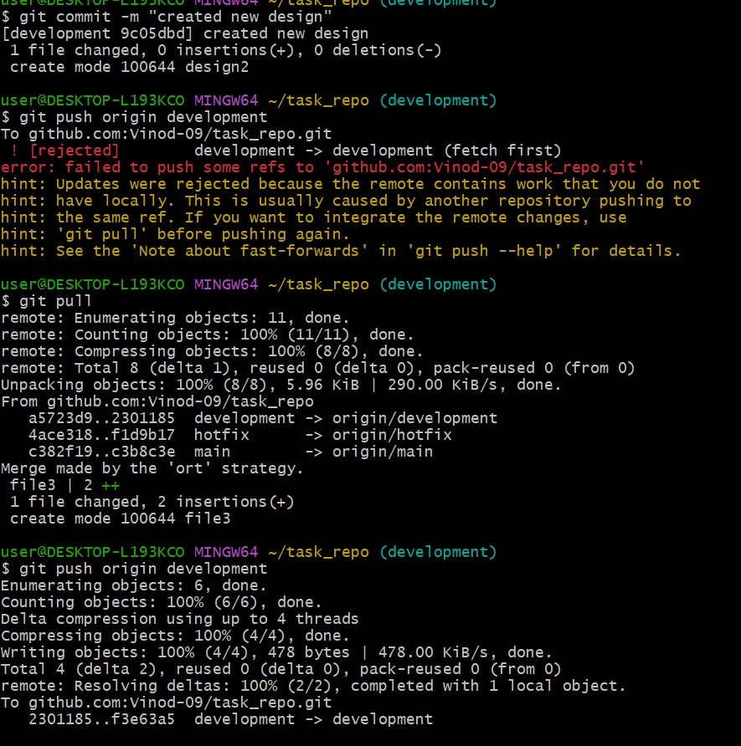

1. **Created a branch in GitHub and cloned that to local.**

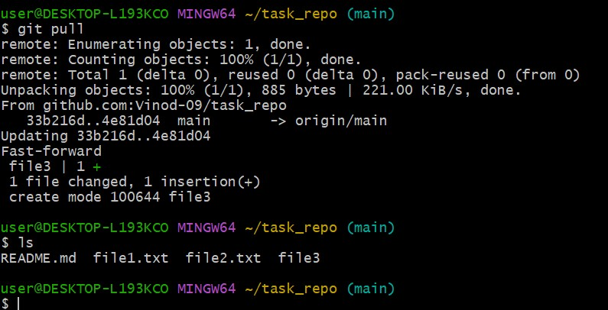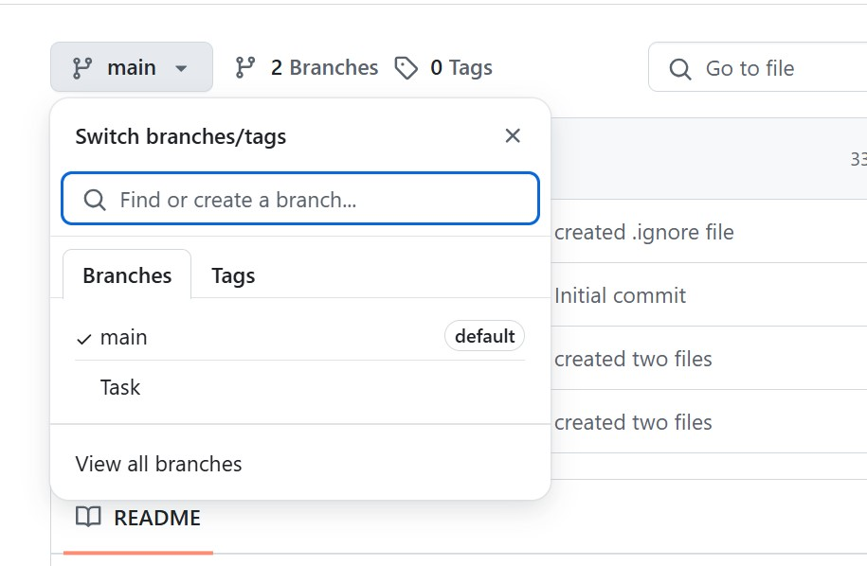

1. **Merge the created branch with master in git local.**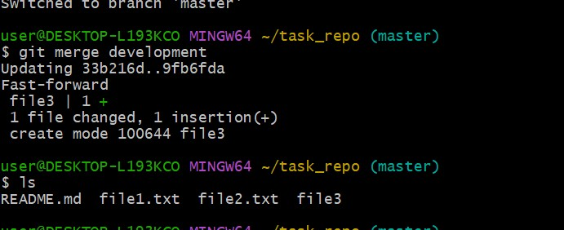
2. **Merge the created branch with master in github by sending a pull request.**

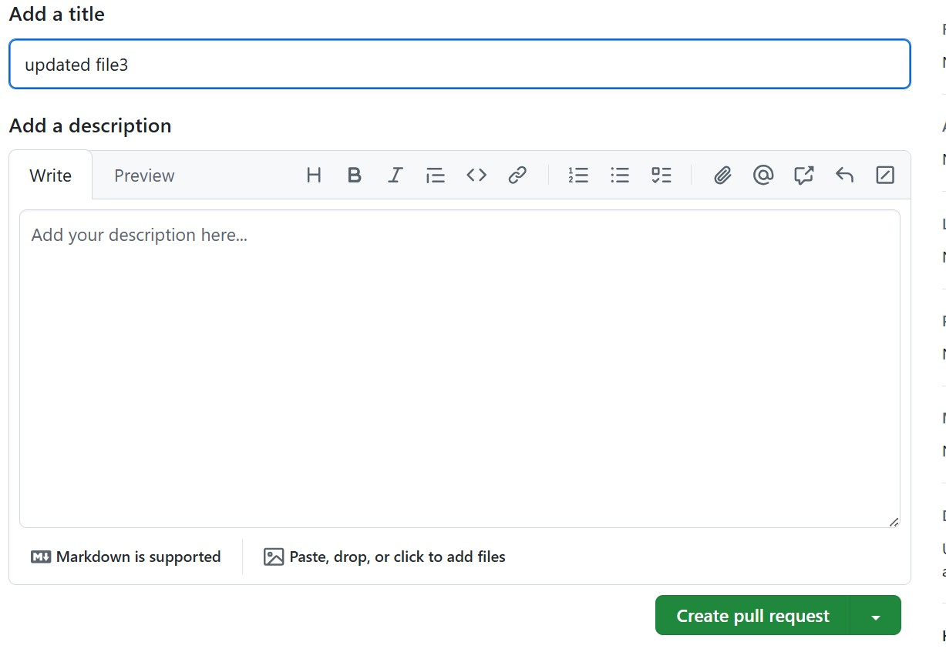

1. **create a file in local and send that to branch in github.**

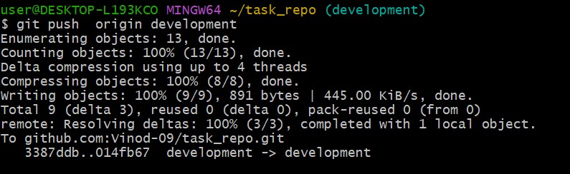

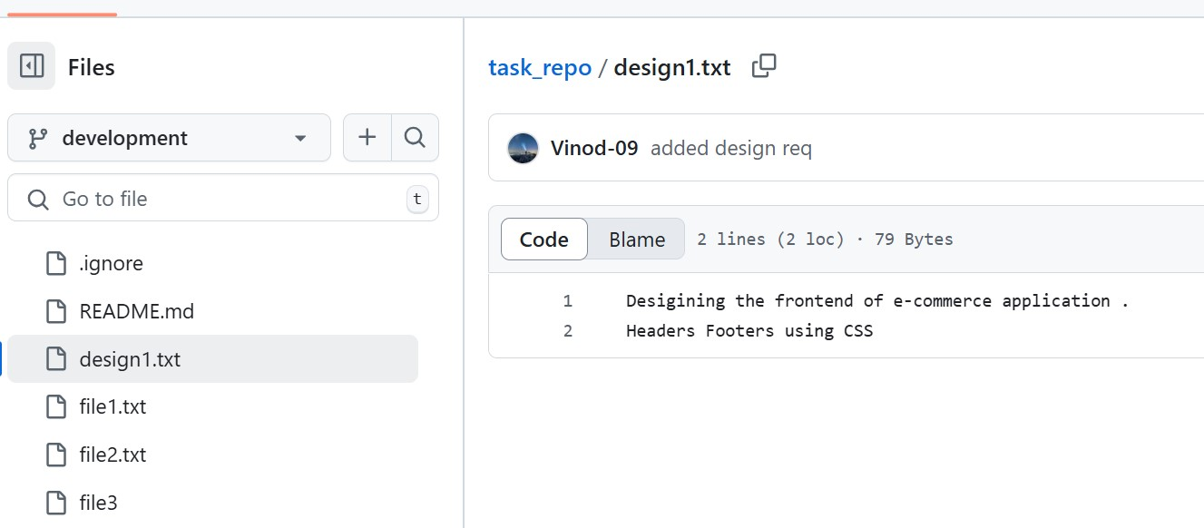

1. **clone only a branch from github to local.**

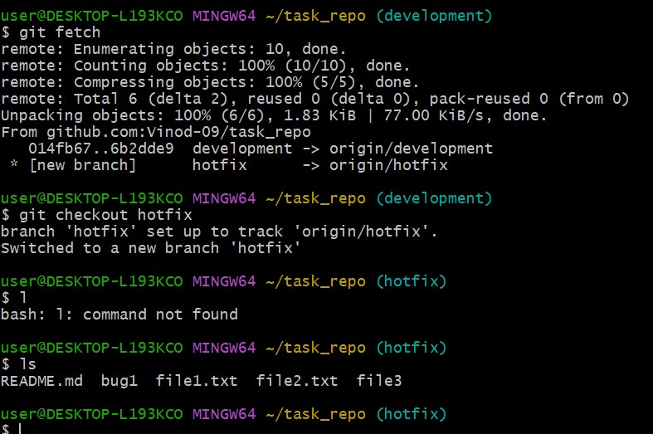

1. **create a file with all passwords and make that untrackable with git.**

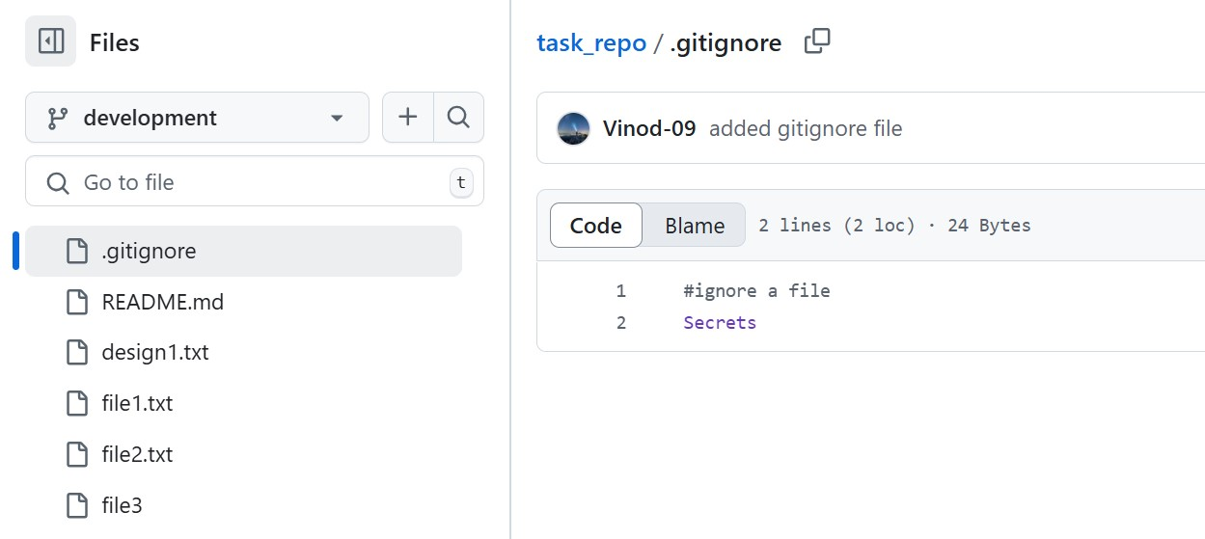

1. **make a commit and make that commit reset without savings changes.**

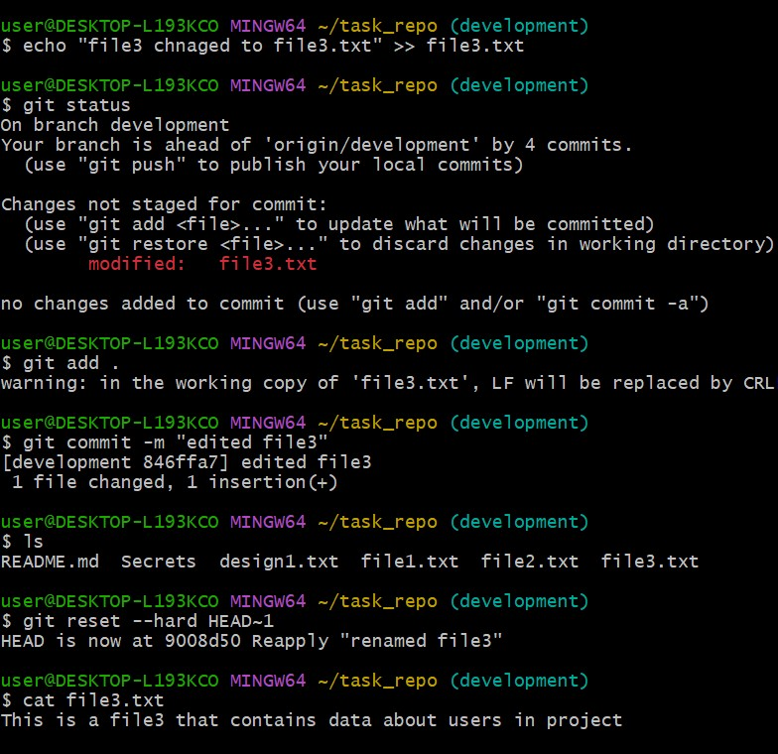

1. **Revert a commited commit to the older version.**

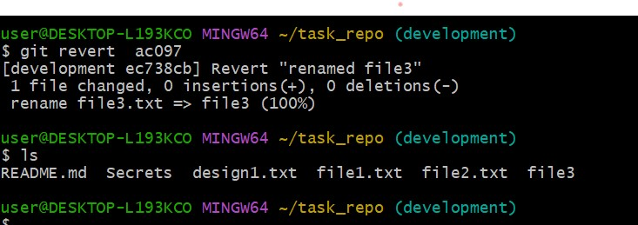

1. **push a file to stash without savings the changes and work on another file.**

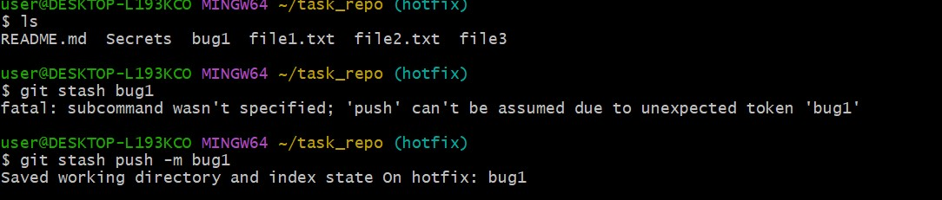

1. **undo the stash file and start working on that again.**

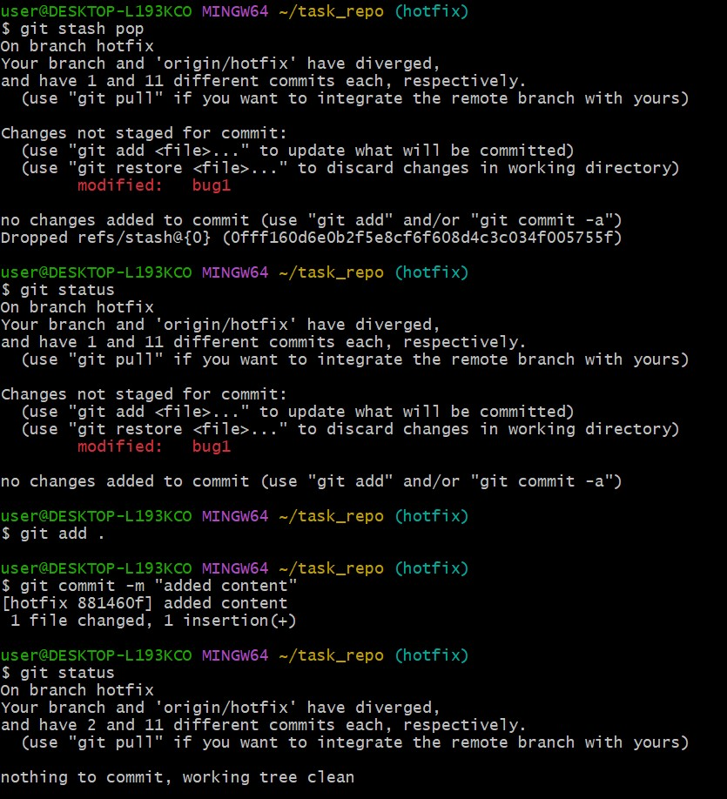

1. **generate a ssh-keygen and configure into github.**

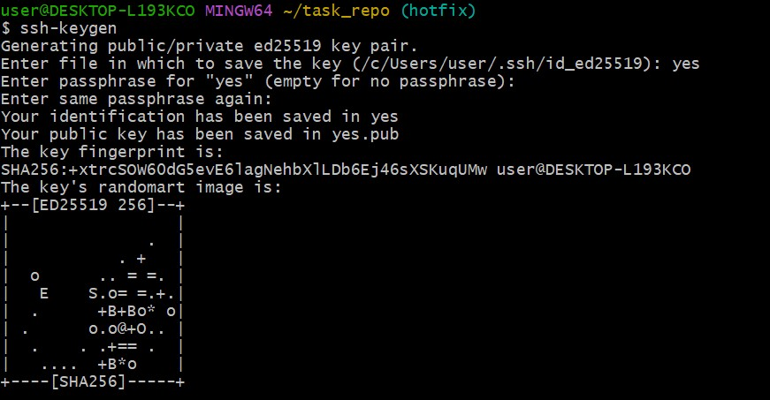

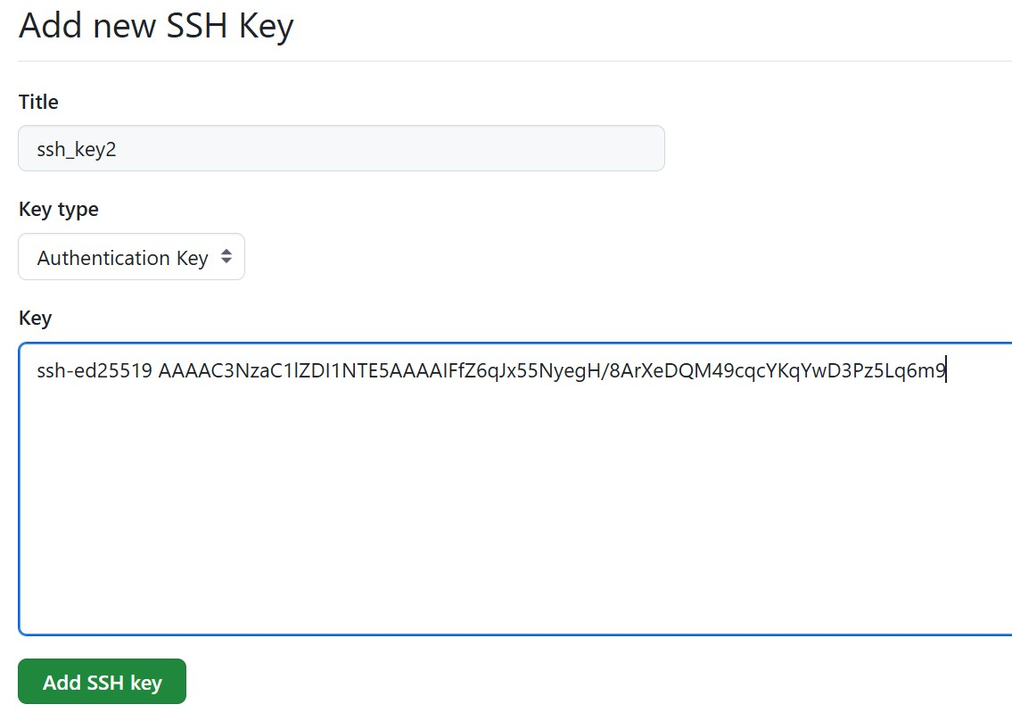

1. **configure webhooks to github.**

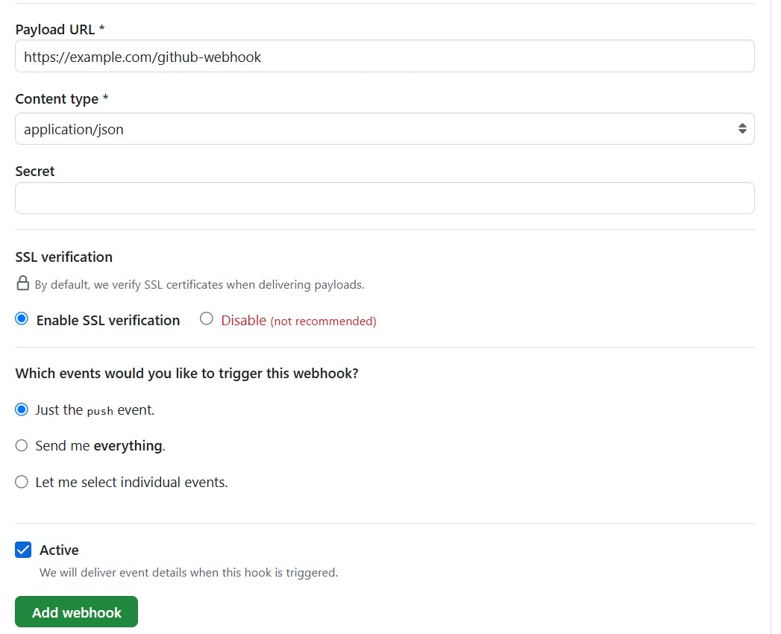

1. **basic understanding of .git file.**

**.git folder has**

1. **HEAD – points to current branch(main,dev,features….)**
2. **Config – it stores username, password…**
3. **Ref/ - pointer to branches heads and tags.**
4. **Objects – stores data (commits, blob) in a compressed form.**
5. **Index- staging area -tracks what’s ready to commit.**
6. **Logs/- history of actions on branches useful for git reflogs.**
7. **Hooks/ - scripts that runs automatically on events.**
8. **Info/ - exclude file for ignoring patterns autside(.gitignore).**

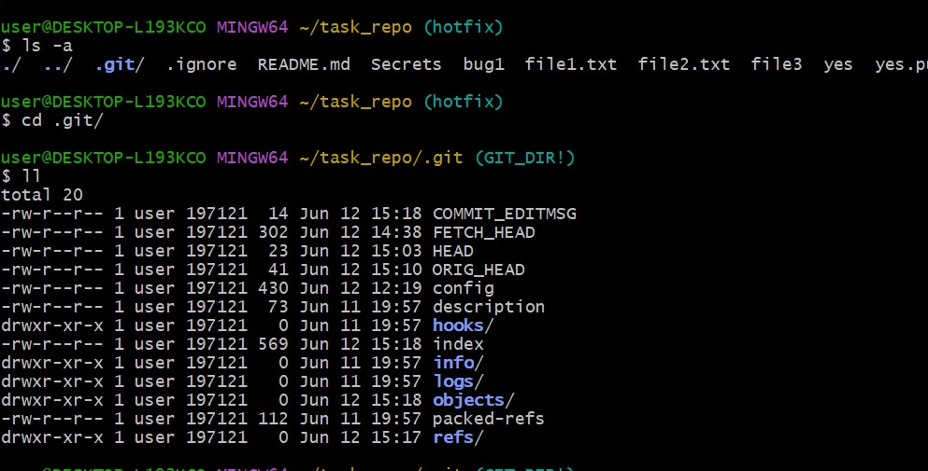

1. **Check all the logs of git.**

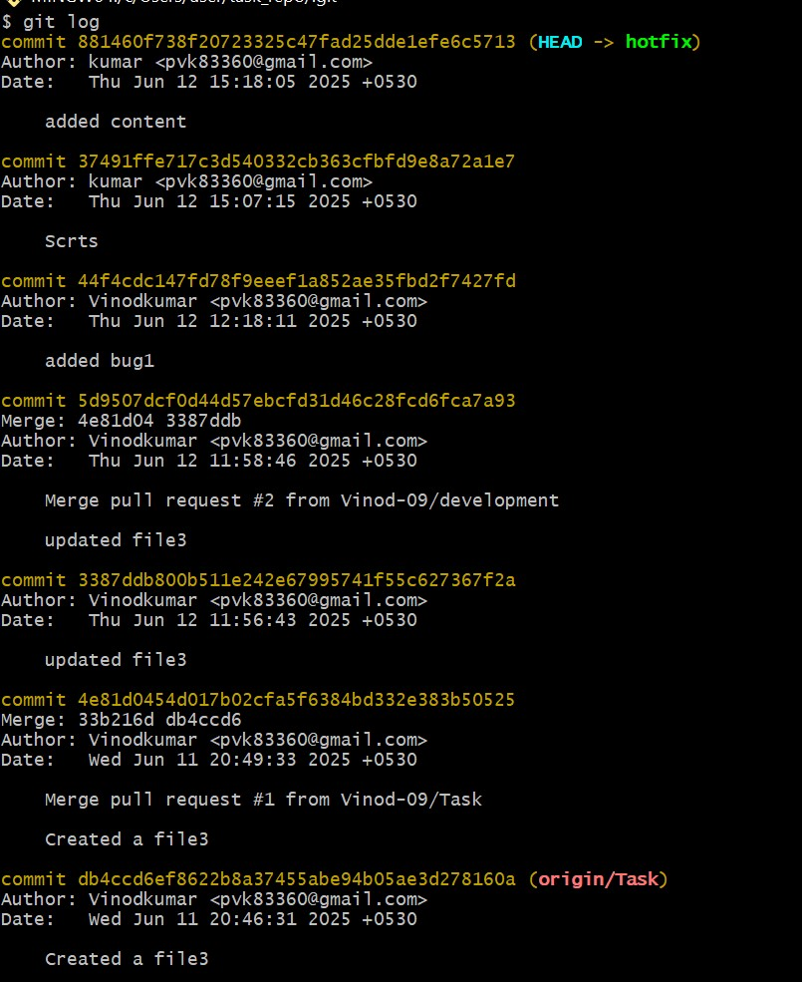

1. **Rename the commit message.**

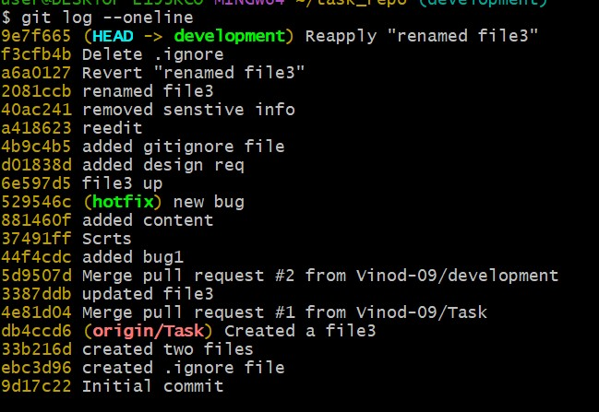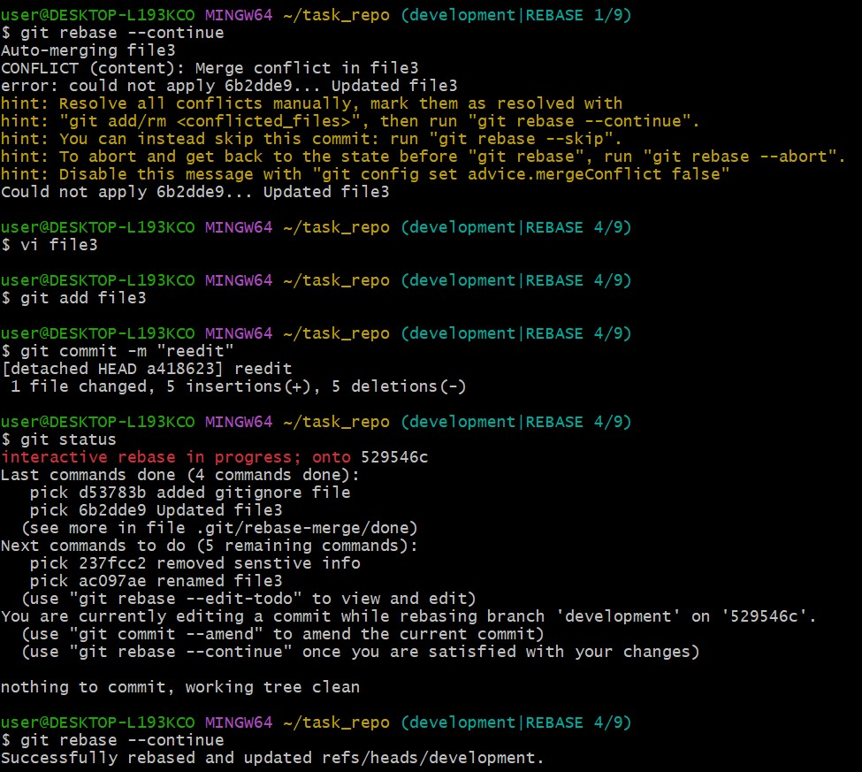

1. **Merge multiple commits into single commit.**

