1. **Install jenkins and run jenkins on port number 8081.**

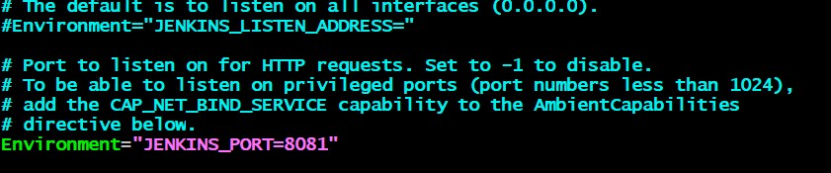

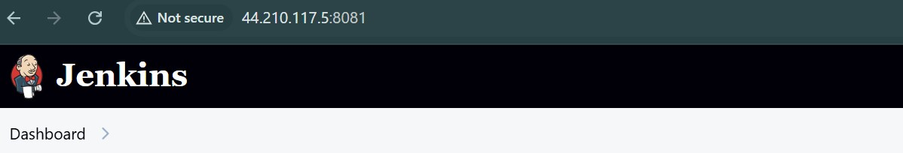

1. **Secured Jenkins server.**

**Secured Jenkins by changing default password to custom password and deleted default password in /var/lib/Jenkins/secrets/InititialPassword.**

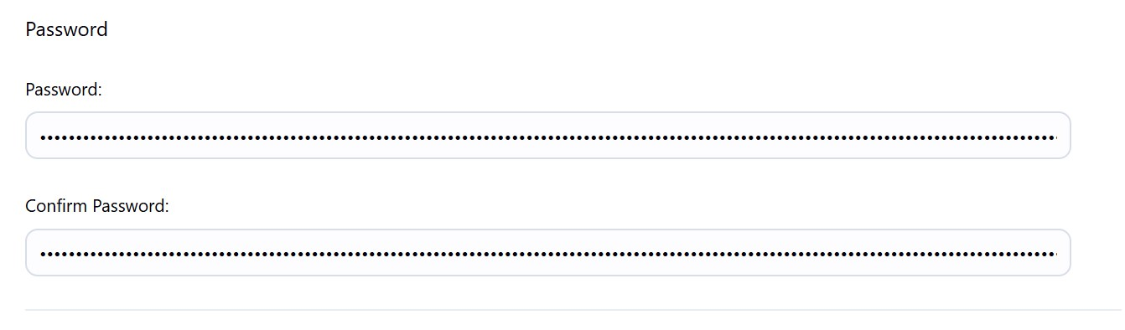

1. **Create users called Devops, Testing in Jenkins with Limited access.**

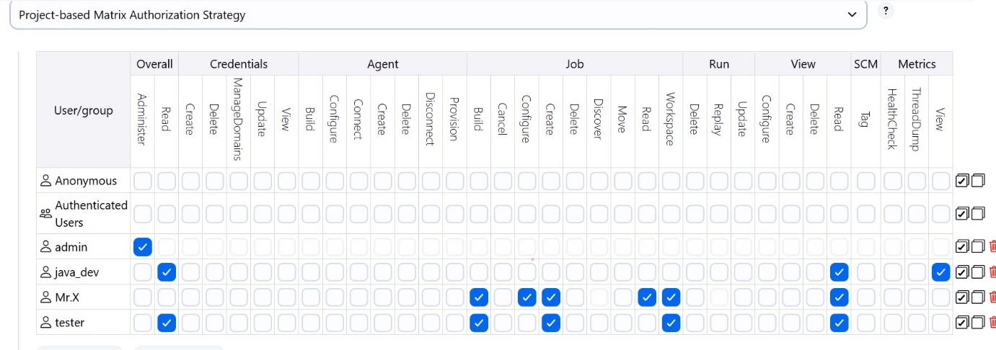

1. **Configure labels and restrict the jobs to execute based on label only.**

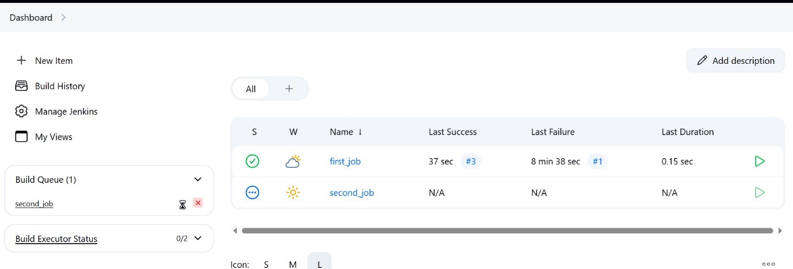

1. **Create Three sample jobs using the below URL. &&**
2. **Create one jenkins job using git hub Private repository.**

