1. **Configure 2 slave machines in jenkins master.**

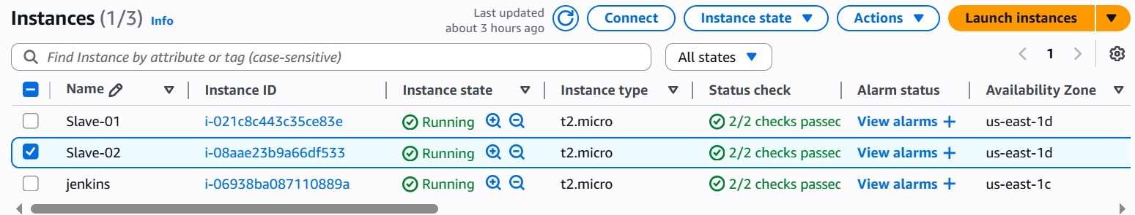

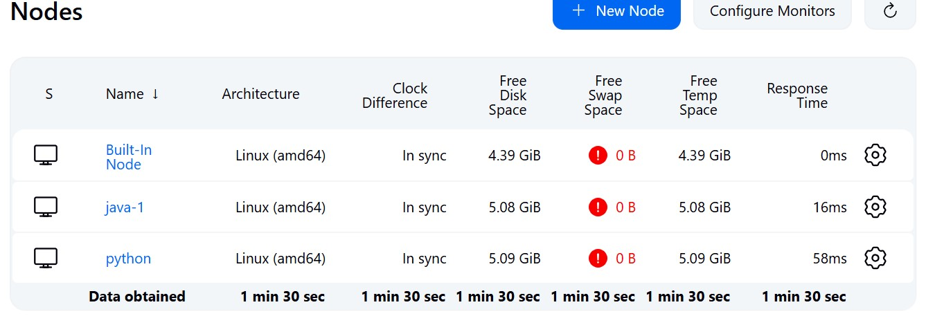

1. **Configure webhooks to jenkins job.**

**GitHub 🡪 project_repo 🡪 settings 🡪 webhooks 🡪 paste Jenkins URL in payload URL 🡪 send everything**

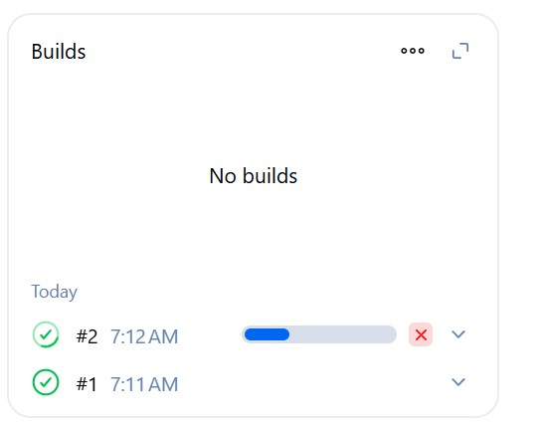

1. **Configure poll scm and build periodical options in jenkins job.**

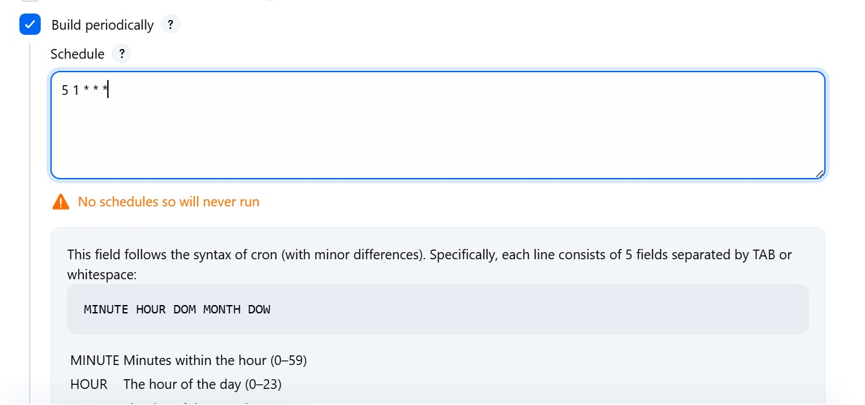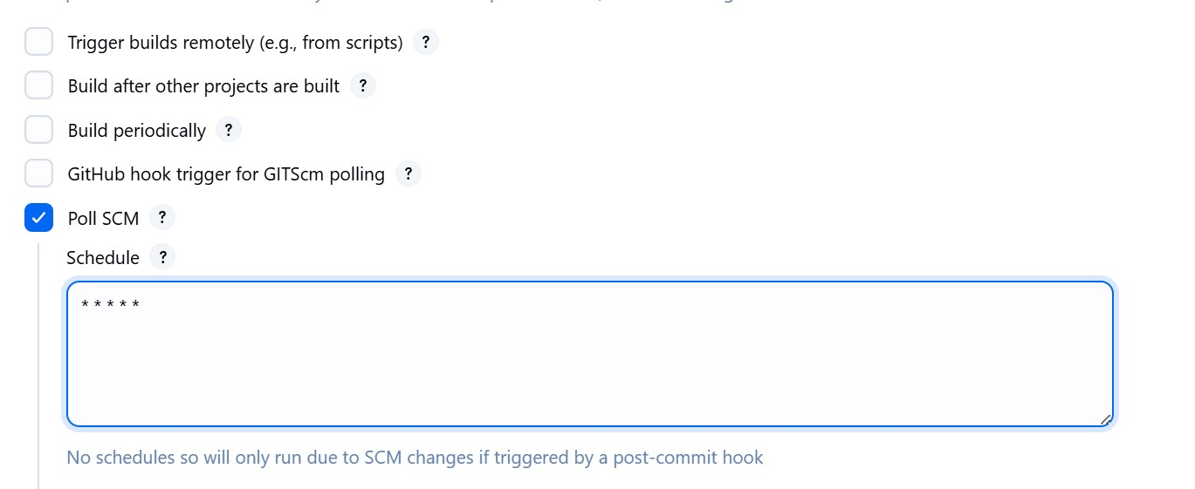

1. **Take backup of jenkins server by using bash script.**

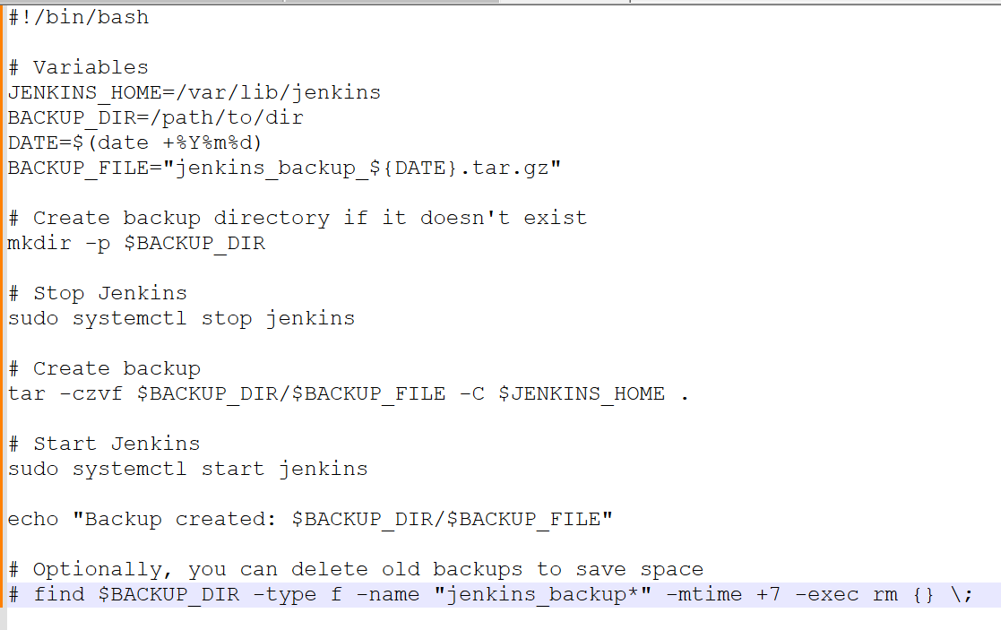

1. **Take backup of jenkins using rethin backup plugin.**

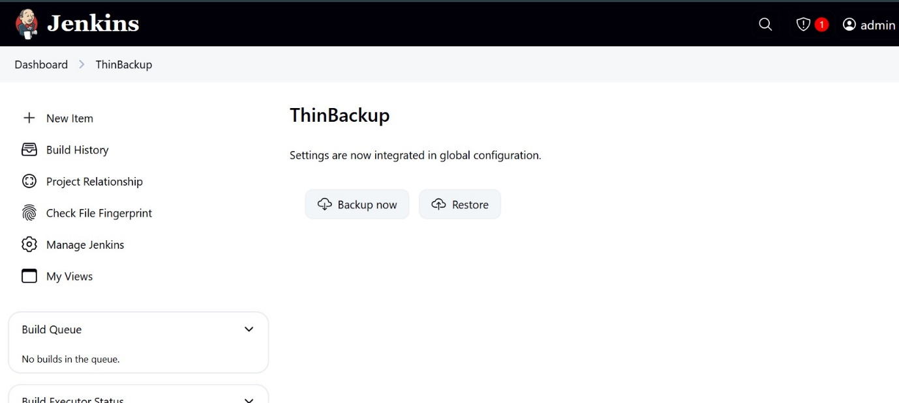

1. **Setup a new jenkins server and dump the backup taken in task4.**



