1. **Create one jenkins job using the below code and create three stages. stage1: Git clone to download the source code.**

**stage2: Sonarqube Integration to check the quality of code**

**stage3: Slack Integration to send the alerts to slack.**

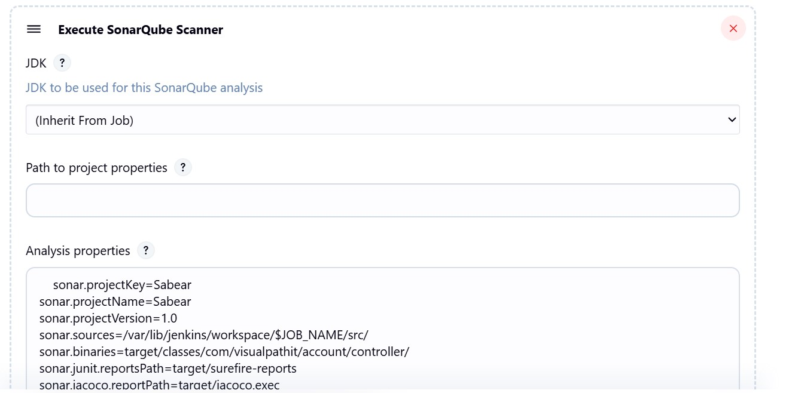

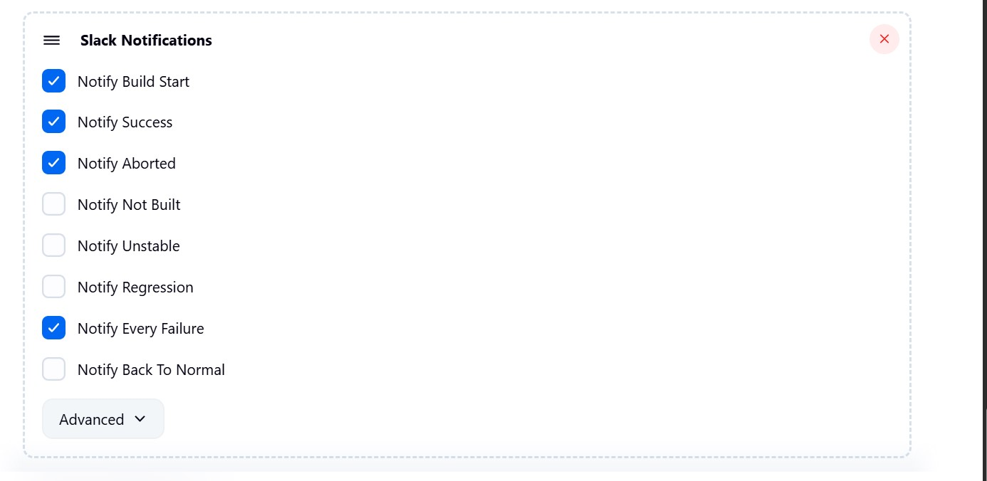

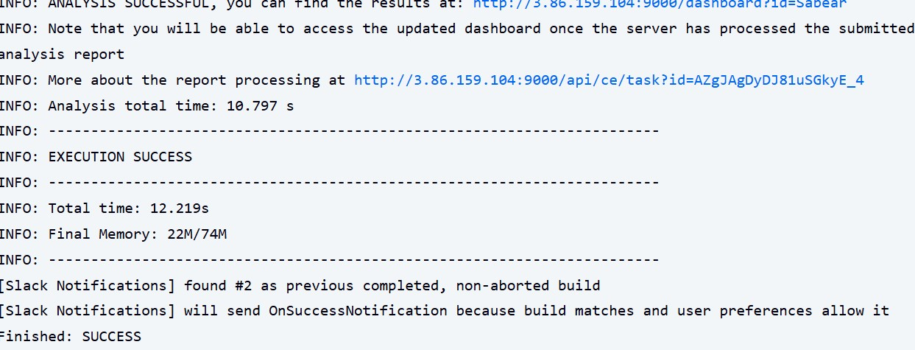

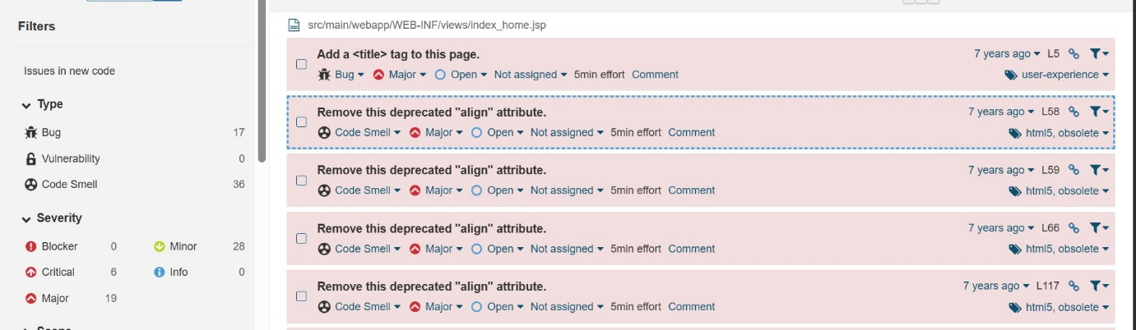

1. **Create one jenkins job using the below code and create three stages. stage1: Git clone to download the source code.**

**stage2: Sonarqube Integration to check the quality of code**

**stage3: Slack Integration to send the alerts to slack.**

