1. **Setup jenkins CICD pipeline using freestyle job using Docker containers using below code.**
2. **Git Clone**

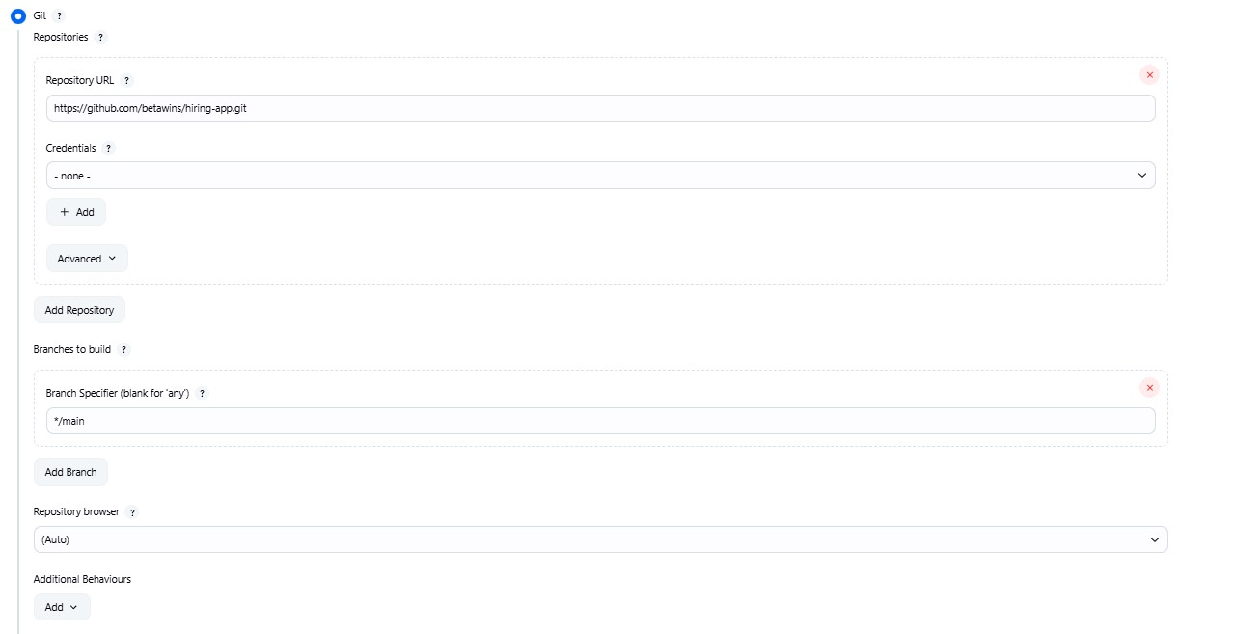

1. **Sonarqube Integration**

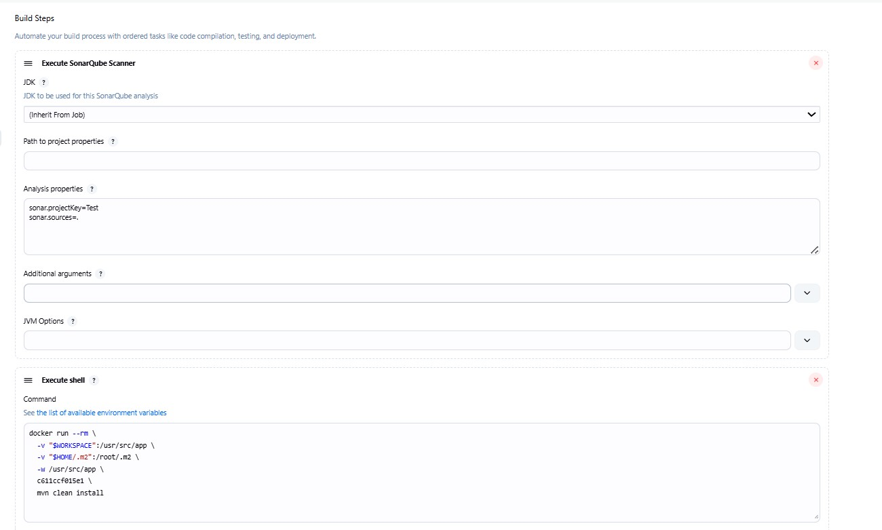

1. **Maven Compilation**

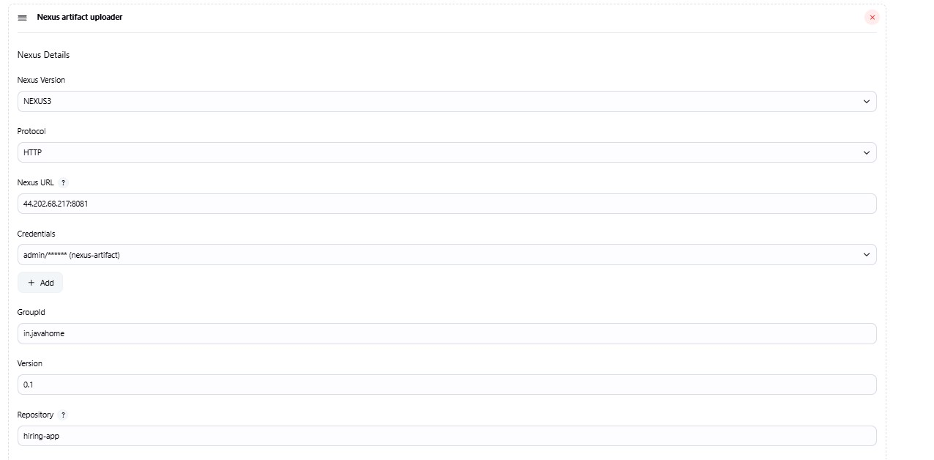

1. Nexus Artifactory

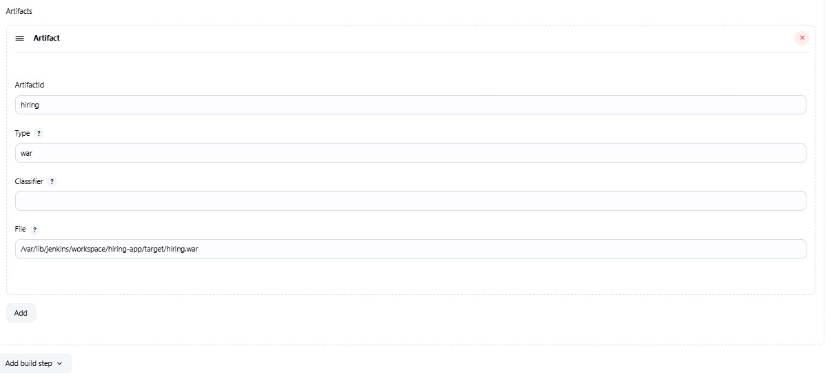

1. Slack Notification

* Installed slack notification plugin
* Configures in system with credentials using secret text

d. Deploy On tomcat

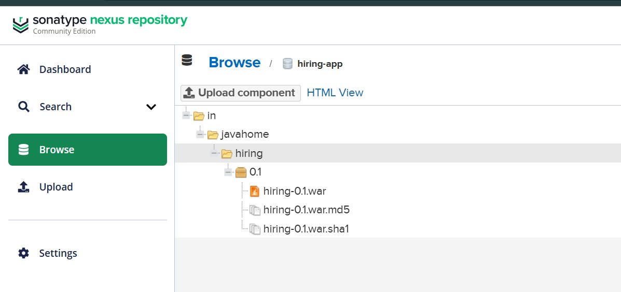



1. **Setup a jenkins CICD pipeline using Declarative pipeline using feature-1.1 branch.**

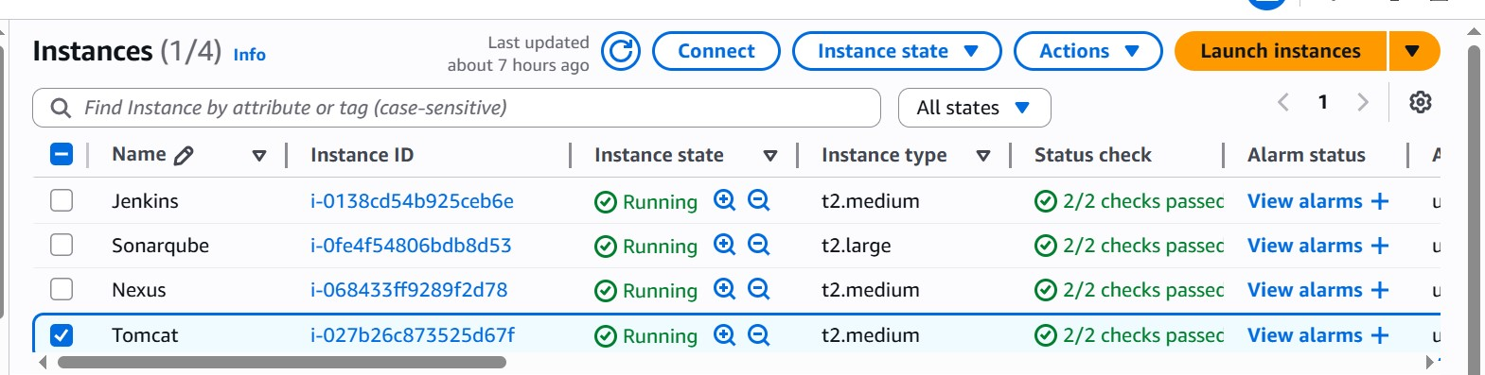

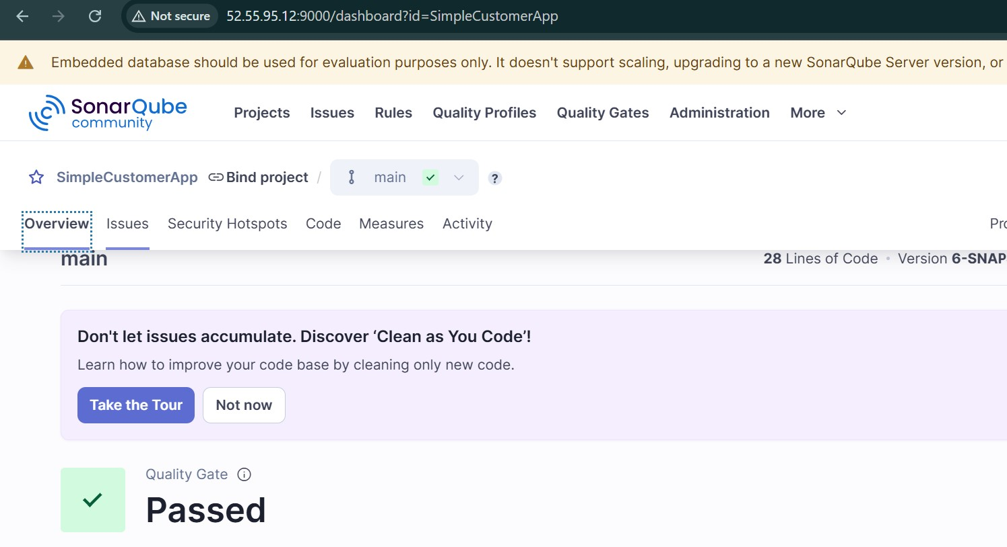

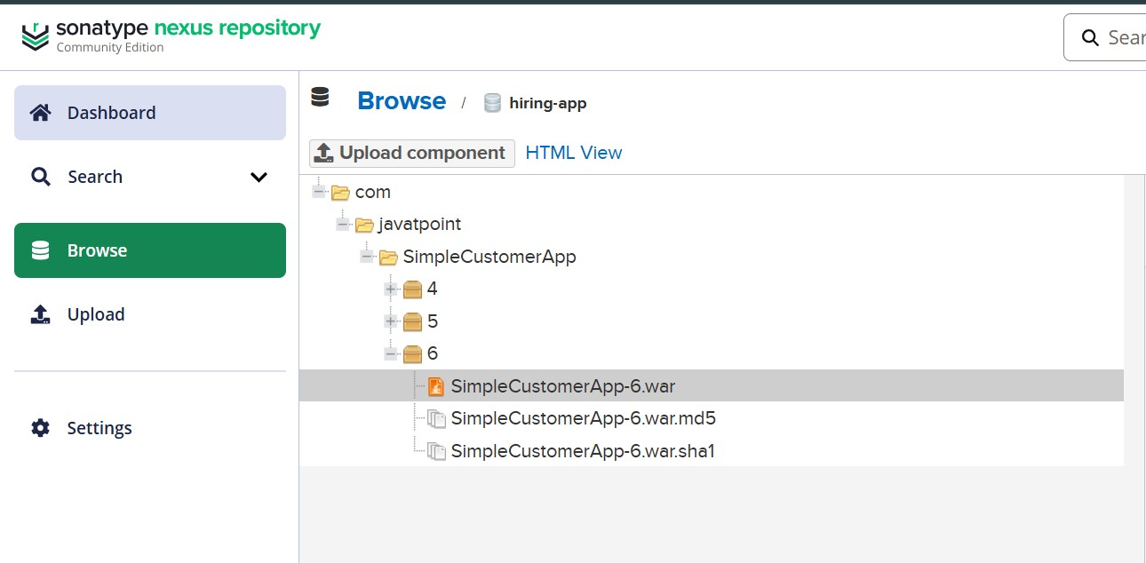

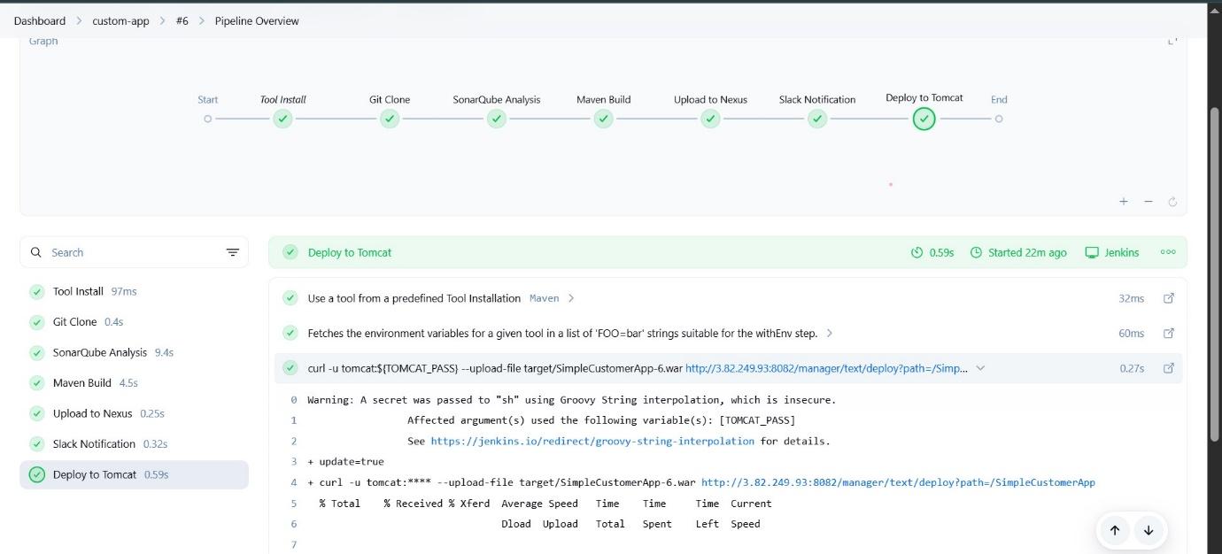

1. **Setup a jenkins CICD pipeline using Scripted pipeline using feature-1.1 branch.**

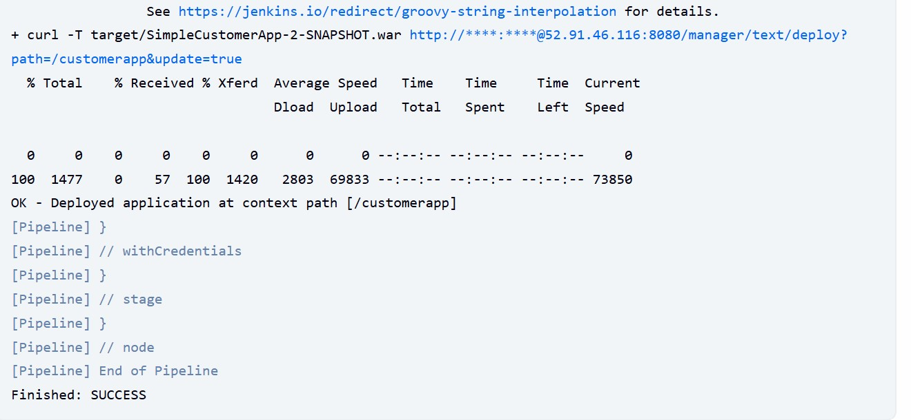

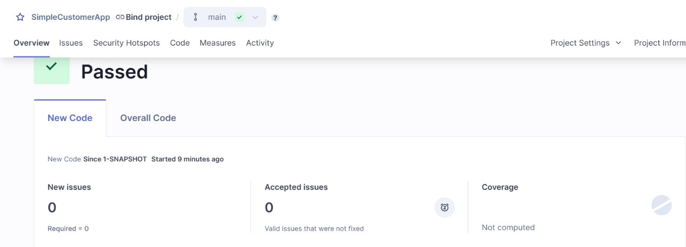



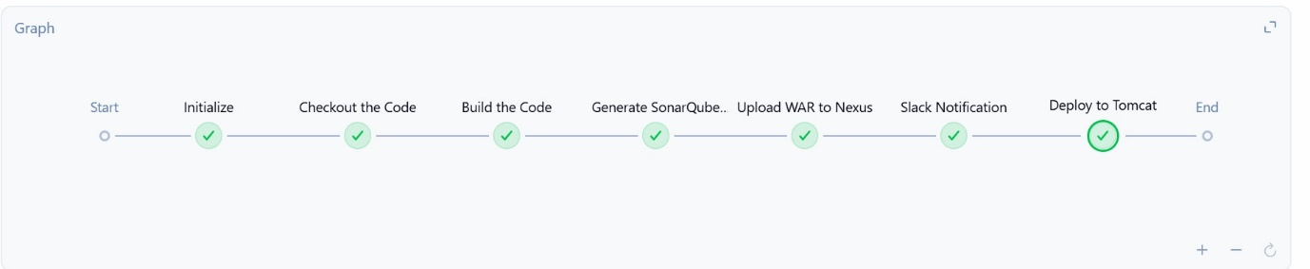

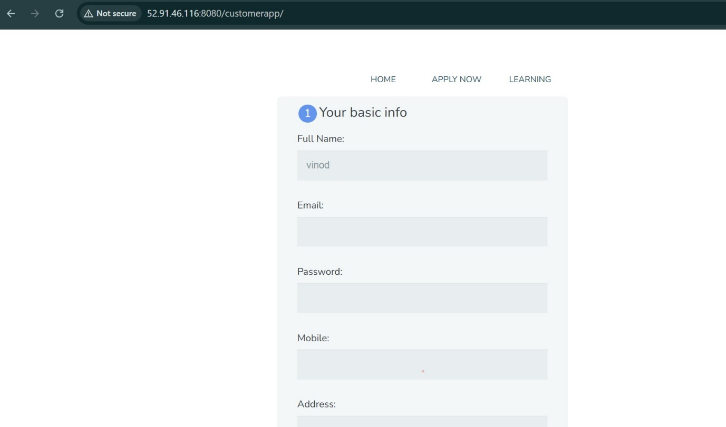

1. **Write sample skeleton of pipelines.**

**Declarative:**

**pipeline{**

**agent any**

**env_variables{**

**}**

**stages{**

**stage('Git Clone'){**

**steps{**

**}**

**}**

**stage('Sonar Analysis'){**

**steps{**

**}**

**}**

**stage('Maven'){**

**steps{**

**}**

**}**

**stage('Push artifact to Nexus'){**

**steps{**

**}**

**}**

**stage('Deploy '){**

**steps {**

**}**

**}**

**post {**

**always{**

**steps{**

**}**

**}**

**}**

**}**

**}**

**Scripted :**

**node {**

**// Define environment variables here**

**env.MY_VAR = 'value'**

**try {**

**stage('Git Clone') {**

**echo 'Cloning repository...'**

**// git url: 'https://github.com/your/repo.git'**

**}**

**stage('SonarQube Analysis') {**

**echo 'Running SonarQube analysis...'**

**// sh 'mvn sonar:sonar'**

**}**

**stage('Maven Build') {**

**echo 'Building project with Maven...'**

**// sh 'mvn clean install'**

**}**

**stage('Push Artifacts to Nexus') {**

**echo 'Pushing artifacts to Nexus...'**

**// sh 'mvn deploy'**

**}**

**stage('Deploy') {**

**echo 'Deploying application...'**

**// sh './deploy.sh'**

**}**

**} catch (e) {**

**echo "Build failed due to error: ${e.message}"**

**// Optional: Send Slack/email notification here**

**currentBuild.result = 'FAILURE'**

**throw e**

**} finally {**

**echo 'Cleaning up or final notifications...'**

**// Optional cleanup or post-build logic**

**}**

**}**

1. **Create a parametirized job in jenkins.**

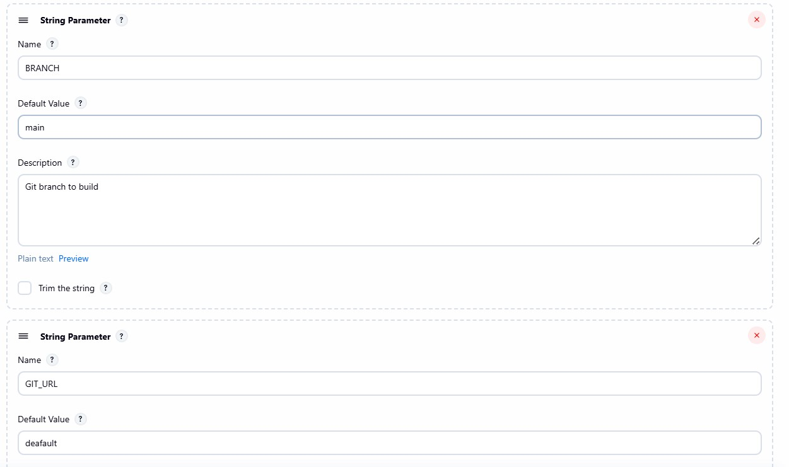

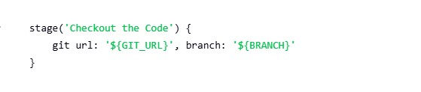

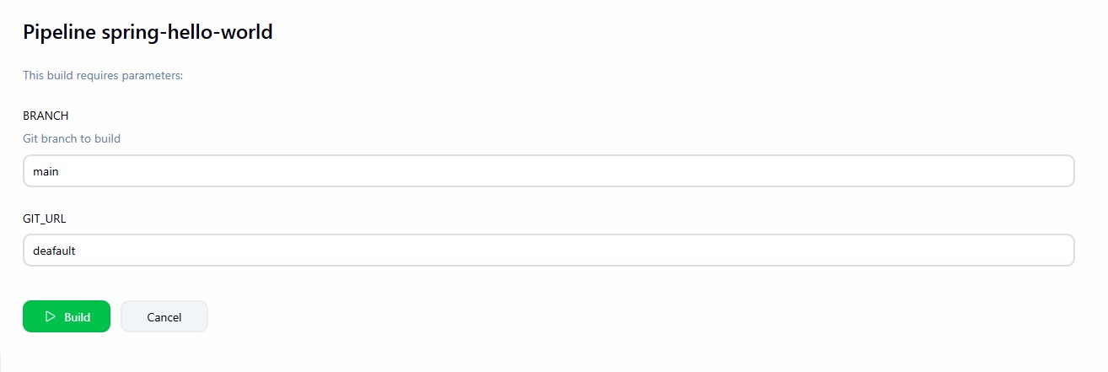

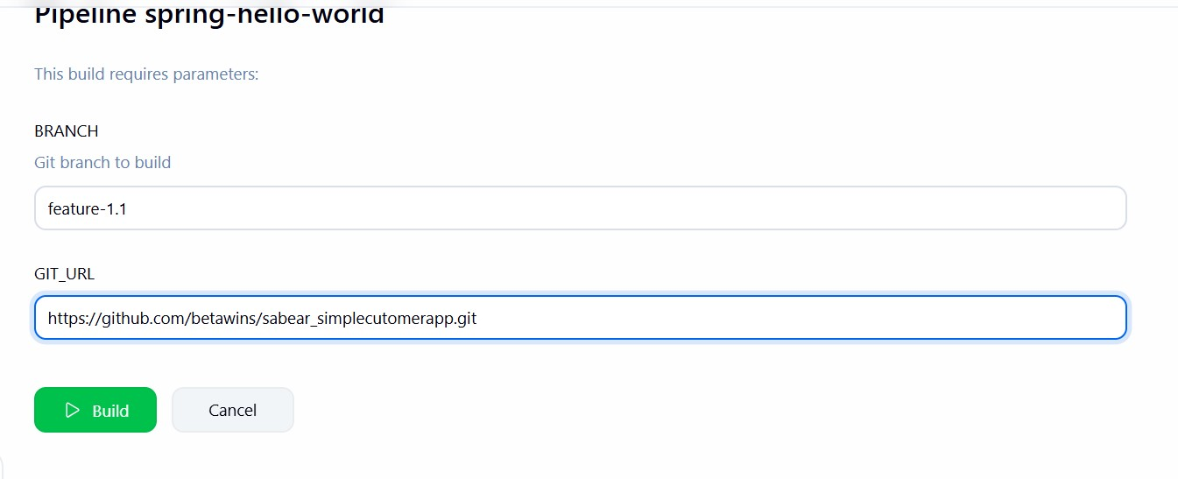

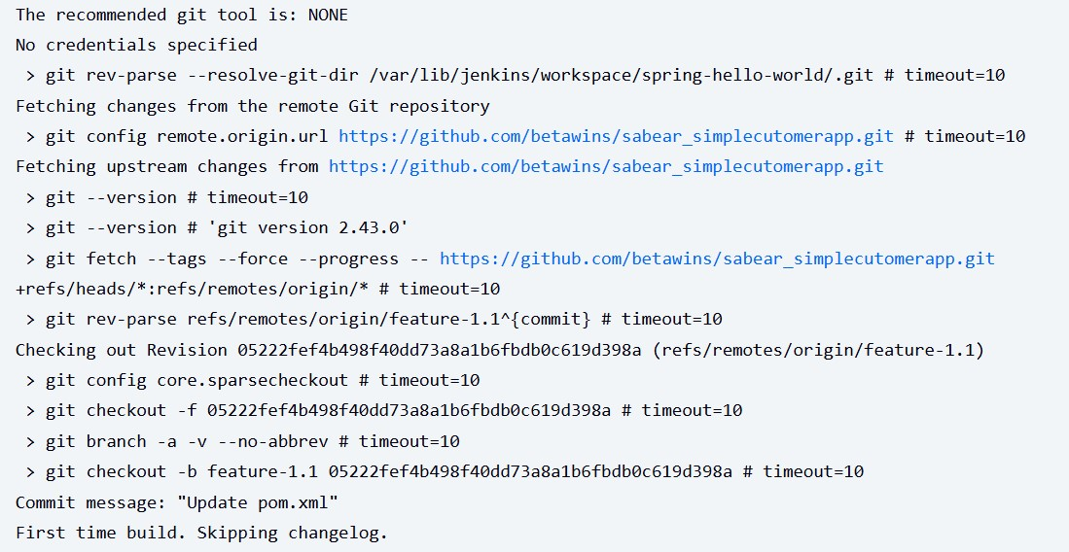

1. **Setup one slave machine for jenkins.**

