1. **Create MariaDB on ec2.**

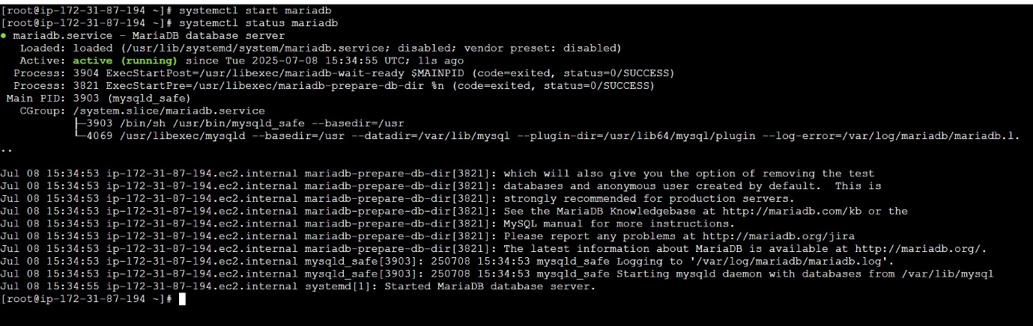

1. **Inserted some dummy data.**

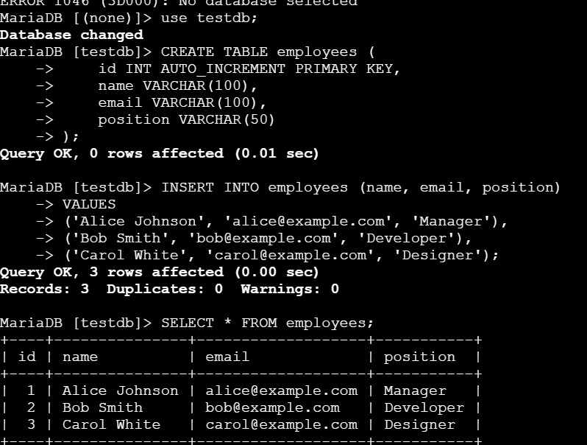

1. **Take the backup of dummy data on ec2.**

* **mysqldump -u root -p testdb > backup_DB.sql**
* **it creates a backup in backup_DB.sql file**

1. **launch MariaDB RDS instance.**

**1.name of your instance.**

**2.Master username -> ID of master user of DB**

**3.select credentials management -> AWS scerect manager , self managed-> create a passwd**

**4.instance config -> Standard class- general ussage -> m-series,**

**memory optimized class-High memory to cpu -> R-series,**

**Brustable class ->DEV, testing, low-traffic applications -T series**

**5.Storage -> ssd or Magnet**

**6.Multi-AZ availability -> create standby instance for PROD.**

**7.COmpute resource -> you can coonect this to ec2 or u can connect later.8.**

**8.Select VPC**

**9.subnet group**

**10.RDS proxy -RDS Proxy is a fully managed, highly available database proxy that improves application scalability, resiliency, and security.**

**11.Monitoring**

1. **Migrated database from ec2 to RDS.**

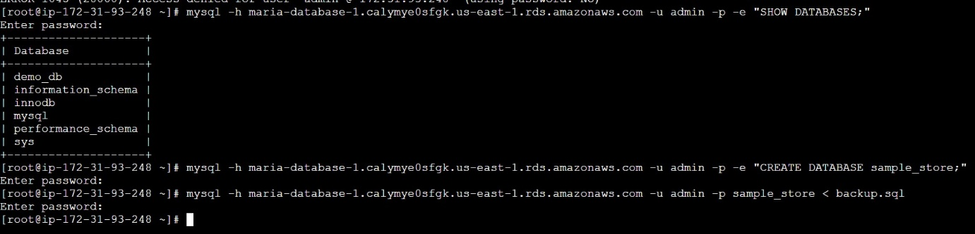

1. **Installed mysql db on ec2. &&**
2. **Launch mysql RDS image.**

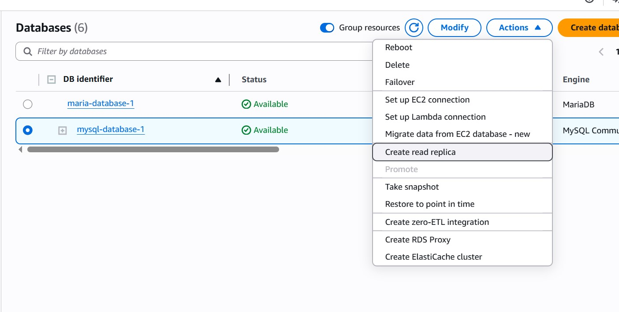

1. **Configured multi AZ.**

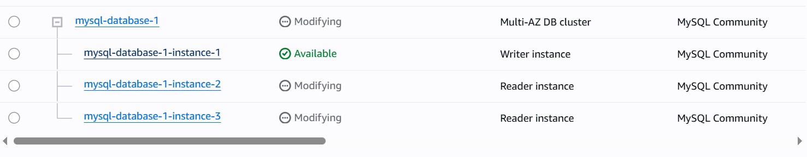

1. **Take Backup of db and restore the DB.**

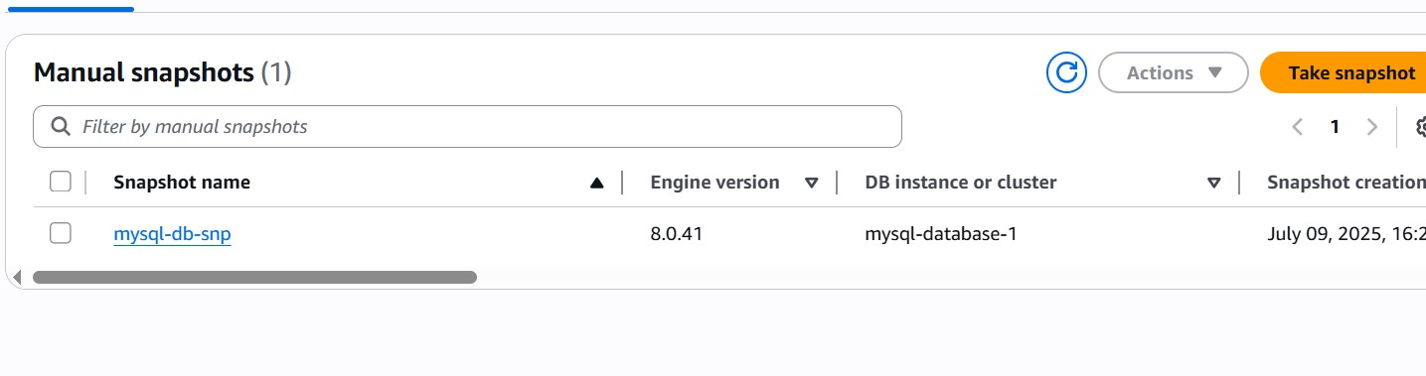

1. **Created ReadReplca.**

