1. **Created s3 bucket and upload some objects to s3.**

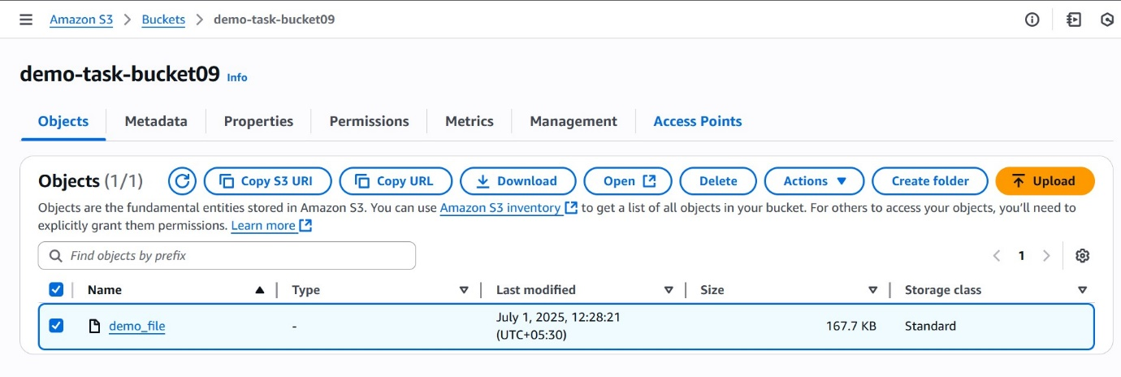

1. **Deployed a static website in s3 bucket.**
2. **Select bucket 🡪 properties 🡪 static web hosting 🡪 edit 🡪 enable static web hosting 🡪 give two file names 🡪 save chnages.**

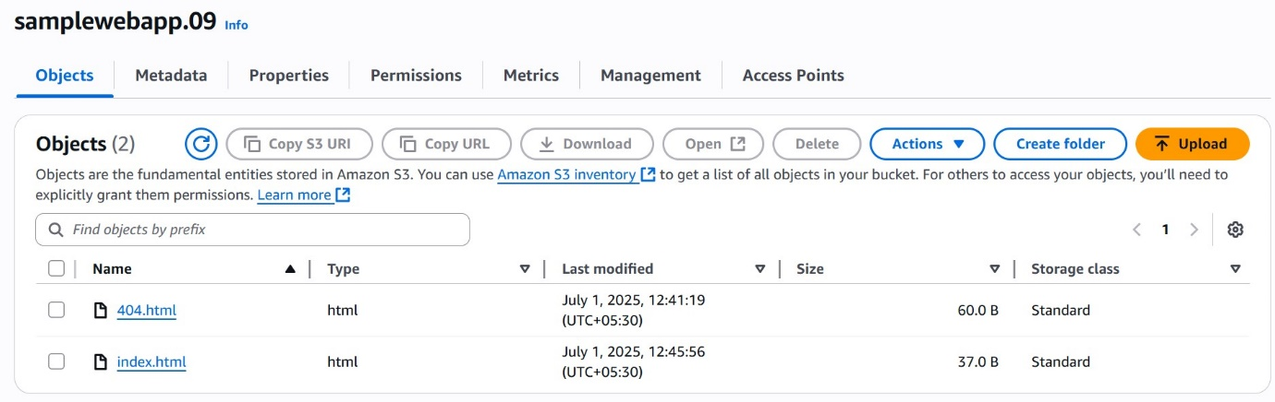

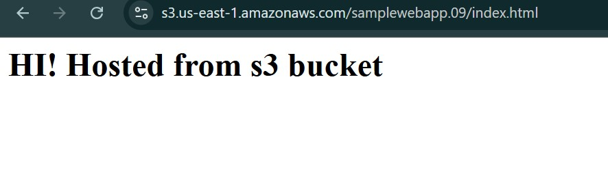

1. **Enable cross region replication on s3 buckets.**
2. **We need to create buckets one is for source and other is for destination (other account or other region).**
3. **Create a IAM role for s3 service .**
4. **Attach a custom policy to role**
5. **We need to attach a bucket policy.**
6. **Select bucket 🡪 management 🡪Replication rules**
7. **We give source bucket name and region and destination bucket name and Role name**
8. **In destination bucket 🡪 permissions 🡪 we give policy that allows source bucket to communicate and also role .**
9. **Configure bucket policy,only Admin user can see the objects of s3 bucket.**
10. **Create a user Admin in IAM**

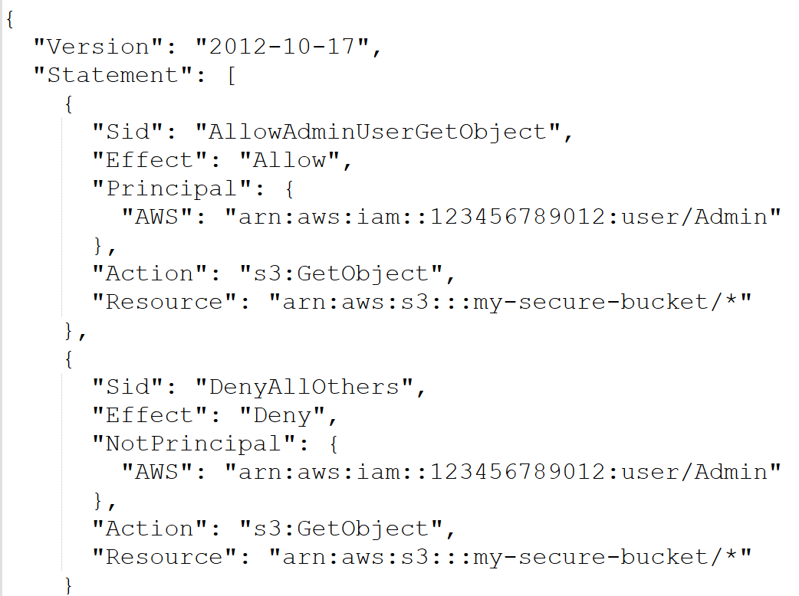

1. **Setup lifecycle policies to automatically transition or delete objects based on specific criteria.**

**Select bucket 🡪 management 🡪 life cycle rules**

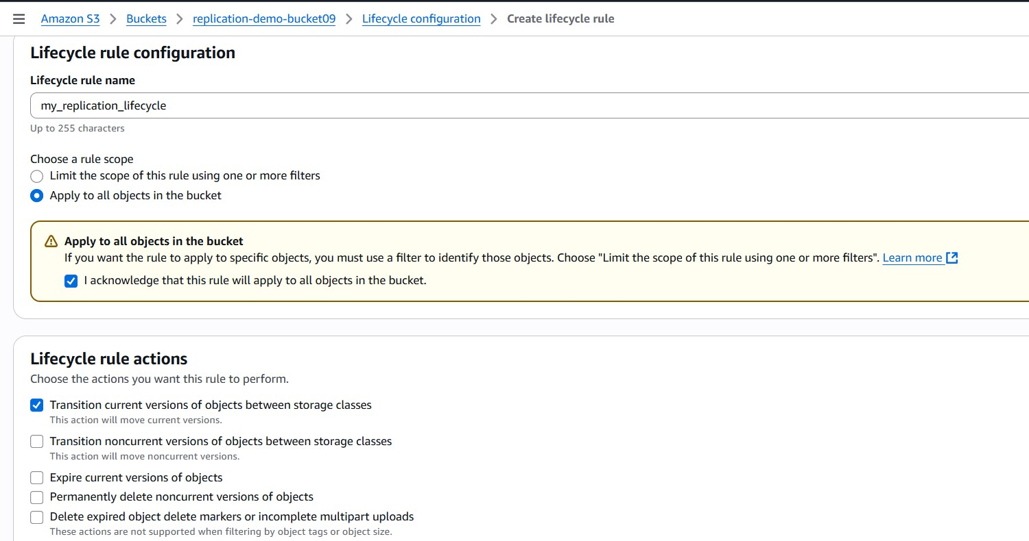

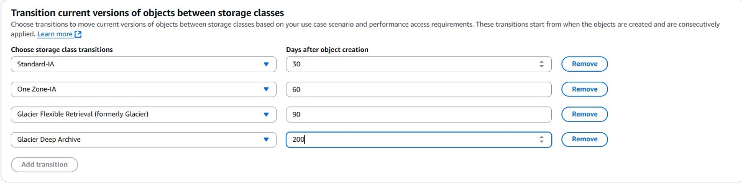

1. **Push some objects in s3 using AWS CLI.**

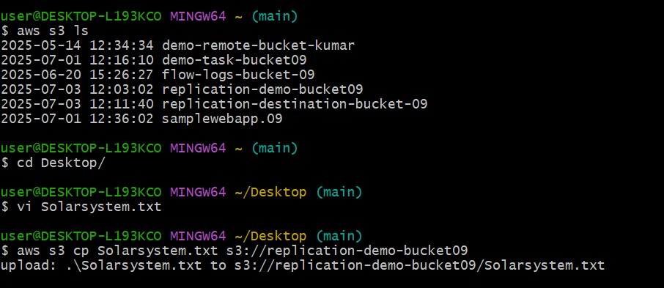

1. **Created a bash script to create s3 bucket.**

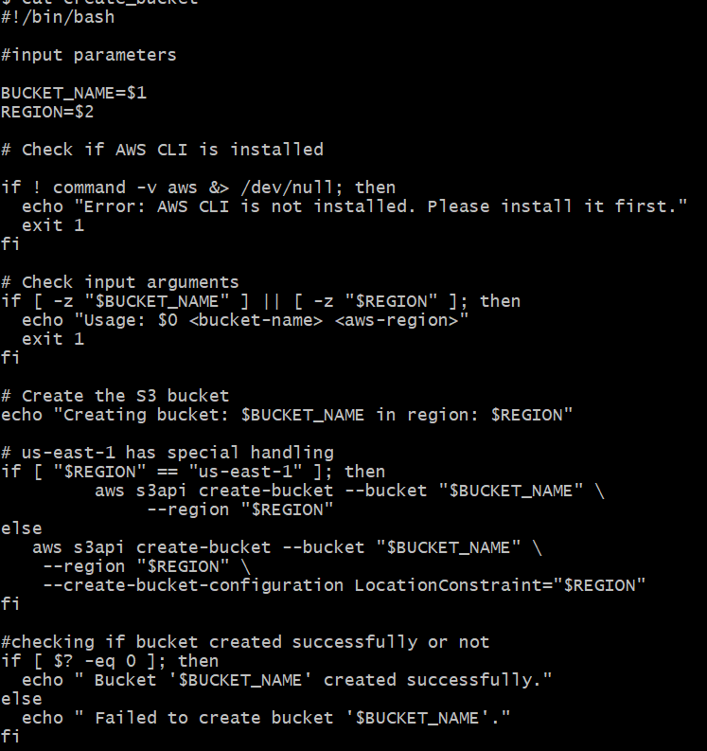

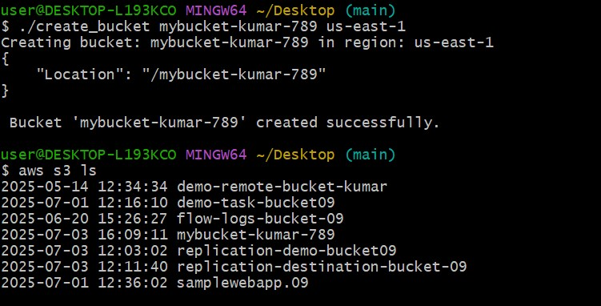

1. **Uploaded one 1 gb of file to s3 using cli.**

