1. **Created VPC with 2 private subnets and 2 public subnets.**

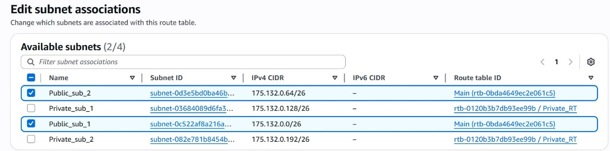

1. **Enabled DNS Hostname in VPC**

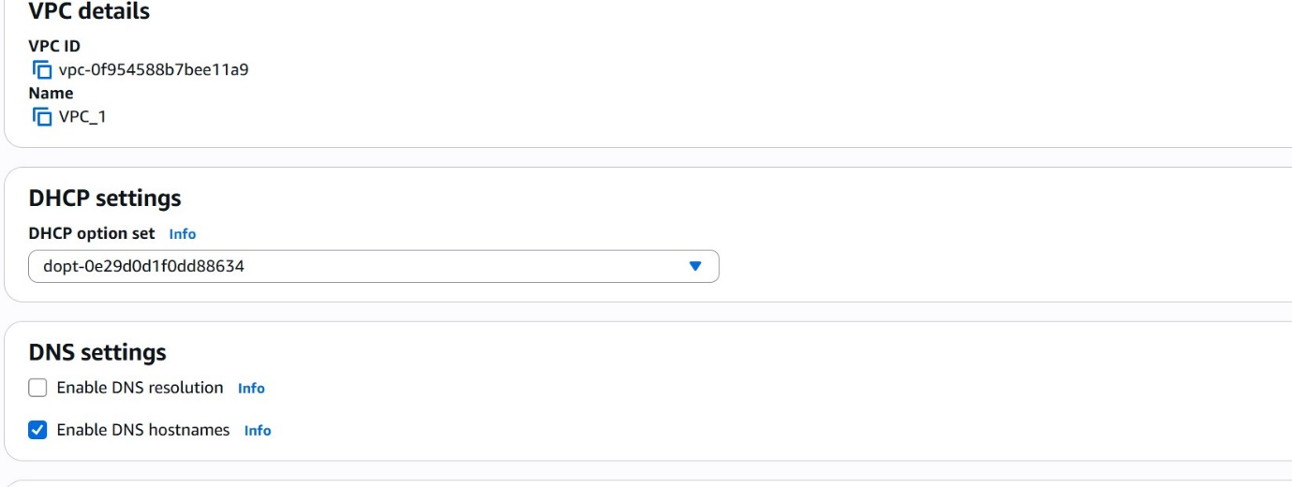

1. **Enabled Auto Assign Public Ip in 2 public subnets.**

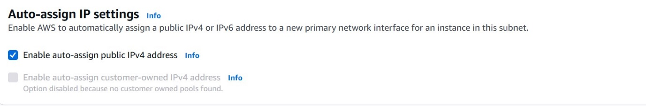

1. **Added 2 private subnets in private route table.**

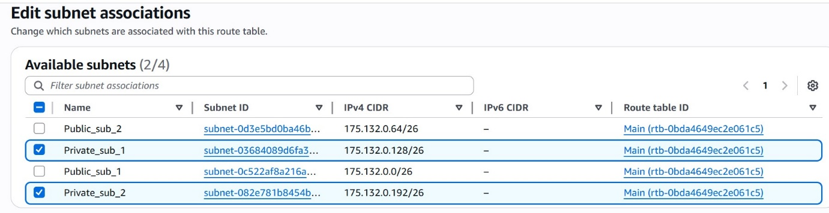

1. **Added 2 public subnets in public route table.**



1. **Public route table will have the routes to internet and local.**

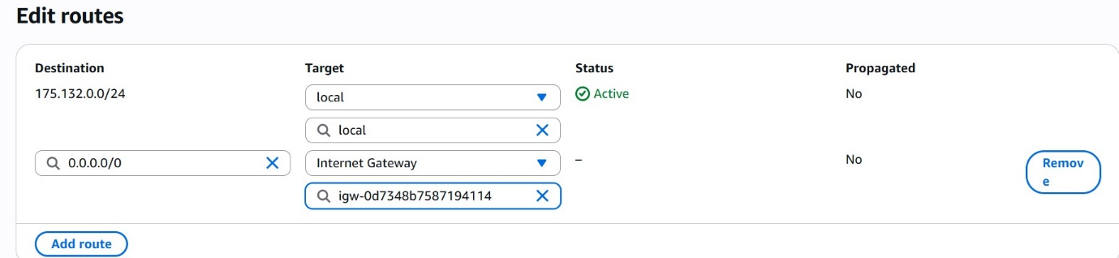

1. **Created Ec2 in public subnet with t2micro and install php.**

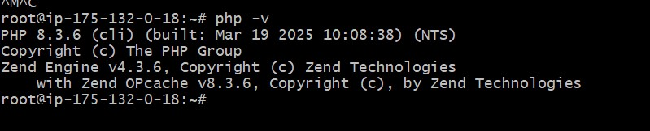

1. **Configured Nat gateway in public subnet and connected to private Instance.**

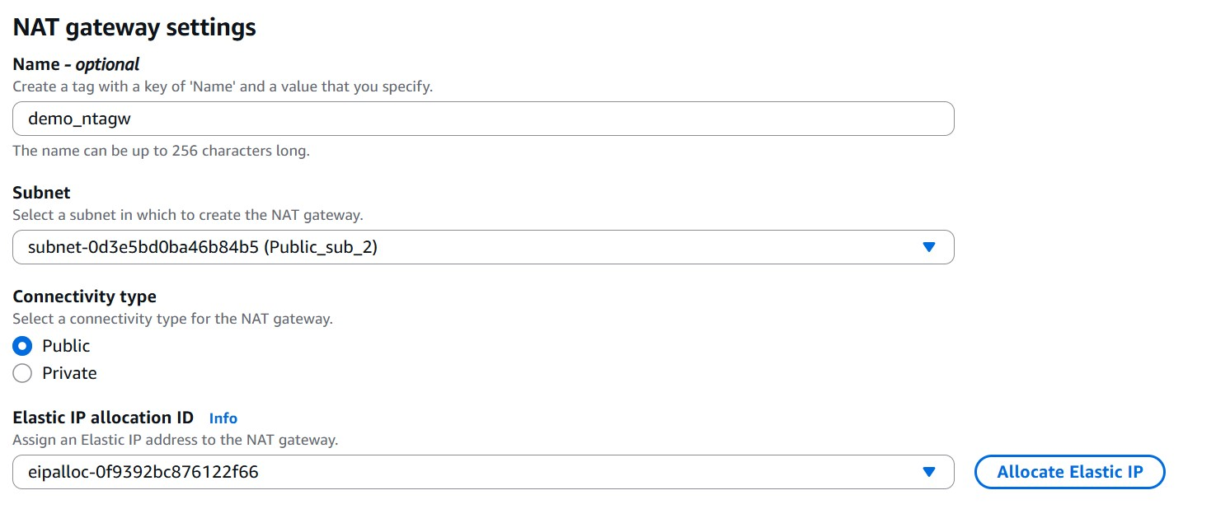

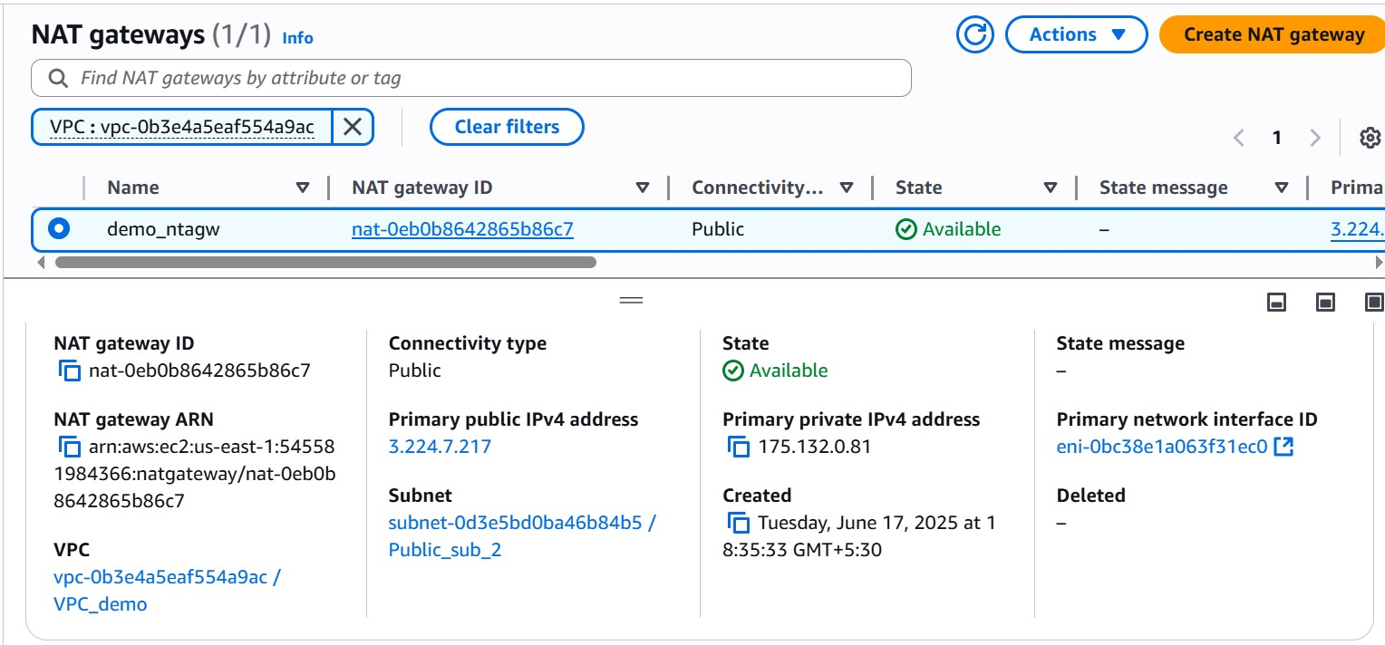

1. **Installed Apache Tomcat in private ec2 and deployed a sample app.**

**Steps :**

1. **Created NAT in public subnet**
2. **Associated NAT to PRV subnet Route table.**
3. **Launched ec2 in private subnet**
4. **From bastion server accessed prv ec2.**
5. **Installed tomcat.**

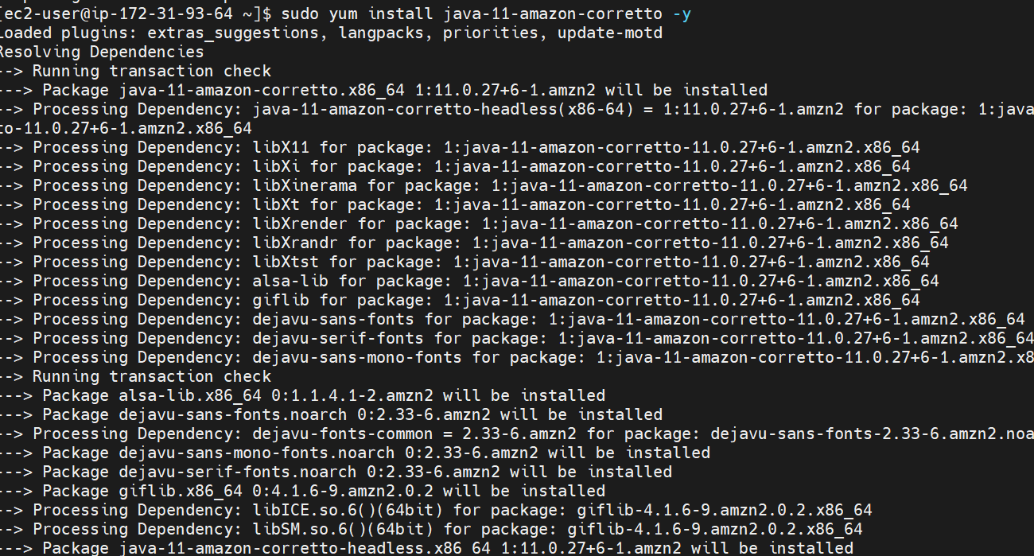

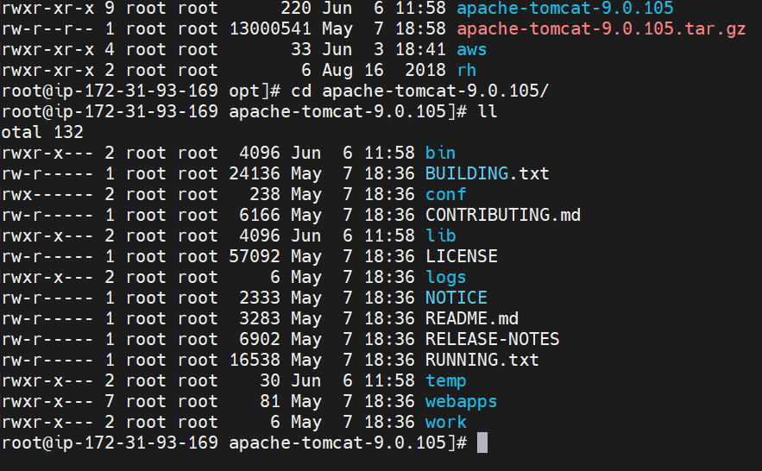

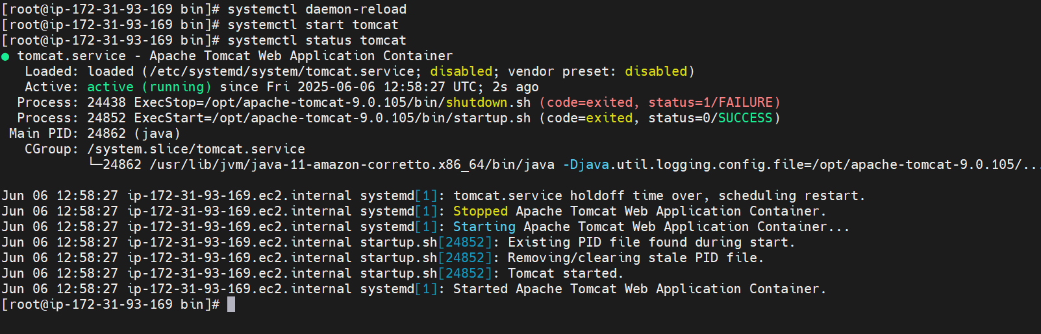

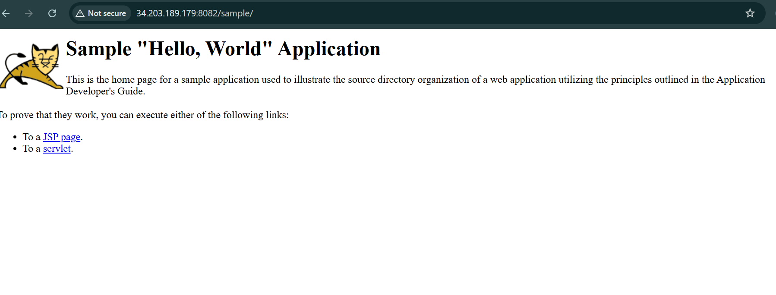

1. **Configured VPC flow logs and store the logs in s3 and CloudWatch.**

**Steps:**

1. **Selected VPC logs 🡪inside VPC**
2. **Selected s3 🡪 created a new bucket and copied arn_id**
3. **Selected watchCloud as storing VPC logs**
4. **Created role and policy.**

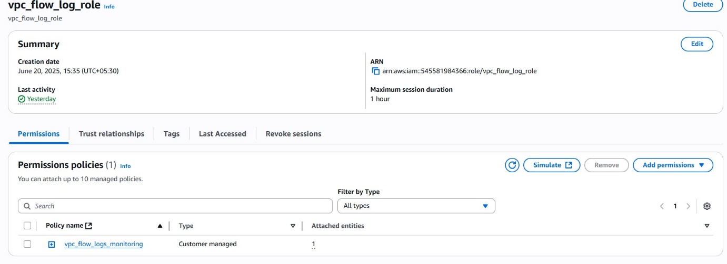

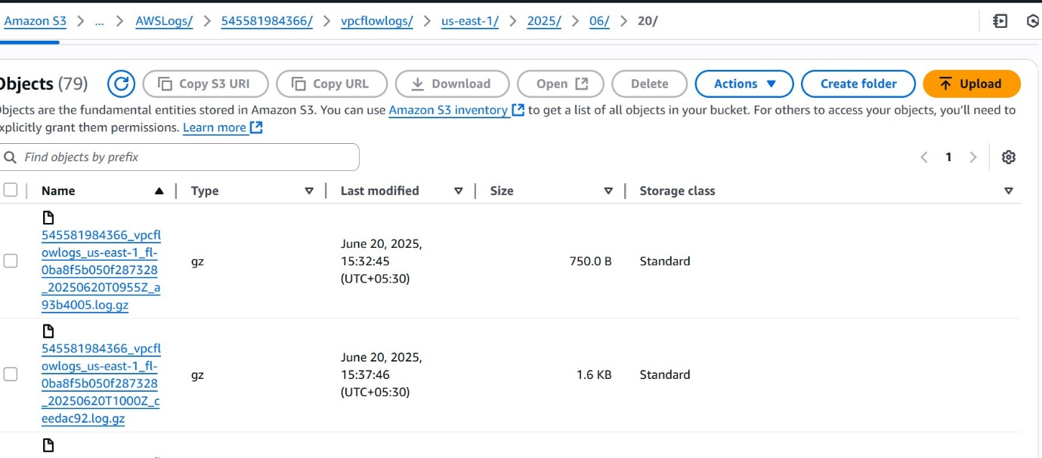

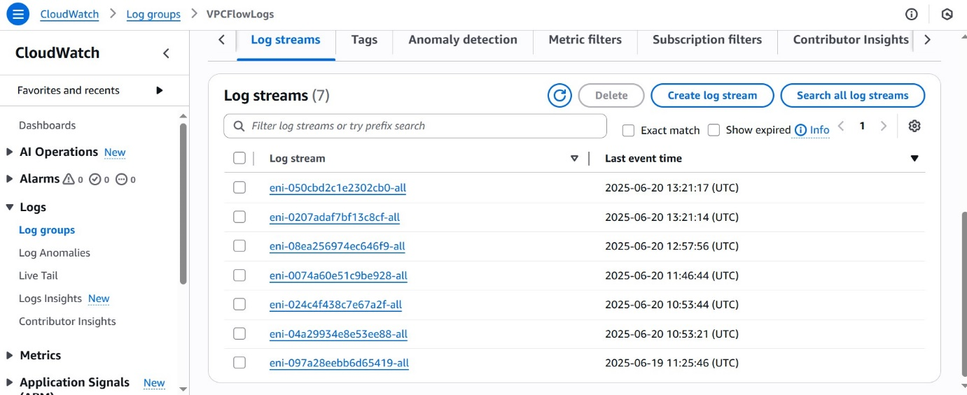

1. **Created one VPC, with 1 one public subnet and 1 private subnet.**

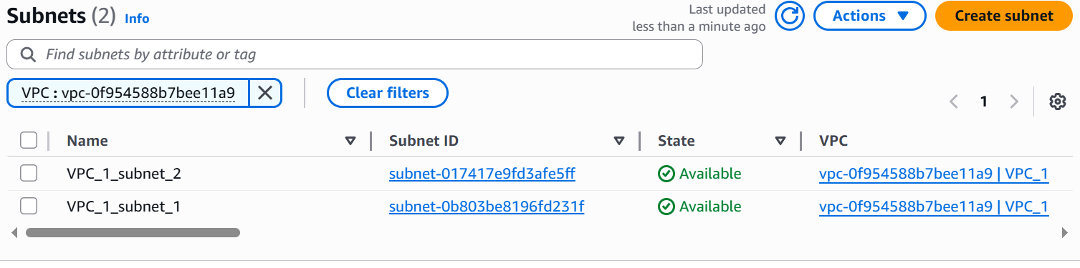

1. **Enabled VPC peering for cross region.**

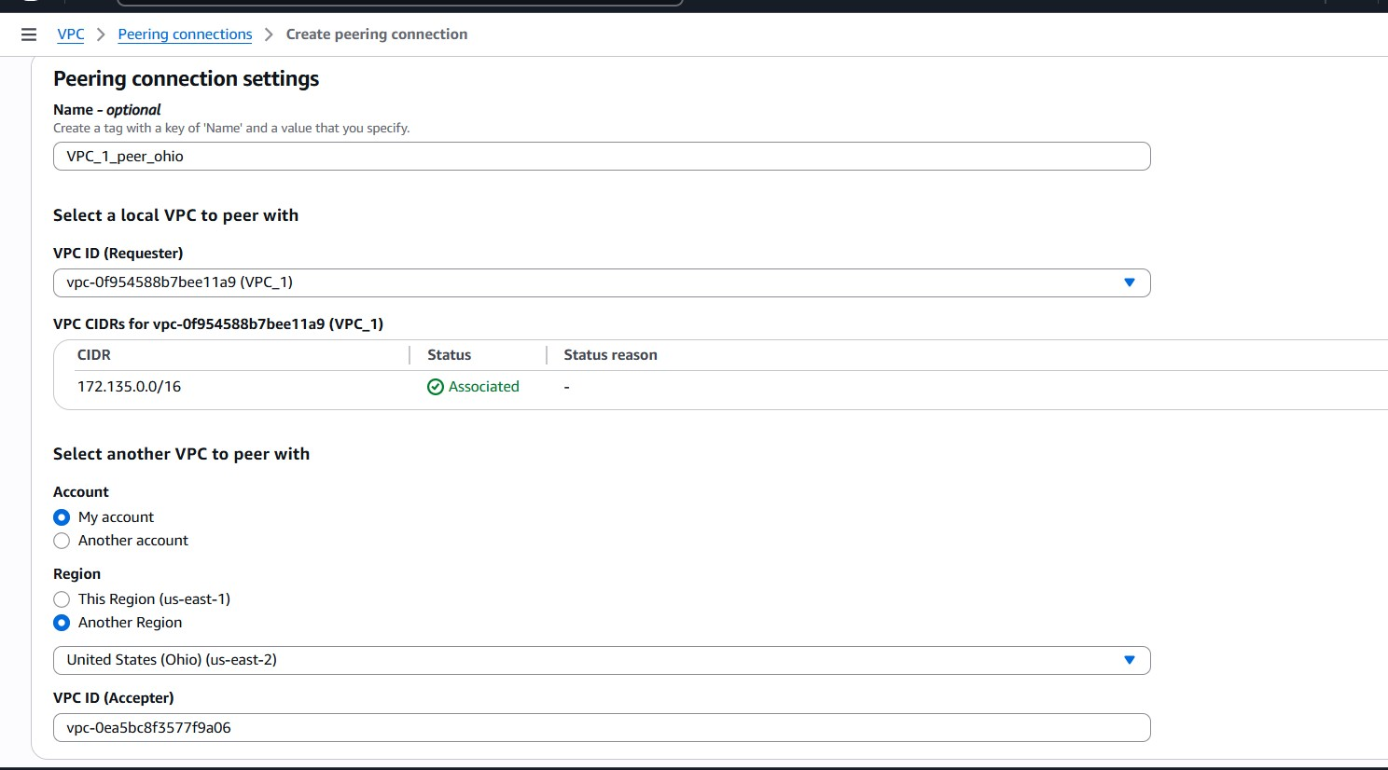

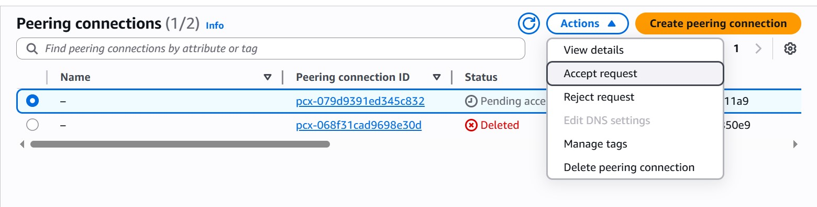

**Ping test with cross region ec2**

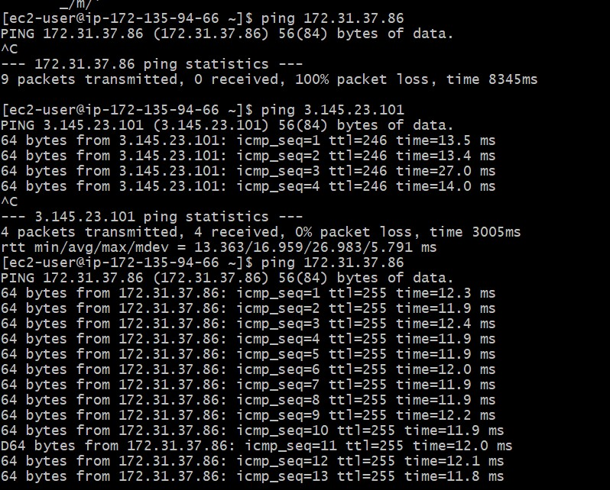

1. **Setup VPC End Point.**
2. **VPC 🡪 endpoint**
3. **Selected type 🡪 aws service**
4. **S3 service**
5. **Associated route table to private subnet.**

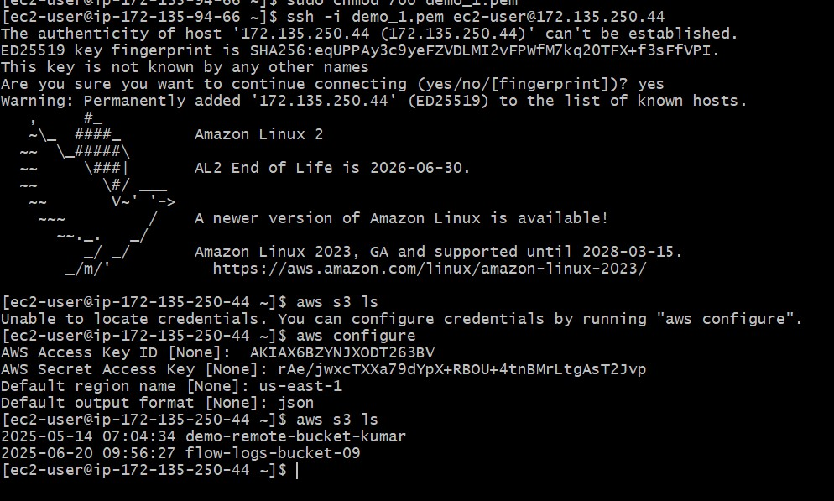

1. **Created Transit gateway connected 3 vpc’s.**

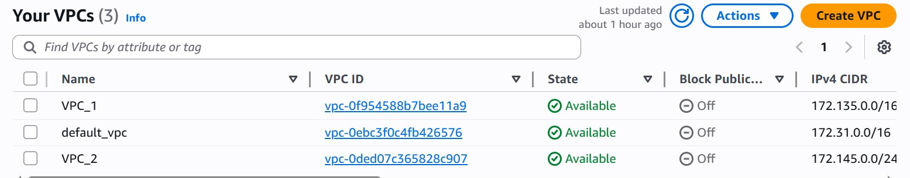

**Created transit gateway**

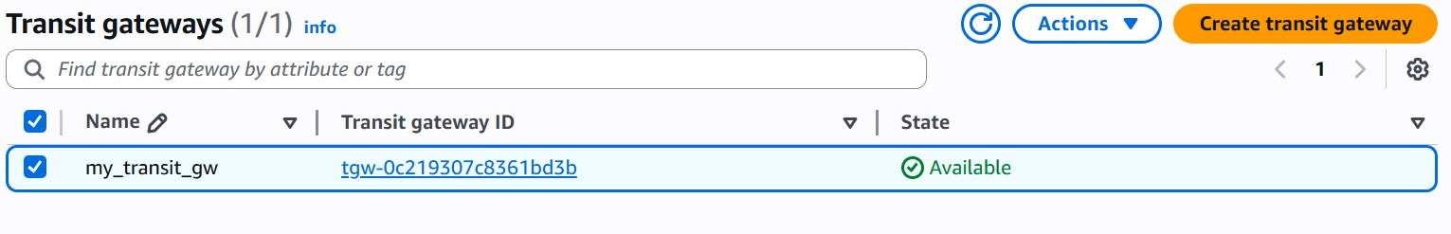

**Routed traffic to three vpc using their CIDR**

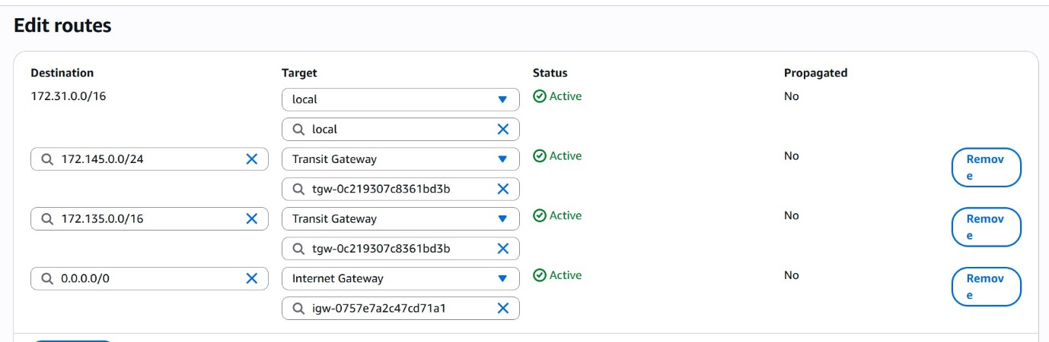

**Attached vpc to transit gateway**

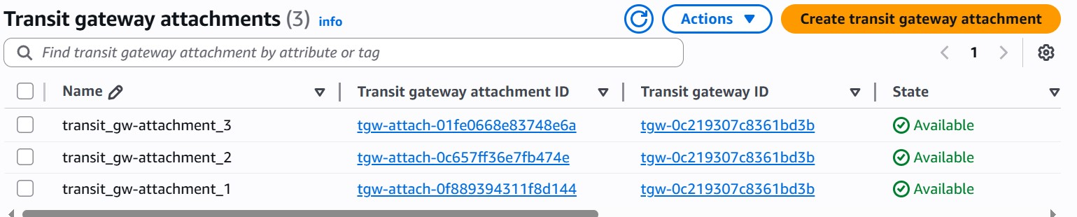

**Tested communication between three vpc’s using Ping**

