1. **Launched one ec2 using Amazon Linux 2 image and added script in user data to install Apache.**

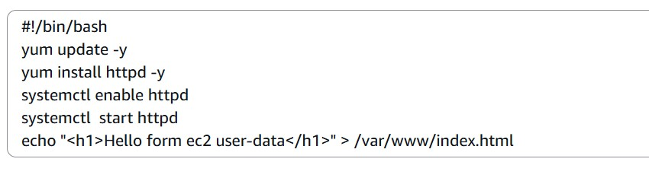

1. **Launched one ec2 using Ubuntu image and added script in user data to install Nginx.**

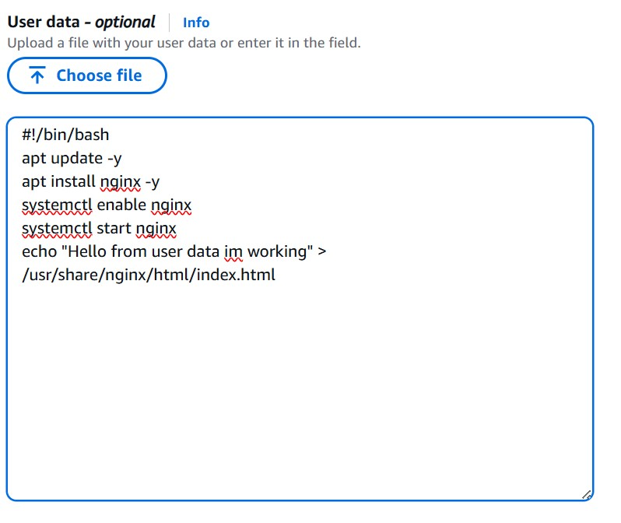

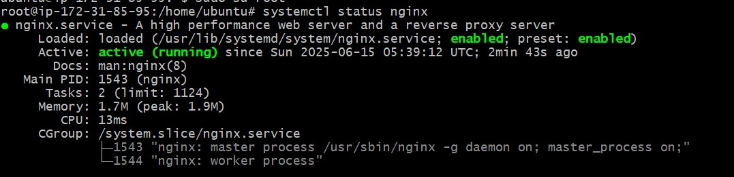

1. **Launch one windows server and install tomcat in windows.**

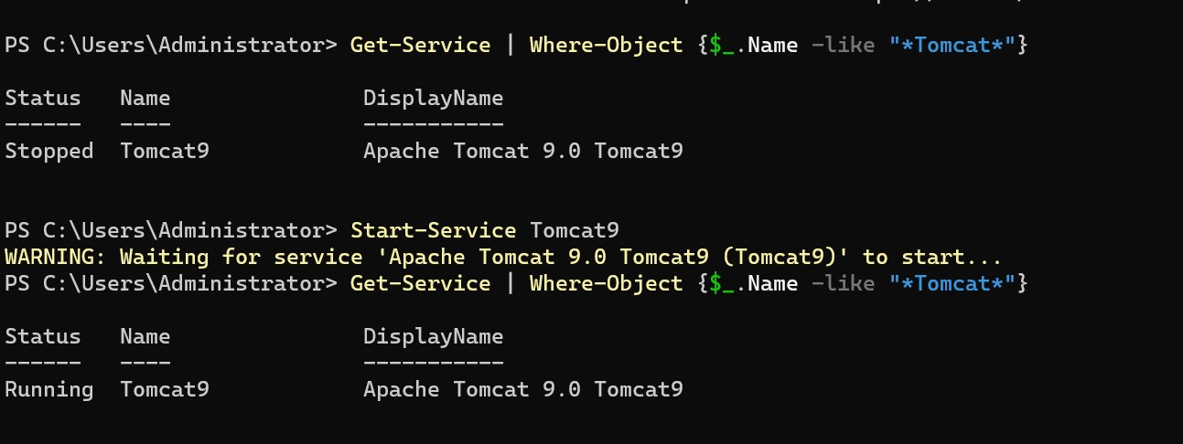

1. **Snapshot of the instane created in Task 1**

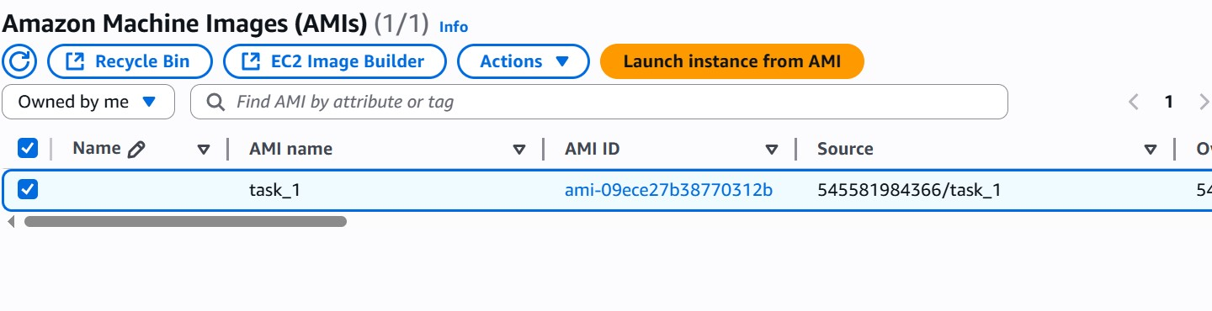

1. **password less authentication for ec2 created on Task 2.**

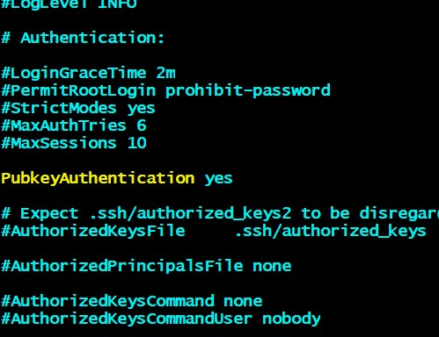

**Pasted pub key inside /home/kumar/.ssh/authorized_keys file with enabling permissions**

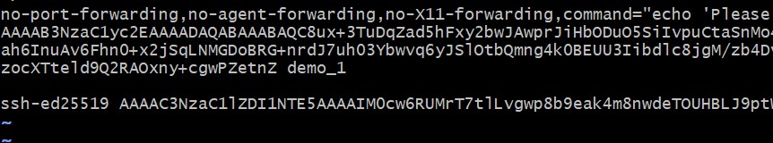

**Password less authentication without pem_key file**

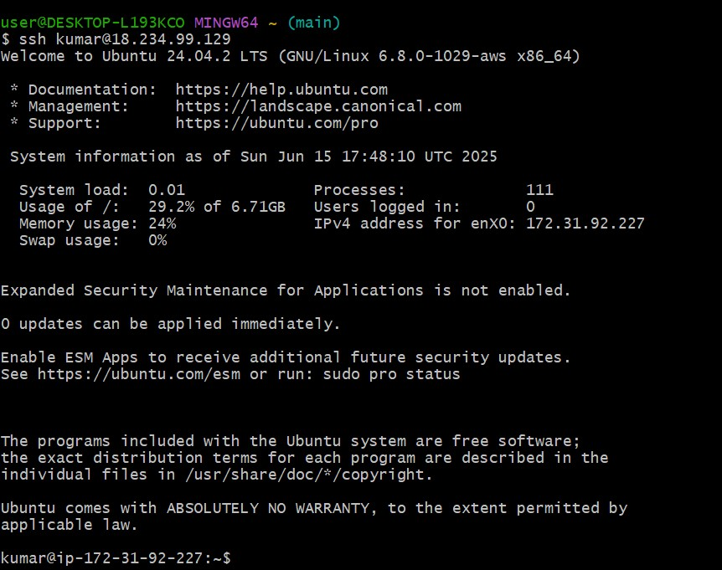

1. **Launch any ec2 using spot purchasing option.**

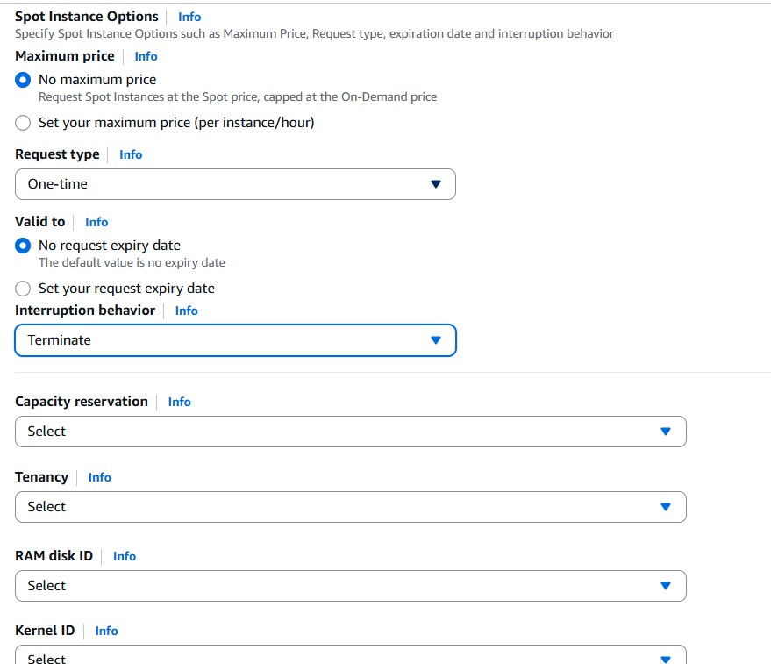

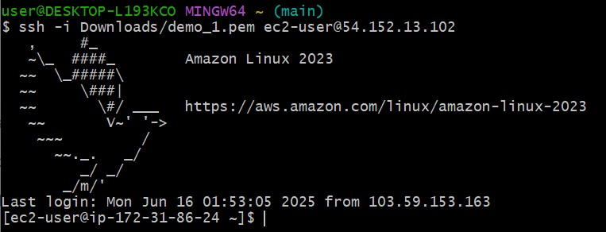

1. **Enabled Termination policy on ec2 created in Task 2.**

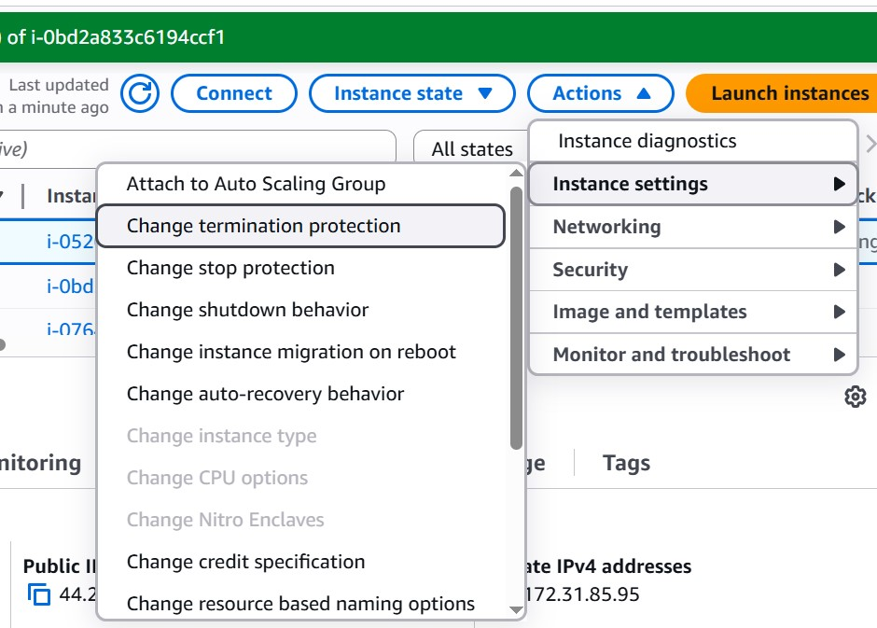

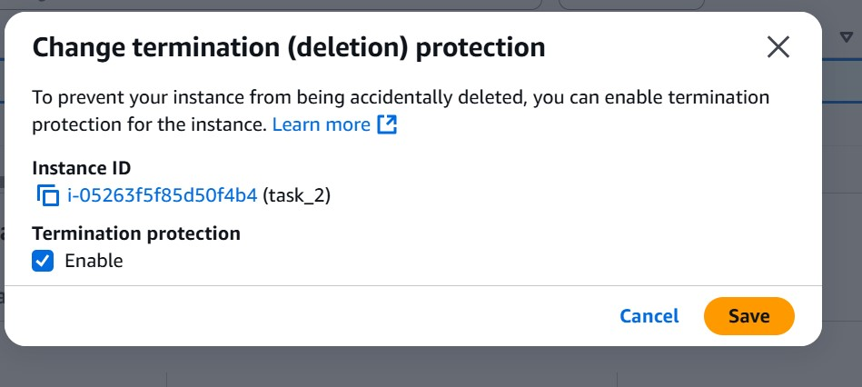

1. **Launch one ec2 using Aws CLI.**

**Launched ec2 using aws cli :**

1. **Configured aws cli using access keys**
2. **Provided Policy that gives Ec2FullAccess to the user**
3. **AMI id, SG id, subnet id, keypair, count**



