1. **Install Docker**

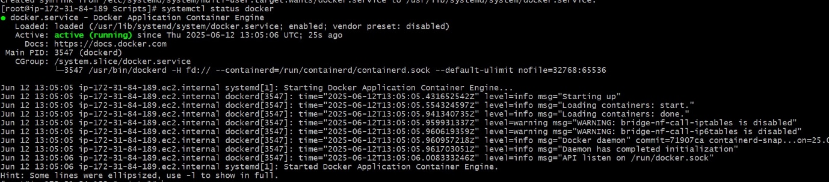

1. **Install Jenkins**

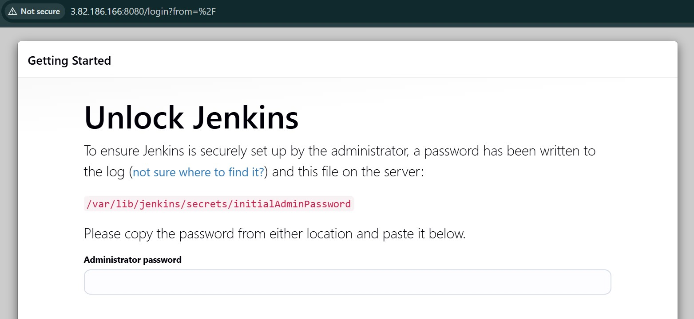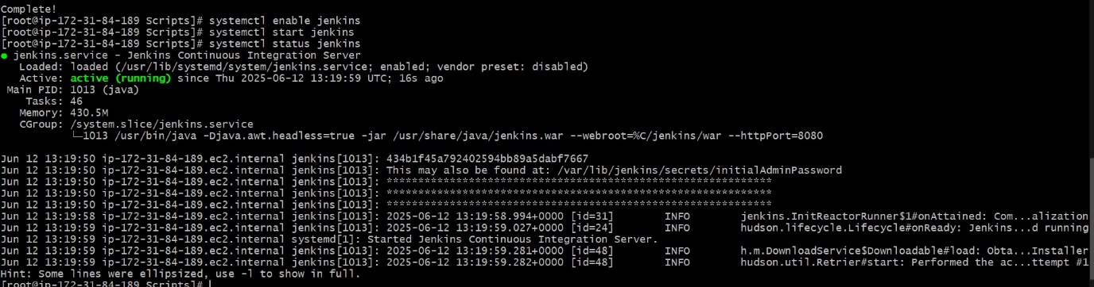

1. **Install Apache**

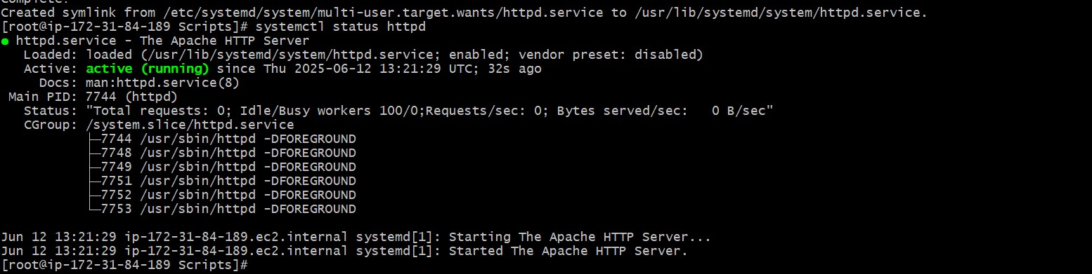

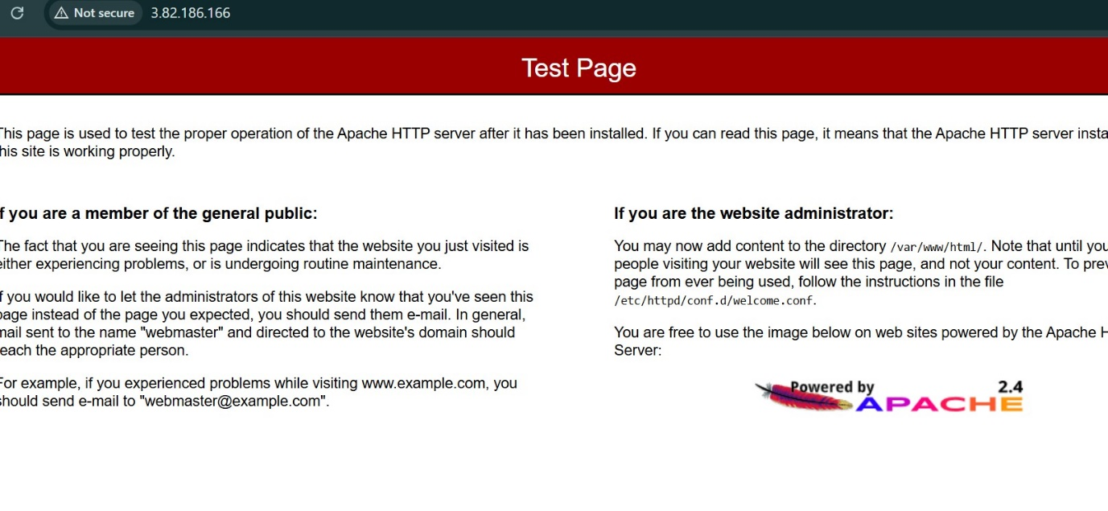

1. **Install nginx**

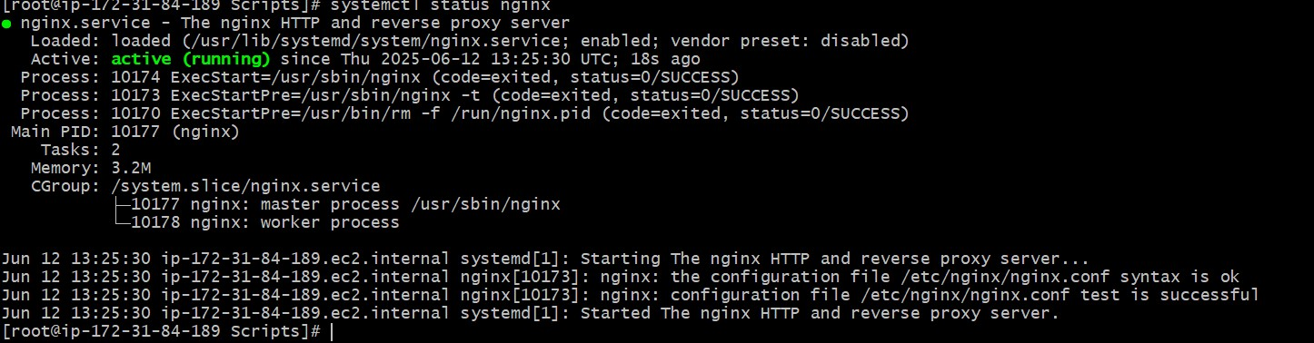

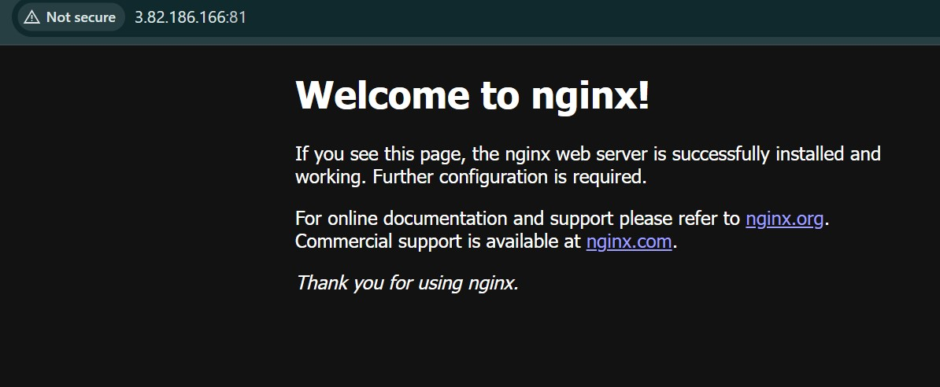

1. **Install Apache Tomcat**

