1. **Created a user with name Techie and provide sudo access to user.**

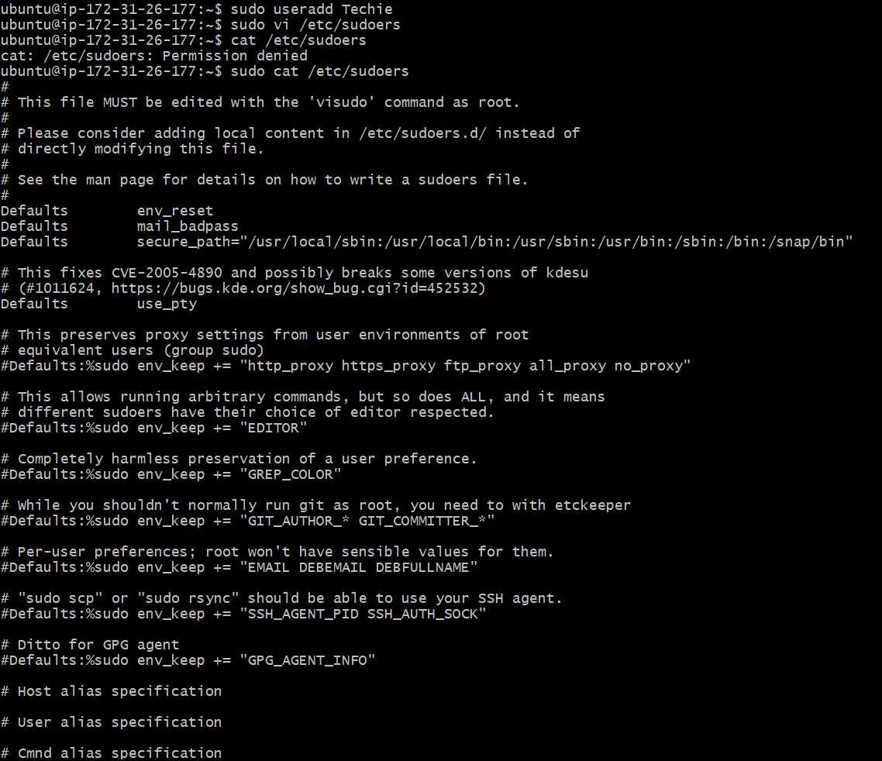

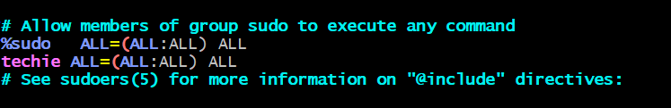

1. **Navigate to the home directory.** &
2. **Create a new directory. &**
3. **List the contents of a directory. &**
4. **Change the current directory. &**

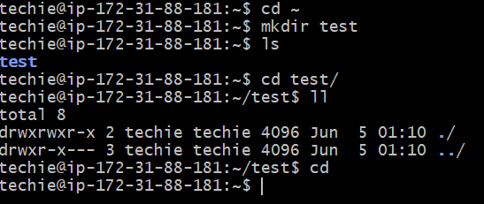

1. **Create a new empty file &**
2. **View the contents of a file &**
3. **Copy a file to another location.**

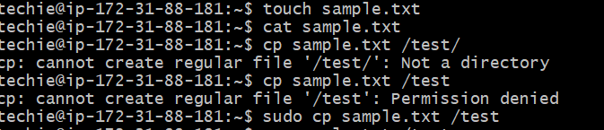

1. **Move a file to another location.**

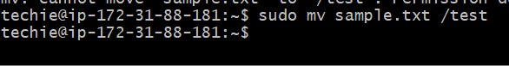

1. **Rename a file &**
2. **Delete a fie**

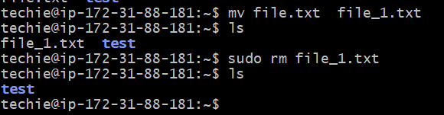

1. **Grant or revoke permissions on a file or directory.**

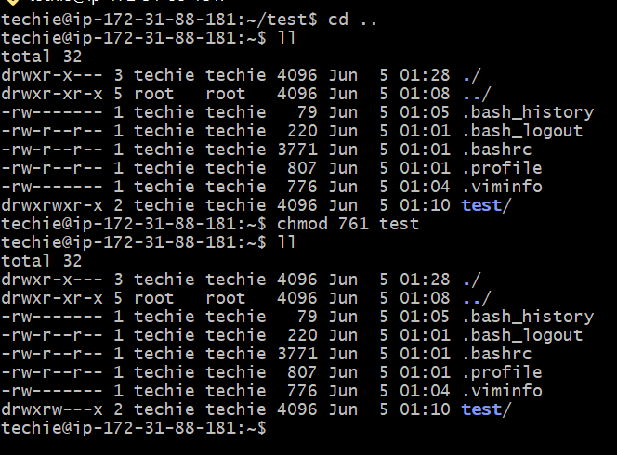

1. **View the current date and time.**

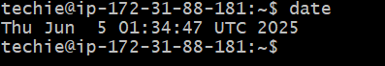

1. **Check the system uptime**



1. **View running process**

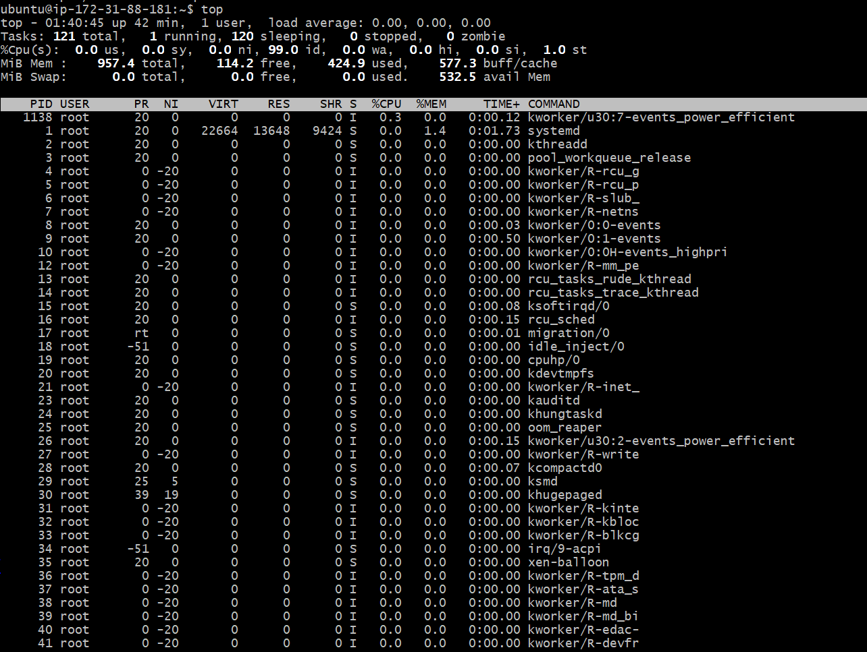

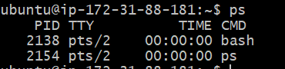

1. **Kill the process**



1. **Install a package using the package manager (e.g., apt or yum).**

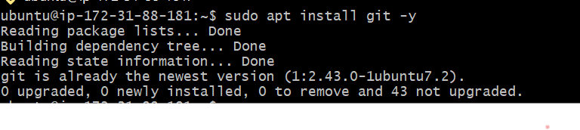

1. **Update the system packages.**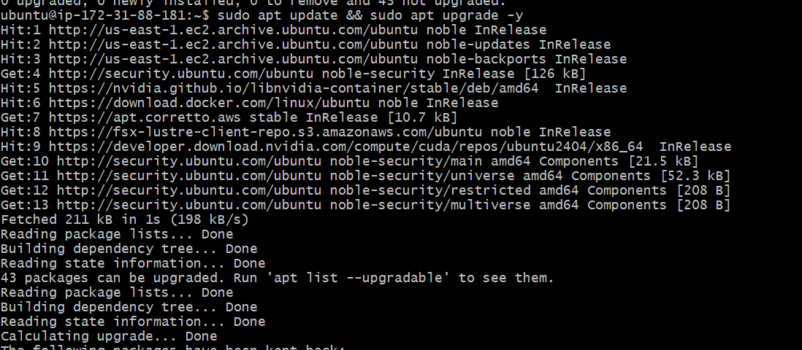
2. **Create a symbolic link.**

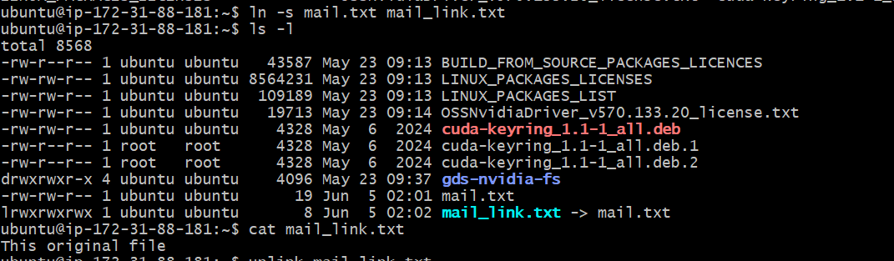

1. **Search for files using the find command**

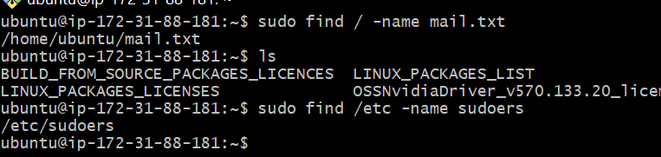

1. **Compress and decompress files using tar**

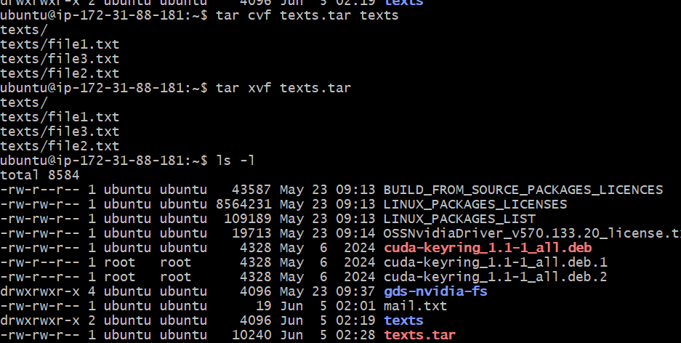

1. **Monitor system resources with htop or top**

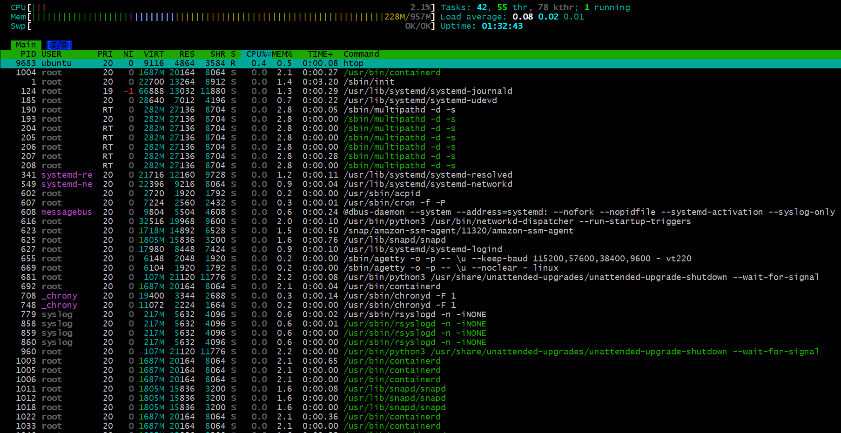

1. **Create and manage user groups.**

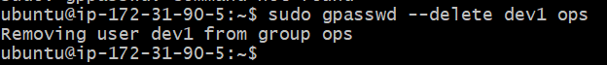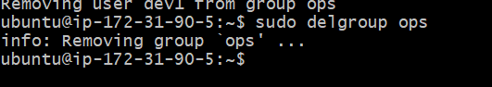

1. **Set up SSH password less authentication.**

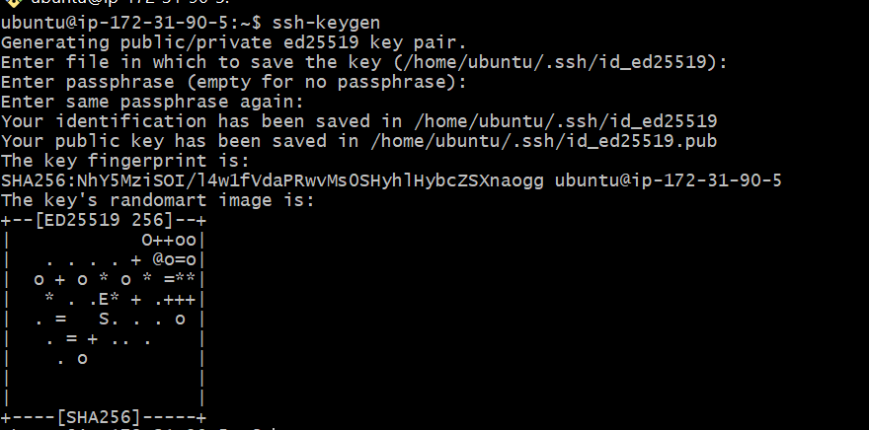

1. **Monitor log files using tail or grep.**



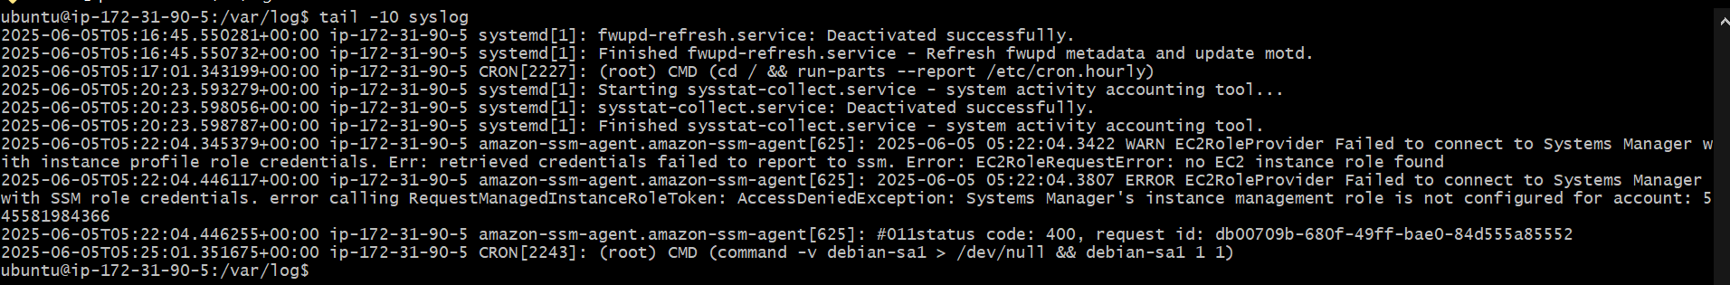

1. **Setting up a web server ( Apache).**

**26.** 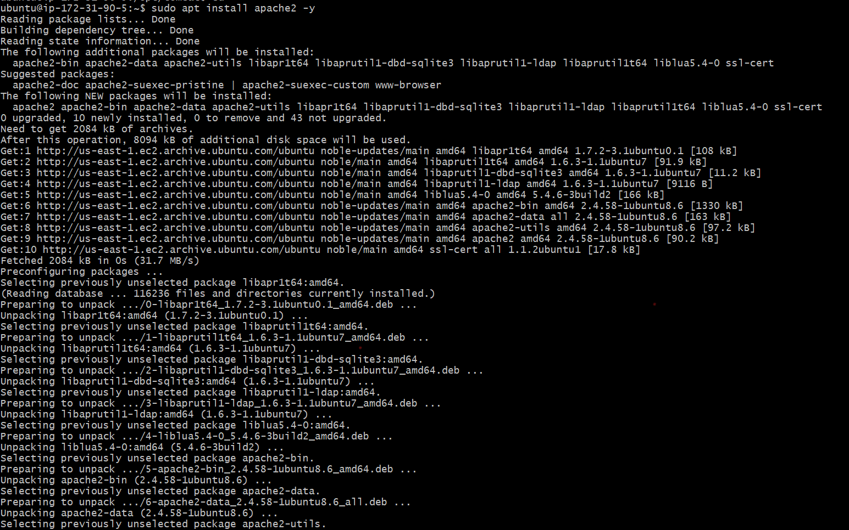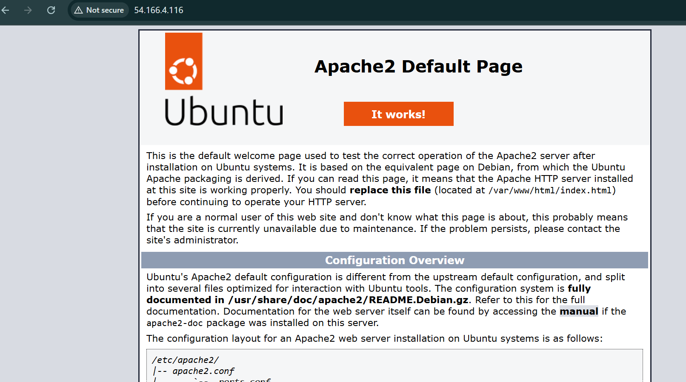

1. **Configured and done to secure a MySQL Database**

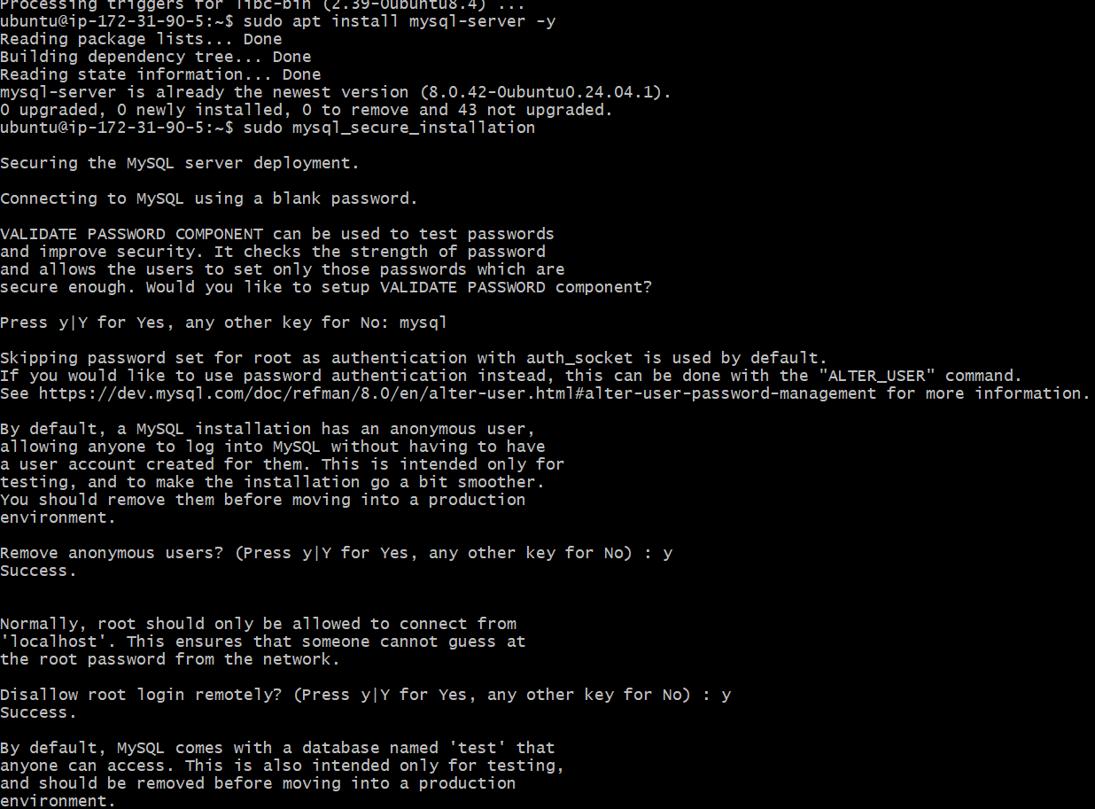

1. **Setting up a Tomcat server**

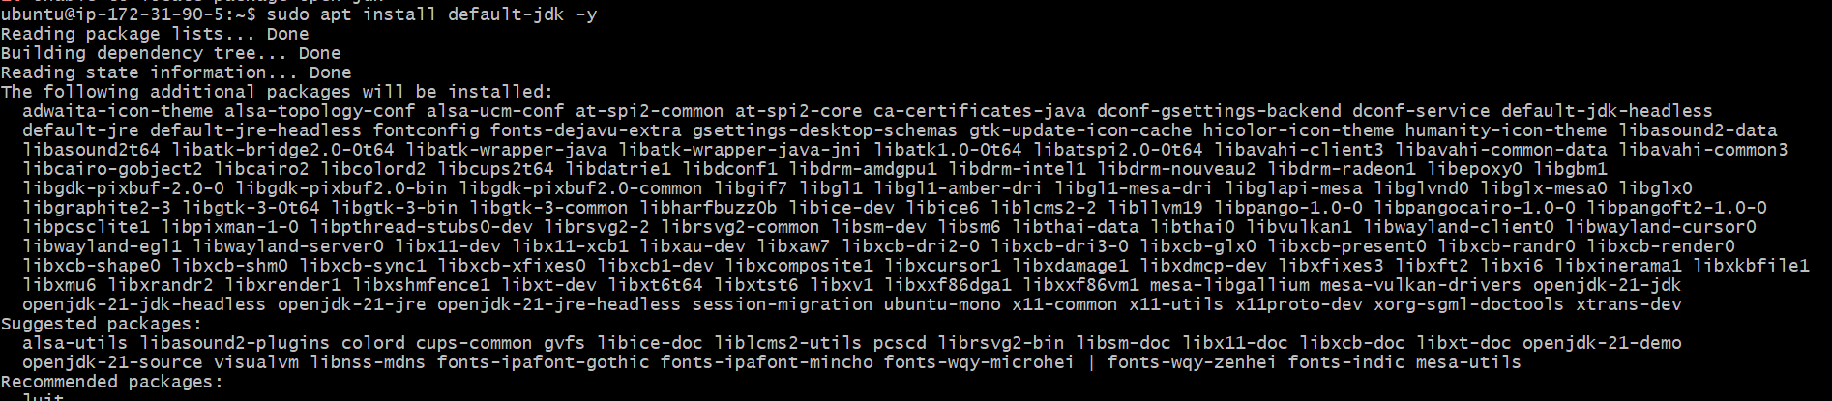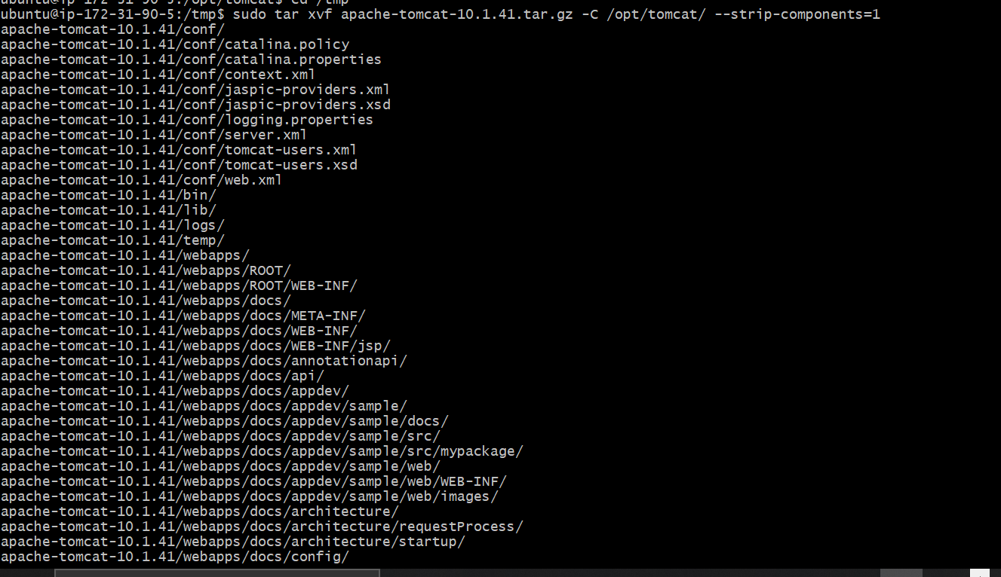

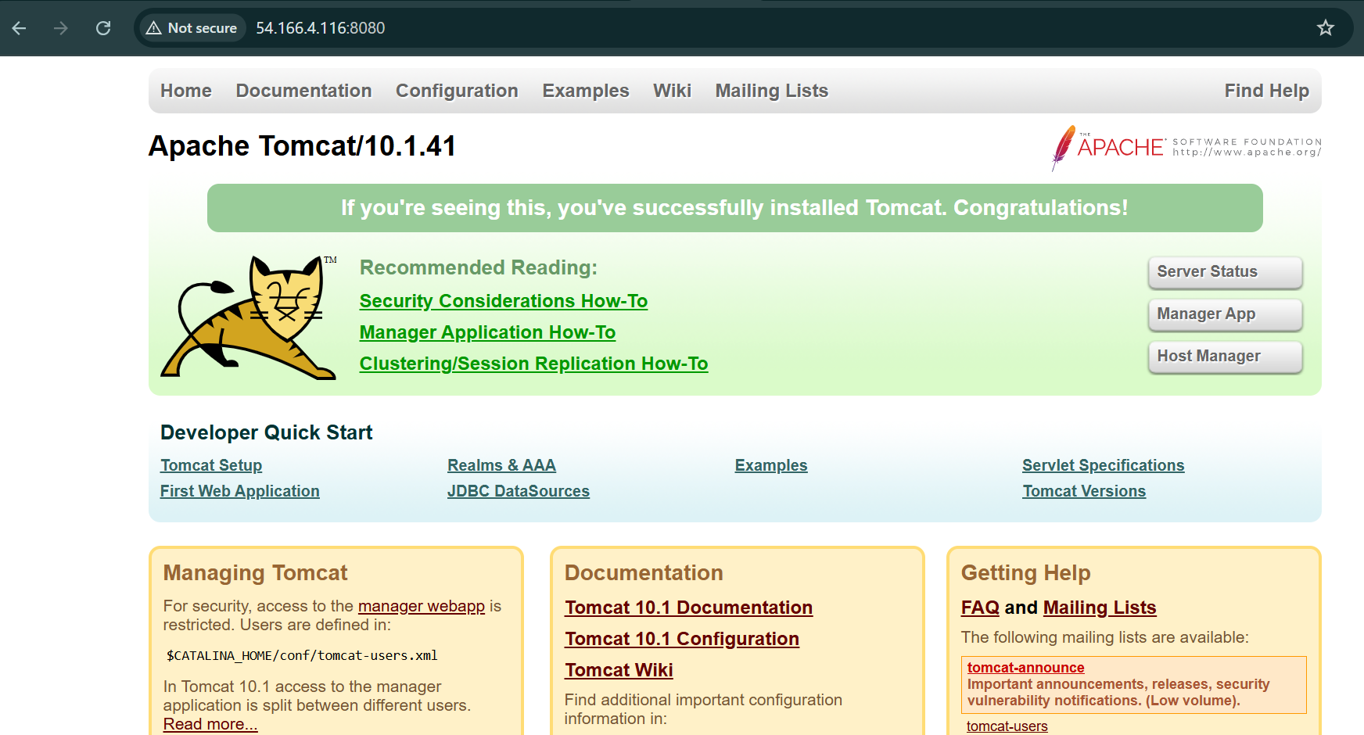

1. **created a service file for Apache Tomcat.**

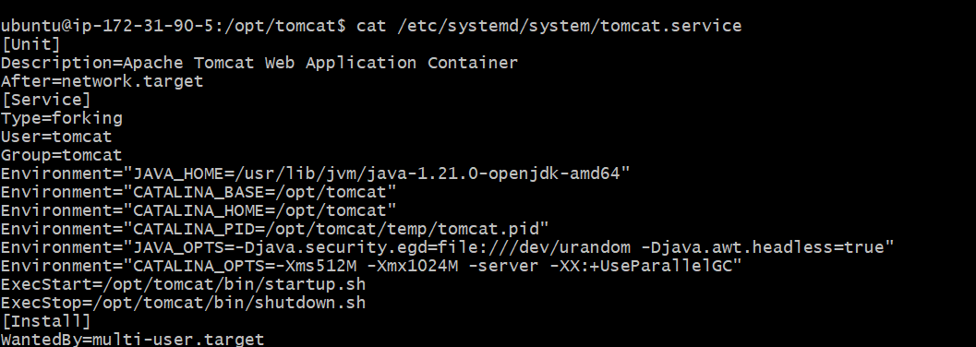

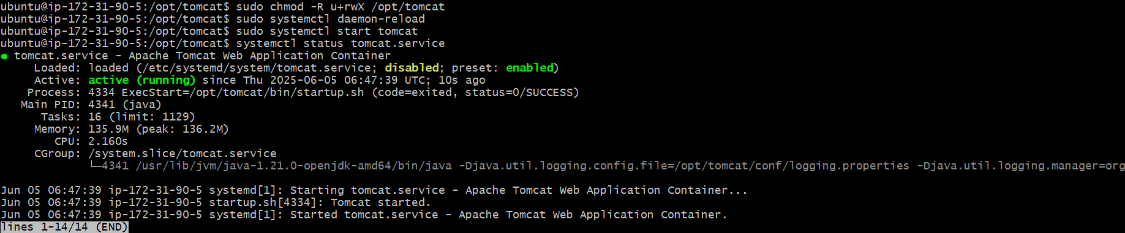

1. **Printed a specific column from a delimited file.**

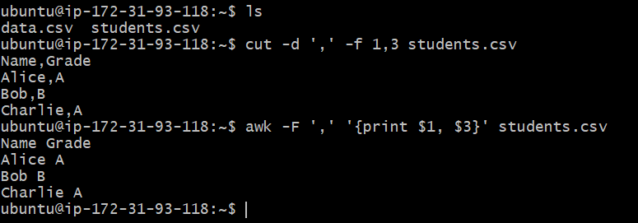

1. **Filter and print lines based on a specific pattern or condition.**

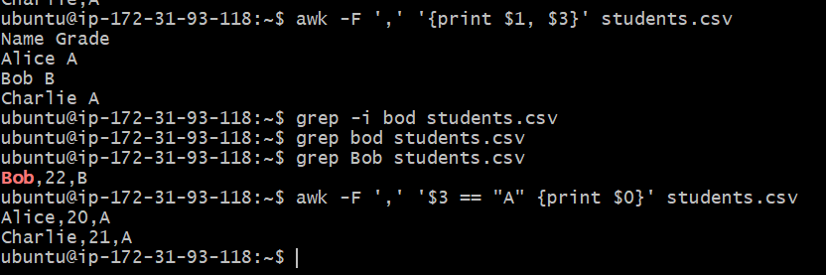

1. **Calculate and print the average, sum, or other statistics of a column. &**
2. **Performing string manipulation, such as extracting substrings or changing case.**

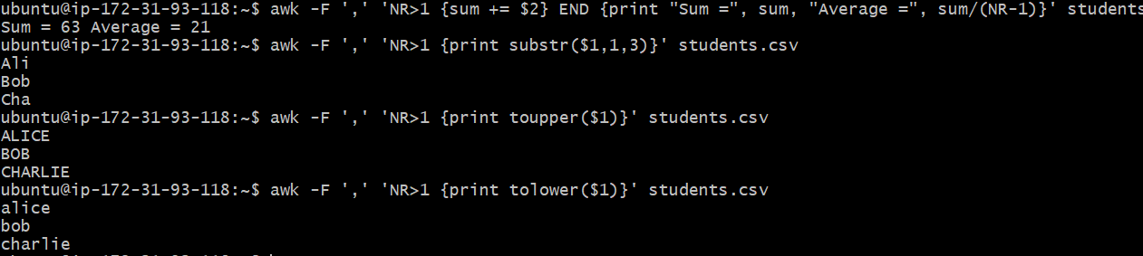

1. **Counting the occurrences of a specific pattern in a file. &**
2. **Sorted lines based on a specific field or column.**

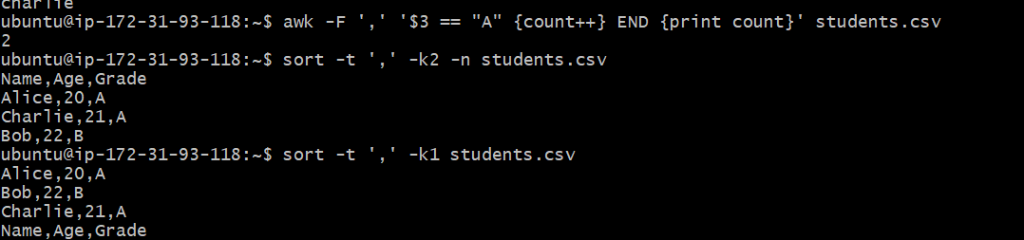

1. **Merging the multiple files based on a common field or column.**

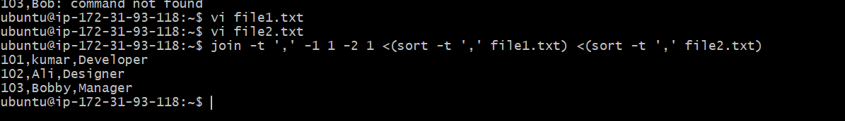

1. **Substitute text in a file using search and replace.**

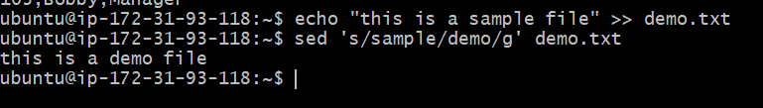

1. **Deleting the specific lines based on a pattern or line number.**

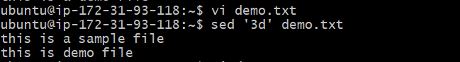

1. **Append or insert text before and after a specific pattern or line.**

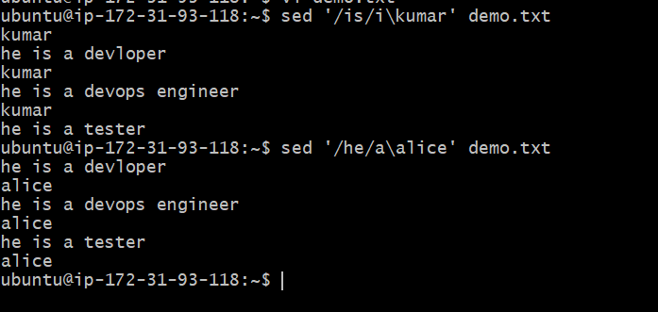

1. **Printed only specific lines from a file.**

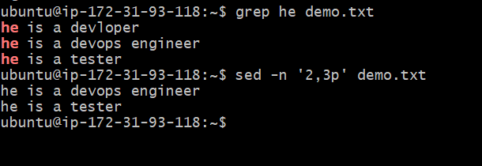

1. **Copying files from linux to windows**

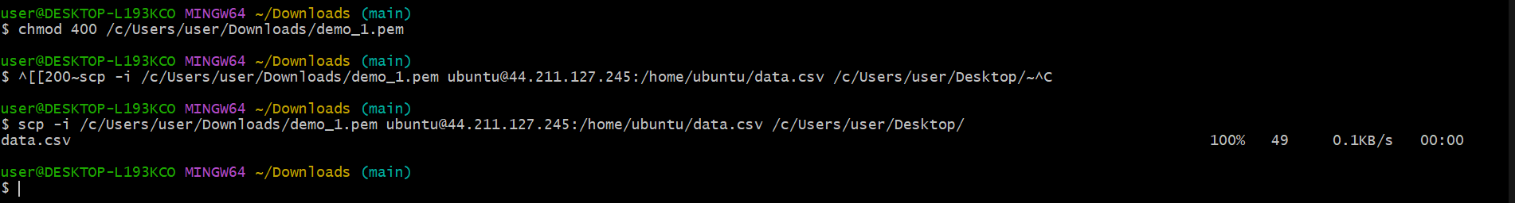

1. **5 use cases for AWK**

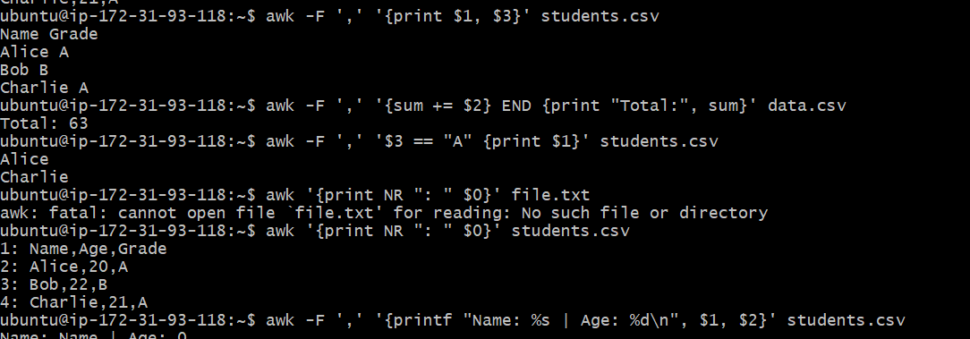

**5 use cases for SED**





