1. **Installation of nginx server and running nginx on port number 81.**

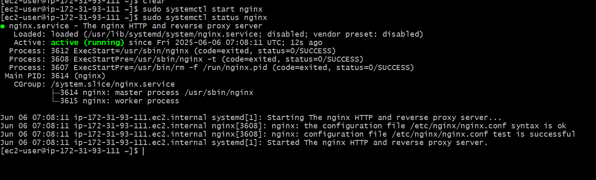

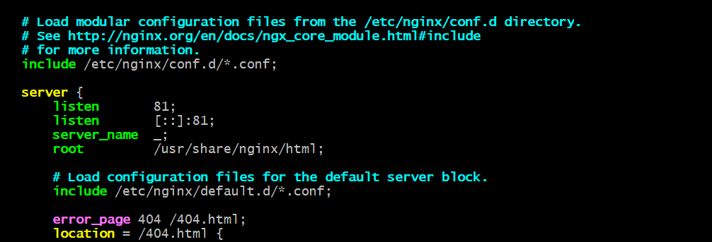

1. **Deployed a sample index.html file on nginx server.**

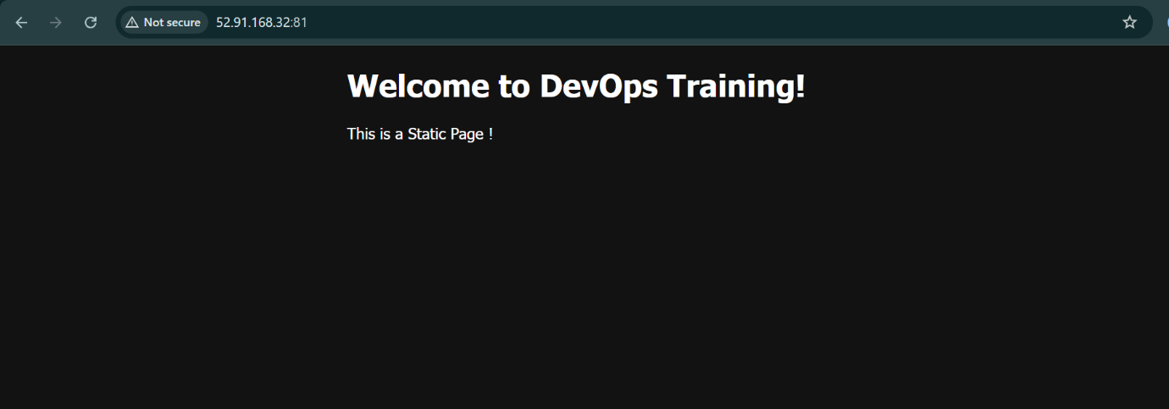

1. **Install Apache and run Apache on port number 82**

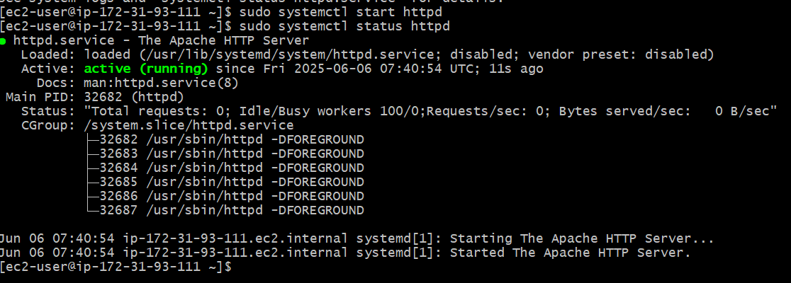

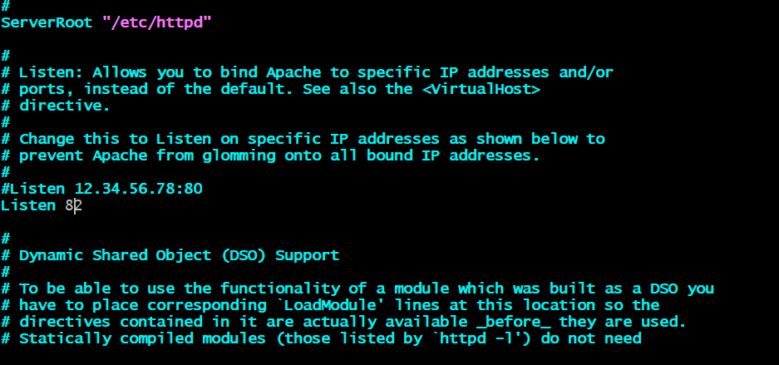

1. **Deploy a sample index.html file on Apache.**

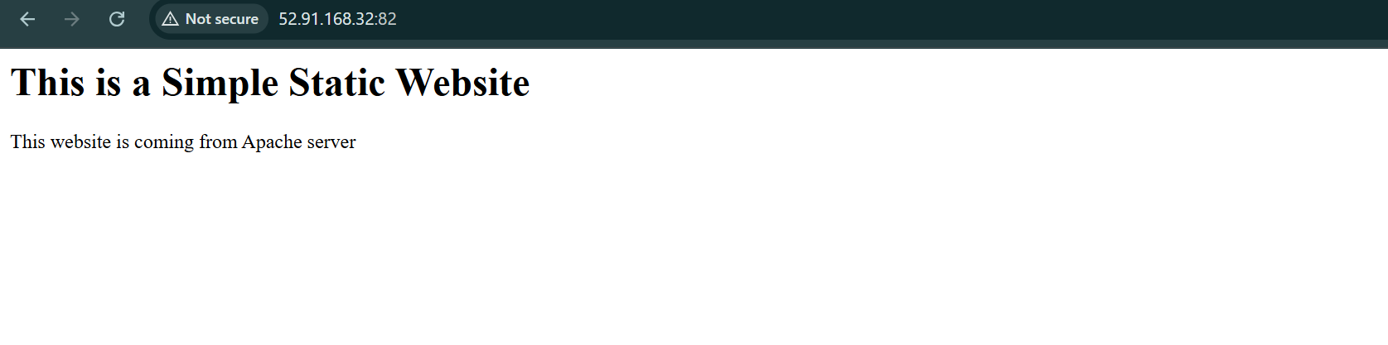

1. **Apache tomcat on port number 8082.**

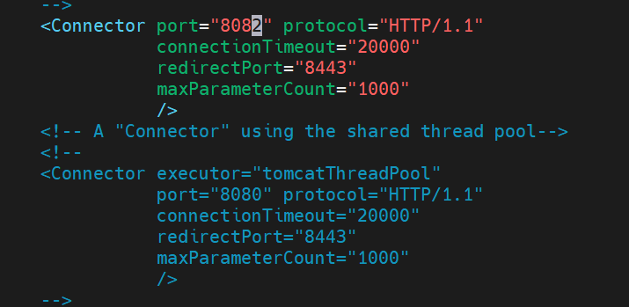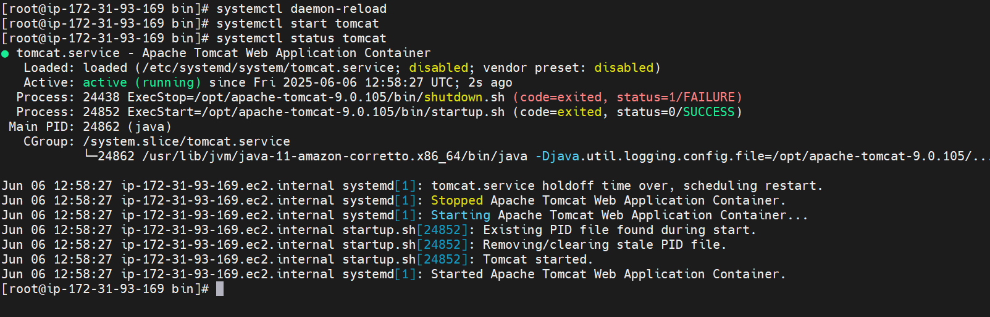

1. **Deploy a sample app on webapps**

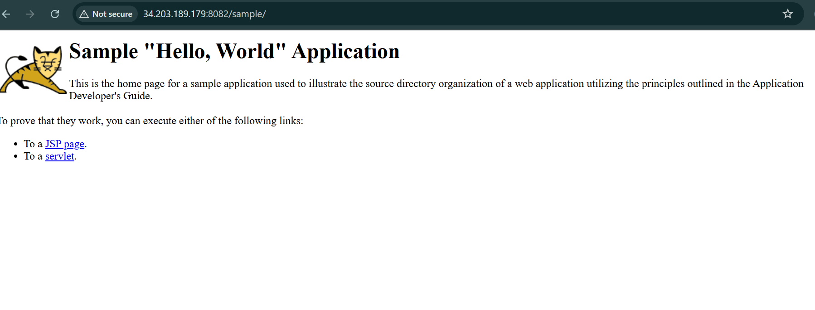

1. **Created a tomcat. service file for tomcat**

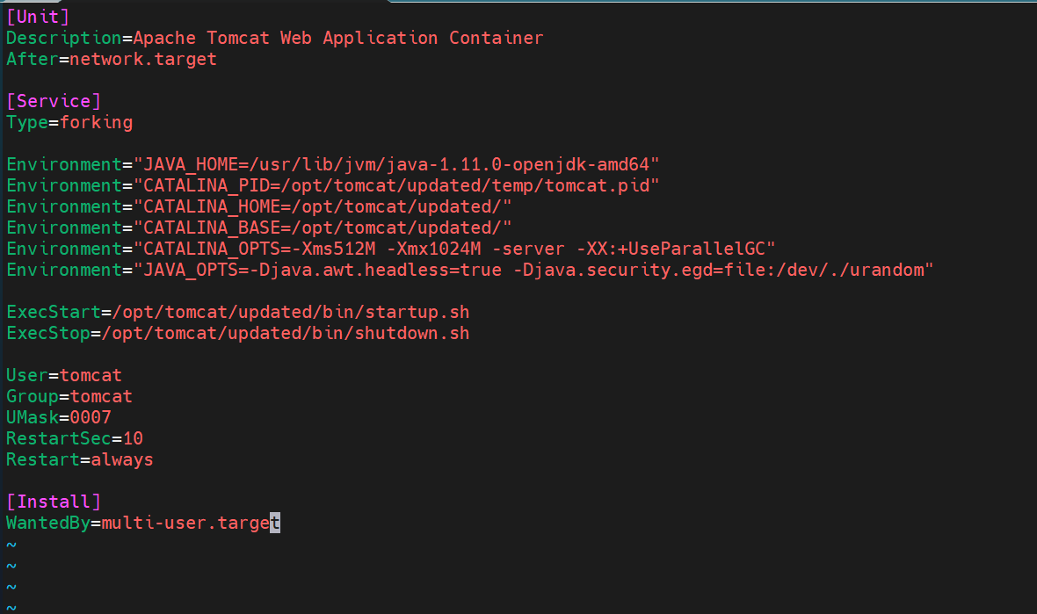

1. **Configure HA Proxy server**

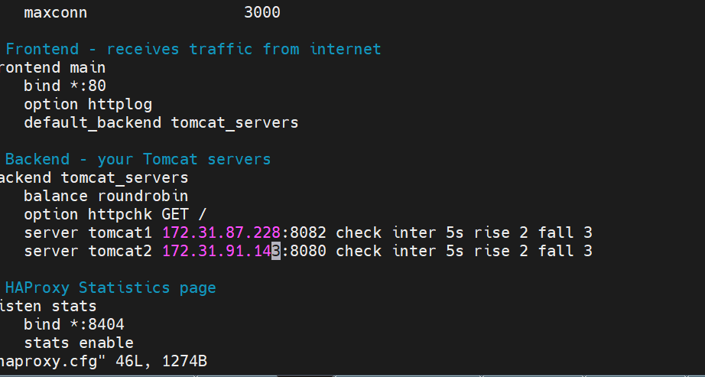

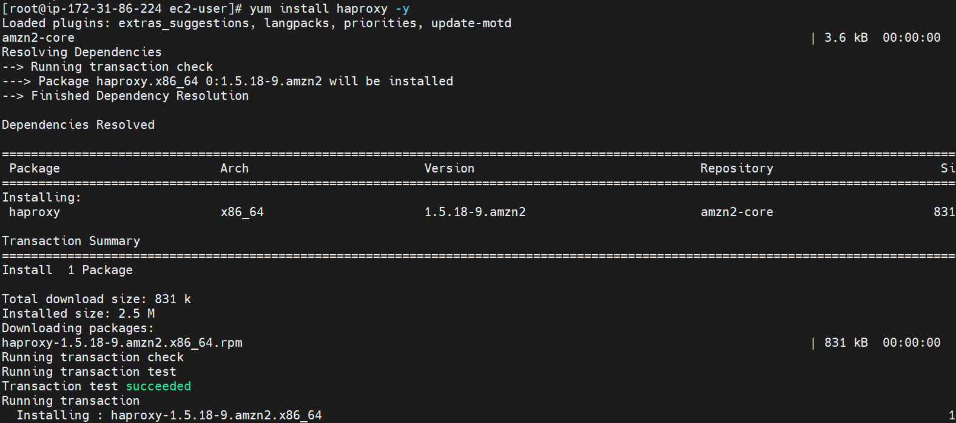

**LB routing traffic :**

