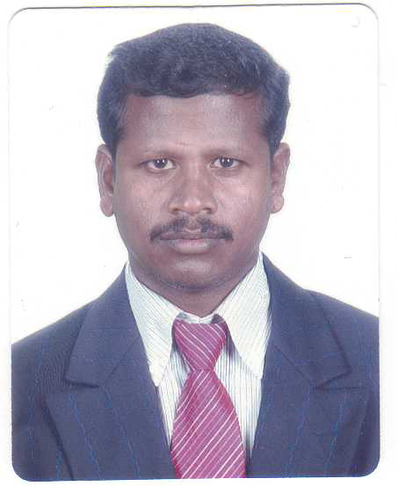
CURRICULAM VITAE

THAVASI RAMESH
Block-469, #05-105
Choa Chu Kang Ave-3
Singapore-680469
Mobil – +65 81838615.
Email – ramesh_thavasi@yahoo.co.in

CAREER OBJECTIVE

To work with a progressive organization to which I can contribute all my technical and analytical skills to enhance my own productivity at the same time achieving the organizational objective with the attribute of my time, quality and hard work for the growth of the organization.
WORK EXPERIENCE

Company : LEAD Management Engineering & Construction Pte ltd.
Singapore

Designation : Project Engineer

Year of Working : Agust2010- till date

- To Plan and execute ACMV installation work as per project schedule.
- Review and Commenting of all relevant working drawings and Material selection documents submitted by the contractor.
- To review A&A work progress and update project schedule to submit relevant parties.

- Check/inspection of the field installations and testing of all equipment done by the contractors.
- Coordination for the consultants and RTO Clear the technical problems.

WORK EXPERIENCE

Company : Corner Stone Facility Managements Pte ltd.
Singapore

Designation : M&E Engineer

Year of Working : April2010- Agust2010

1. To Plan and execute M&E installation work as per project schedule.

2. Review and Commenting of all relevant drawings and documents submitted by the contractor.

3. To review A&A work progress and update project schedule to submit relevant parties.

4. Check/inspection of the field installations and testing of all equipment done by the contractors.

WORK EXPERIENCE

Company : ACE Tai Soon (S).Pte .Ltd.
Singapore

Designation : M&E Engineer

Year of Working : May 2008 –Nov2009

Responsibilities

- Installation and supervision of chiller plan equipments for chiller, cooling towers and pumps with complete network.
- Installation and supervision of various air site equipments like air handling units, fan coil unite and building mechanical ventilation system inclusive of basement car park.
- Installations of various refrigeration system like server room and air-conditioning.
- In Charge of the day-to-day construction activities of the expansion of project which included Man, Material and Machine Management.
- Good liaising with the Main contractor, subcontractor’s to construction site check/inspection of the field installations of mechanical equipment and testing & commissioning.
- Timely scheduling & liaising with the client and preparation of documents for submission.
Reason of leaving : One year contract projects Completed.

Company : SPIC-SMO
A Division of Southern Petrochemical Industries
Corporation Ltd., Chennai, India.

Designation : Project Engineer.
Year of working : JAN 2005 – Mar 2008
Responsibilities

- Construction, Installation and supervision of drainage pipe line system.
- Installation of petrochemical industrial pipe work of main plan retrofitting and re-development work.
- Timely scheduling & liaising with the client and preparation of documents for submission.
- Installation of fire safety system pipe works for sprinkler, hose reel, fire hydrant and inergen gas system.
- Installation of various split air-conditioning system for plant control room and office areas.
- Check/inspection of the field installations of mechanical equipment and testing & commissioning.
- Inspection Hydro & Pneumatic testing of CS & SS Piping and Field Quantity Plans.

Reason of leaving : I got the overseas (Singapore) job

EDUCATION QUALIFICATION

Bachelor Degree

Course of study : Bachelor of Engineering.
(Mechanical Engineering)

College & University : Annamalai University, Chidambaram,
Tamil Nadu, India.

Year of Passing : Nov 2004.

SOFTWARE SKILLS

Can comfortably work on MS Word, Excel that runs on Windows XP, Vista
ACADEMIC PROJECTS

Under Graduate Degree Project
Title : Heat Transfer Studies in Pin-Fin-Array.

Duration : Six Months.

PERSONAL PROFILE

Nationality : Indian
Date of Birth : 09.04.1981
Sex : Male
Languages known Speak : English, Tamil and Hindi.
Write : English and Tamil.
Passport No : F5866224

DECLARATION

I hereby declare that the statements furnished above are true and correct to the best of my knowledge and belief.

Place : Singapore Yours Truly,

Date :
(Ramesh.T)

