Name: SASIKUMAR G  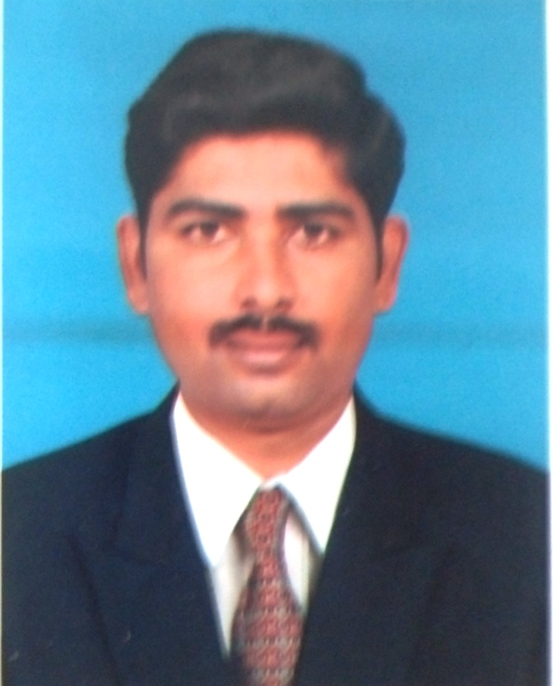  Email:  gsasikumar1@gmail.com  Communication Address  No.23A/8G4 ,Amman Nager  Senthoorvelan Street ,  East Colony,  Komarapalayam,  Namakkal -638183  Mobile:0091-9659369936  Personal Data  Father Name : N. Gurusamy  Date of Birth : 28-04-1987  Gender : Male  Nationality : Indian  Religion : Hindu  Language : English, Tamil,  Blood Group : B +ve  Marital Status : Married | RESUME  Professional Summary  - Branding & Marketing communications, business development professional with 6+ years of experience in creating brand communication, retail management, Channel sales management , Media relation, Event Management, Brand Activation, Corporate Communications and Brand Management, Other key strengths include:  - Creative development — ability to lead and develop successful Integrated Marketing Campaigns with external agency partners.  - Excellent planning and time management skills with the ability to balance multiple projects under tight time lines, and function effectively in a fast-paced environment.  - Designing and creative product marketing & sales promotion campaigns targeted at urban and rural markets.  Core Competency  - Brand Management  - Event Management  - Marketing Communications, Strategic Sales Scheme Planning  - Market Research & Analysis, Customer retention planning  - Product Marketing & strategic business development planning  - Retail Branding, Rural Branding  - Advertising  - Media Relations  - Vendor Management  - ATL & BTL Activations  Career Contour: 4  - Currently working with Muthoot Finanace Limited as Assistant Manager – Marketing from Aug 2013 to till date  CORE RESPONSIBILITIES:  - Handling entire Branding ATL & BTL activation, Promotion, Brand extension,  - Sales scheme development and implementation  - Customer retention planning.  - Market analysis and strategy implementation

- Developing and implementing advertising campaigns and promotions.
- Co ordinate with vendors for various ATL & BTL implementations.
- Market visit to understand the market dynamics, customer behavior and for regular promotional planning.
- BTL implementations of increasing brand initiatives for increasing brand visibility

Career Contour: 3

- Just Dial Limited, Salem as Campaign Manager (Sales & Marketing) from March 2013 to July 2013.

CORE RESPONSIBILITIES:
- Responsible for establishing and strengthening relationship with Customers
- Scheduling for Weekly & Monthly Targets.
- Weekly Report Submits to the Management.
- Attending the Prefixed appointments given by the company.
- Converting the leads allotted through direct marketing technique.
- Generating Leads through Referrals and natural market.

Career Contour: 2

- Getit info Services Pvt Ltd., Coimbatore as Senior Sales Executive from June 2011 to Feb 2013.

CORE RESPONSIBILITIES:
- Responsible for establishing and strengthening relationship with Customers and selling product
- Scheduling for Weekly & Monthly Targets.
- Weekly Report Submits to the Management.
- Daily MIS Report to the Management
- Credit control & Payments follow-up

Career Contour: 1
- Victus Dyeing – Tirupur - as Marketing Executive
( From August 2008 to August 2009 )
CORE RESPONSIBILITIES:
- Generating and retaining new clients. To follow the Export orders as well as the buyer communication
- Merchandise sales –Mail Coordination with Buyer
- Preparing the status report of Export orders sample.

EDUCATIONAL QUALIFICATION

DEGREE | COLLEGE / SCHOOL | BOARD / UNIVERSITY | YEAR OF  PASSING | PERCENTAGE OF MARKS
MBA (Finance & Marketing) | Excel Engineering College | Anna University | May 2011 | 83 %
B.Sc | Shri Kandan College of Arts and Science | Periyar University | May 2008 | 74 %

TECHNICAL SKILL
Application Software : MS office , ERP, SAP- Project management

ACHIEVEMENT
- Achieved Employer of the month Award on April and August 2015
- Achieved Best performer award - 2015 in marketing and advertisement activity from “Muthoot Finance Ltd”

I hereby declare that all the above furnished details are correct to the best of my knowledge and I bear the responsibility for the correctness of the above mentioned particulars.

Date:

Station: Erode (G.SASIKUMAR)

