JFrog
- Data is the actual content or information that is stored or processed.
- Metadata provides additional details that describe and contextualize the data, making it easier to manage and retrieve.
→Common Contents of Binary Files:
- Images: Formats like JPEG, PNG, and GIF store pixel data and metadata about the image.
- Audio: Formats like MP3, WAV, and FLAC contain audio data that is not directly readable as text.
- Video: Formats like MP4, AVI, and MKV store video and audio streams along with metadata.
- Executable Files: Programs (.exe, .bin) contain compiled code and binary data that can be executed by a computer.
- Databases: Some database systems store data in binary formats for efficient retrieval and storage
→Software Packages
- A software package is a bundle of software components or libraries that can be installed, upgraded, or removed together. This can include executables, libraries, and configuration files.
→Library Packages
- In many programming languages, a library package is a collection of pre-written code that developers can use to perform common tasks without having to write code from scratch.
→Supported Package Formats
- Alpine: Package manager for the Alpine Linux distribution, commonly used for lightweight Docker images.
- Maven: A build automation tool used primarily for Java projects, which manages dependencies through a centralized repository.
- Gradle: An advanced build tool that supports multiple languages and allows for dependency management.
- Docker: A platform for developing, shipping, and running applications in containers, Artifactory can serve as a Docker registry.
- Cargo: The Rust package manager, which enables users to manage Rust projects and their dependencies.
- Conda: A package manager for managing environments and packages in Python and other languages.
- Conan: A C/C++ package manager that simplifies dependency management for C/C++ projects.
- Debian: Package format used by Debian-based systems (like Ubuntu), allowing for easy software installation and management.
- Go: Supports Go modules, enabling dependency management for Go projects.
- Helm: A package manager for Kubernetes applications, making it easier to define, install, and upgrade applications on Kubernetes.
- Vagrant: A tool for building and managing virtualized development environments.
- YUM: A package manager for RPM-based distributions, commonly used in Red Hat and CentOS.
- P2: A package format for Eclipse-based applications and plugins.
- Ivy: A dependency manager for Java that integrates with Apache Ant.
- NuGet: The package manager for .NET, providing a way to share and consume code libraries.
- PHP: Support for Composer, the dependency manager for PHP.
- NPM: The package manager for JavaScript, used for managing Node.js packages.
- Ruby Gems: A package manager for the Ruby programming language.
- PyPI: The Python Package Index, where Python packages can be shared and installed.
- Bower: A package manager for front-end web development.
- Cocoa Pods: Dependency manager for Swift and Objective-C Cocoa projects.
- GitLFS: Git extension for versioning large files.
- Opkg: A lightweight package management system for embedded Linux systems.
- SBT: A build tool for Scala and Java projects that provides dependency management.
- Swift: Package management for Swift applications.
- Terraform: A tool for building, changing, and versioning infrastructure safely and efficiently, supporting module management.
→SDLC Tools list
1. Requirement Gatherings
- JIRA
- Trello
- Microsoft Project
- Asana
2. System Analysis:
- Confluence
- Track and Rally
- Click Up
3. Design:
- Lucid chart
- Draw.io
- Adobe XD
- Sketch
- Sigma
4. Implementation:
- Git
- GitHub/GitLab/Bitbucket
- Jenkins
5. Testing:
- Selenium
- JUnit
- Postman
- Sonar cube
- JMeter
6. Deployment:
- Docker
- Kubernetes
- Ansible
- Terraform
7. Maintenance:
- Prometheus
- Dynatrace
-Datadog
=============================================================================
Day-1 25/10/2024
- SDLC
Requirement Gatherings:
- In this initial phase, the development team interacts to understand the needs and gather requirements
System Analysis:
-This phase involves analysing the gathered requirement with the system’s overall architecture, components, and data flow.
Design:
- The team designs the software based on analysis and needs
Building:
- Also known as the coding phase, in which the software development takes place.
Testing:
- Software is tested to identify faults and bugs and to ensure the proper functioning of the software.
Deployment:
- Once tested, the software is deployed to the end-user
Maintenance:
-After deployment, the software enters the maintenance phase. It includes monitoring software, fixing bugs and making updates if required.

- JFrog
- It enables freedom of choice supporting 25+ software builds packages, all major CI/CD platforms, and DevOps tools you already use.
- JFrog is a software supply chain platform that helps organizations manage and release software updates
- The JFrog Platform gives you an end-to-end pipeline to control the flow of your binaries from build to production.
- JFrog is considered the "Database of DevOps" and is used by millions of developers and the majority of Fortune 100 companies
- Integrate security tools to scan for vulnerabilities in your packages

JFrog:
- Primarily a repository manager for binaries and artifacts.
GitHub:
- A platform for version control and collaboration primarily focused on source code.
- Individual files in a repository should ideally be kept under 100 MB.

- Typical Stages in JFrog Artifactory
- Development
- Build and Completion
- Testing
- Staging
- Production

- JFrog Platform Main Features
→Artifactory
→X-ray
→Mission control
→Pipelines
→JFrog bintray / (distribution)
- https://jfrog.com/help/r/get-started-with-the-jfrog-platform/jfrog-platform-overview
  - JFrog Artifactory is a universal DevOps solution providing end-to-end automation and management of binaries and artifacts through the application delivery process that improves productivity across your development ecosystem.
Artifactory provides full meta data for all major package formats for both artifacts and folders.
Ex: YUM, Docker, NPM, Debian, Terraform, Cargo, Maven, PyPI
Artifacts: These are the building block of software’s, here we can store the binaries and repositories
- artifacts are files or components generated during the build process. This can include compiled code, libraries, documentation, configuration files, and any other outputs that are needed for deployment or further development.

  - JFrog Xray is a security and compliance tool used to scan software components for vulnerabilities, license compliance issues, and security risks.
  - JFrog Xray is a universal software composition analysis (SCA) solution

  - JFrog Mission Control: (Optimize Release Processes)
It is a single access point and dashboard, for managing all JFrog services under your
administrative control, whether they are installed on your own site or at geographically remote sites.

  - JFROG BINTRAY (JFrog Distribution): (Deliver Global Updates)
Efficiently distributes immutable release bundles and automates the delivery of your software updates.

  - JFrog Pipelines: (Pipelines as Code)
It is a next-generation Cl/CD automation and orchestration tool that embraces and enhances your pipeline processes by providing a centralized command and control mechanism across all your DevOps pipelines.
- Subscription Option:

- Self-Hosted
Pro (Artifactory), pro X (artifactory & x-ray), Enterprise X (artifactory & x-ray), Enterprise+ (Artifactory, Insight, Xray, Pipelines, Distribution)
- Cloud
Pro, Enterprise X, Enterprise+

- System Requirements
  - Environment JDK-17(java development kit), JRE (Java Run time Environment)
  - 8vcpu, 16Gb memory, 150>GB fast disk for storage
  - External network ports 8081(Artifactory), 8082(x-ray)
  - Ubuntu server 22.04LTS x64 Gen
  - Database PostgreSQL
----------------------------------------------------------------------------------------------------------------------------------
Day-2 25/10/2024
- Generic Directory Layout
- https://jfrog.com/help/r/jfrog-installation-setup-documentation/data-directory
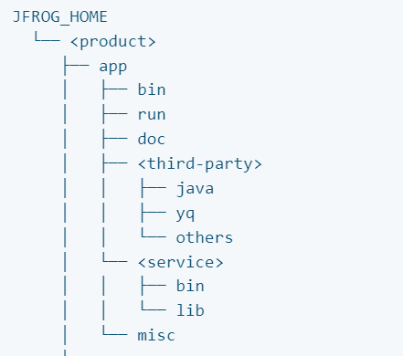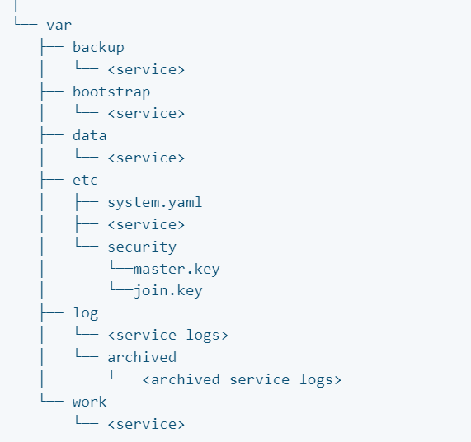

Cd /opt/JFrog—artifactory & Xray
/opt/JFrog/<product>/app
Artifactory → app(brdtms), data(bbdlew)
Xray→ app, data
- JFrog Projects are a management entity that hosts all your resources related to a specific project.
- https://jfrog.com/help/r/jfrog-platform-administration-documentation/projects
JFrog Projects help administrators and DevOps to assign, manage, access, control, and share Project resources.
From Artifactory 7.31.10, the JFrog Projects feature is now supported on all JFrog Subscriptions but varies on the number of projects, according to the following subscription types:
1) Pro/X subscription: Up to 3 projects (No option to extend this subscription).
2) Enterprise subscription: Up to 30 projects (No option to extend this subscription)
- Enterprise+ subscription: Up to a total of 300 unique projects for each subscription with the option to increase the number of projects by purchasing an additional License Bucket. Each bucket supports an additional 100 projects.
----------------------------------------------------------------------------------------------------------------------------------Day-3 26/10/2024
JFrog Artifactory service
- Layers in Artifactory
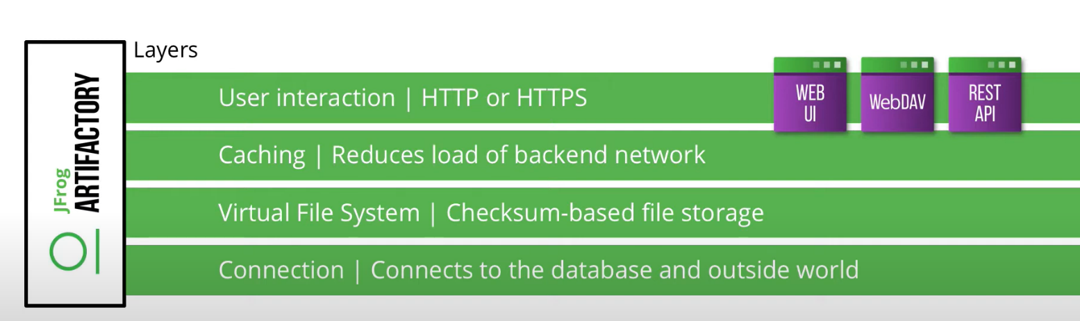

- Repositories
- https://jfrog.com/whitepaper/best-practices-structuring-naming-artifactory-repositories/
- It is a central system for storing and managing collection of file/artifactory
- This structure produces the following JFrog recommended repository naming structure that should be used throughout your organization:
- <team/project Key>-<technology>-<maturity>-<locator>
- A project, product or team name as the primary identifier of the project
- The technology, tool or package type being used.
- The package maturity level, such as the development, staging and release stages.
- The locator, the physical topology of your artifacts
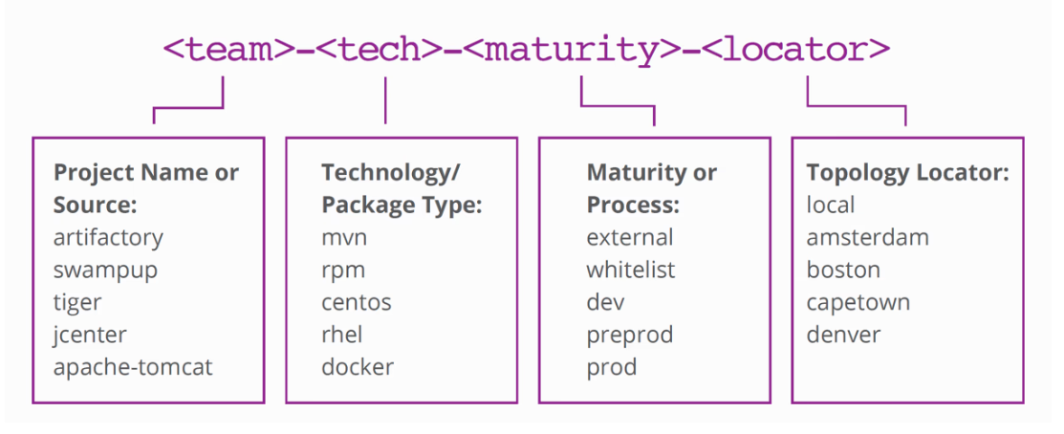
  - Types of repositories:
- Local
- Remote
- Virtual
- Federated
- Local repositories: Local repositories are physical, locally managed repositories into which you can deploy artifacts.
  - We can deploy to local repositories
- Remote repositories: A remote repository serves as a caching proxy for a repository managed at a remote site such as ConanCenter.
  - We can download from the remote repositories
- Virtual repositories: A virtual repository encapsulates any number of local and remote repositories and represents them as a unified repository accessed from a single URL.
  - Add is possible only both repositories have same software package type
  - We can access both remote and local repositories content throw single URL
- Federated repositories: is a collection of federated type repositories in different JPD (Java Package Descriptor) that are automatically configured for full bidirectional mirroring.
2.2) Permission
- Read: View all files within configured target or download artifacts and read the metadata
-Annotate: annotate artifacts and folders with metadata and properties
-Deploy/cache: Download from remote and upload to locally or deploy artifacts and deploys to remote repositories cache
-Delete/overwrite: Delete, move, overwrite and change files
-Manage Xray metadata: to manage x-ray setting
-Manage: admin permissions
3) Artifactory properties setup
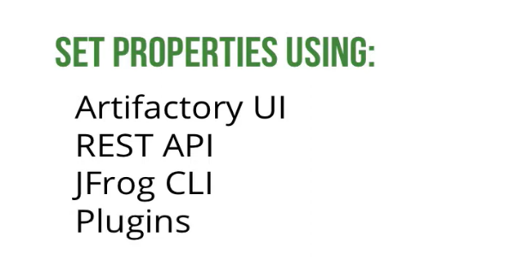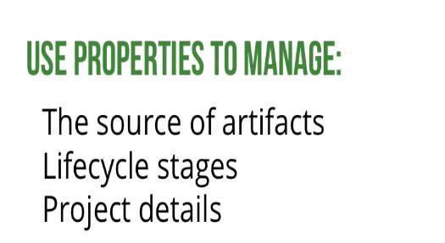
4)Possible Causes
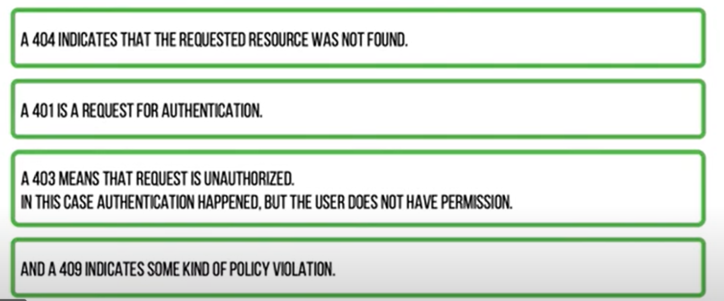
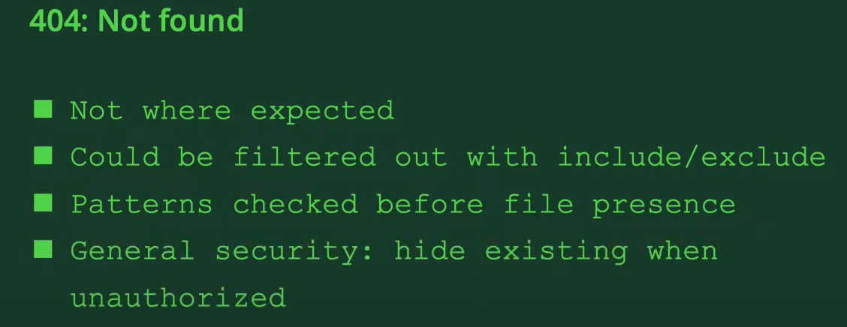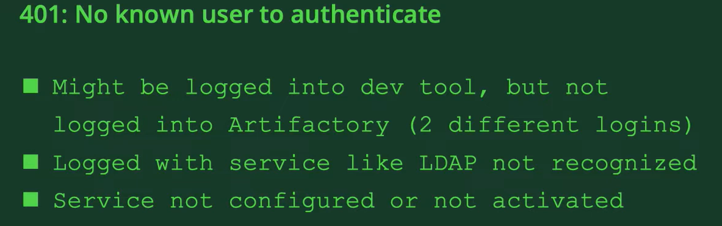
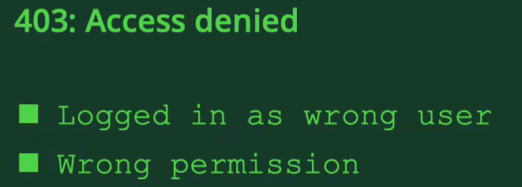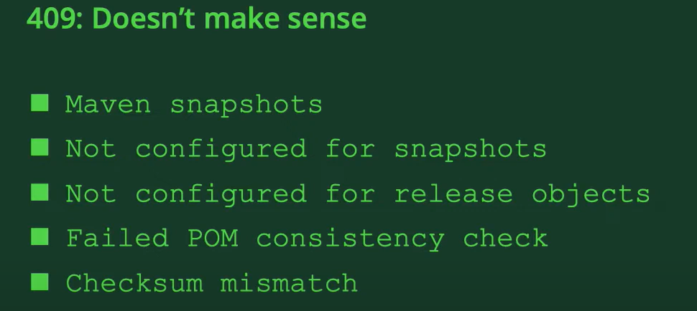
----------------------------------------------------------------------------------------------------------------------------------
Day-4 28/10/2024
- Access Token 2) Platform monitoring
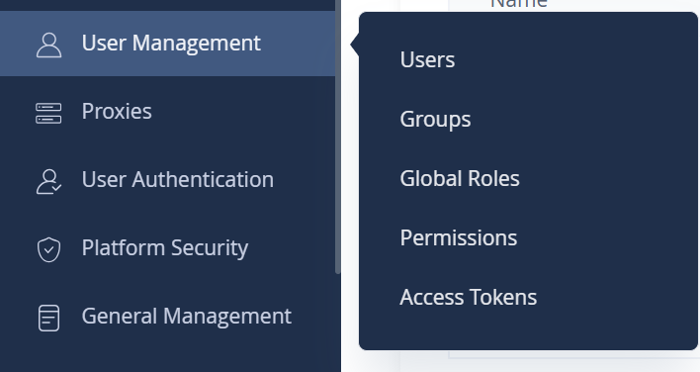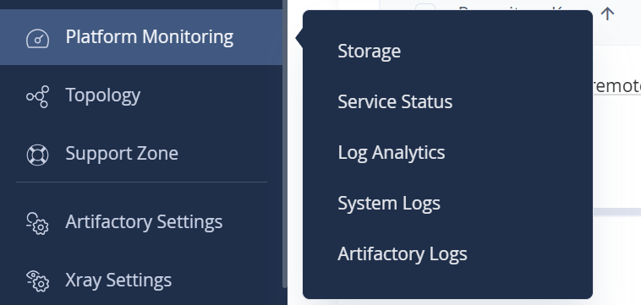
- General manage
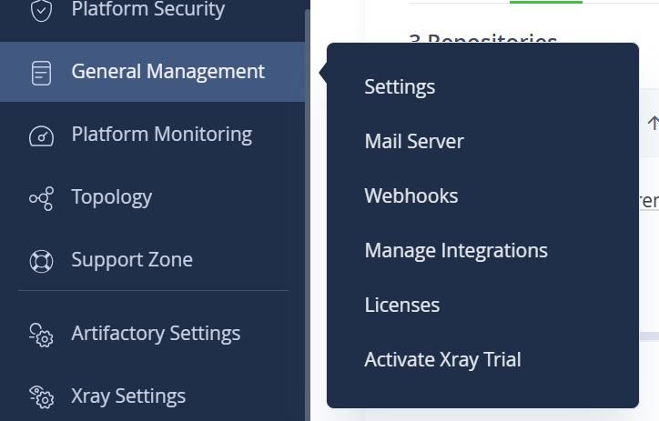
- Support zone
- a "support zone" typically refers to areas in your software development lifecycle or artifact management process where you encounter challenges or require assistance.
----------------------------------------------------------------------------------------------------------------------------------
Day-5 29/10/2024
JFrog X-ray service
- X-ray service contains the following microservices.
1.Indexer - Indexer for caching and scanning data and all components(Downloads new components ,creates graph , indexes and upgrade graph)
2.Persist - Persist for causing the components that can check for scanning.
3.Analysis - Responsible for enriching component metadata such as vulnerabilities , licenses and versions.
4.Server - This server responsibilities include generating violations by matching analysis data with watches and policies.
5.Router - (to connect an x-ray and microservices.)Responsible for communication between microservices and cross products.
- X-ray policies
- Policies defines security and license compliance behaviour specifications.

- The types of JFrog Xray:
- Security Management: Focuses on identifying and managing vulnerabilities in open-source components to protect applications from security risks.
- License Compliance: Ensures that the software components used comply with licensing requirements, helping avoid legal issues.
- Operational Risk Management: Assesses potential risks related to the use of software components, helping organizations make informed decisions about their software supply chain.
- Xray Watches: Monitors components for new vulnerabilities, license changes, and compliance issues, providing real-time alerts.
• Xray Watches are used to manage policies related to security and license compliance.
• They serve as the central point for viewing and managing security and license violations within the JFrog platform.
• Watches help monitor repositories for security vulnerabilities and ensure compliance with licensing requirements.
- Pre-requirements:
- Database: Xray requires a PostgreSQL database.
- jq Installation: Install jq before starting the Xray installation.
- RabbitMQ: External RabbitMQ instances are not officially supported; use Erlang instead.
- JFrog security IDs:
- CVE (Common Vulnerabilities and Exposures): A system that provides a reference-method for publicly known information-security vulnerabilities and exposures. Each CVE has a unique identifier.
- CVSS (Common Vulnerability Scoring System): A standardized scoring system that evaluates the severity of vulnerabilities, helping organizations assess the potential impact and prioritize responses.
=============================================================================Day-06 5/11/2024
Docker
Basic
- Docker is an open-source platform that enables developers to build, package, and run applications in containers.
- Containers are lightweight, portable, and self-sufficient units that can be run consistently across different environments, from a developer’s local machine to production servers.
- A Docker image is a snapshot of a container, including everything it needs to run the application code, runtime, libraries, environment variables, and config files.
- a Docker registry is a place to store and manage Docker images. JFrog Artifactory provides a secure, private registry where you can push, pull, and version your Docker images for development and deployment.

- To add a docker path in local system
- C:\Program Files\Docker\Docker\resources\bin
- Edit the system environmental variables->set in system ->path-> edit->new ->add path->save/ok
- Docker install and login commands in VM without SSL & TLS certificate (http)
- https://docs.docker.com/engine/install/ubuntu/
- systemctl start docker
- systemctl enable docker
- Cd /etc/docker
- Vi daemon. Json (“insecure-registries”:[“135.233.99.177:8082”])
- Sudo systemctl restart docker
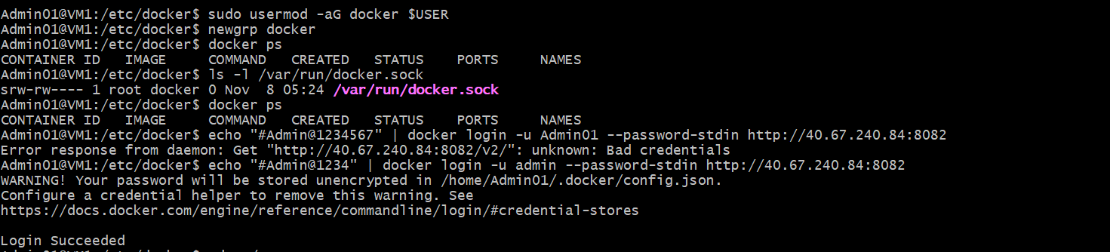
- echo < UI password> | docker login -u <UI user id> --password-stdin http://135.233.99.177:8082
- Docker login commands in VM with SSL & TLS certificate (https)
- docker login v6domain.shop --username "username" –password "password"
- To Pull Images to remote repositories (Application -> artifactory ->artifacts -> docker-remote-repositories)
- docker pull 135.233.99.177:8082/training-docker-remote/<DOCKER_IMAGE>:<DOCKER_TAG>
- To Push images from registry to remote repository (To push an image, first tag your image and then push it) (Application->artifactory->artifacts->docker-local-repositories)]
- docker images
- docker tag <IMAGE_ID> trialbtc4cs.jfrog.io/team1-test-docker-local/<DOCKER_IMAGE>:<DOCKER_TAG>
- docker push trialbtc4cs.jfrog.io/team1-test-docker-local/<DOCKER_IMAGE>:<DOCKER_TAG>
- If a manifest error occurs indicating that the image does not exist in the registry, ask for the correct image registry in support team and then pull the image.
=============================================================================
Day-07 6-11-2024
JFrog Artifactory and Xray Installation
- Installation Document
- https://jfrog.com/xray/install/
- Debian for Debian (9, 10) / Ubuntu (16.04, 18.04)
1. Download the installer
- wget -O jfrog-deb-installer.tar.gz https://releases.jfrog.io/artifactory/jfrog-prox/org/artifactory/pro/deb/jfrog-platform-trial-prox/[RELEASE]/jfrog-platform-trial-prox-[RELEASE]-deb.tar.gz
2. Extract it
- tar -xvzf jfrog-deb-installer.tar.gz
- CD into directory
- cd jfrog-platform-trial-pro*
- Run the installer
- sudo ./install.sh
- If JQ error comes
sudo apt update
sudo apt install -y jq
- Again, Run the command
sudo ./install.sh
If Error comes
sudo apt update
sudo apt install net-tools
sudo ./install.sh
- Start Artifactory
sudo systemctl start artifactory.service
- Start Xray
sudo systemctl start xray.service
Add the network port:
Inbound : 8081 and 8082
UI default credentials
Username: admin
Password: password
License update:
Xray database sych
----------------------------------------------------------------------------------------------------------------------------------
- To install NodeJS & NPM
- sudo apt update
- sudo apt upgrade
- mkdir npm
- sudo apt install -y nodejs
- sudo apt install npm
- node -v
- npm -v
=============================================================================
Day-08 8-11-2024
NPM set up process
- vi ~/. npmrc (add registry-local, authentication token) (only once)
- before you do anything you have to login particular artifactory (r,l,v)
- to install package from registry, use remote artifactory link
- to install package from local to client local environment, use local artifactory install link
- to move packages from remote to local artifactory login local -> node modules->package name-> and publish
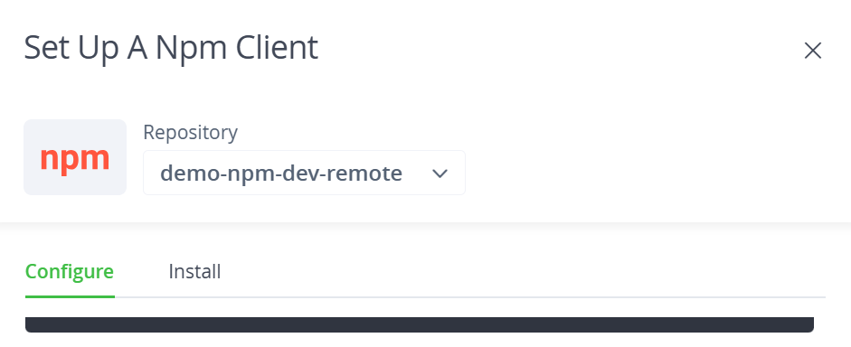
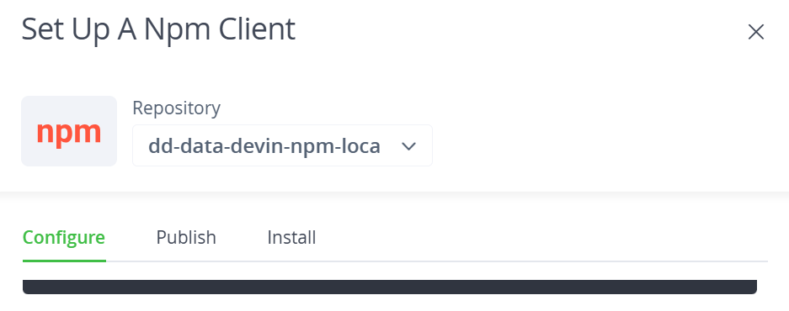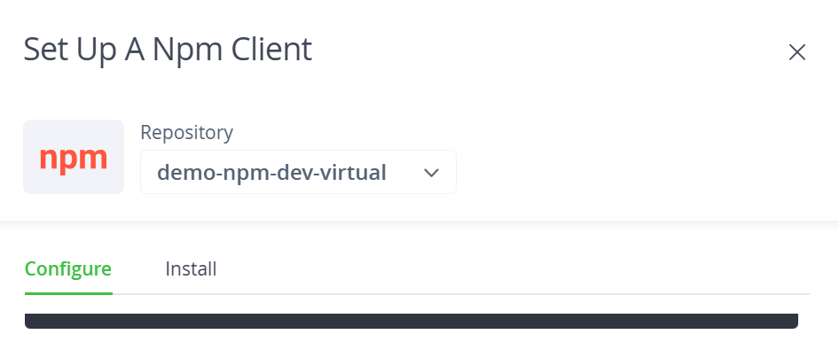
=============================================================================
Day-09 11-11-2024
How to create npm project
- In the home directory: create a directory > mkdir <project-name>
- cd <project-name>
- npm init -y
- Install the dependency packages if required to run your code: (node-modules folder)
- npm install <package-name> http ://172.183.157.24:8081/artifactory/api/npm/demo-npm-remote/
- Touch index.js (create a index.js file)
- Vi index.js (write your code here)
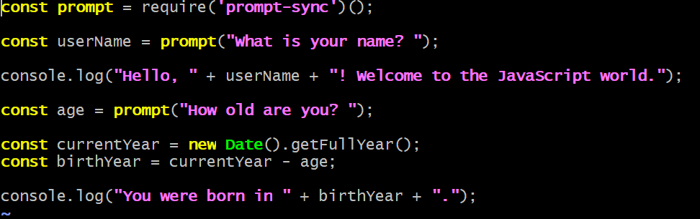
- Login to local artifactory
- npm publish --registry http://172.183.157.24:8081/artifactory/api/npm/el-npm-local/
- If we get the permission denied error run,
chmod +x ./index.js
- sudo ./index.js (if this command is not working go for the other command node index.js) or node index.js (to run a code)
- Now update a code
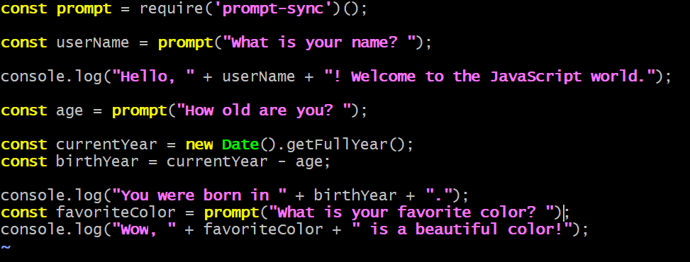

- node index.js (run a code)
- npm init -y: You don’t notice the change in the version.
- npm version patch: To update the version.
=============================================================================
Day-10 12-11-2024
- Maven & JDK 17 installation
- sudo apt update
- sudo apt install maven
- mvn -v
- sudo apt update
- sudo apt install openjdk-17-jdk
- java -version
- cd /etc/maven/settings.xml
- Edit the code (Copy the code from the UI by going to Setup, selecting the local repo, configuring it, and then clicking on General Settings)->Paste it in settings.xml file
- Updating UI username and password
- To create a project in maven
- mkdir <new directory>
- cd <new directory>
- mvn archetype:generate -DgroupId=com.example -DartifactId=<project name> -DarchetypeArtifactId=maven-archetype-quickstart -DinteractiveMode=false
- ls
- Add the code (Copy the code from the UI by going to Setup, selecting the local repo, go to deploy)
- Paste it before closing of the </project> tag
- Paste the build code below the </dependencies>tag is closed.
- mvn clean
- mvn install
- mvn deploy
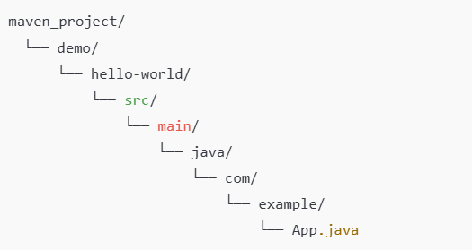
- cd ~/maven_project/demo/hello-world/ //hello-world=project_name
- javac src/main/java/com/example/App.java //App.java=program.java
- java -cp src/main/java com.example.App //App=program_name
- Run the project:
- Go to the path /mvn/hello/src/main/java$
- Run the following comands:
- javac com/example/App.java
- java com.example.App
=============================================================================

