Software Architecture
CDSS Editor 0.1

Approval
Document | Template-Software-Architecture-V1.docx |  | Version | 1.0
Author | <Author> |  | Date
Name / Role |  | Name / Role | Name / Role |  | Name / Role
Signature  Datum |  | Signature  Datum | Signature  Datum |  | Signature  Datum

Content
Approval 1
Content 2
1 Meta-Information 4
1.1 Product / Software 4
1.2 Version History 4
1.3 Addressees and intention of this document 4
1.4 Relevant documents 4
2 Introduction and Objectives 5
3 Constraints 5
3.1 Technical constraints and requirements 5
3.1.1 Runtime environment 5
3.1.2 Coding Guidelines 5
3.1.3 Tools and more 6
3.2 Organizational constraints and requirements 6
3.3 Regulatory requirements 6
3.3.1 General 6
3.3.2 Software-safety classification 6
4 Context 6
5 Solution Strategy 7
6 Static View (data) 7
6.1 Overview 7
6.1.1 Top-level components (self developed) 8
6.1.2 SOUP components 8
6.1.3 Database schema 8
6.2 Components on first level 9
6.2.1 Component A: <NAME_OF_COMPONENT> 9
6.2.2 Component B: <NAME_OF_COMPONENT> 9
6.3 Components on second level 9
6.3.1 Component A1: <NAME_OF_ COMPONENT> 9
6.3.2 Component A2: <NAME_OF_ COMPONENT> 9
7 Dynamic View (Runtime view) 10
7.1 Runtime scenario 1: <NAME_OF_SZENARIO> 10
7.2 Runtime scenario 1: <NAME_OF_SZENARIO> 10
8 Deployment view 10
9 Testing 11
9.1 Integration strategy 11
9.2 Other instructions and requirements for testing 11
10 Design decisions 11
11.1 Design decision 1: Web Development 11
11.2 Design decision 2: Inclusion of Amazon S3 Storage 11
11 Risks 12
12 Traceability 12
13 Appendix 12
13.1 Results of prototype validation 12
13.2 Literature 12

Meta-Information

Product / Software
Product name | CDSS Editor 0.1 | Product version | 0.1
 |  | Software version | 0.1

Version History
Version | Datum *) | Author | Status**) | Modifications
1.0 | 2018-MARCH-28 |  | Draft | Initial creation
*) Format: JJJJ-MON-TT **) Status: Draft, Reviewed, approved
Table 1: Version History

Addressees and intention of this document
This document describes how the software architects plan the technical implementation of the software requirements. The document has to fulfill the following goals:
- Serve as input for the development team how to technically implement/develop the system – ideally without the need of any further inquiries.
- Provide an overview of the structure of the software system, also for the future project staff.
- Give the test team sufficient information about the software components, about the integration strategy and how to perform software unit and integration tests.

Relevant documents
For this software architecture the following documents are relevant:
Nr. | Document | Relationship
1 | Glossary | Company-specific definition of terms and definitions
2 | Document list (Excel) | Links between the versions documents in the technical file (e.g. this one) and the product versions.
3 | Risk management file | Provides and documents all risk management activities as risk analysis, evaluation and control for specific product.
4 | Software requirements (SRS) | Contains the reacted software requirements.
7 | Software development plan | Provides project specific requirements
8 | IEC 62304 in particular 5.3 und 5.4 (SW Architecture and Detailed Design) | Contains the normative requirements of a software design specification.
9 | Coding Guidelines | Can be adapted and referenced
10 | ISO 9126 e.g. ISO 25010 (List der SW- quality criteria) | Includes basic software quality criteria and is therefore very helpful. In particular, for maintainability.
11 | ARC42 structural requirements (www.arc42.de ) | Origin of the structure of this document. Is available in German and English.
Table 2: Relevant Documents
The actual file name, version and date of the corresponding referenced document can be found in [2].

Introduction and Objectives
A physician is making clinical decisions based on clinical decision rules which are part of his personal medical knowledge.
A clinical decision is meant to be ruling the management of health and healthcare of an individual person (patient) [2].
A clinical decision rule maps from the characteristics of the situation to the behavior that should be performed or the conclusions that should be reached in that situation. Clinical decision rules are also called production rules or condition-action-rules.
A clinical decision support system (CDSS) is understood here as a software system designed to apply automated reasoning on digitized patient data following provided clinical rules and to demonstrate recommendations to users (physicians) for the diagnosis, prevention, monitoring, treatment or alleviation of a disease.
Support is meant to be the aiding of, rather than the making of decisions [2], which means demonstrating recommendations to healthcare professionals.
A clinical decision support system (CDSS) is supposed to aid these decision-making processes by presenting recommendations based on clinical decision rules that were earlier determined and stored within a CDSS knowledge base.

Constraints

Technical constraints and requirements

Runtime environment
The software must be executable on non-mobile devices like a PC or a laptop with Chrome web browser.

Coding Guidelines
There are the following coding guidelines for CDSS Editor:
- Programming Languages – PHP, JavaScript, HTML5, jQuery, CSS3
- IDE – VSCode
- Version Control – GIT
- Static Code Analysis (PHP) – Code Sniffer
- Static Code Analysis (JS) – JS Lint
- Refer relevant documents – CodingGuidelinesPHP.pdf, CodingGuidelinesJS.pdf, CodingGuidelinesHTML.pdf, and CodingGuidelinesCSS.pdf for coding guidelines.
- Refer the document for version control – Versioning System.pdf
There are the following general coding guidelines:
- Manual Testing must be performed using following type of browsers available –
  - Chrome
  - Mozilla
- The developers must be updated to latest VSCode and latest browsers.
The versions must be controlled with help of GIT.

Tools and more
Repeat amend the other technical constraints as described in software requirements specification [4].

Organizational constraints and requirements
There are the following organizational constraints and requirements:
- Team size of 6 to 8 members with 1 to 3 years of experience.
- Responsibilities and contact persons
Area | Responsibilities | Contact Person
Technical Domain | Coding and Architecture. | Mr. Parag Walimbe  Email – parag.walimbe@media4u.com
Design Domain | App Design, UI design, Look and feel of software. | Ms. Mariona D.  Email -mariona.dieguez@media4u.com
Editorial Domain | Content and Interactive Tools. | Dr. Nathalie Blanck.  Email – nathalie.blanck@media4u.com
Management | Budget, License, Cost. | Dr. Philipp Börm.  Email – philipp.boerm@media4u.com  Parag Walimbe  Email – parag.walimbe@media4u.com
Client Side | Accounts, Purchase Decisions. | ?

Regulatory requirements

Software-safety classification
The software safety of the software system is B.

Context // Waiting for Shaishav’s response
Repeat briefly the technical context in particular the neighbor systems the new system has to connect with. This information should be part of the software requirement specification already. We recommend a context diagram like the following. This should be the same diagram as in chapter 2 of the SSRS.
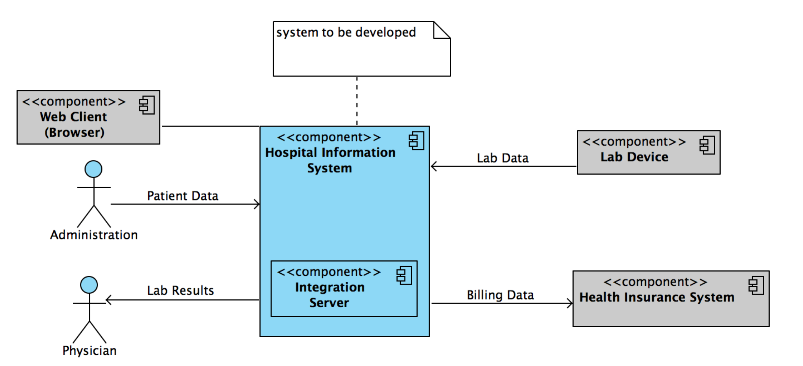
Fig. 1: Example for a context diagram (to be replaced by a real one)
Examples for interfaces include user interfaces, TCP/IP based interfaces, bus systems, databases (only if not part of the solution).

Solution Strategy
There are the following approaches for the solution strategy:
- The main technologies used in the software development must be HTML5, CSS3, PHP, JavaScript and jQuery and nuSoap Web services.
- The Web services and web backend must be developed in core PHP.
- Model – View – Controller Design pattern must be used to develop the applications. Using an Object Oriented architectural style.

Static View (data)

Overview
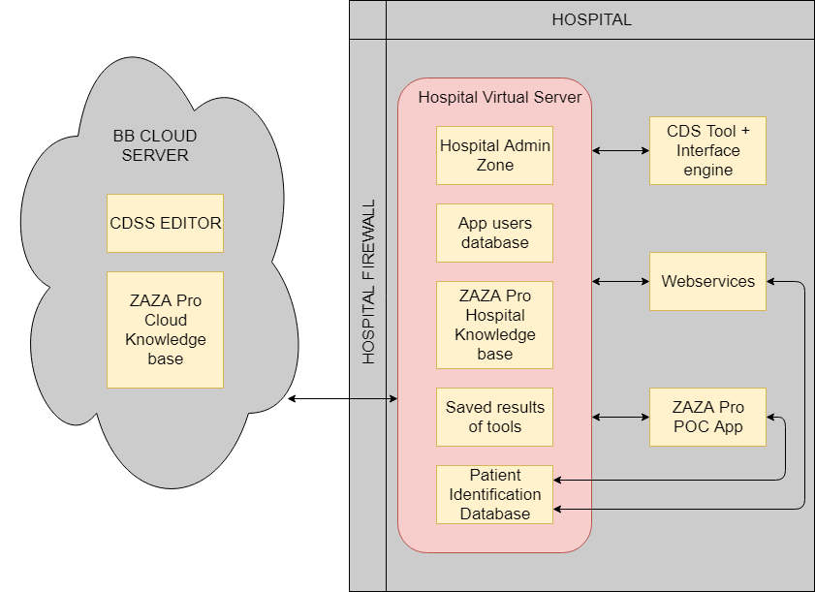
Fig. 2: Top-level components

Top-level components (self developed)
Component | Short description of the function and responsibility | Safety classification | See chapter
CDSS EDITOR | Provides web interface for creation, verification and validation of Clinical Decision Support Tools.
ZAZA Pro Cloud Knowledge base | For saving and delivering content and CDST  a. Server for delivery and communication  b. CDST and content databases for storing relational data
Hospital Admin Zone | Interface for the administrator in the hospital from where he can add users and synchronize tools from Amazon S3 to their local server.
App users database | The ZAZA Pro POC app uses an in-device database to synchronize data with the local hospital database and then sends data to the local hospital database
ZAZA Pro Hospital Knowledge base | This is the local database that is present at the hospital to store tool results for patients and other patient related information
Saved results of tools | When a tool is run against a patient, we get an outcome from the tool and this outcome is known as result of the tool. This tool result is saved in the database.
Patient Identification Database | Independent secured database to store patient data
CDS Tool + Inference engine | For processing CDSS clinical decision rules
Web services | To transfer data between the components
ZAZA Pro POC App | This is the Point Of Care app. It’s an interface to interact with the tools created by medical editors to treat patients.

SOUP components
Name | Manufacturer | Version | Description of the SOUP (function and responsibility) | Safety classification
MySQL | Oracle | 5.7.14 | MySQL is an open source relational database management system (RDBMS) based on Structured Query Language (SQL). ... LAMP is a Web development platform that uses Linux as the operating system, Apache as the Web server and MySQL as the relational database management system and PHP as the object-oriented scripting language. | Class B

Database schema
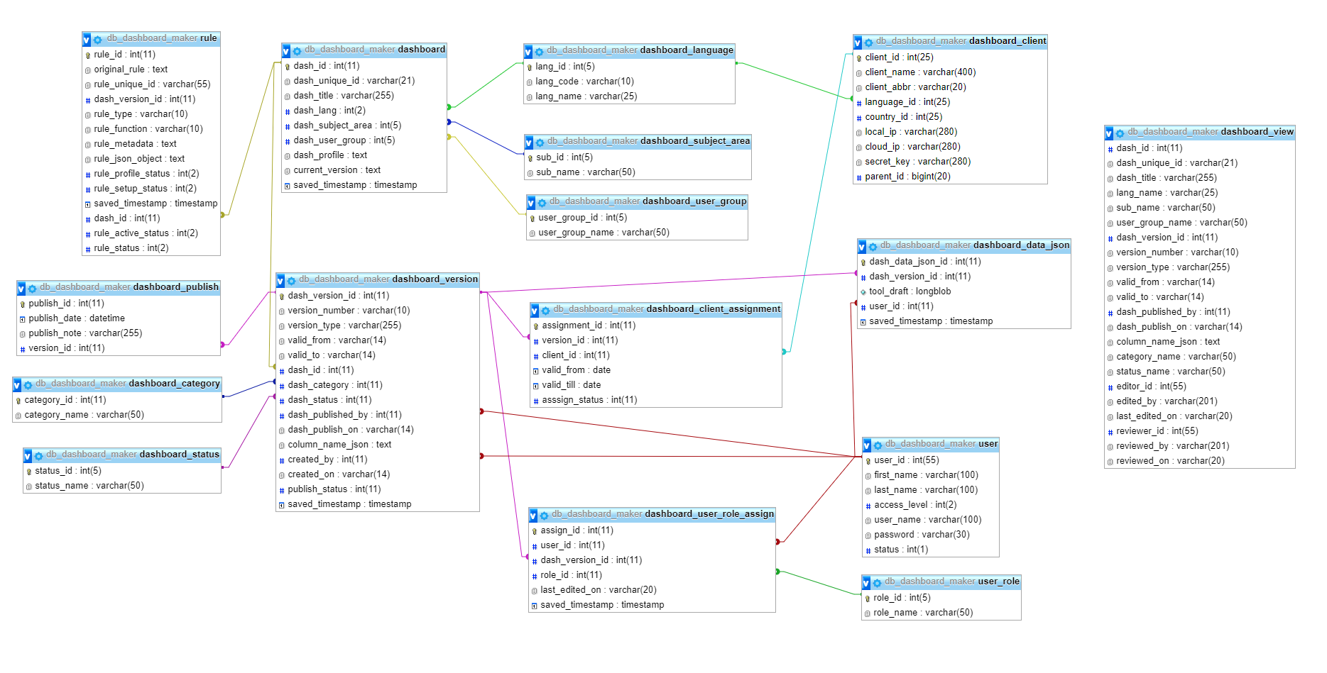

Components on first level // Aniket
The first level component specification describes the components identified in the figure 2 from a black box perspective, i.e. it specifies the components’ behavior via the respective interfaces. Chapter 6.3 describes the inner structure, the white-box perspective, of each of the components.

Component A: <NAME_OF_COMPONENT>
Describe in this chapter
- Task, responsibilities of component.
- Specify interface e.g. in terms of an API description. Mention methods, parameters and return values.
- If the component does not offer a programming interface ( API) describe the interface using the interoperability layers
  - Structural layer: How are data (“binary stream”) transferred, mention protocols (TCP/IP, bus protocol, …)
  - Syntactic layer: How are information entities identified in the binary stream e.g. data formats as HL7, XML etc.
  - Semantic layer: How do you guarantee a common understanding of the meaning of information entities ( value tables, classification systems)
  - Organizational layer: Address if applicable access rights
- If the component has interfaces to the “outside world” just refer to specification (SRS)
- Requirements with respect to performance, data volumes, number transactions
- Requirements with respect to missing, faulty, out-of-range, delayed etc. data
- Justification if safety classification is lower than classification of software system
- Optional: Instructions and requirements for unit or integration testing

Component B: <NAME_OF_COMPONENT>
Analogous

Components on second level

Component A1: <NAME_OF_ COMPONENT>
Describe internal structure of component using component or class diagrams. This step is optional if the parent component has safety class B or A. Use a component or class diagram to illustrate the inner structure of the component. Specify the components on the second analogous to first level components.
If the component is very comprehensive, consider extracting this description into a dedicated document.

Component A2: <NAME_OF_ COMPONENT>
Analogous

Optionally continue with components on third and following levels using numbering scheme B1, B2 etc.

Dynamic View (Runtime view) // Akash

Runtime scenario 1: <NAME_OF_SZENARIO>
Describe the dynamic behavior of the system e.g. the sequence in which the components (on same and on different levels) interact. Examples that might be described include
- Start of system
- Most relevant use cases like invoke measurement, admit patient, …
- Invocation via external interfaces
- Behavior in case of safety critical errors
Describe these scenarios using
- Plain text
- UML sequence, activity, timing or communication diagrams

Runtime scenario 1: <NAME_OF_SZENARIO>
Analogous

Deployment view
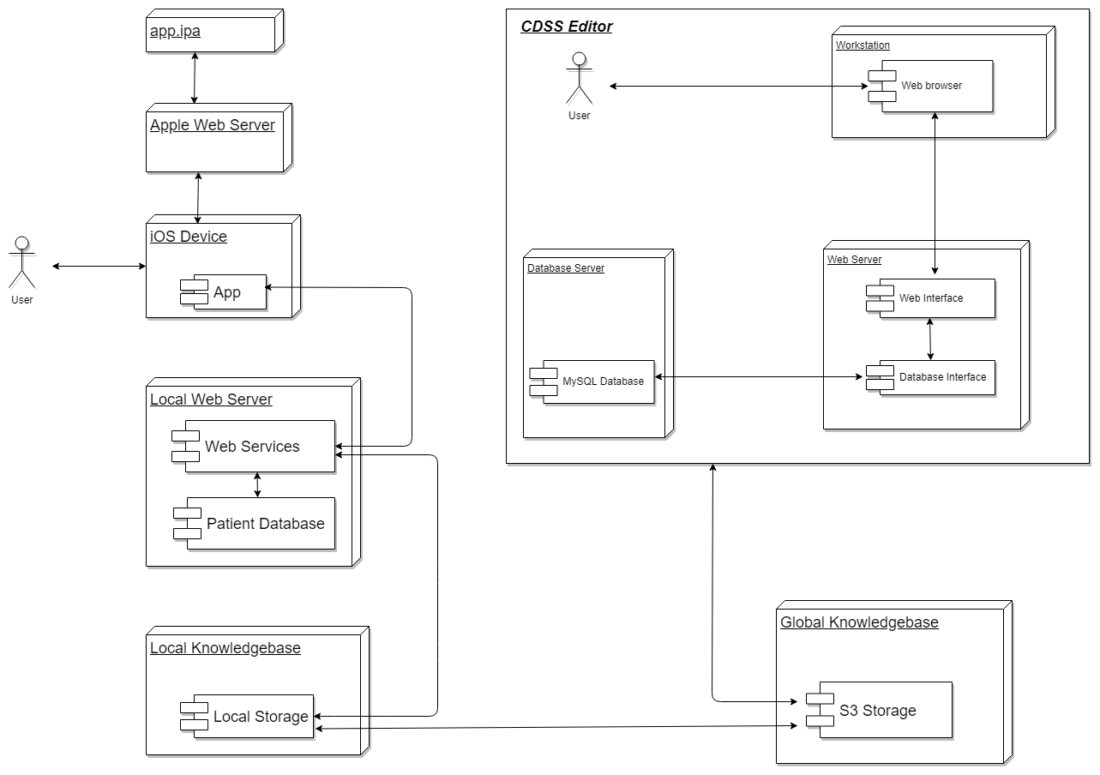
Fig. 3: Deployment diagram

Testing // Akash

Integration strategy
Describe
- in which sequence which combination of components has to be tested,
- whether/which test drives and/or mock-objects are required and
- the aspects to tested (e.g. performance, robustness)

Other instructions and requirements for testing
If not already part of software development plan you can address coverage, tools, test frameworks, frequency of regression testing etc.

Design decisions

Design decision 1: Web Development
- What had to be decided
- How to build the web interface
- What have been the options
- Web interface in JSP, ASP, PHP.
- SOAP or RESTful services.
- The advantages and disadvantages of the respective options
- JSP and ASP.NET experience was absent
- REST accesses data while SOAP performs operations through a more standardized set of messaging patterns. Since SOAP fulfilled our requirement of performing operations via a standardized set of messaging patterns, SOAP was used.
- The reason you have chosen one alternative over the others
- PHP experience was present.
- Test server and Main server supported PHP.
- Had experience with SOAP web services.

Design decision 2: Inclusion of Amazon S3 Storage
- What had to be decided
- How to push the tools to the app
- What have been the options
- Pushing the tools from S3 to the hospital server
- The advantages and disadvantages of the respective options
- The tools are kept secure on S3 storage and pushed as needed to the hospital server
- The reason you have chosen one alternative over the others
- There was no other option available

Risks
- Web App will fail/malfunction/data loss can occur IF:
  - Internet connectivity is lost
  - Communication link with the server is lost
  - Screen size less than 20 inches (1680 x 1050 pixels) is being used
  - Browser window is closed without clicking on save button or logging off properly
  - Invalid tool profile and rule profile data was entered
  - Rules having flaws in logic were created
  - Unverified tool/rule was published

Traceability
Describe briefly how requirements are addressed e.g. referring to a subchapter in this document, mentioning a function, method, component, architectural style or any other design decision. Alternatively you can trace the software requirements to the software architecture as part of the software architecture verification (review).
ID of software system requirement | Risk relevant | Keyword or sentence how requirement is addressed

Appendix

Results of prototype validation
Architectural / vertical prototypes are recommended to evaluate whether requirements (e.g. performance) will be met with the chosen architecture.

Literature

