DJANGO
DOCUMENTATION

NAME: M.vinod kumar

ROLL NO:234311

The Process:
Github Django -docker container-dockerhub
1.create a new folder:
- Go to file manager
- Go to direct
- Create a new folder
- Save it with a name
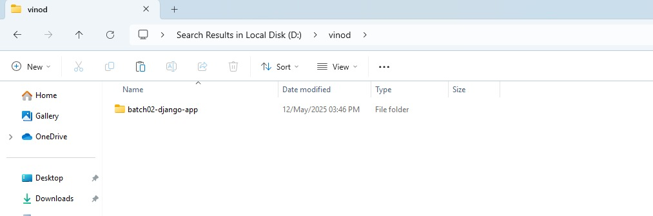
Local disk (D):
2. Open gitbash and change directory to new folder:
- Go to file where did you save
- Change it your folder name
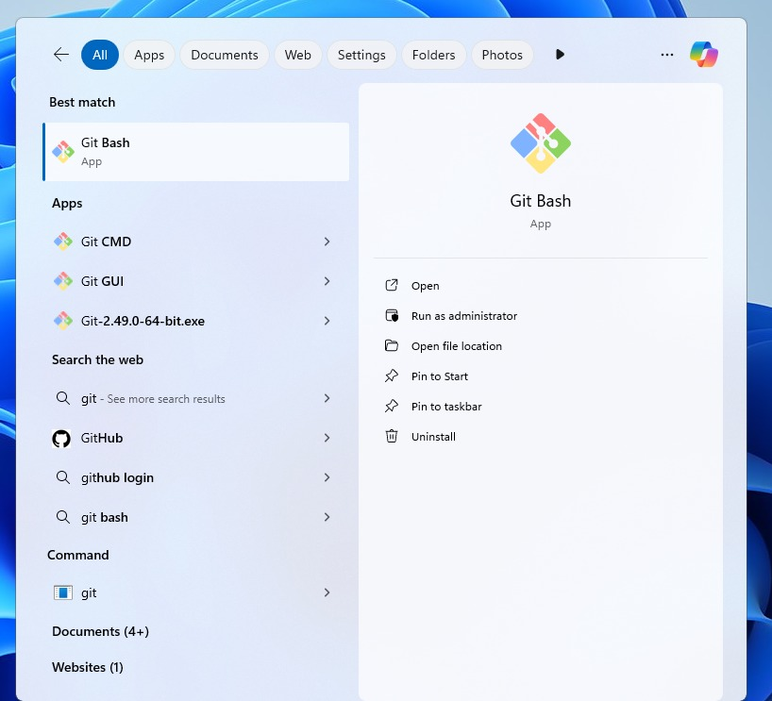
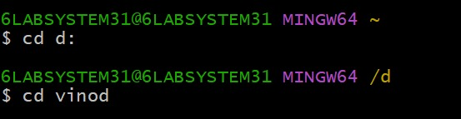
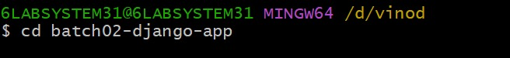
3.clone for git:
- It is used to copy the file which is already exits syntax
Gitclonehttps://github.com/rajasoxit/batch02-django-app.git
Example :
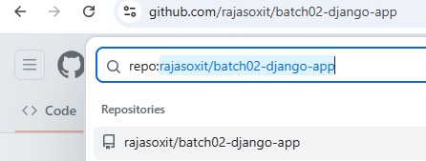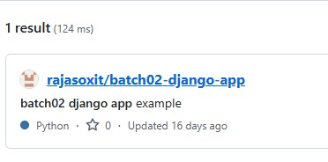

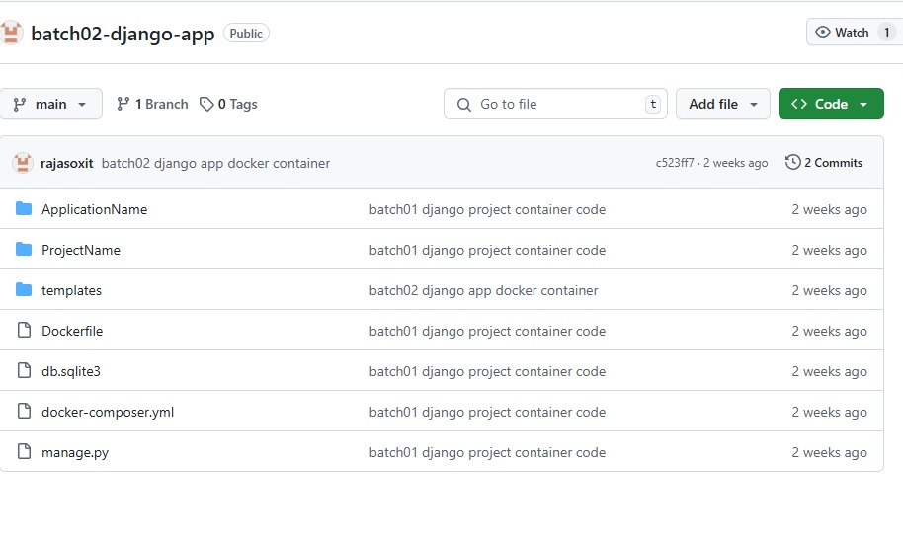

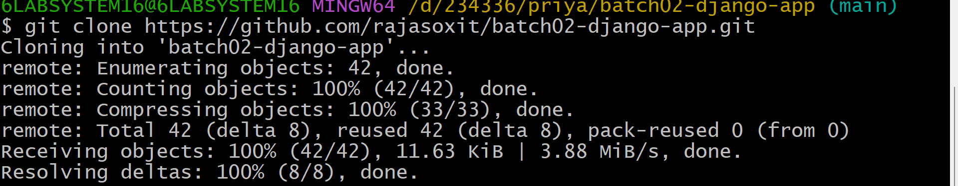

4.change directory:
- it is used to change directory.
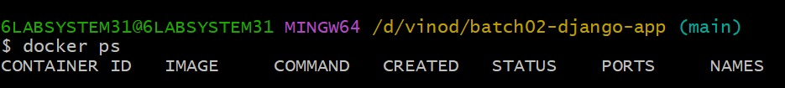
5.Docker ps:
- Ps means “process status”.
- Docker ps command is used to list all the running containers in the
docker host.
6.Docker build:
- It is used for build a image.
- it is used to bring all file in the folder to build.
Example:
Docker build -t batch02-django-app
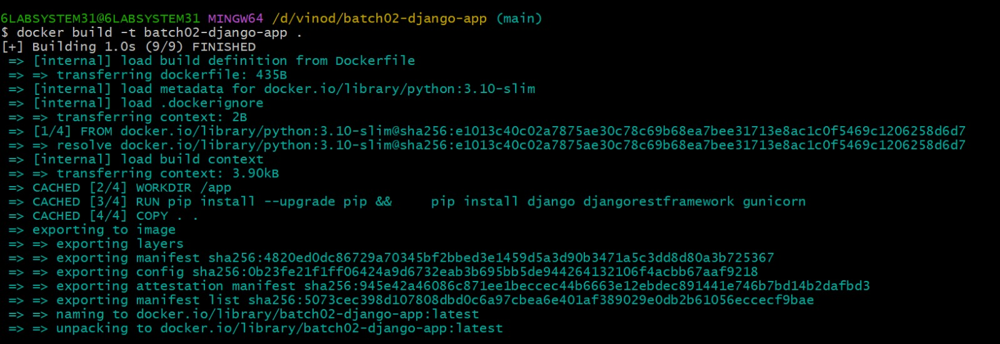

7. docker image
- It is used for to save the builded image in docker container.
- It contains all the libraries, dependencies and files to run a container.

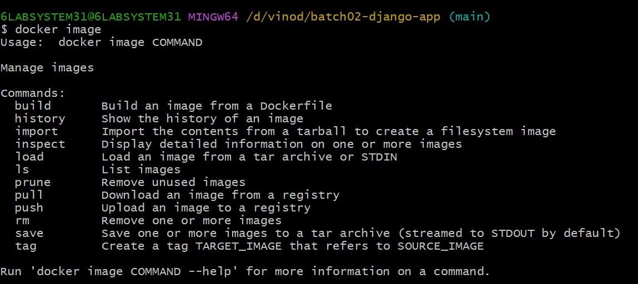
8.docker run:
- It is used to run a build image in docker file.
- Example:
- Docker run-p 8000:8000 batch02-django-app
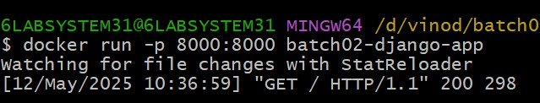
9.open browser:
- Open browser
- type https://localhost:8000/
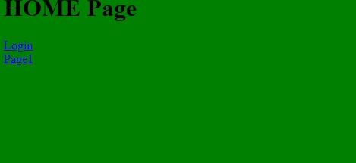
10.Vs code:
- Open vs code
- New file new window
- Open folder with latest created folder .
- Go to templates and select index.html
- Homepage replace with KBN
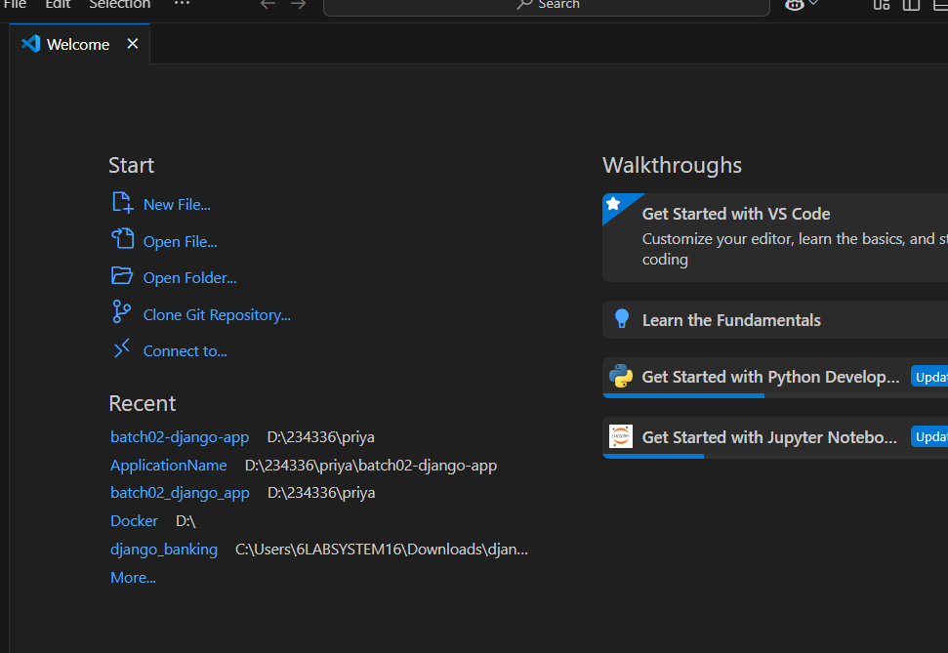
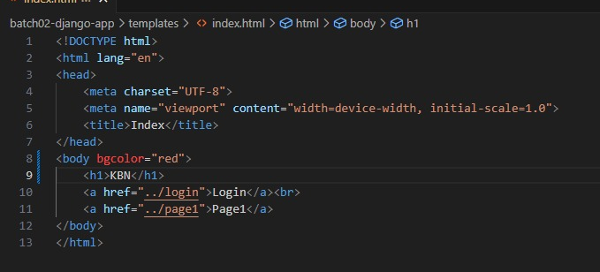
11.docker build :
Save the file and create build
12.run the server:
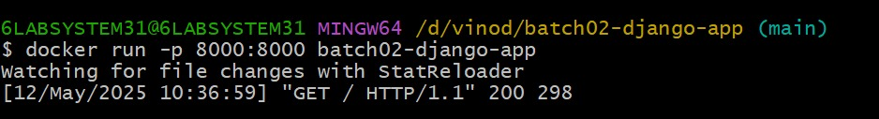
- Again open

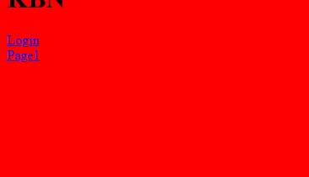

14.Login of docker hub:
- Create and login into docker hub
- Create repository batch02-django-app
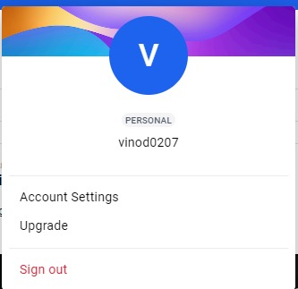
Repositories:
All repositories within the vinod0207 namespace.
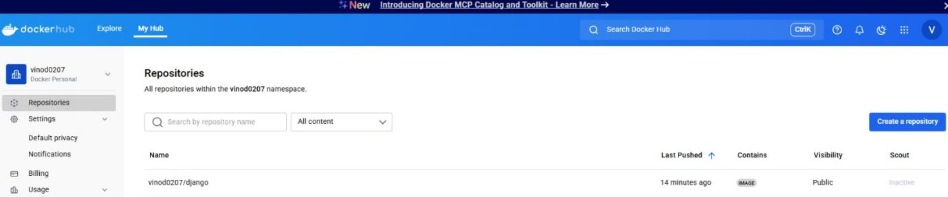
15.Docker tag:
Giving name to a docker image
16.Docker login:
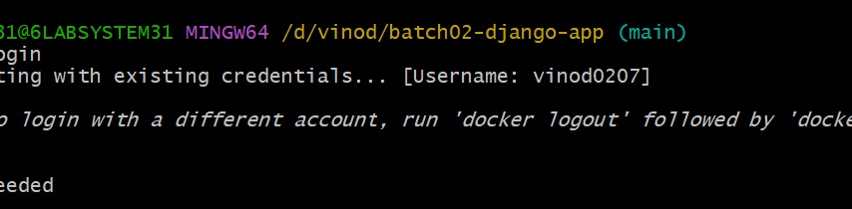
17.Docker push:
