**<entry key="ownerNameSuggestBoxWorkItemListForward">**

**<value>**

**<IdentityFilter name="Manager" order="Ascending">**

**<FilterSrc>**

**<FilterSource>**

**<BasicFilter>**

**<Filter operation="EQ" property="managerStatus">**

**<Value>**

**<Boolean>true</Boolean>**

**</Value>**

**</Filter>**

**</BasicFilter>**

**</FilterSource>**

**</FilterSrc>**

**<OrderBy>**

**<String>firstname</String>**

**<String>lastname</String>**

**<String>name</String>**

**<String>id</String>**

**</OrderBy>**

**</IdentityFilter>**

**</value>**

**</entry>**

The above we can keep into the identity selector Configuration Object for displaying the active manager’s into the forward workItem.

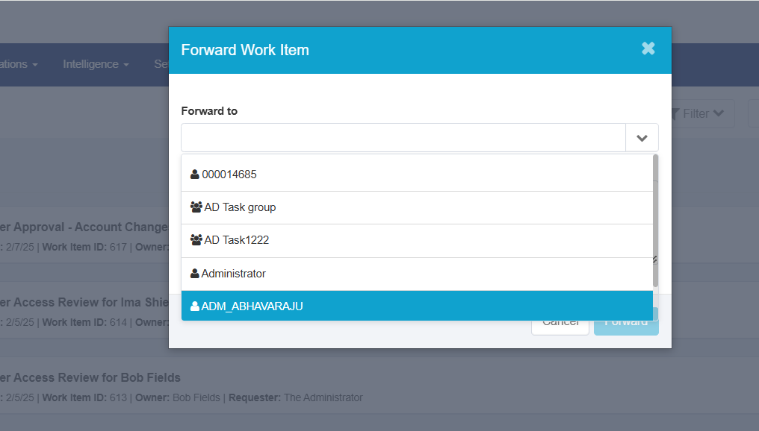

**Scenario – 1 :** approval Mode : serial , approvalScheme=manager,owner

Observation: serial

Approvals are processed one at a time and there must be consensus.

The first approver that rejects terminates the entire approval.

**serialPoll**

Approvals are processed in order but consensus is not required.

All approvals will be processed, we don’t stop if there are any

rejections. In effect we are taking a poll of the approvers.

First manager got the approval. if he will reject it then complete approval will stop. And owner will not get the approval.

First manager got the approval, then he approved and owner is rejected. Approval’s stopped .

**parallelPoll**

Approvals are processed concurrently and there must be consensus,

we wait for all approvers to approve. The first approver that

rejects terminates the entire approval.

Manager is rejected . Owner is approved . then changes will not effect on the user.

**Parallel :** Manager got the approval , manager is rejected then entire approval is rejected.