Assignment-14

1. Write a command that puts the following values, is their given order, into the salespeople table: City - San Jose, Name - Blanco, Comm - NULL, Cnum -1100.

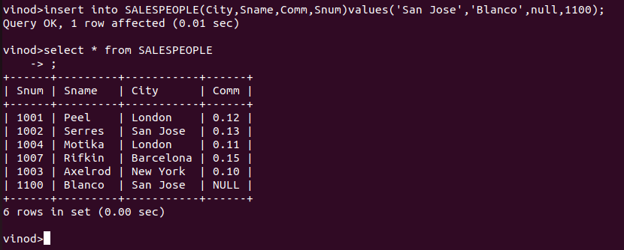

2. Write a command that removes all orders from customer Clemens from the Orders table.

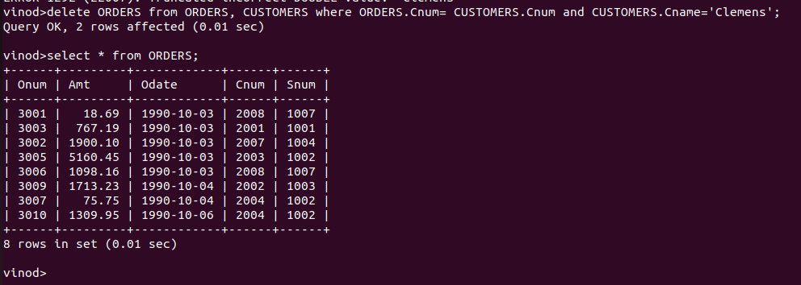
3) Write a command that increases the rating of all customers in Rome by 100.

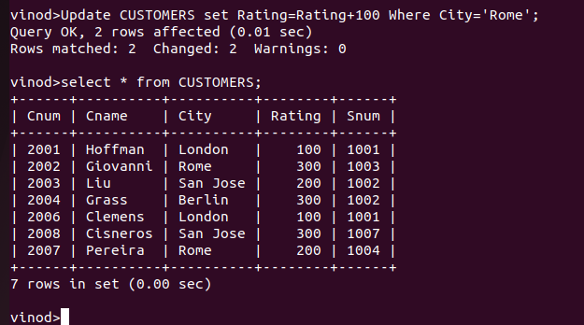

4. Salesperson Serres has left the company. Assign her customers to Motika.
