Assignment No-1

Q.1) Creating sample tables and inserting values.

Create the following tables with the given structures and insert sample data as specified.

A) SALESPEOPLE

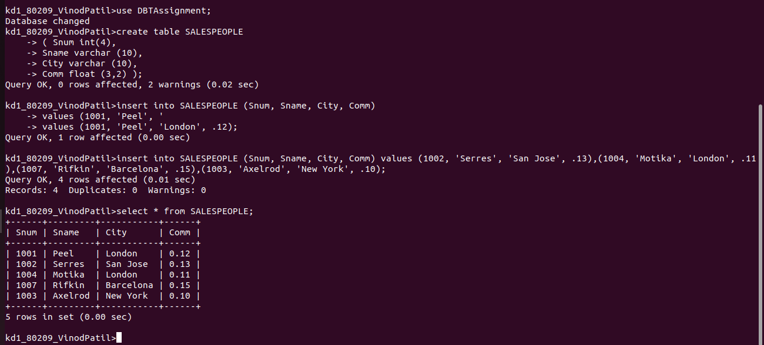

B) CUSTOMERS

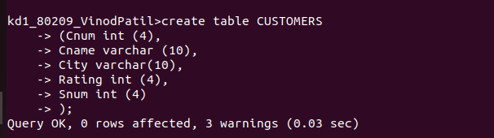

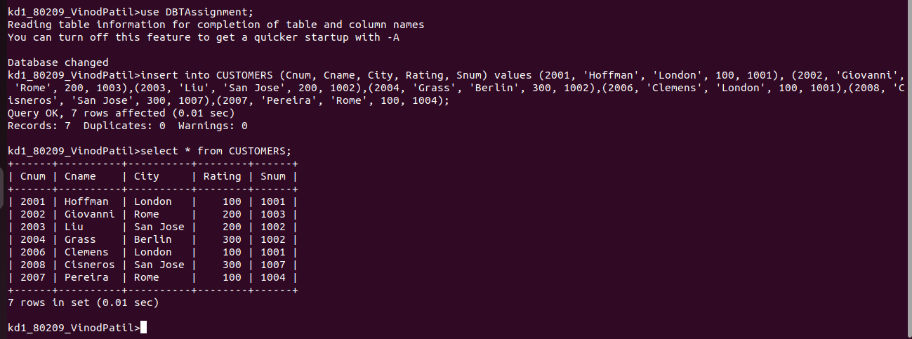

C) ORDERS

