Assignment-6

1. Write two different queries that would produce all orders taken on October 3rd or 4th, 1990.
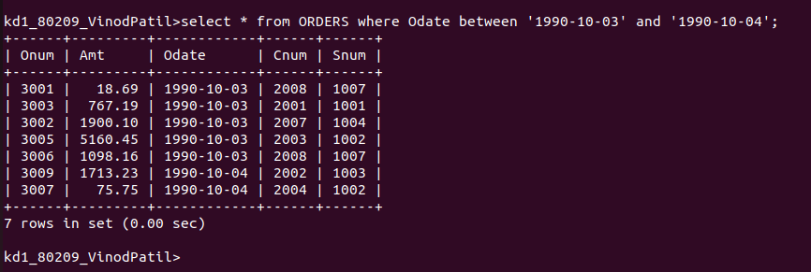
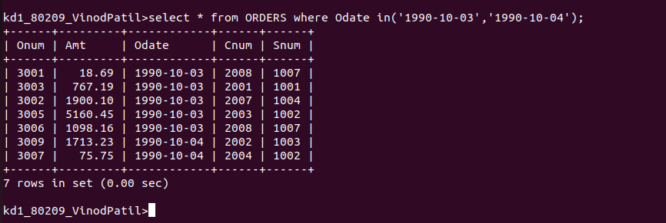

2. Write a query that selects all of the customers serviced by Peel or Motika. (Hint: the snum field relates the two tables to one another).

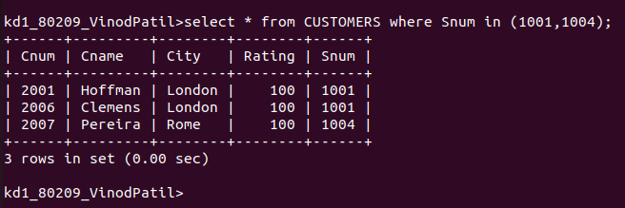

3. Write a query that will produce all the customers whose names begin with letter from ‘A’ to ‘G’.

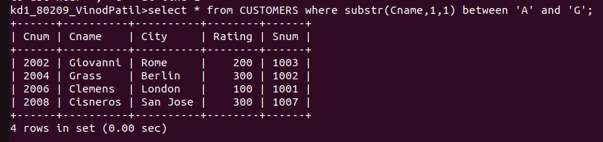

4. Write a query that selects all customers whose names being with the letter ‘C’.

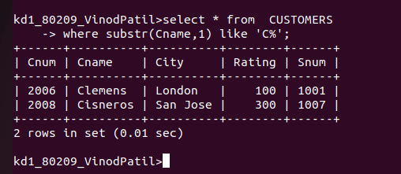
5. Write a query that selects all orders except those with zeroes or NULLS in the amt field.

