ASSIGNMENT-5

1.Write query that will give you all orders for more than Rs.1000 ?

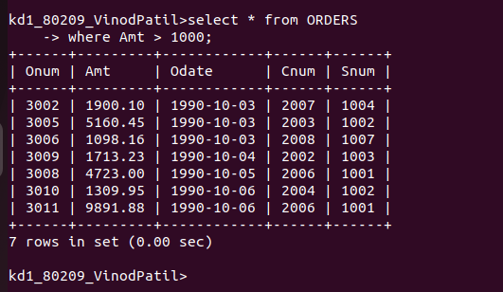

2.Write a query that will give you the names and cities of all salespeople in London with a commision above 0.10?

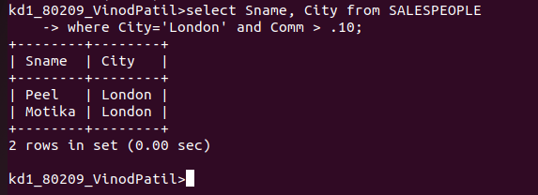

3. Write a query on the Customers table whose output will exclude all customers with a rating <= 100, unless ther are located in Rome.

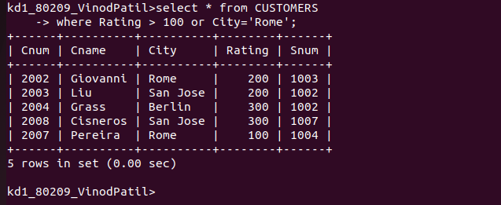

4. What will be the output from the following query
Select * from Orders
where (amt<1000 OR
NOT (odate = ‘1990-10-03’
AND cnum > 2003));

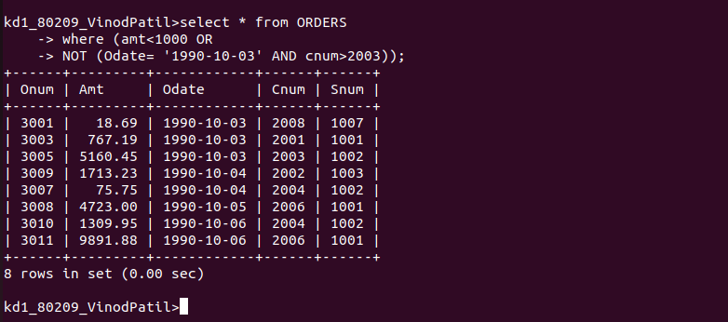

5. What will be the output from the following query
Select * from Orders
where NOT((odate= ‘1990-10-03’ OR snum>1006
AND amt>= 1500);

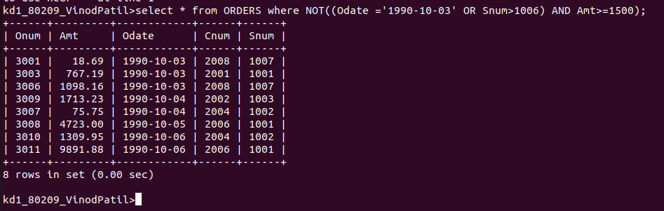
6. What is a simpler way to write this query?
Select snum, sname, city, comm, From Salespeople
where (comm>.12 OR comm<.14);

