From Fields to Dose: Study Report
Evaluating Large Language Models for Weight-Based Pediatric Medication Extraction and Dosing Consistency
Author record: https://orcid.org/0009-0005-3459-0859
Purpose of this document. A single, self-contained account of the study: what question it asks, why, how it was built, how it was validated, what it has found, what remains, and why each consequential decision was taken. Every number is traceable to a file in the public repository; every change after registration is a dated row in the deviations log, which also records corrections to earlier drafts of this report. Gemini 3.1 Pro rows are added when its runs complete. Companion documents: From Fields to Dose: System Architecture (software and operations), From Fields to Dose: Feature Article (publishable text), and From Fields to Dose: Review Guide.
Writing standard: no em or en dashes; no clock times; hyphens only inside compound terms; every number traceable to a committed file named in Section 11.

Abstract
Weight-based pediatric dosing turns a clinical note into a dose through several dependent steps: identify the current weight, the weight-normalised dose, its basis (per day or per dose), the frequency and the route, then compute the amount per administration. A language model that extracts each element correctly can still imply the wrong dose, and a model that abstains correctly on one missing element can still supply an unsupported value for another. This study measures those outcomes directly. A synthetic test set of 361 pediatric records (ages birth to 18 years; weights sampled from WHO and CDC growth references; regimens for 21 medications taken from FDA labeling; three documentation complexity levels; 57 abstention cases) was locked and registered on the Open Science Framework before any evaluated model was run. Five models, under the identifiers as used (GPT-5.5, Claude Sonnet 5, Gemini 3.1 Pro, DeepSeek V4 Pro, Llama 3.1 8B), were evaluated under two workflows: end-to-end extraction with model-computed dose (B) and extraction with deterministic arithmetic (C). Scoring is four-level: field accuracy, complete-regimen accuracy, dosing consistency, and a composite dose-consequence test at a 10 percent tolerance adapted from a published modified-Delphi definition of pediatric dosing error, whose two components (computed exposure more than 10 percent off; exposure not reconstructable) are reported separately. Five hypotheses were pre-specified. With all five models complete, the four frontier models performed at or near ceiling on routine extraction (field accuracy 0.996 to 1.000; primary endpoint 0.970 to 1.000), showed no statistically significant pairwise difference after multiple-comparison correction, and exceeded the small open-weight contrast model by 0.64 to 0.94 on the primary endpoint. Of the five pre-registered hypotheses, two are not supported, the workflow hypothesis is not supported under the protocol's Section 1 wording and supported under its Section 16 wording, one is provisional pending manual coding and one is inconclusive. Three patterns stand out: all four frontier models accepted a three-month-old prior-visit weight as current on the same five records; in five notes whose weight-based product exceeded a maximum written in the order, three of the four frontier models extracted the maximum correctly and then wrote an uncapped amount in at least one note (nine outputs; seven exceed the tolerance, two are 8 percent over and passed), while a fourth model that capped the amount reported the order's nominal mg/kg and so failed the structured-regimen test on four notes with correct written amounts; and the hybrid workflow met the Section 1 criterion for two frontier models (Claude, Gemini) and the Section 16 criterion for three (GPT-5.5, Claude, Gemini), while raising the small model's composite failures from 196 to 271 of 304 and changing their composition from inconsistent reported mg/kg values to unreconstructable exposures; the small model's written per-dose amount, scored separately, was within 10 percent of the order in 250 and 249 of 304 records, so its failure is one of regimen reconstruction rather than of the displayed amount. Unassisted manual error coding and the re-coding check complete the study; all code, synthetic data, logs and a deviations log will be released.

1. The question and why it matters
1.1 Clinical motivation. Dosing error is the largest category of pediatric medication error in the studies that have measured it. Kaushal et al. (JAMA 2001) found potential adverse drug events in 1.1 percent of pediatric inpatient orders, about three times the 0.35 percent of an earlier adult study with similar methods; dosing errors were the most common category (28 percent of medication errors, 34 percent of potential adverse drug events). Doherty and Mc Donnell (Pediatrics 2012) described five years of tenfold dosing errors at a university-affiliated pediatric hospital, traced to dose-calculation mistakes, decimal-point documentation and confusion with zeroes.
1.2 Evaluation gap and comparators. Levin et al. (Pediatric Research 2025) tested ChatGPT-4o, Claude 3.0 and Llama 3 8B on nine pediatric dosage-calculation questions against 101 pediatric nurses: the two frontier models scored 100 percent, the 8B model 66 percent with consistent reduction errors, the nurses 93 percent. MedCalc-Bench (Khandekar et al., 2024) evaluated models on more than 1,000 medical-calculation instances spanning entity extraction, equation selection and arithmetic and found none adequate for clinical use. Neither combines narrative regimen reconstruction, abstention on missing elements, a dose-consequence test and a paired comparison of model arithmetic against a deterministic calculator; this study tests that combination and its small-model result is consistent with Levin et al.
1.3 Research questions (verbatim from Protocol v1.0, Section 1).
RQ1 (field level). How accurately do contemporary LLMs extract each element of a weight-based pediatric medication regimen from narrative synthetic records?
RQ2 (regimen level). How often are all required elements correct together, and how large is the gap between mean field accuracy and complete-regimen accuracy?
RQ3 (dosing consistency and consequence). When extracted values are used to recompute mg/kg/dose and mg/kg/day, how often does the result differ from the intended regimen by more than a pre-specified tolerance, and which error classes produce dose-consequential errors?
RQ4 (abstention). When required information is absent or conflicting, do models abstain appropriately or supply unsupported values?
RQ5 (architecture). Does a hybrid workflow (LLM interpretation plus deterministic arithmetic) reduce dose-consequential errors relative to LLM end-to-end reconstruction?
RQ6 (moderators, exploratory). How do documentation complexity and pediatric age band affect the above?
1.4 Pre-specified hypotheses (verbatim).
H1. Complete-regimen accuracy will be at least 10 percentage points lower than mean field accuracy for every evaluated model.
H2. The dose-consequential error rate will increase monotonically from complexity Level 1 to Level 3.
H3. The hybrid workflow (C) will have a lower dose-consequential error rate than the end-to-end workflow (B) for the same model (primary comparison).
H4. Dose-basis confusion (mg/kg/day vs mg/kg/dose) and weight-selection errors will together account for the largest share of dose-consequential errors.
H5 (exploratory). Performance will be lower in the neonate and infant bands than in the adolescent band under matched challenges.

2. Literature and standards the study rests on
Source | Role in the study
Roumeliotis N, Pullenayegum E, Rochon P, et al. A modified Delphi to define drug dosing errors in pediatric critical care. BMC Pediatrics 2020;20:488 | The panel treated doses more than 10 percent outside a reference range as errors for most intermittent medicines. The study adapts that figure to a constructed intended dose; it is an operational threshold, not a harm claim. The panel's definition concerns numerical doses; the study's composite failure additionally counts an exposure that cannot be reconstructed, and reports the two components separately (3.4). Sensitivity at 20 percent.
Kaushal R, Bates DW, Landrigan C, et al. Medication errors and adverse drug events in pediatric inpatients. JAMA 2001;285(16):2114-2120 | Clinical motivation.
Doherty C, Mc Donnell C. Tenfold medication errors: 5 years' experience at a university-affiliated pediatric hospital. Pediatrics 2012;129(5):916-924 | Motivation for unit-scale and decimal error classes.
Levin C, Orkaby B, Kerner E, Saban M. Can large language models assist with pediatric dosing accuracy? Pediatric Research 2025;98(5):1760-1765. doi:10.1038/s41390-025-03980-8 | Closest comparator: frontier models at 100 percent, an 8B model at 66 percent on dosage calculations.
Khandekar N, Jin Q, Xiong G, et al. MedCalc-Bench: Evaluating Large Language Models for Medical Calculations. arXiv:2406.12036 (2024) | Comparator for calculation benchmarks: extraction, equation selection, arithmetic.
Williams K, Thomson D, Seto I, et al. Standard 6: age groups for pediatric trials. Pediatrics 2012;129(Suppl 3):S153-S160 (NICHD terminology) | Age bands, with two NICHD categories collapsed (Section 3.2).
WHO Child Growth Standards, weight-for-age 0 to 24 months (boys and girls files from cdc.gov/growthcharts/who-data-files.htm, merged by hand into sources/wtageinf.csv, 50 rows); CDC Growth Charts, weight-for-age 2 to 20 years (sources/wtage.csv) | Weight sampling by age and sex; z in minus 2 to plus 2 with 10 percent tails at z 2.05 to 2.5; cap at 2.2 times the median.
FDA labeling via openFDA (21 medications; set identifiers and SPL versions in sources/dosing_sources.csv) | Pediatric dosing ranges, bases, frequencies, routes, concentrations and labelled maxima; one label per drug, verified by the author.
Gallifant J, Afshar M, Ameen S, et al. The TRIPOD-LLM reporting guideline for studies using large language models. Nature Medicine 2025;31:60-69 | Reporting guideline; a completed checklist will accompany the paper.
Open Science Framework, Open-Ended Registration | osf.io/3p9ey (DOI 10.17605/OSF.IO/3P9EY), project osf.io/uajs3.

Manuscripts previously drafted by an external writer on overlapping topics were audited and set aside because their data provenance could not be established. Nothing from them is used here.

3. Study design
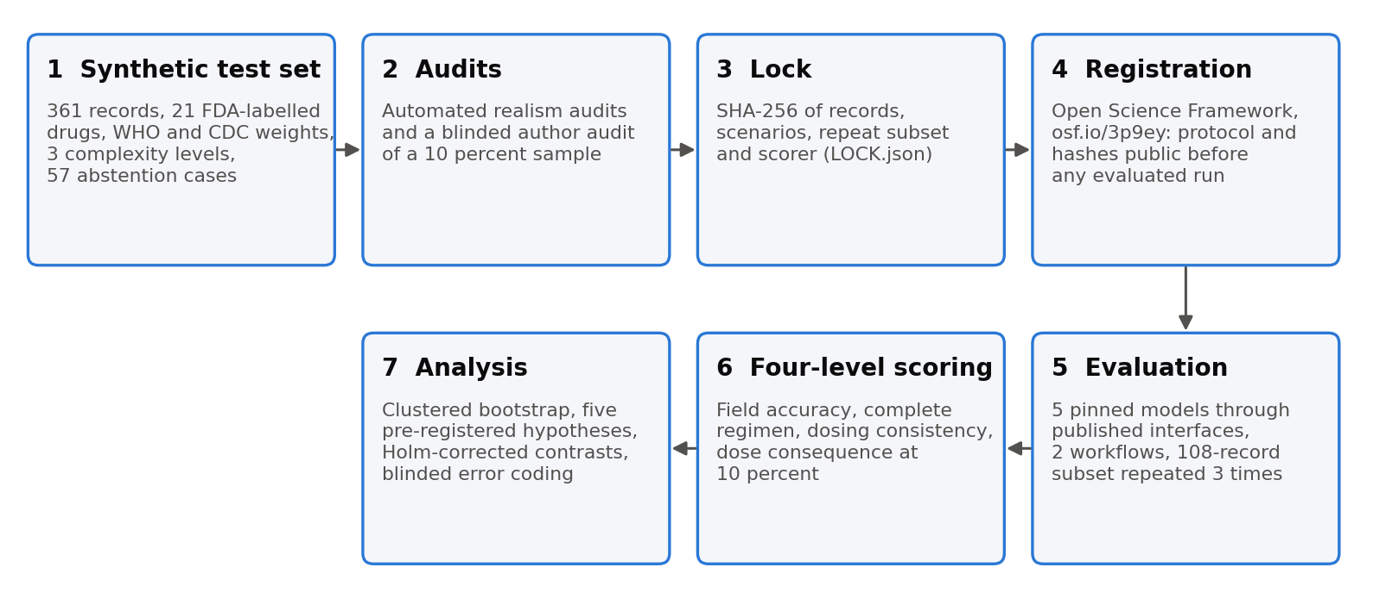
Figure 1. The study in seven steps.
3.1 Constraints adopted at the outset and kept throughout. No real patient data; no clinician or pharmacist review; no employer data, systems, name or resources; API-only access to pinned model identifiers; a 200 USD spending ceiling for the test phase; all materials releasable.
Why no clinician panel. The ground truth is known by construction: each record is generated from a canonical regimen, so correctness does not depend on human adjudication. Plausibility is enforced by automated gates (label ranges, growth-reference weights, age floors) and an automated realism audit, and the author performed a blinded read of a 10 percent sample whose correction rate is reported. A panel would add face validity, not ground truth; the protocol states the limitation.
Why synthetic. Full releasability, no protected information, and control of the exact failure paths under test (stale weight, discontinued order, second medication, pound-denominated weight, missing interval). The cost is generalisation: the study bounds performance on documentation it can fully specify. Both points are in the protocol.
3.2 Test set. 361 records (two variants per scenario after audit removals), 57 abstention cases, a 108-record stratified repeat subset. Record fields: record id (pattern test-<drug>-<basis>-<band>-L<level>-v<variant>-r<round>), scenario id, split, complexity, age band, generation method (template or paraphrase), abstention flag, text. Scenario fields include the canonical regimen (drug, dose basis, weight-normalised dose, frequency, route, concentration, labelled maxima as max_per_dose_mg or max_per_day_mg), current and prior weight values with units and timestamps, expected per-dose amount and expected mg/kg values, missing and conflict fields, distractor orders and challenge tags.
Age bands (sources/age_bands.json): neonate 0 to 27 days; infant 28 to 365 days; toddler and young child 366 to 2190 days, which collapses the NICHD categories toddler (13 months to 2 years) and early childhood (2 to 5 years); school-age child 2191 to 4380 days (NICHD middle childhood); adolescent 4381 to 6574 days.
Complexity levels. Level 1: a bare order with weight, drug, dose, frequency and route. Level 2: an HPI and plan with vitals, a second medication (cholecalciferol under 6 months, cetirizine otherwise) and a computed per-dose amount with volume. Level 3: an admission note adding a prior-visit weight with its date, a discontinued order for the same drug, and in some records weights in pounds. Of the 103 non-abstention Level 3 scenarios, 36 withhold the per-dose amount (challenge tag derive_per_dose), so the model must derive it; 67 print it.
Abstention cases (57). A required element is absent ("interval to be confirmed") or only a dated prior weight is present. The correct response is null with the field named in insufficient_information.
Medications (21). Amoxicillin, amoxicillin-clavulanate, cephalexin, cefdinir, azithromycin, clindamycin, fluconazole, ampicillin, ceftriaxone, gentamicin (per-dose and per-day regimens), acetaminophen IV, ibuprofen, ondansetron, dexamethasone, prednisolone, famotidine, levothyroxine, digoxin, fentanyl, midazolam, vancomycin.
Reference definition and the printed per-dose amount. The note prints the per-dose amount as an order would, with practical rounding and with labelled maxima applied; the scenario's expected_dose_per_admin_mg is that printed amount. Level 2 scores extraction of the printed amount at a 1 percent tolerance. Levels 3 and 4 compare mg/kg/dose and mg/kg/day with the canonical regimen; in workflow B the observed values are the mg_per_kg_per_dose and mg_per_kg_per_day fields the model itself reports (score.py, Level 3/4 block: obs_dose, obs_day = p.get("mg_per_kg_per_dose"), p.get("mg_per_kg_per_day")), so a model that derives those from a copied printed amount inherits its rounding, and in workflow C they are computed by the calculator from the extracted weight, mg/kg value and frequency (reconstruct(...)). Audit of the 304 non-abstention scenarios (caps applied, units matched): about 53 print an amount more than 1 percent from the exact product and one (neonatal dexamethasone, 0.02 mg printed for an exact 0.0226 mg, a 13 percent gap) is more than 10 percent from it. Consequences. (a) A model that reports the exact product rather than the printed amount is scored incomplete at Level 2 and correct at Levels 3 and 4, which is what happened to GPT-5.5 in nine workflow-B records (5.4). (b) On the one neonatal record no single internally consistent per-dose amount satisfies both the 1 percent Level 2 tolerance on the printed amount (0.0198 to 0.0202 mg) and the 10 percent Level 4 tolerance on the mg/kg figure read back from it (equivalent to 0.0203 to 0.0249 mg): Claude Sonnet 5 copied the printed amount and was scored a composite failure; GPT-5.5 and DeepSeek V4 Pro wrote the exact product and were scored incomplete at Level 2 (5.11). Because workflow B scores dose_per_admin_mg at Level 2 and the model's reported mg/kg fields at Level 4 with no consistency check between them, an output reporting 0.02 mg in the amount field and 0.005 mg/kg per dose in the computed field passes both; this was verified by running that constructed output through the locked scorer (5.11). No model produced such an output. The scorer is locked and is applied as registered; the record is disclosed, and the pre-registered 20 percent sensitivity removes it. A sensitivity analysis scoring Level 2 against the exact product is listed as exploratory follow-up. An earlier draft of this report stated that the rounding affects Level 2 only; that was wrong for workflow B and is withdrawn.
3.3 Models and workflows. The protocol registered three workflows: a rules-only Workflow A with no language model, which was not run (recorded in the deviations log, with the reason that it lies outside the hypotheses and that the calculator in the hybrid workflow already provides the non-model arithmetic reference), and Workflows B and C, which keep their registered letters because the letters are fixed in the registration, in the locked prompt files and in every result file; renumbering them after registration would make the results disagree with the registered design. Identifiers as used: gpt-5.5-2026-04-23, claude-sonnet-5, gemini-3.1-pro-preview (OpenAI-compatible endpoint), deepseek-v4-pro, llama3.1:8b (Ollama, local; digest 46e0c10c039e). The GPT-5.5 identifier carries a release date; the Claude and Gemini identifiers name a release; the DeepSeek identifier resolves to the provider's current release at call time and is therefore not immutable, so the manifest records first and last call timestamps per run file (all test runs 4 to 5 October 2026) rather than claiming every provider version was fixed. Paraphrase generator and realism auditor: qwen2.5:14b (local), a family distinct from every evaluated model; the harness refuses an evaluated model that shares a family with the generator. Workflow B: the model extracts all fields and computes dose_per_admin_mg. Workflow C: the model extracts the fields; the deterministic calculator computes exposure at scoring time. The committed system prompt specifies the output object with an example (amoxicillin values), the abstention rule, and no rule on the permissible age of a documented weight.
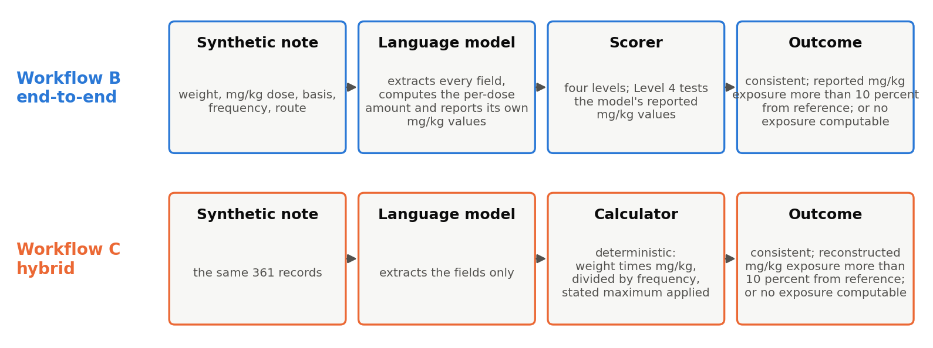
Figure 2. The two workflows and the composite outcome.
3.4 Scoring (Protocol Section 12) and flag definitions as implemented. Source of the observed mg/kg values: workflow B uses the model's reported mg_per_kg_per_dose and mg_per_kg_per_day; workflow C reconstructs them from current_weight_kg, dose_basis, weight_normalized_dose, dose_unit, frequency_per_day and the maxima (score.py lines 66 to 74 of the Level 3/4 block). The written per-dose amount (dose_per_admin_mg) enters Level 2 at a 1 percent tolerance and the exploratory check in 5.12; it does not enter Level 4 in either workflow. Level 1 field accuracy after normalisation (1 percent numeric tolerance). Level 2 complete-regimen accuracy; dose_per_admin_mg is not required when the note withholds it. Level 3 dosing consistency (observed mg/kg/dose and mg/kg/day within tolerance of canonical). Level 4 composite dose-consequence: dose_consequential is True when the worse of the two relative deviations exceeds 10 percent or when no exposure can be computed (either mg/kg value missing); dose_consequential_sens applies 20 percent. The two components, "computed exposure more than 10 percent off" and "no exposure computable", are reported separately wherever the composite is reported, and the phrase "more than 10 percent off" is reserved for computed exposures. exceeds_labeled_max is a separate flag that tests the observed daily exposure against max_per_day_mg only; a per-dose maximum (amoxicillin, 875 mg) is not tested by the flag, which is why one of the six maximum-dose outputs in 5.10 carries the flag False. Primary endpoint: complete dose-consistent regimen accuracy on non-abstention records; a malformed output counts as a failure (Section 7). Abstention cases: appropriate abstention, unnecessary abstention, unsupported-value hallucination as implemented; "incorrect inference" is not scored separately (Section 7).
3.5 Error taxonomy (Protocol Section 13). Automatic classes by committed rules: weight selection, weight unit, unit scale, dose basis, frequency, route, strength versus dose, dose cap, adult fixed-dose assumption, unsupported-value hallucination, conflict resolved without flag, arithmetic inconsistency, malformed output, extraction (value wrong, no finer class). Residual extraction errors coded manually by the author, blinded to model, randomised order: E1 extraction, E2 normalisation, E3 association, E4 temporal, E5 volume versus dose, E6 other. A random 10 percent re-coded after two weeks; intra-rater agreement reported.
3.6 Statistics (Protocol Section 16). Unit of analysis record; clustering by scenario; clustered bootstrap, 2,000 resamples. H3 paired at the record level per model; supported if the CI excludes zero in the hypothesised direction for a majority of models. Secondary pairwise model contrasts with Holm correction (implemented after registration; Section 7). Exploratory mixed-effects regression not performed (Section 7).

4. Validation of the test set before lock
4.1 Development phase (172 records). Two prompt defects found and fixed on development data: no output schema (models invented key names); JSON-Schema type descriptors copied literally by one model. Final prompt shows a concrete example object. Scorer fixes before lock: non-scalar values treated as missing; dose_per_admin_mg not required at Level 2 when the note withholds it; billing and quota errors stop the runner.
4.2 Audits. First automated realism audit flagged three generator defects (unbounded tail weights to 108 kg; prior-visit dates before birth; cetirizine in young infants); all fixed and the set rebuilt. Second audit flagged 45 of 363 records; all reviewed; no generator error. Two level-3 neonatal records with pre-birth prior dates removed; generator corrected. Blinded author self-audit of 36 records: no note requiring correction; three reader entry slips, reported.
4.3 Lock. data/test/LOCK.json, written by tools/lock_testset.py on 3 October 2026 (commit 528c2b5), holds SHA-256 of records.jsonl, scenarios.jsonl and repeat_subset.txt as raw file bytes, and a scoring hash computed by hash_scoring() over the scoring code and the prompt files together; the runner refuses to start a test run without the lock file, and scoring/score.py check_lock() refuses to score if the records hash or the scoring hash differs. hash_scoring() covers seven files together: scoring/score.py, generator/calculator.py, harness/prompts/system.txt, harness/prompts/task_B.txt, harness/prompts/task_C.txt, harness/output_schema.json and analysis/analyze.py. Verification on 5 October: the three data files recompute to the registered values with shasum; scoring/score.py was last changed in commit 7c948c4 (3 October, before the lock) and git reports the working file identical to that commit (blob ace4c0fa); no commit after the lock commit touched any of the seven files. The first recomputation of hash_scoring() on 5 October returned a different value because the malformed-row correction to analysis/analyze.py (Section 7) had been applied in the working copy of a hashed file. The locked analyze.py was restored byte for byte from the repository, the correction was moved to analysis/analyze_malformed_as_failure.py outside the hashed set with its diff saved (results/logs/analyze_malformed_as_failure.diff, 15 lines), and hash_scoring() then returned the registered value 7be9bc8704e09b94014741847f16b047b115c7b2c7c7846ec01afe03445461ed. The locked and corrected scripts produce identical run1 tables (results/analysis_primary_locked.txt and results/analysis_primary_corrected.txt differ only in the print order of one line). All scoring to date was performed before the working-copy change, under the registered scorer; the scorer's refusal rule is what surfaced the discrepancy. The fact-check packet carries the commands and their output. Hashes: records 492d7ca2209719eb8bf96548403dab1e26cb9fed36be3482733dd69790cea7f4; scenarios 432be74fe65c2164ad9e21705821f5814055994f389526614aa744a671c220cb; repeat subset f1012bdcb01f9cdcf80cf000b0ad6831352d9a98a6e57a0e8ebd207dbdfa4196; scoring 7be9bc8704e09b94014741847f16b047b115c7b2c7c7846ec01afe03445461ed.

5. Results (five models, all run1 records)
Source files: results/analysis_primary.txt (run1, five models), results/analysis_stability.txt, results/analysis_pairwise.txt, results/per_drug_run1.csv, results/admin_amount_run1.csv and .txt, results/by_stratum_run1.csv and .txt, results/max_check_run1.csv, results/export/. The four-model versions of the first three files are retained with the suffix _four_models for the record.
5.1 Primary endpoint and field accuracy (non-abstention records, n = 304 per model and workflow; malformed outputs 0 of 361 for every model after resumption).
Model | Workflow | Field accuracy | Complete regimen | Composite failure | Primary endpoint
GPT-5.5 | B | 0.996 | 0.970 (0.947 to 0.987) | 0.000 | 0.970 (0.947 to 0.987)
GPT-5.5 | C | 1.000 | 1.000 | 0.000 | 1.000
Claude Sonnet 5 | B | 1.000 | 0.997 (0.990 to 1.000) | 0.016 (0.003 to 0.033) | 0.980 (0.964 to 0.993)
Claude Sonnet 5 | C | 1.000 | 0.997 (0.990 to 1.000) | 0.000 | 0.997 (0.990 to 1.000)
DeepSeek V4 Pro | B | 1.000 | 0.997 (0.990 to 1.000) | 0.007 (0.000 to 0.016) | 0.990 (0.977 to 1.000)
DeepSeek V4 Pro | C | 1.000 | 1.000 | 0.000 | 1.000
Gemini 3.1 Pro | B | 1.000 | 0.997 (0.990 to 1.000) | 0.016 (0.003 to 0.033) | 0.980 (0.964 to 0.993)
Gemini 3.1 Pro | C | 1.000 | 1.000 | 0.000 | 1.000
Llama 3.1 8B | B | 0.968 | 0.809 (0.766 to 0.855) | 0.645 (0.592 to 0.697) | 0.329 (0.276 to 0.382)
Llama 3.1 8B | C | 0.759 | 0.062 (0.036 to 0.089) | 0.891 (0.855 to 0.924) | 0.056 (0.030 to 0.082)

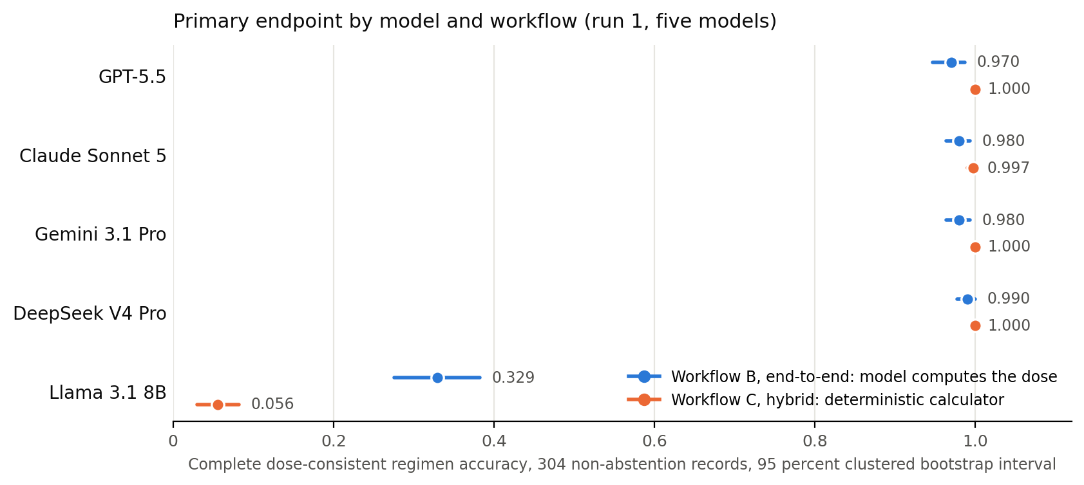
Figure 3. Primary endpoint by model and workflow with 95 percent clustered bootstrap intervals.
Composite failure counts behind the rates (304 records): Claude B 5 (four maximum-dose outputs, 5.10, and the neonatal rounding record, 5.11); DeepSeek B 2 (both maximum-dose outputs); Gemini B 5 (one maximum-dose output and four reporting-convention outputs, 5.15); GPT-5.5 both workflows, Claude C, DeepSeek C and Gemini C 0; Llama B 196, of which 189 reported exposures more than 10 percent off and 7 not computable; Llama C 271, of which 2 and 269. The small model's written per-dose amount, which Level 4 does not use, was within 10 percent of the order in 250 (B) and 249 (C) of 304; see 5.6 and 5.12 for the reconciliation.
5.2 Hypothesis ledger (analysis version: analyze.py with the malformed-row correction of 5 October; run1 files; four models).
Hypothesis | Pre-specified rule | Result | Verdict
H1 | Field accuracy minus complete-regimen accuracy at least 0.10 for every model | GPT-5.5 0.026 (B), 0.000 (C); Claude 0.003, 0.003; Gemini 0.003, 0.000; DeepSeek 0.003, 0.000; Llama 0.159, 0.697 | Not supported (holds for Llama only)
H2 | Composite failure rate rises monotonically L1 to L3 | Frontier near zero at all levels; Llama B 0.634, 0.700, 0.602; Llama C 0.851, 0.940, 0.883 | Not supported
H3 (primary) | C minus B composite failure rate below zero with CI excluding zero, for a majority of models | GPT-5.5 +0.000 (null at ceiling); Claude -0.016 (-0.033 to -0.003), supported; DeepSeek -0.007 (-0.016 to +0.000), not supported; Gemini -0.016 (-0.030 to -0.003), supported; Llama +0.247 (+0.178 to +0.312), reversed | Not supported under Section 1: 2 of 5; supported under Section 16: 3 of 5 (see below)
H4 | Dose-basis and weight-selection classes are the largest share of composite failures | Largest automatic classes: adult fixed-dose assumption and arithmetic inconsistency (Llama); dose basis distant third; weight selection rare. Row inspection (5.6): of the 154 Llama B records with a correct written amount and a failed composite, 74 carry the mg amount in the per-dose mg/kg field, 48 the per-day value in the per-dose field, 15 a null, 17 other; much of "arithmetic inconsistency" is unit and basis confusion inside the reported fields | Not supported as automatically coded; manual coding will settle the class
H5 (exploratory) | Neonate and infant bands lower than adolescent | Frontier: no band effect; Llama B 0.571 adolescent, 0.638 infant, 1.000 neonate; Llama C 0.929 adolescent, 0.914 infant, 0.462 neonate | Inconclusive; neonate estimates oppose across workflows

H3 under both protocol wordings. Section 1 (verbatim): "H3. The hybrid workflow (C) will have a lower dose-consequential error rate than the end-to-end workflow (B) for the same model (primary comparison)." Section 16 (verbatim): "Primary comparison (H3): Workflow C minus Workflow B on the primary endpoint, per model, paired at the record level, with clustered bootstrap 95% CI. The comparison is declared supported if the CI excludes zero in the hypothesized direction for the majority of evaluated models." The two name different outcome measures. The analysis follows Section 1; the dated record of that choice is the registration itself: analysis/analyze.py, which implements H3 on the composite rate, is one of the seven files whose combined hash was published in the registration (lock commit 528c2b5, before any test run), so the analysed definition was fixed before any result existed. Section 16's rule (paired, clustered, majority) applies to either measure. Results are stated "under Section 1" and "under Section 16" throughout:
Model | C minus B, composite failure rate (Section 1) | C minus B, primary endpoint (Section 16)
GPT-5.5 | +0.000 (null at ceiling) | +0.030 (+0.013 to +0.049), supported; the entire gain is the nine Level 2 rounding records of 5.4, no dose changed
Claude Sonnet 5 | -0.016 (-0.033 to -0.003), supported | +0.016 (+0.003 to +0.033), supported
DeepSeek V4 Pro | -0.007 (-0.016 to +0.000), not supported | +0.010 (+0.000 to +0.023), not supported
Gemini 3.1 Pro | -0.016 (-0.030 to -0.003), supported | +0.020 (+0.007 to +0.036), supported
Llama 3.1 8B | +0.247 (+0.178 to +0.312), reversed | -0.273 (-0.336 to -0.211), reversed
Verdict | Under Section 1: not supported, 2 of 5 (Claude, Gemini) | Under Section 16: supported, 3 of 5 (GPT-5.5, Claude, Gemini), a majority

The two wordings now give different verdicts. The report states the Section 1 verdict as the analysed one, because that definition is the one hashed into the registration, states the Section 16 verdict beside it, notes that the GPT-5.5 effect under Section 16 is a scoring effect of the printed-amount rounding (3.2) rather than a change in any computed dose, and that Gemini's effect under both wordings consists of its five end-to-end failures, four of which are the reporting-convention outputs of 5.15. The paper discusses the protocol's double wording openly. Hypothesis tally, stated individually: H1 not supported; H2 not supported; H3 not supported under Section 1, supported under Section 16; H4 provisional pending unassisted manual coding; H5 inconclusive. No aggregate count is reported until coding is complete.
5.3 Secondary pairwise contrasts (primary endpoint, paired by record, clustered bootstrap, Holm-adjusted, 20 contrasts). No statistically significant pairwise difference among the four frontier models was detected in either workflow, which is not evidence of equivalence (largest B contrast DeepSeek minus GPT-5.5 +0.020, adjusted p 0.92; Claude minus Gemini B +0.000; all C contrasts within 0.003, adjusted p 1.00). Every frontier model exceeds Llama: B +0.641 to +0.661; C +0.941 to +0.944; all adjusted p below 0.0001.
5.4 GPT-5.5 workflow B shortfall. Nine records fail only on dose_per_admin_mg with no error class and no composite failure: the model reported the exact product (6.15 kg times 2 mg/kg is 12.3 mg) where the order printed a rounded amount (12 mg). The neonatal dexamethasone record of 5.11 is one of the nine. See 3.2 for the reference definition and counts.
5.5 Abstention (n = 57 records). All four frontier models: 52 of 57 appropriate (0.912, CI 0.842 to 0.982), identical across models and workflows because the same five records account for every miss; Gemini wrote the prior weights 6.6, 17.6, 14.61, 23.3 and 66.8 kg as current in both workflows, as the others did. The five records are five distinct scenarios: test-clindamycin-mg_kg_day-infant-L3-v0, test-gentamicin-mg_kg_day-school_age-L3-v1, test-dexamethasone-mg_kg_day-toddler-L3-v1, test-dexamethasone-mg_kg_day-school_age-L3-v1, test-dexamethasone-mg_kg_day-adolescent-L3-v0. Each note documents only a weight dated at a prior visit (2025-12-01) against an order dated 2026-03-10; every frontier model supplied that weight as current. For the 8-month-old clindamycin record the prior weight is about 20 percent below the generator's withheld reference weight; for the 13-year-old the gap is marginal. Seven of the 52 appropriate abstentions also withheld a computable per-dose amount (flagged dose cap by the automatic rule; on inspection, a withheld computable field). Llama: 0.772 (B), 0.825 (C).
5.6 Error classes (run1 code counts) and the calculator mechanism. Llama C: extraction dose wrong 270, adult fixed-dose assumption 261, frequency 25, arithmetic 2. Llama B: arithmetic inconsistency 146, frequency 27, extraction dose wrong 17, dose basis 14, weight wrong 1. Claude B: arithmetic 5, dose basis 1. Claude C: dose basis 1. DeepSeek B: arithmetic 2. DeepSeek C and GPT-5.5: none. For the small model the calculator raised the composite failure count from 196 to 271 of 304 and changed its composition: 189 wrong computed exposures and 7 unreconstructable under B became 2 and 269 under C. From the row-level trace: in a typical Llama workflow-C failure the note states "28 mg/kg/day ... (266 mg per dose)"; the model returns dose_basis "fixed", weight_normalised_dose null, dose_per_admin_mg 266; the calculator cannot form an mg/kg exposure from a null weight-normalised dose, the record is scored dosing-inconsistent, and the automatic classes are adult fixed-dose assumption and extraction dose wrong. Complete traces for two B and two C failures are in the fact-check packet (Section 11).
Reconciliation of the composite with the written amount (Llama, run1, 304 records per workflow; written-amount status from 5.12):
Workflow | Written amount | Composite pass | Reported or computed exposure more than 10 percent off | No exposure computable
B | within 10 percent (250) | 96 | 139 | 15
B | off (27) | 4 | 21 | 2
B | missing (27) | 8 | 0 | 19
C | within 10 percent (249) | 14 | 2 | 233
C | off (21) | 0 | 0 | 21
C | missing (34) | 19 | 0 | 15

Reading. In B, 154 records have a correct written amount and a failed composite; the model's reported mg/kg fields, not its amount, fail: 74 records carry the milligram amount in the per-dose mg/kg field (note "195 mg per dose", reported mg_per_kg_per_dose 195 or similar), 48 carry the per-day value in the per-dose field (43 mg/kg/day reported as 43 mg/kg/dose), 15 are null, 17 other. In C, 233 records have a correct written amount and no computable exposure because the model labelled the order "fixed" and nulled the mg/kg value. Statement for the paper: the composite is a regimen-reconstruction failure; measured on the amount it wrote, the small model matched the order in about five records of six under both workflows; measured on the structured regimen a calculator or range check would use, it failed 196 and 271. A user of workflow B who read only dose_per_admin_mg would see a correct number in 250 of 304 records; a system that consumed the mg/kg fields would see a wrong or empty regimen in 196. The eight records in B where the written amount is missing yet the composite passes are records whose reported mg/kg values were right while the amount field was left empty.
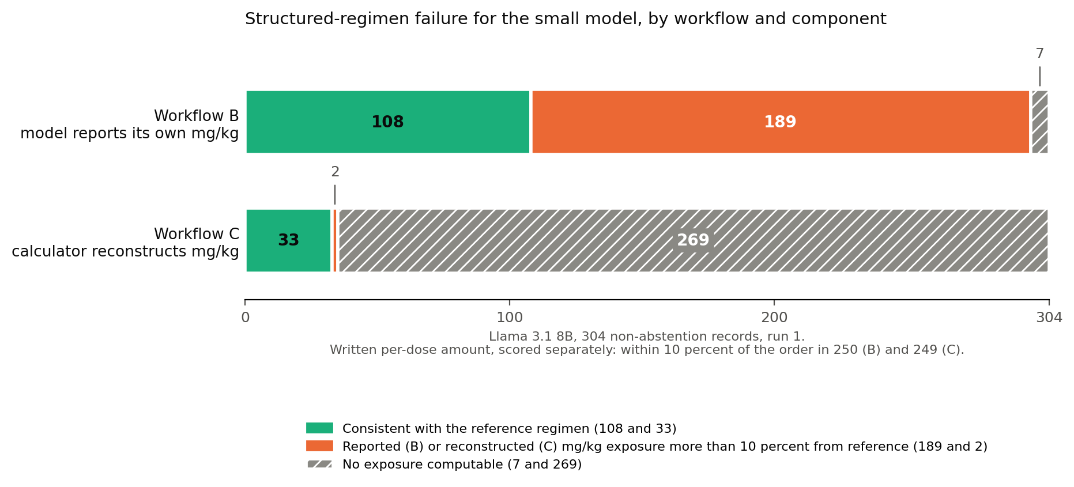
Figure 4. Composite failure for the small model by workflow and component.
5.7 Stability (108-record repeat subset, three runs). Agreement 0.972 to 1.000 for all five models in both workflows; Gemini 1.000 (C) and 0.991 (B) on complete regimen, dosing consistency and the composite. Llama at 1.000 reflects deterministic local inference, not robustness. Lowest frontier values: Claude C complete regimen 0.972; GPT-5.5 B dose per administration 0.981; DeepSeek B 0.991 on all fields. Two DeepSeek B run2 records returned empty responses on three attempts and are malformed.
5.8 Exploratory moderators. Paraphrased notes scored lower than template notes in workflow B for every frontier model (Claude 0.948 versus 1.000; Gemini 0.948 versus 1.000; GPT-5.5 0.957 versus 0.979; DeepSeek 0.974 versus 1.000). All twelve frontier composite failures (5.10, 5.11, 5.15) occurred in paraphrased records; the template-note composite failure rate is 0.000 for every frontier model in both workflows. The four maximum-dose notes state the maximum unambiguously in their paraphrased form ("max 875 mg/dose", "maximum daily dose not to exceed 2000 mg", "not to exceed 60 mg/day"), so paraphrase did not remove the instruction; whether paraphrase raises the failure rate is a hypothesis for a larger set, not a result of this one. Per-drug table: results/per_drug_run1.csv (160 rows).
5.9 Cost. Approximate test-phase spend: OpenAI 37 USD, Google 28 USD, Anthropic 13 USD, DeepSeek 11 USD; Llama local. Under 100 USD against the 200 USD ceiling; final figures from provider dashboards go in the run manifest.
5.10 Maximum-dose outputs (row-level resolution). Five non-abstention Level 3 notes give a weight-based rule, a maximum written into the order, and no per-dose amount, and in each the weight-based product exceeds the maximum. Nine workflow-B outputs wrote the uncapped product (Claude five, DeepSeek two, Gemini two): seven exceed the maximum by more than 10 percent and are composite failures; the other two (Claude and Gemini, prednisolone adolescent v0, 64.65 mg against 60 mg per day, 7.75 percent over) is inside the 10 percent tolerance and passed Level 4 (dev_dose 0.0775, dose_consequential False, primary endpoint True); the registered exceeds_labeled_max flag is True for it, so the registered per-day flag did record it, and the post hoc maximum check of 5.14 is what brought it into the count of uncapped outputs. In every one of the nine the model had placed the maximum in the correct structured field (max_per_dose_mg or max_per_day_mg) before computing the amount without it; the failure is therefore neither extraction nor a specification gap. GPT-5.5 applied the maximum in all five notes; the amoxicillin per-dose maximum (875 mg) was missed by three of the four frontier models. The automatic scorer labelled the seven larger outputs as arithmetic inconsistency; the pattern was identified by row inspection.
Record (scenario) | Order as written | Maximum (field; FDA label set id) | Reference per dose | Claude Sonnet 5 | DeepSeek V4 Pro | Gemini 3.1 Pro | exceeds_labeled_max (Claude row)
test-amoxicillin-mg_kg_day-school_age-L3-v1-r0 (11 y F, 70.4 kg) | 42 mg/kg/day PO divided q12h; max 875 mg/dose | 875 mg per dose (max_per_dose_mg; 06e5c07d-d95c-4955-8d35-a4703ca2359e) | 875 mg | 1478.4 mg | 1478.4 mg | 1478.4 mg | False (flag tests per-day maxima only)
test-ceftriaxone-mg_kg_day-adolescent-L3-v1-r0 (17 y M, 153 lb) | 54 mg/kg/day IV divided BID; maximum daily dose not to exceed 2000 mg | 2000 mg per day (max_per_day_mg; 53df951b-2eee-44b1-bae2-df7ed85bc0ed) | 1000 mg | 1873.8 mg twice daily (3747.6 mg/day) | 1873.8 mg twice daily | 1000 mg (capped; nominal mg/kg reported, 5.15) | True
test-prednisolone-mg_kg_day-school_age-L3-v1-r0 (9 y F, 90.6 lb) | 2 mg/kg/day PO q24h; not to exceed 60 mg/day | 60 mg per day (max_per_day_mg; 286a6032-41de-435a-b6e6-14052b66b85d) | 60 mg | 82.19 mg once daily | applied | 60 mg (capped; nominal mg/kg reported, 5.15) | True
test-prednisolone-mg_kg_day-adolescent-L3-v1-r0 (17 y M, 87.3 kg) | 1.5 mg/kg/day PO q24h; not to exceed 60 mg/day | 60 mg per day (max_per_day_mg; 286a6032-41de-435a-b6e6-14052b66b85d) | 60 mg | 130.95 mg once daily | applied | 60 mg (capped; nominal mg/kg reported, 5.15) | True
test-prednisolone-mg_kg_day-adolescent-L3-v0-r0 (adolescent, 43.1 kg) | 1.5 mg/kg/day q24h; not to exceed 60 mg/day | 60 mg per day (max_per_day_mg; 286a6032-41de-435a-b6e6-14052b66b85d) | 60 mg | 64.65 mg once daily (7.75 percent over; within tolerance, Level 4 pass) | applied | 64.65 mg once daily (as Claude) | True (B); the calculator applied the cap in C, flag False

Provenance of the maxima. The maxima are the ones the synthetic orders state, and the model's task was to apply the maximum written in the order it read. Their derivation from the labels, recorded in sources/dosing_sources.csv, differs by drug. Ceftriaxone: the label states 50 to 75 mg/kg/day once daily or divided every 12 hours, not to exceed 2 g per day, for serious non-meningitis infections; the 2000 mg per day maximum is stated by the label, and the 1000 mg reference per dose is that daily limit divided by the twice-daily frequency. Amoxicillin: the label lists 875 mg every 12 hours as the regimen for patients over 40 kg; the study uses that adult regimen dose as the per-dose ceiling for a child whose weight-based product exceeds it, a common prescribing convention and the author's derivation, not a maximum the label states as such. Prednisolone: the label gives an initial pediatric range of 0.14 to 2 mg/kg/day and cites NHLBI asthma dosing of 1 to 2 mg/kg/day; the 60 mg per day figure is the upper end of the label's general initial-dose range applied as a ceiling, the author's derivation, not a ceiling the label attaches to asthma. The article therefore describes all four as maxima stated in the order and names only ceftriaxone's as the label's own. No pharmacist reviewed the four notes; this is the study's standing constraint and is stated as a limitation. The synthetic order is a valid extraction target because the maximum was present in the text the model read, whatever its clinical pedigree; the study does not present the notes as validated prescriptions.
5.11 The neonatal rounding record (row-level resolution). test-dexamethasone-mg_kg_day-neonate-L1-v0-r0: a 17-day-old, 4.52 kg, dexamethasone 0.02 mg/kg/day PO divided four times daily, note prints "0.02 mg per dose"; exact per-dose 0.0226 mg. Claude Sonnet 5 (B) wrote dose_per_admin_mg 0.02 and mg_per_kg_per_dose 0.0044; the scorer's observed mg/kg/dose is 0.0044 against 0.005 expected, dev_dose 0.12, dev_day 0.0, dosing_consistent False, dose_consequential True, dose_consequential_sens False, exceeds_labeled_max False. GPT-5.5 (B) wrote 0.0226 mg: all fields correct except dose_per_admin_mg (13 percent from the printed 0.02 at a 1 percent tolerance), dev_dose 0.0, dose_consequential False, primary endpoint False at Level 2. DeepSeek V4 Pro (B) and Gemini 3.1 Pro (B) likewise wrote 0.0226 mg. The error is in neither extraction nor cap application nor scorer arithmetic; it is a test-set record whose printed rounding exceeds the Level 4 tolerance, on which no internally consistent per-dose amount meets both locked tolerances. Probe (5 October): a constructed output identical to Claude's but with dose_per_admin_mg 0.02, mg_per_kg_per_dose 0.005 and mg_per_kg_per_day 0.02 was written to a probe raw file and scored by the locked scorer: field accuracy 1.0, complete regimen True, dev_dose 0.0, dosing_consistent True, dose_consequential False, primary endpoint True. The scorer therefore does not reject an internally inconsistent output on this record; an earlier draft's claim that no output could pass both levels was too strong and is withdrawn. The probe files were removed and the Claude scored file verified unchanged by hash. Disclosed in 3.2; removed by the 20 percent sensitivity; Level 2 sensitivity against the exact product listed as follow-up.
5.12 Written per-dose amount (exploratory; added after registration; tools/admin_amount.py; results/admin_amount_run1.csv). Question: is the number the model wrote in dose_per_admin_mg usable on its own, independent of the mg/kg fields that Level 4 uses? Rule set: reference is the scenario's expected_dose_per_admin_mg (printed, rounded, maximum applied, mg); "off" is absolute relative deviation above 10 percent; "missing" is absent, null or non-numeric; denominator 304 non-abstention run1 records per model and workflow; no unit conversion (both sides mg). Missing values are split by whether the note withholds the amount (36 Level 3 scenarios) or prints it.
Model | Workflow | Compared | Off (more than 10 percent) | Missing, amount withheld in note | Missing, amount printed
GPT-5.5 | B | 304 | 1 (neonatal rounding record) | 0 | 0
GPT-5.5 | C | 268 | 0 | 36 | 0
Claude Sonnet 5 | B | 304 | 4 (the four maximum-dose outputs) | 0 | 0
Claude Sonnet 5 | C | 296 | 3 (amoxicillin, ceftriaxone, prednisolone school-age: uncapped amounts written in the extraction-only workflow) | 8 | 0
DeepSeek V4 Pro | B | 304 | 3 (two maximum-dose outputs; neonatal rounding record) | 0 | 0
DeepSeek V4 Pro | C | 277 | 0 | 27 | 0
Gemini 3.1 Pro | B | 304 | 2 (amoxicillin maximum-dose output; neonatal exact product) | 0 | 0
Gemini 3.1 Pro | C | 268 | 0 | 36 | 0
Llama 3.1 8B | B | 277 | 27 (Level 1: 2; Level 2: 1; Level 3: 24) | 13 | 14
Llama 3.1 8B | C | 270 | 21 (all Level 3) | 16 | 18

Reading. Workflow B written-amount deviations among the frontier models number ten (GPT-5.5 1, Claude 4, DeepSeek 3, Gemini 2), against twelve composite failures (Claude 5, DeepSeek 2, Gemini 5). Reconciliation: the seven larger maximum-dose outputs are in both counts; the exact-product neonatal amounts of GPT-5.5, DeepSeek and Gemini are written-amount deviations only (7 + 3 = 10); Claude's copied neonatal amount and Gemini's four reporting-convention outputs (5.15) are composite failures only (7 + 1 + 4 = 12). The two 64.65 mg outputs (5.10) are in neither count, being 7.75 percent over. In workflow C a missing amount on a withholding note is correct behaviour (the model was asked to extract, not compute), so GPT-5.5's 36 and DeepSeek's 27 are not failures; Claude computed the amount in 28 of the 36 withholding notes although not asked to; three of those computed amounts exceed the stated maximum by more than 10 percent and a fourth by 7.75 percent (5.14). Those three are invisible to Level 4 in workflow C, which recomputes exposure from the mg/kg field, so a deployment that displayed the model's written number without the calculator would not have the protection the workflow-C score implies. For the small model, 14 of 27 missing amounts in B and 18 of 34 in C are on notes that print the amount: the model failed to copy a number that was in the text. The earlier working figure of 28 off for Llama B was computed against the exact product; this table uses the printed reference and supersedes it.
5.13 Stratified results and heat maps (exploratory beyond the pre-specified strata; tools/by_stratum.py; results/by_stratum_run1.csv). Composite failure rate by complexity, age band, generation method, documentation challenge and drug, for each model and workflow. Challenge strata overlap (a record carries several tags) and do not sum to the total.
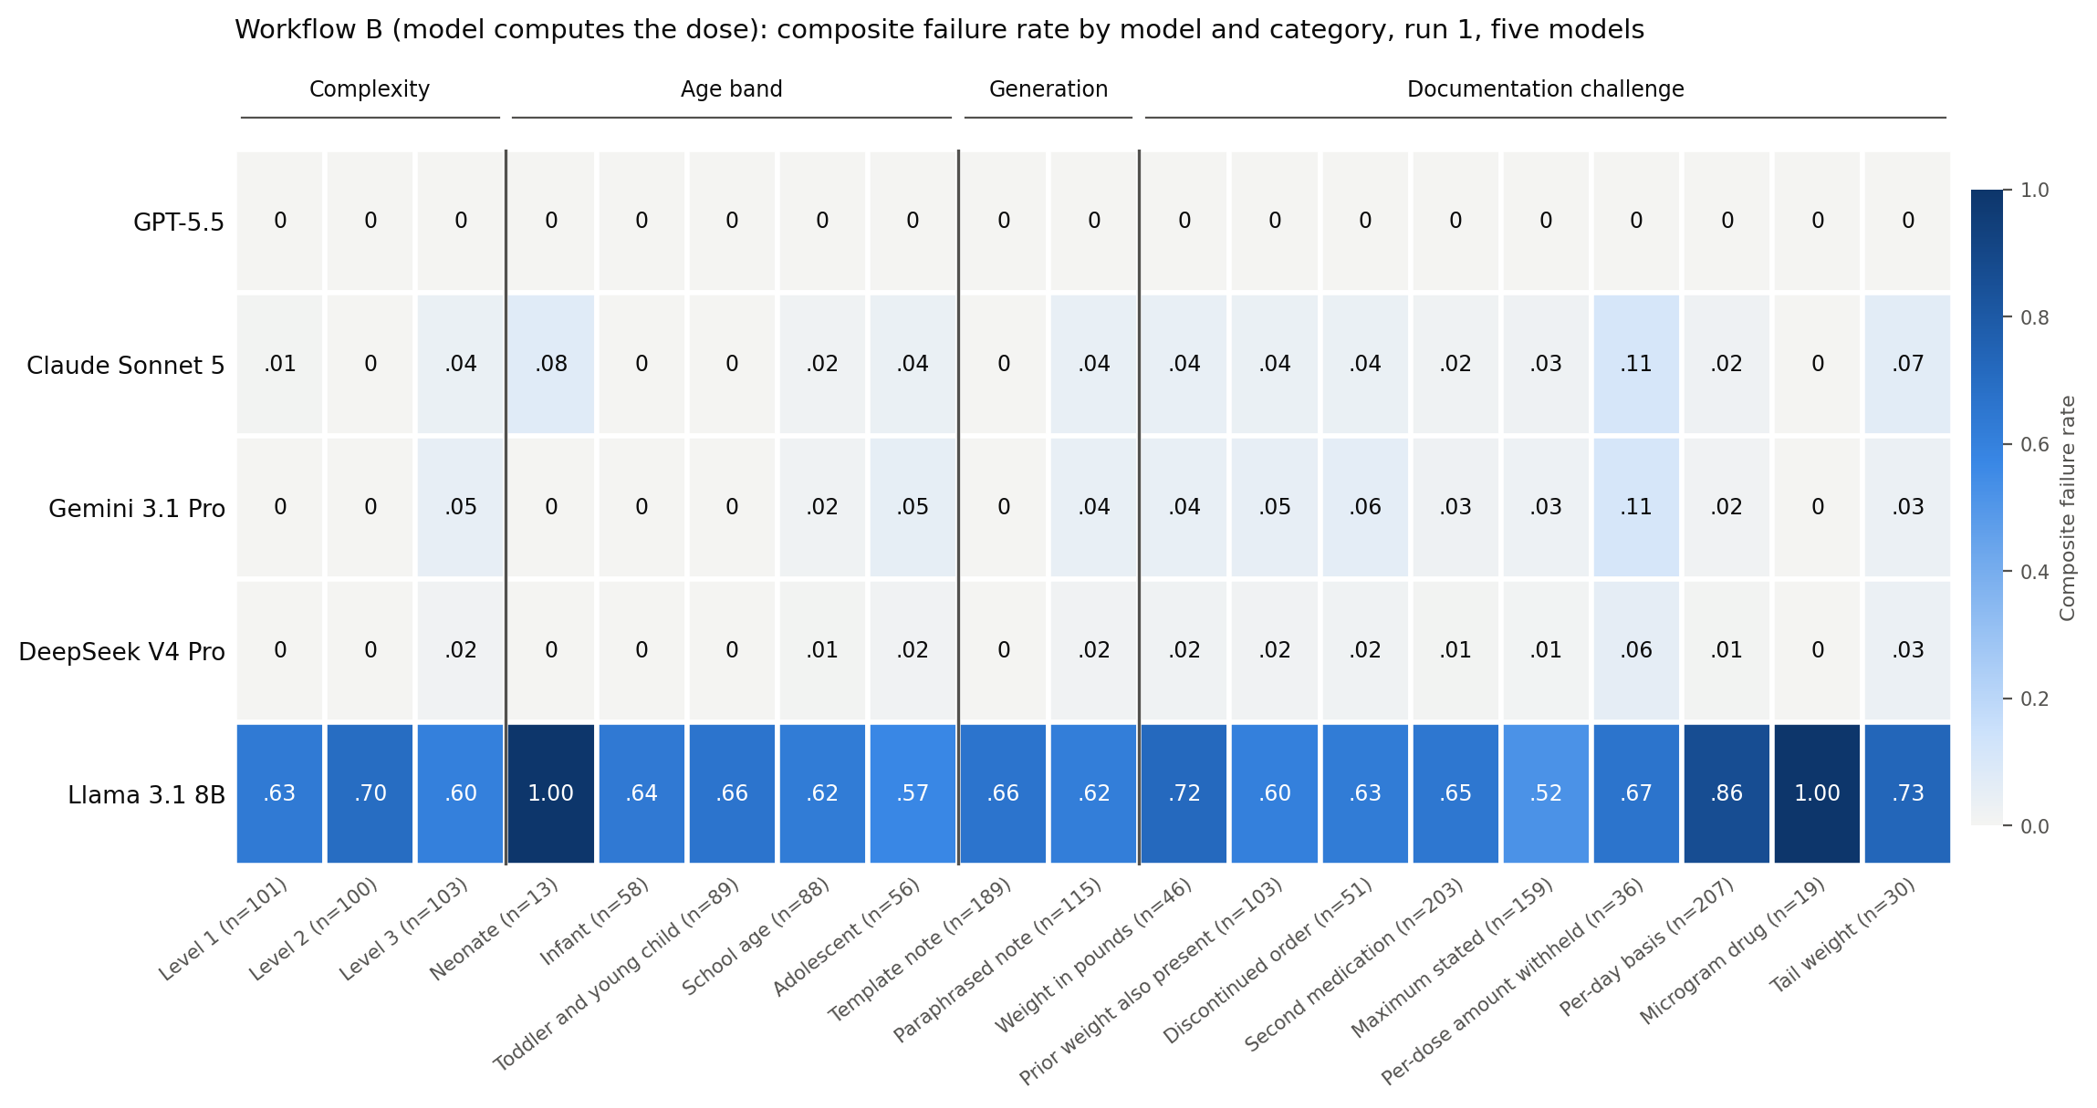
Figure 5. Workflow B composite failure rate by model and category.
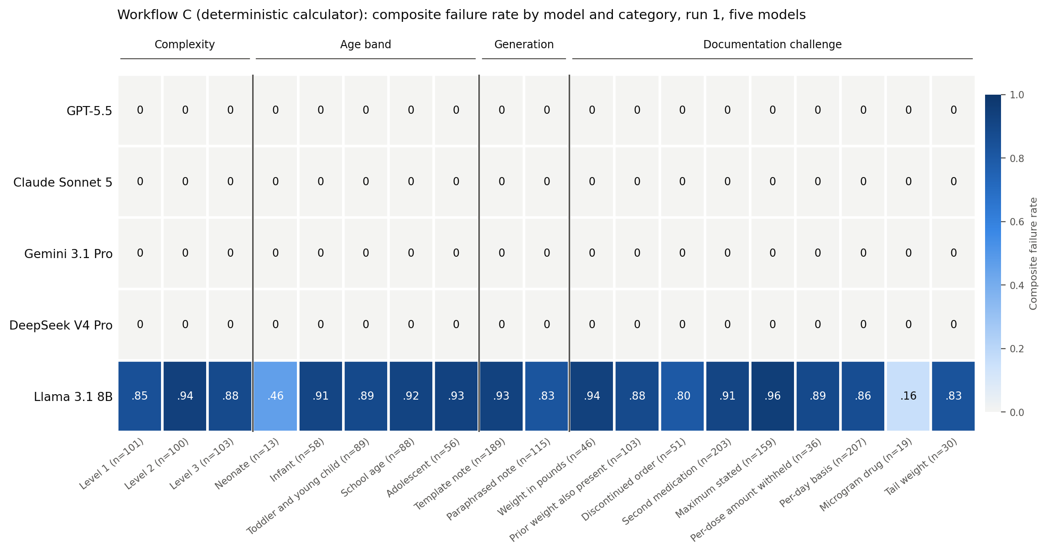
Figure 6. Workflow C composite failure rate by model and category.
Observations. Frontier models in workflow B: every non-zero cell is accounted for by the twelve records of 5.10, 5.11 and 5.15; the highest cell is "per-dose amount withheld" (Claude 0.111 and Gemini 0.111, 4 of 36 each; DeepSeek 0.056, 2 of 36), where the maximum-dose notes sit; Claude's neonate cell (0.077) is the single rounding record among 13; Gemini's cells follow Claude's within one record except neonate (0) and discontinued order (0.059, its azithromycin note). Frontier models in workflow C: zero in every stratum. Llama B: fails every per-day-basis order at 0.865 against 0.126 primary-endpoint success, fails all 13 neonatal and all 19 microgram-drug records, and does best on the per-dose fixed-frequency drugs (azithromycin, famotidine, ondansetron, midazolam). Llama C: 0.80 to 0.96 in every stratum except neonate (0.462) and microgram drugs (0.158), where the calculator recovers what the model's own arithmetic lost; these are the only strata in which the calculator helped the small model, and they are small (13 and 19 records). Drug-level rates are in the CSV; frontier drug cells are at ceiling except amoxicillin, ceftriaxone, prednisolone and dexamethasone, for the records above.
5.14 Post hoc maximum check (exploratory; added after external review; tools/max_check.py; results/max_check_run1.csv). Question: would a check of the written per-dose amount against the maximum the model itself extracted have flagged the uncapped outputs? Rule: flag if dose_per_admin_mg exceeds max_per_dose_mg, or dose_per_admin_mg times frequency_per_day exceeds max_per_day_mg, each with a 0.1 percent tolerance, using the model's own extracted maxima; a parallel column uses the scenario's maxima. Non-abstention run1 records, both workflows, 3,040 outputs from the five models.
Model | Workflow | Flagged by the model's own maxima | Flagged by scenario maxima
GPT-5.5 | B and C | 0 | 0
Claude Sonnet 5 | B | 5 (the four composite-failure outputs and the 64.65 mg output) | 5
Claude Sonnet 5 | C | 4 (the same notes except ceftriaxone replaced by the v0 prednisolone note) | 4
DeepSeek V4 Pro | B | 2 (amoxicillin, ceftriaxone) | 2
DeepSeek V4 Pro | C | 0 | 0
Gemini 3.1 Pro | B | 2 (amoxicillin 1478.4 mg; the 64.65 mg prednisolone output) | 2
Gemini 3.1 Pro | C | 0 | 0
Llama 3.1 8B | B | 0 | 0
Llama 3.1 8B | C | 1 (against its own wrongly extracted maximum; not against the scenario's) | 0

Reading. Denominator: 3,040 non-abstention first-run outputs from the five models under both workflows, not every output in the study (the repeat runs are excluded). Among the four frontier models the check flags exactly the nine uncapped outputs in workflow B and the four in workflow C (Claude's uncapped amounts written in the extraction-only workflow, which that workflow's Level 4 never uses), and nothing else; agreement between the own-maximum and scenario-maximum columns is complete for them; the single small-model flag is against a maximum the model extracted wrongly. The check is retrospective and has not been tested as a prospective safeguard. The registered exceeds_labeled_max flag, which tests per-day maxima only, misses the amoxicillin per-dose outputs and records the five per-day ones, including the 64.65 mg output that the tolerance passed; the flag does not feed the primary endpoint. The article says the check was run after the fact, what it found, and that it is not yet a tested safeguard; the explicit-instruction rerun (6.4) remains the test of whether the behaviour changes.
5.15 Reporting-convention finding (Gemini 3.1 Pro, workflow B). Gemini applied the maximum correctly to the written amount in four capped notes (ceftriaxone 1000 mg, prednisolone 60 mg in two notes, azithromycin 500 mg against a 500 mg per-dose maximum) and then reported the order's nominal mg/kg (27, 2, 1.5, 10) rather than the mg/kg implied by the capped amount (14.4, 1.46, 0.69, 7.44), which GPT-5.5, Claude Sonnet 5 and DeepSeek V4 Pro reported on the same notes. harness/prompts/task_B.txt asks the model to compute dose_per_admin_mg, mg_per_kg_per_dose and mg_per_kg_per_day from the values it extracted; harness/output_schema.json names the two fields with the description "Workflow B only"; neither states whether a cap applied to the amount carries into the mg/kg values. Under the registered scorer, which compares the reported mg/kg with the effective regimen, these four outputs are composite failures (dev_dose 0.874, 0.370, 1.183, 0.344) and exceeds_labeled_max is True on the three per-day notes from the reported figure although the written amounts were under the limit. Together with the uncapped amoxicillin output they are Gemini's five end-to-end composite failures. The written amounts were correct in all four; the written-amount check (5.12) counts Gemini as 2 deviations in workflow B (amoxicillin 1478.4 mg and the exact-product neonatal amount), not 6. The finding is reported as a reporting-convention ambiguity the study did not anticipate, scored as registered, and recorded as a clarification in the deviations log; it is also the clearest frontier-model instance of the general point in 5.6 that the composite tests the reported regimen and not the written amount.

6. Pending work and why each item stays in
6.1 Gemini 3.1 Pro: complete. Workflow C run1 (361), workflow B run1 (361) and the four repeat files (108 each) finished on 6 October across two Google Cloud projects under one billing account, after the 250 requests per model per project per day quota on the paid tier stopped the first chain; same model identifier, endpoint and parameters; zero errors in the final chains; first and last call timestamps per file in the run manifest.
Why Gemini is not dropped. It is one of the five models in the public registration. Removing it after more than 700 outputs exist is the deviation a reviewer reads as selective reporting, with "quota" as the only available reason. Partial reporting would unbalance the strata and the paired comparison. Keeping it cost about 15 USD and one day; with Gemini in, H3's verdict under Section 16 changed from pending to supported (Section 5.2).
Why no sixth model. Grok was proposed; it is not pre-registered, would be a post hoc addition, would almost certainly sit at ceiling, and would add about 1,150 calls plus coding time without changing a conclusion.
6.2 Manual error coding. A first 40-item pass carried assistant input (one suggested code and one suggested reclassification) and was discarded; file retained as results/manual_codes_assisted_pass_discarded.jsonl. The author codes all residual errors from the five models unassisted from the codebook; a random 10 percent is re-coded after two weeks and intra-rater agreement is reported on the unassisted file.
6.3 Final analysis and export: done on 6 October (30 scored files; analyze, stability, pairwise, per-drug, admin_amount, by_stratum, max_check; Figures 3, 5 and 6 regenerated; H3 under both wordings for five models; results/export written). Remaining: TRIPOD-LLM checklist completed and mapped to this report.
6.4 Exploratory follow-ups, clearly labelled post hoc: (a) the five stale-weight records rerun with an explicit staleness rule in the prompt, all models, both workflows, about 50 calls; (b) Level 2 sensitivity scoring the per-dose field against the exact product instead of the printed amount; (c) the five maximum-dose notes rerun with an explicit instruction to apply any stated maximum, all models, workflow B, about 25 calls, to separate instruction-following from arithmetic; (d) the four reporting-convention notes of 5.15 rerun with the mg/kg convention stated in the prompt, all models, about 20 calls.
6.5 Public repository. A public release repository carries an allow-listed copy of the working repository: code, prompts, schema, dosing sources, growth references, the locked test split with its lock file, the protocol folder, raw and scored outputs, analysis outputs and supplementary tables, the evidence packet, the official documents and figures, with licences (code MIT; data, protocol and outputs CC BY 4.0) and CITATION.cff carrying ORCID and the OSF DOI. Excluded: environment files, virtual environment, caches, operational logs, backups and archived drafts. The release is regenerated from the working repository at each milestone by one script after a secret scan; the tagged release commit is recorded in the paper; at acceptance the OSF project is updated with the paper DOI and the repository URL and all provider keys are rotated.

7. Deviations and clarifications after registration (all in protocol/DEVIATIONS.md)
Date | Item | Why
4 Oct | Workflow A (rules baseline) not run | Outside H1 to H5; calculator in C is the non-LLM arithmetic reference; decided before results
4 Oct | Resumed runs re-query records with no parsed output; scorer keeps the last attempt | Runner's documented behaviour; identical for all models; before and after malformed counts reported
4 Oct | Gemini requests split across two Google Cloud projects | Per-project daily cap; same model, endpoint, parameters
4 Oct | Two DeepSeek run2 records persistently empty, scored malformed | Protocol rule; three attempts
5 Oct | H3 wording: Section 1 (dose-consequential rate) versus Section 16 (primary endpoint); script follows Section 1 | Both differences reported
5 Oct | sources/age_bands.json verification note replaced by the band mapping statement; no boundaries changed | Housekeeping; mapping stated in the paper
5 Oct | Malformed non-abstention rows count as failures on primary endpoint, complete regimen and dosing consistency; previously dropped from the bootstrap denominator. First applied inside the locked analyze.py; the locked file was then restored and the correction implemented as analysis/analyze_malformed_as_failure.py outside the hashed set, diff retained; outputs identical on run1 (no malformed rows); the corrected script is used for any file containing malformed rows (two DeepSeek run2 records) | Definition alignment with Section 12; locked file set unchanged; run1 unaffected
5 Oct | "Incorrect inference" abstention category not scored separately; folded into unsupported-value hallucination | Scorer locked; stated as implemented
5 Oct | Pairwise Holm-corrected contrasts implemented in analysis/pairwise.py after registration; mixed-effects regression not performed (degenerate at ceiling) | Analysis code not under lock
5 Oct | Manual coding: first 40-item pass with assistant input discarded; unassisted recoding | Provenance
5 Oct | Clarification: dose_consequential is a composite (exposure more than 10 percent off, or not computable); components reported separately; exceeds_labeled_max tests per-day maxima only | Scorer locked; stated as implemented
5 Oct | Clarification: one test-set record (neonatal dexamethasone) has a printed amount 13 percent from the exact product, so Level 2 and Level 4 cannot both be met in workflow B; scored as registered, disclosed, removed by the 20 percent sensitivity | Test set locked; scorer locked
5 Oct | Exploratory written per-dose amount analysis added (tools/admin_amount.py) | Not pre-specified; reported as exploratory with its rule set
5 Oct | Exploratory stratified table and heat maps by challenge tag, generation method and drug added (tools/by_stratum.py); complexity and age band were pre-specified moderators, the rest were not | Not pre-specified; reported as exploratory
5 Oct | H3 reported under both protocol wordings (Section 1 composite rate; Section 16 primary endpoint); Section 1 kept as the analysed definition, reason stated | Protocol names two outcome measures for one hypothesis
5 Oct | Clarification: workflow B Level 4 scores the model's reported mg/kg values, not a value derived from its written amount; the written amount is scored at Level 2 and in the exploratory check | Scorer locked; stated as implemented; earlier report wording corrected
5 Oct | Clarification: the lock's scoring hash is hash_scoring() over seven files (scorer, calculator, three prompt files, output schema, analysis script), not SHA-256 of score.py alone; recomputed and matching after the restoration above; earlier report wording corrected | Documentation
5 Oct | Exploratory post hoc maximum check added (tools/max_check.py); found a seventh uncapped output inside the 10 percent tolerance | Not pre-specified; reported as exploratory
5 Oct | Neonatal record: probe of a constructed output through the locked scorer; an earlier draft's claim that no output could pass both levels withdrawn and restated | Scorer locked; probe files removed; scored files unchanged
5 Oct | Model identifiers described as used, with run timestamps and the local model digest in the manifest; deepseek-v4-pro resolves to the provider's current release | Provider documentation
6 Oct | Gemini 3.1 Pro workflow B run1 and the four repeat files completed across two Google Cloud projects under one billing account; same identifier, endpoint, parameters; timestamps in the manifest | Quota; no change to design
6 Oct | Clarification: the task prompt does not state whether mg_per_kg_per_dose and mg_per_kg_per_day should reflect a maximum applied to the amount; three models reported the capped figure, Gemini reported the order's nominal figure on four notes; scored as registered and disclosed (5.15) | Prompt locked; convention stated for the paper and the follow-up rerun

8. Decisions and rationale (log)
Decision | Rationale
Solo authorship, no clinician or pharmacist | Ground truth by construction; gates and audits; blinded self-audit reported; limitation stated
Synthetic data only | Releasability; no protected information; controlled failure paths; generalisation limitation stated
Pre-registration with hashes before any test run | Removes post hoc flexibility; later changes are logged deviations
21 drugs from FDA labeling, one label each | Verifiable provenance; ranges drive plausibility gates
361 records | Audit removals and two-variant design; registration states 361
Repeat subset 108, three runs | Stability at affordable cost
Gemini kept; two projects | Pre-registered model; quota is per project
Grok not added | Not pre-registered; no expected change in conclusions
Locked scorer applied as registered on the neonatal rounding record | Changing a locked scorer after results is the deviation a reviewer reads as tuning; disclosure plus the pre-registered sensitivity is the defensible route
Public-document standard | ORCID on every document; no clock times; no em or en dashes; human authorial voice; reviewer-first drafting
AI assistance | Protocol Section 20: assistants as development and drafting aids under the author's direction; not evaluated models; overlapping family evaluated only through its pinned API; assisted coding pass discarded and disclosed

9. Anticipated challenges and prepared answers
Challenge | Answer
Synthetic notes are easier than real ones | Agreed and stated; the benchmark bounds the floor; discriminating strata were pre-identified
No clinician validated the gold standard | Ground truth by construction from labelled dosing; committed gates and audits; blinded self-audit rate reported
Frontier models are at ceiling, so the study shows nothing | Predicted in the protocol; the study found a uniform abstention failure, six maximum-dose outputs with the maximum correctly extracted, and a workflow interaction that reverses for a weak extractor; four hypotheses failed and are reported
Things changed after registration | Every change is in DEVIATIONS.md with date and reason; test-set and scorer hashes match the registration
The printed per-dose amount and the mg/kg regimen disagree in some notes | Yes: about 53 of 304 by more than 1 percent, one by more than 10 percent; in workflow B the rounding reaches Level 4 when a model copies the printed amount, which happened once; the record is traced (5.11), scored as registered, and removed by the 20 percent sensitivity
The stale-weight result is a prompt artefact | By design the prompt had no staleness rule; the finding is that models do not supply one; a rule test is a listed follow-up, not a claim
The maximum-dose result is a prompt artefact | The maximum was in the note in plain words and the model wrote it into the correct field; the prompt's example object includes the maximum fields; an explicit-instruction rerun is a listed follow-up
The amoxicillin and prednisolone maxima are not label maxima | Correct, and stated (5.10): they are documented derivations recorded in dosing_sources.csv; the model's task was to apply the maximum written in the order it read; the article calls them maxima stated in the order
The small model's "wrong dose" rate is overstated | The composite is a regimen-reconstruction measure on the reported or reconstructed mg/kg values; the written amount is scored separately and was within 10 percent in 250 and 249 of 304; both are reported with the cross-tab (5.6) and the article says which number a user of each workflow would see
H3 was analysed on the wording that fails | Both wordings are reported side by side with the protocol passages (5.2) and give different verdicts; Section 1 is the wording hashed into the registration and names the hypothesis's quantity; under Section 16 the hypothesis is supported, with the GPT-5.5 gain a rounding artefact and the Gemini gain four reporting-convention records
Gemini's end-to-end failures are an artefact of the scorer | Four of its five are reporting-convention outputs with correct written amounts (5.15); the fifth is an uncapped amoxicillin amount shared with two other models; both facts are stated and the written-amount check reports Gemini at 2 deviations
The tolerance hides a cap violation | Yes: one output 7.75 percent over a stated maximum passed Level 4; the registered per-day flag recorded it (exceeds_labeled_max True) but the flag does not feed the primary endpoint; reported (5.10, 5.14)
The scorer hash does not match a shasum of score.py | The lock's scoring hash covers seven files via hash_scoring(); git shows none changed by any commit since the lock; a working-copy edit to the analysis script was caught by the recomputation, reverted, and moved outside the hashed set; the registered value is reproduced and the packet carries the command and output (4.3)
The hybrid workflow is supposed to be safer | It met the criterion for one model and reversed for the small model; it cannot repair a wrong dose basis; it also masks a written amount that exceeds the maximum (5.12)
"Dose-consequential" implies harm | It is an operational threshold on a constructed intended dose; the composite's two components are reported separately and the Delphi figure is applied only to computed exposures
Were models given multiple attempts? | One repair per call; resumed runs re-queried unparsed outputs identically for all models; counts reported
Gemini is a preview model | Pinned identifier, manifest and raw outputs released; limitation stated
A development assistant family is also evaluated | Disclosed; evaluated only via pinned API; generator and auditor are a different family
Was the error coding human? | A first assisted pass was discarded; the reported coding is unassisted and the re-code is intra-rater on that file
Who is the independent commentator? | None fabricated; the assessment section rests on published standards; the outlet may add one

10. Publication and evidence plan
Paper: Results and Discussion drafted from the four-model analysis, completed with Gemini; TRIPOD-LLM checklist; venue after results are final. Article: four-part format with one author mention, four figures, three Gemini insertion points, sources list, quotes awaiting approval; placement must be in an outlet with editorial control, a byline that is not the author's, and no press-release label. Registration, project, repository and ORCID record form the verification chain.

11. Evidence packet (results/packet in the public repository, built by script from the working repository and refreshed from the final five-model export)
Contents as built: 01_lock_verification.txt (LOCK.json, shasum of the three data files, hash_scoring() output, the empty list of post-lock commits to hashed files, HEAD); 02_row_level/ (stale_weight, maximum_dose, neonatal_rounding: note text, scenario fields, every model's parsed output and scored row in both workflows, as text and JSONL); 03_written_amount/ (admin_amount, by_stratum, per_drug and max_check CSVs with their scripts and the written-amount versus composite cross-tab); 04_h3/ (locked and corrected primary analyses, pairwise contrasts, H3 under both wordings); 05_manifest/ (per-file model, endpoint, workflow, run, attempts, first and last timestamps, prompt hash; Ollama digest; models.yaml with environment-variable names only); 06_deviations/ (DEVIATIONS.md, LOCK_hashes.txt). Still to add with the final version:
1. Final analysis tables with model, workflow, numerator, denominator, CI and adjustment method for every quoted number (analysis_primary.txt, analysis_pairwise.txt, analysis_stability.txt, per_drug_run1.csv, admin_amount_run1.csv, by_stratum_run1.csv).
2. Hypothesis ledger (Section 5.2) with the analysis version.
3. The five stale-weight records: scenario ids, note text, each model's weight output per workflow, the generator's withheld reference weight.
4. The four maximum-dose notes: note text, scenario fields, all six outputs with parsed JSON, scored rows, label set identifiers (Section 5.10).
5. The neonatal rounding record: note text, three models' outputs, scored rows, the scorer's Level 4 path (Section 5.11).
6. Calculator traces: two workflow-B and two workflow-C failures, note to extracted fields to calculator input to result to scored outcome, with "no exposure computable" separated from "exposure more than 10 percent off".
7. Rounding audit: list of the 53 records and the one record above 10 percent.
8. Registration evidence: dated capture of the OSF registration page showing the hashes; LOCK.json; LOCK_hashes.txt; the output of shasum on the three data files and of hash_scoring() on the scoring code, with the git log of score.py.
9. Source provenance: dosing_sources.csv with label set ids; growth file download record; age_bands.json.
10. Figures as PNG at 200 dpi with the data file behind each.
11. Approved quotes with the author's written approval.

12. Figures
Figure | File | Data source
1 Study pipeline | F2D_Figure_Study_Pipeline.png | Protocol v1.0; LOCK.json
2 Two workflows | F2D_Figure_Two_Workflows.png | Protocol Section 12; harness configuration
3 Primary endpoint | F2D_Figure_Primary_Endpoint.png | analysis_primary_four_models.txt
4 Small model failure composition | F2D_Figure_Small_Model_Failure_Composition.png | scored run1 files, Llama B and C
5 Heat map, workflow B (report only) | F2D_Figure_Heatmap_Workflow_B.png | by_stratum_run1.csv
6 Heat map, workflow C (report only) | F2D_Figure_Heatmap_Workflow_C.png | by_stratum_run1.csv

13. Document map
From Fields to Dose: Feature Article (publishable text with four figures). From Fields to Dose: Study Report (this document). From Fields to Dose: System Architecture (software, data model, pipeline, operations, release). From Fields to Dose: Review Guide (contents, review history, pending items). Protocol v1.0 (OSF): the registered design, whose title is kept as registered.

Repository
Code, synthetic data, locked test split, protocol, raw and scored outputs, analysis outputs, evidence packet, figures and documents: https://github.com/VinodRufus/from-fields-to-dose

