From Fields to Dose: Supporting Information
Supporting document for the article "From Fields to Dose: What Language Models Get Right, and Wrong, When Reading a Child's Drug Order".
Author record: https://orcid.org/0009-0005-3459-0859

1. Purpose
This document gives an editor or fact-checker everything needed to verify the article: the study's design in one page, the figures, the tables behind every number quoted, the sources cited, the status of the work, its stated limits, and where the underlying files are. The full study report, the technical documentation and the evidence packet are in the public repository named at the end.

2. The study in one page
Title. From Fields to Dose: Evaluating Large Language Models for Weight-Based Pediatric Medication Extraction and Dosing Consistency.
Registration. Open Science Framework, open-ended registration https://osf.io/3p9ey (DOI 10.17605/OSF.IO/3P9EY); project https://osf.io/uajs3. The registration carries the protocol (Protocol v1.0), the model configuration and SHA-256 hashes of the test set and the scoring code, published before any evaluated model saw a test record.
Design. Synthetic test set of 361 pediatric records (birth to 18 years; weights from WHO and CDC growth references; regimens for 21 medications from FDA labeling; three documentation complexity levels; 57 abstention cases; a 108-record subset repeated three times). Five models evaluated under the identifiers as used: GPT-5.5, Claude Sonnet 5, Gemini 3.1 Pro, DeepSeek V4 Pro, Llama 3.1 8B (local). Two workflows were run: end-to-end, Workflow B in the registration and in every file name (the model extracts the fields, computes the per-dose amount and reports its own mg/kg values), and hybrid, Workflow C (the model extracts the fields only; a deterministic calculator computes the exposure). The protocol registered three workflows: a rules-only Workflow A with no language model, which was not run (recorded in the deviations log, with the reason that it lies outside the hypotheses and that the calculator in the hybrid workflow already provides the non-model arithmetic reference), and Workflows B and C, which keep their registered letters because the letters are fixed in the registration, in the locked prompt files and in every result file; renumbering them after registration would make the results disagree with the registered design. Four-level scoring: field accuracy at a 1 percent tolerance; complete-regimen accuracy; dosing consistency of the stated mg/kg values; and a composite dose-consequence test, failed when the reported (end-to-end) or reconstructed (hybrid) mg/kg exposure is more than 10 percent from the regimen the note was generated from or cannot be computed at all. Primary endpoint: complete dose-consistent regimen accuracy on the 304 non-abstention records. Statistics: clustered bootstrap by scenario, 2,000 resamples; paired workflow comparison per model; Holm-corrected pairwise model contrasts.
Constraints. Solo, self-funded; synthetic data only; no patient records; no clinician or pharmacist review (stated as a limitation); no institutional resources; test-phase spending ceiling 200 USD, actual spend under 100 USD.
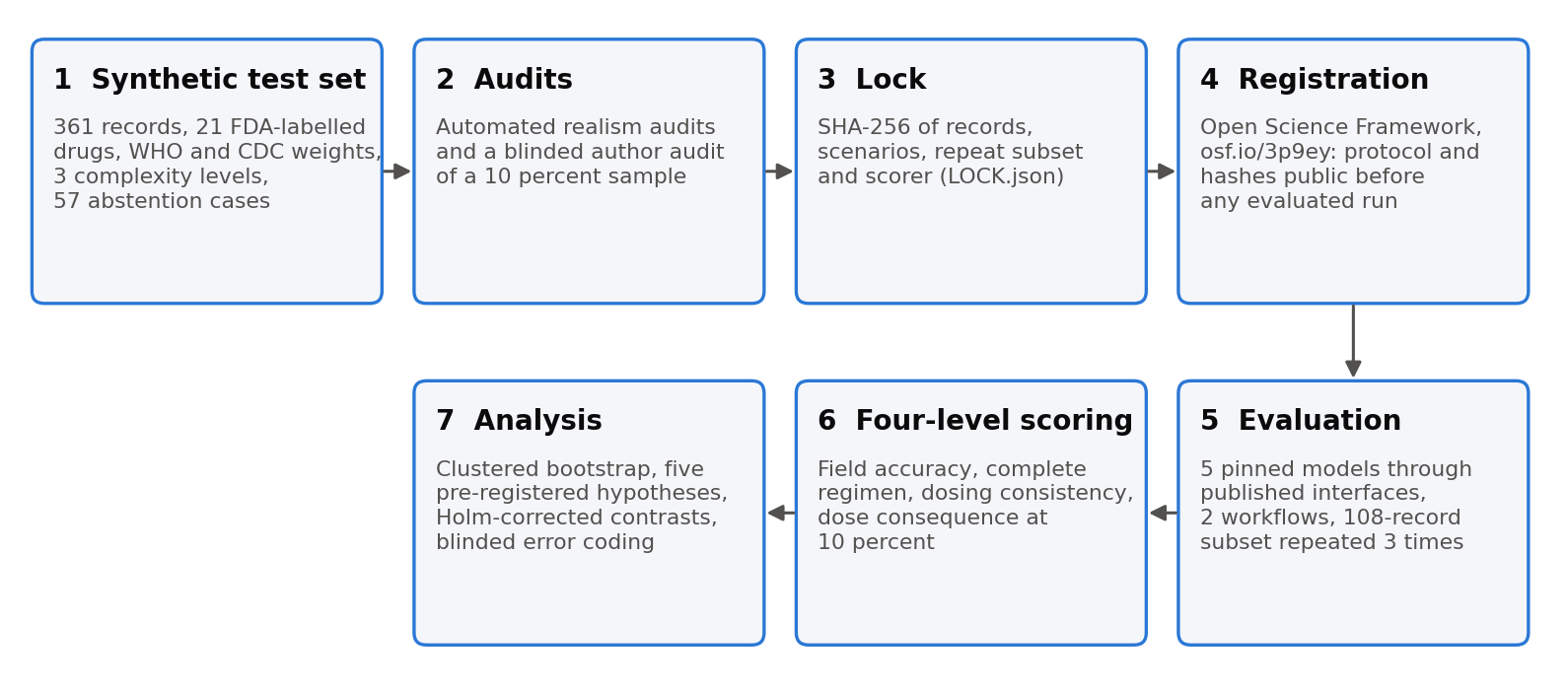
Figure 1. The study in seven steps.
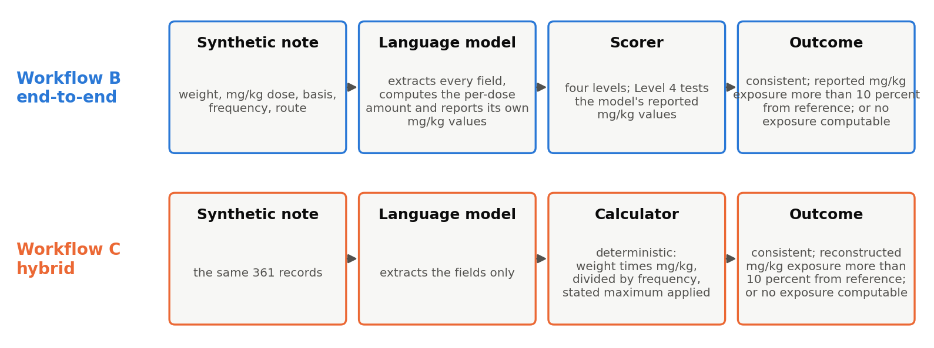
Figure 2. The two workflows and the composite outcome.

3. Results behind the article's numbers (five models, first run, 304 non-abstention records per model and workflow)
Model | Workflow | Field accuracy | Complete regimen | Composite failure | Primary endpoint (95 percent interval)
GPT-5.5 | End-to-end | 0.996 | 0.970 | 0.000 | 0.970 (0.947 to 0.987)
GPT-5.5 | Hybrid | 1.000 | 1.000 | 0.000 | 1.000
Claude Sonnet 5 | End-to-end | 1.000 | 0.997 | 0.016 | 0.980 (0.964 to 0.993)
Claude Sonnet 5 | Hybrid | 1.000 | 0.997 | 0.000 | 0.997 (0.990 to 1.000)
DeepSeek V4 Pro | End-to-end | 1.000 | 0.997 | 0.007 | 0.990 (0.977 to 1.000)
DeepSeek V4 Pro | Hybrid | 1.000 | 1.000 | 0.000 | 1.000
Gemini 3.1 Pro | End-to-end | 1.000 | 0.997 | 0.016 | 0.980 (0.964 to 0.993)
Gemini 3.1 Pro | Hybrid | 1.000 | 1.000 | 0.000 | 1.000
Llama 3.1 8B | End-to-end | 0.968 | 0.809 | 0.645 | 0.329 (0.276 to 0.382)
Llama 3.1 8B | Hybrid | 0.759 | 0.062 | 0.891 | 0.056 (0.030 to 0.082)

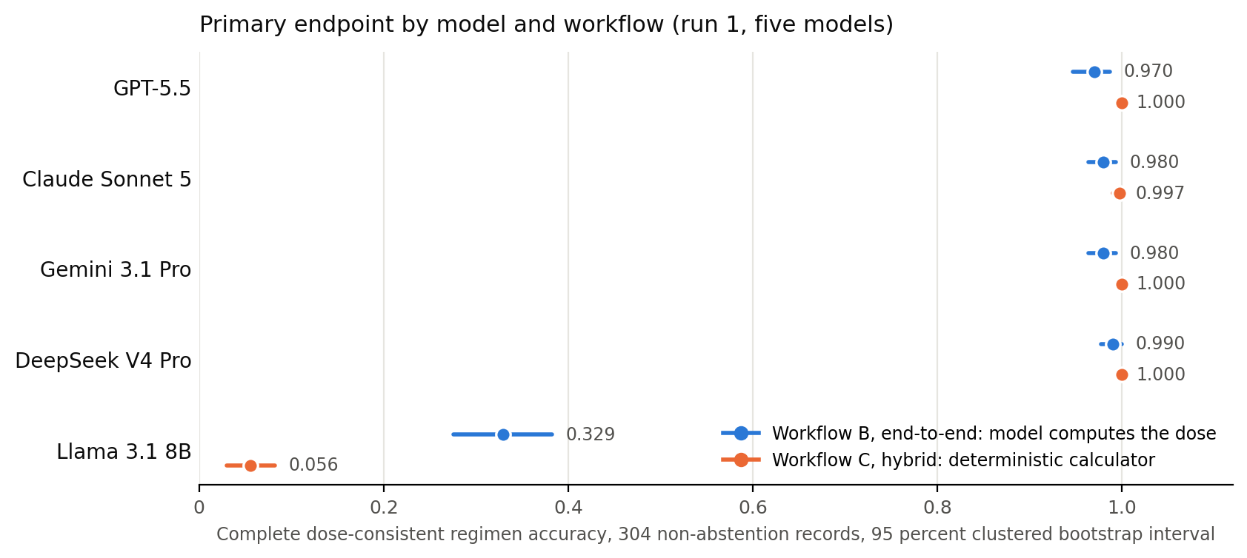
Figure 3. Primary endpoint by model and workflow with 95 percent clustered bootstrap intervals.
Pairwise contrasts. No statistically significant pairwise difference among the four frontier models in either workflow after Holm correction (all adjusted p at or above 0.92), which is not evidence of equivalence. Every frontier model exceeds Llama 3.1 8B by 0.64 to 0.66 (end-to-end) and 0.94 (hybrid), all adjusted p below 0.0001.
Stability. Run-to-run agreement on the 108-record subset: 0.972 to 1.000 for all five models in both workflows (Gemini 3.1 Pro 0.991 end-to-end, 1.000 hybrid).
Abstention (57 records). All four frontier models: 52 of 57 appropriate (0.912; 0.842 to 0.982), identical across models and workflows because the same five records account for every miss, and in every case the model wrote the prior-visit weight as the current weight. Scenario identifiers: test-clindamycin-mg_kg_day-infant-L3-v0, test-gentamicin-mg_kg_day-school_age-L3-v1, test-dexamethasone-mg_kg_day-toddler-L3-v1, test-dexamethasone-mg_kg_day-school_age-L3-v1, test-dexamethasone-mg_kg_day-adolescent-L3-v0. Llama: 0.772 (end-to-end), 0.825 (hybrid).
Maximum-dose outputs (end-to-end workflow). Five notes whose weight-based product exceeds a maximum written into the order; nine outputs wrote the uncapped product (Claude Sonnet 5 five, DeepSeek V4 Pro two, Gemini 3.1 Pro two); GPT-5.5 applied the maximum in all five.
Note (scenario) | Order as written | Maximum stated in the order (field; provenance) | Reference per dose | Claude Sonnet 5 | DeepSeek V4 Pro | Gemini 3.1 Pro | GPT-5.5
amoxicillin, 11 y F, 70.4 kg | 42 mg/kg/day PO divided q12h; max 875 mg/dose | 875 mg per dose (author's derivation from the label's over-40 kg regimen) | 875 mg | 1478.4 mg | 1478.4 mg | 1478.4 mg | applied
ceftriaxone, 17 y M, 153 lb | 54 mg/kg/day IV divided BID; not to exceed 2000 mg/day | 2000 mg per day (stated by the label) | 1000 mg | 1873.8 mg twice daily | 1873.8 mg twice daily | applied (1000 mg; nominal mg/kg reported, see below) | applied
prednisolone, 9 y F, 90.6 lb | 2 mg/kg/day PO q24h; not to exceed 60 mg/day | 60 mg per day (author's derivation, upper end of the label's initial range) | 60 mg | 82.19 mg once daily | applied | applied (60 mg; nominal mg/kg reported) | applied
prednisolone, 17 y M, 87.3 kg | 1.5 mg/kg/day PO q24h; not to exceed 60 mg/day | 60 mg per day (as above) | 60 mg | 130.95 mg once daily | applied | applied (60 mg; nominal mg/kg reported) | applied
prednisolone, adolescent, 43.1 kg | 1.5 mg/kg/day q24h; not to exceed 60 mg/day | 60 mg per day (as above) | 60 mg | 64.65 mg once daily (8 percent over; within tolerance; recorded by the maximum flag) | applied | 64.65 mg once daily (as Claude) | applied

In all nine outputs the model had placed the maximum in the correct structured field (max_per_dose_mg or max_per_day_mg) before computing the amount without it; seven exceed the 10 percent tolerance and are composite failures, two (the 64.65 mg outputs) are inside it. Post hoc maximum check over the 3,040 eligible first-run outputs of the five models: nine end-to-end and four hybrid-workflow flags among the four frontier models, nothing else from them; one small-model flag against a maximum that model had extracted wrongly; retrospective, not tested as a prospective safeguard.
Reporting-convention finding. Gemini 3.1 Pro applied the maximum correctly to the written amount in four capped notes (ceftriaxone 1000 mg, prednisolone 60 mg twice, azithromycin 500 mg) and then reported the order's nominal mg/kg (27, 2, 1.5, 10) rather than the mg/kg implied by the capped amount (14.4, 1.46, 0.69, 7.44), which GPT-5.5, Claude Sonnet 5 and DeepSeek V4 Pro reported on the same notes. The task prompt asks for mg_per_kg_per_dose and mg_per_kg_per_day to be computed from the extracted values and the schema only names the fields; neither states which convention applies. Under the registered scorer, which compares the reported mg/kg with the effective regimen, those four outputs are composite failures, and the per-day maximum flag fires on three of them from the reported figure although the written amounts were under the limit. They are reported as a convention ambiguity the study did not anticipate, with the written amounts correct, and recorded as a clarification in the deviations log.
The neonatal record. test-dexamethasone-mg_kg_day-neonate-L1-v0-r0: 4.52 kg, 0.02 mg/kg/day divided four times daily; exact per-dose 0.0226 mg; the note prints 0.02 mg. The exact product is 13 percent above the printed amount; the printed amount read back as mg/kg is 12 percent below the regimen's figure. Claude Sonnet 5 copied the printed amount and failed the composite; GPT-5.5, Gemini 3.1 Pro and DeepSeek V4 Pro wrote the exact product and failed the 1 percent field tolerance. A constructed output reporting the printed amount in one field and the regimen's mg/kg in another passes both when run through the locked scorer; no model produced one. The record is scored as registered, disclosed, and removed by the pre-registered 20 percent sensitivity check.
Workflow comparison under both protocol wordings.
Model | Hybrid minus end-to-end, composite failure rate (Protocol Section 1) | Hybrid minus end-to-end, primary endpoint (Protocol Section 16)
GPT-5.5 | +0.000 (null at ceiling) | +0.030 (+0.013 to +0.049); the entire gain is nine field-level rounding records, no dose changed
Claude Sonnet 5 | -0.016 (-0.033 to -0.003), supported | +0.016 (+0.003 to +0.033), supported
DeepSeek V4 Pro | -0.007 (-0.016 to +0.000), not supported | +0.010 (+0.000 to +0.023), not supported
Gemini 3.1 Pro | -0.016 (-0.030 to -0.003), supported | +0.020 (+0.007 to +0.036), supported
Llama 3.1 8B | +0.247 (+0.178 to +0.312), reversed | -0.273 (-0.336 to -0.211), reversed
Verdict | Not supported: 2 of 5 (Claude, Gemini) | Supported: 3 of 5 (GPT-5.5, Claude, Gemini), a majority

Section 1 is the definition implemented in the analysis script hashed into the registration before any run; the verdict differs between the two wordings and both are reported, with GPT-5.5's gain under Section 16 consisting entirely of the nine field-level rounding records.
Small model, composite failure versus written per-dose amount (304 records per workflow).
Workflow | Written amount | Composite pass | Reported or reconstructed mg/kg exposure more than 10 percent from reference | No exposure computable
End-to-end | within 10 percent of the order (250) | 96 | 139 | 15
End-to-end | more than 10 percent off (27) | 4 | 21 | 2
End-to-end | missing (27) | 8 | 0 | 19
Hybrid | within 10 percent of the order (249) | 14 | 2 | 233
Hybrid | more than 10 percent off (21) | 0 | 0 | 21
Hybrid | missing (34) | 19 | 0 | 15

Of the 154 end-to-end records with a correct written amount and a failed composite: 74 carry the milligram amount in the per-dose mg/kg field, 48 carry the per-day value in the per-dose field, 15 are null, 17 other.
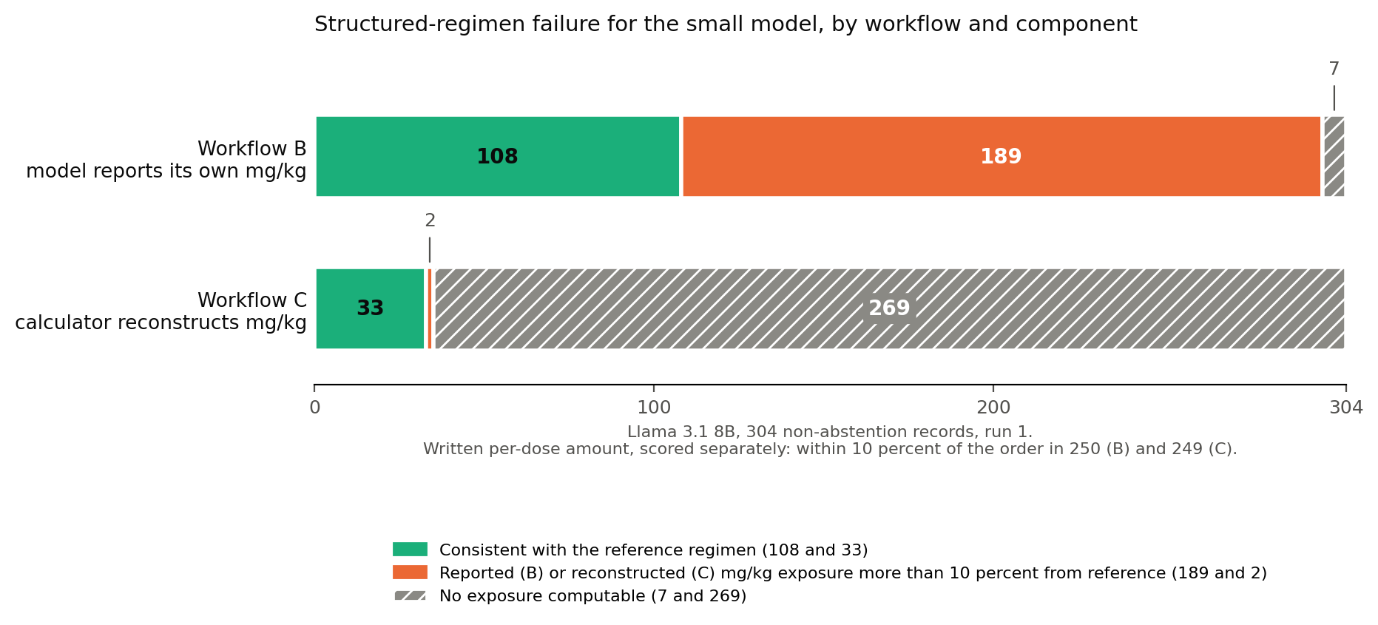
Figure 4. Structured-regimen failure for the small model by workflow and component, with the written-amount result stated separately.
Hypotheses, stated individually. H1 (complete-regimen accuracy at least ten points below field accuracy for every model): not supported. H2 (failures rise with complexity): not supported. H3 (hybrid lowers failures): not supported under Section 1; supported under Section 16. H4 (dose-basis and weight-selection errors dominate): provisional pending unassisted manual coding; row inspection shows much of the automatic "arithmetic inconsistency" class is unit and basis confusion inside the computed fields. H5 (neonate and infant bands lower, exploratory): inconclusive.

4. Sources cited in the article
1. OSF registration https://osf.io/3p9ey (DOI 10.17605/OSF.IO/3P9EY); project https://osf.io/uajs3.
2. Kaushal R, Bates DW, Landrigan C, et al. Medication errors and adverse drug events in pediatric inpatients. JAMA. 2001;285(16):2114-2120. (Dosing errors the most common category: 28 percent of medication errors, 34 percent of potential adverse drug events; potential adverse drug events in 1.1 percent of orders.)
3. Doherty C, Mc Donnell C. Tenfold medication errors: 5 years' experience at a university-affiliated pediatric hospital. Pediatrics. 2012;129(5):916-924.
4. Roumeliotis N, Pullenayegum E, Rochon P, et al. A modified Delphi to define drug dosing errors in pediatric critical care. BMC Pediatrics. 2020;20:488. (Source of the 10 percent threshold; applies to numerical doses; the study's composite additionally counts an unreconstructable exposure and reports the two components separately.)
5. Gallifant J, Afshar M, Ameen S, et al. The TRIPOD-LLM reporting guideline for studies using large language models. Nature Medicine. 2025;31:60-69. (Reporting guideline; the completed checklist accompanies the paper.)
6. Williams K, Thomson D, Seto I, et al. Standard 6: age groups for pediatric trials. Pediatrics. 2012;129(Suppl 3):S153-S160. (Age bands; toddler and early childhood collapsed into one band.)
7. WHO Child Growth Standards, weight-for-age 0 to 24 months, as distributed by the CDC; CDC Growth Charts, weight-for-age 2 to 20 years (LMS parameter files).
8. FDA drug labeling via openFDA; label set identifiers per medication are in sources/dosing_sources.csv in the repository.
9. Khandekar N, Jin Q, Xiong G, et al. MedCalc-Bench: Evaluating Large Language Models for Medical Calculations. arXiv:2406.12036 (2024).
10. Levin C, Orkaby B, Kerner E, Saban M. Can large language models assist with pediatric dosing accuracy? Pediatric Research. 2025;98(5):1760-1765.

5. Status and pending items
Complete: all five models, all runs (run 1 on 361 records in both workflows; three runs on the 108-record subset); scoring; primary, stability, pairwise, per-drug, written-amount, stratified and maximum-check analyses; row-level resolution of every frontier composite failure; lock verification; evidence packet. Pending: unassisted manual error coding and a 10 percent re-coding check two weeks later; the TRIPOD-LLM checklist; the dated capture of the registration page for the packet; approval of any quotation attributed to the author.

6. Stated limits
Synthetic records bound performance on documentation the study can fully specify, not on an electronic health record. Ground truth is by construction, with automated gates, two realism audits and a blinded author audit; no clinician or pharmacist reviewed the records, and two of the stated maxima in the headline notes are the author's documented derivations from the labels. The composite measure is a structured-regimen measure on reported or reconstructed mg/kg values; the written amount is scored separately and is reported beside it wherever the small model is discussed. One test-set record has a printed amount that no internally consistent answer can satisfy under both scoring conventions. The DeepSeek identifier resolves to the provider's current release at call time; run timestamps are in the manifest. The post hoc maximum check is retrospective. The prompt did not state whether reported mg/kg values should reflect a cap applied to the amount; one model read it the other way and its four such outputs are scored as registered and disclosed.

7. Verification
Hashes in the registration: records 492d7ca2209719eb8bf96548403dab1e26cb9fed36be3482733dd69790cea7f4; scenarios 432be74fe65c2164ad9e21705821f5814055994f389526614aa744a671c220cb; repeat subset f1012bdcb01f9cdcf80cf000b0ad6831352d9a98a6e57a0e8ebd207dbdfa4196; scoring code and prompts (combined) 7be9bc8704e09b94014741847f16b047b115c7b2c7c7846ec01afe03445461ed. Recompute in the repository with: shasum -a 256 data/test/records.jsonl data/test/scenarios.jsonl data/test/repeat_subset.txt, and python3 -c "from tools.lock_testset import hash_scoring; print(hash_scoring())". The evidence packet (results/packet) holds the row-level note, output and score for the five stale-weight records, the five maximum-dose notes and the neonatal record across all models and both workflows, the tables and scripts behind every count, the two workflow analyses, the run manifest and the deviations log.

Repository
Code, synthetic data, locked test split, protocol, raw and scored outputs, analysis outputs, evidence packet, figures and documents: https://github.com/VinodRufus/from-fields-to-dose

