**Screen Shoots**

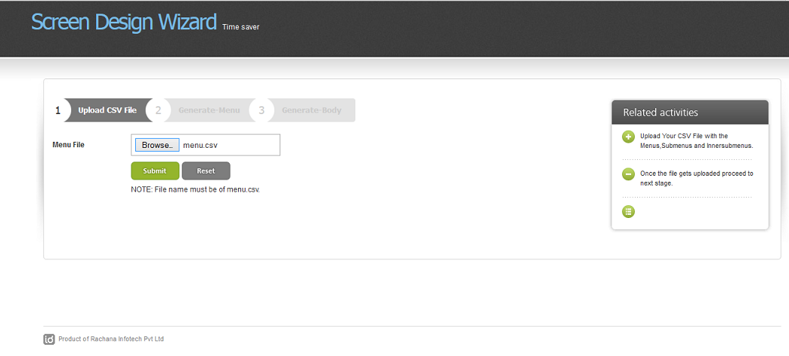

Fig 1 :Upload CSV files ( Menu.csv) file name must be of menu.csv.

\\

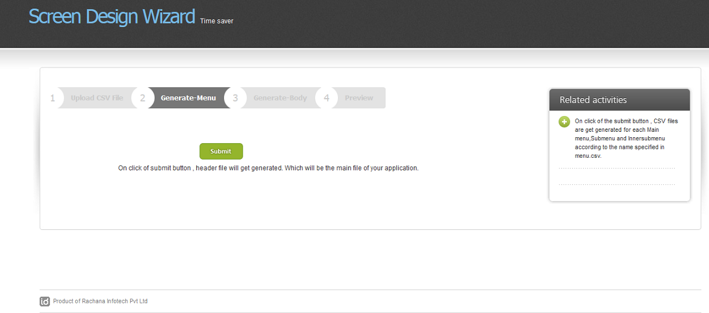

Fig 2 : On click of submit button , header file will get generated. Which will be the main file of your application.

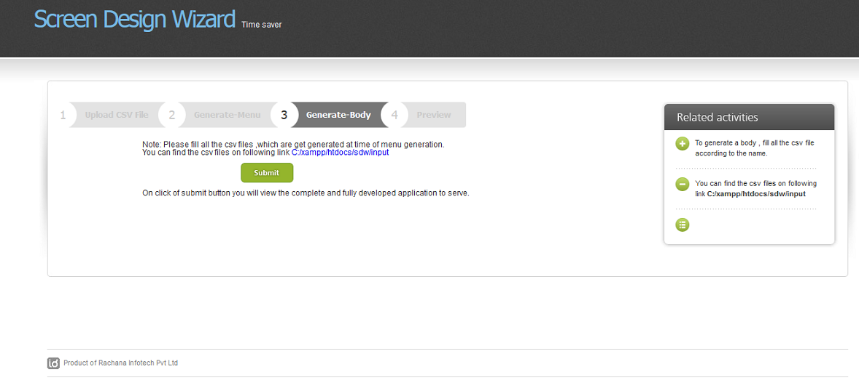

Fig 3 : Please fill all the csv files ,which are get generated at time of menu generation.

You can find the csv files on following link C:/xampp/htdocs/sdw/input

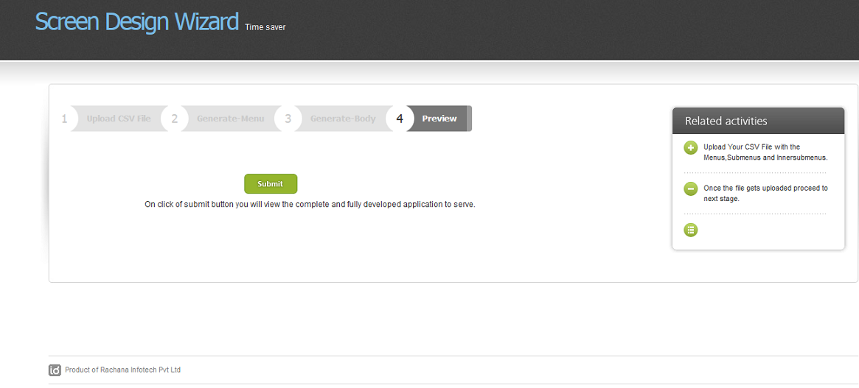

Fig 4 : On click of submit button you will view the complete and fully developed application to serve.

On click of submit button you will view the complete and fully developed application to serve.

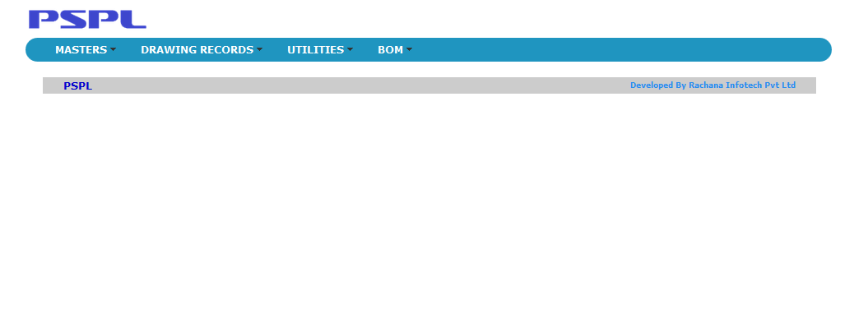

Fig 5 : Main Page ( header file)

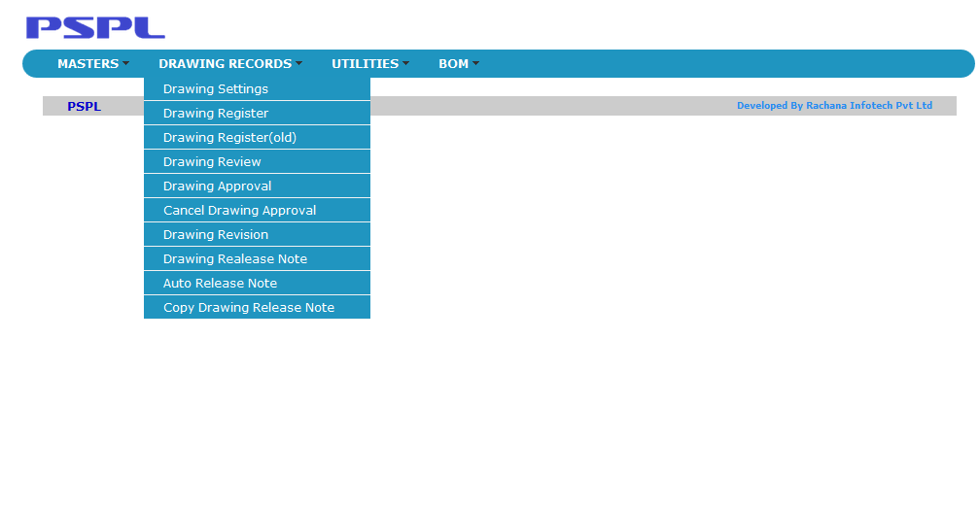

Fig 6 : Display of Inner menus

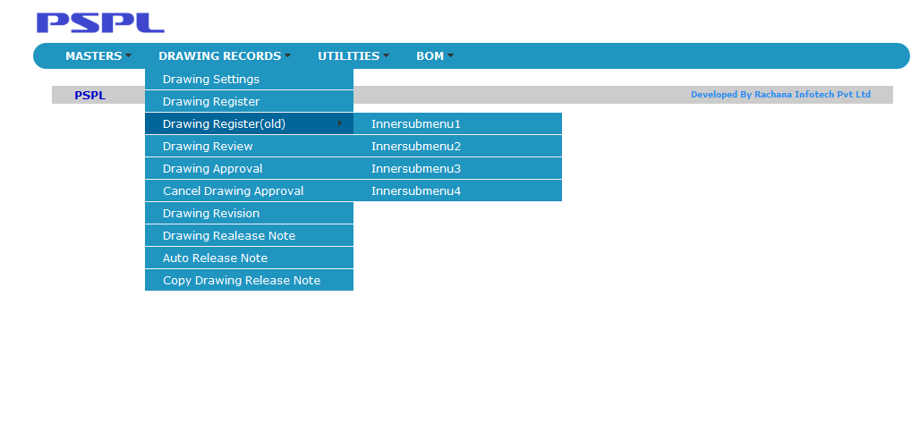

Fig 7 : Display of Sub Inner Menus

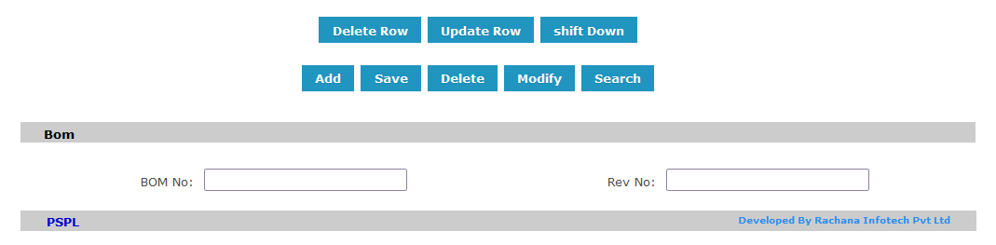

Fig 8 : Display of Buttons

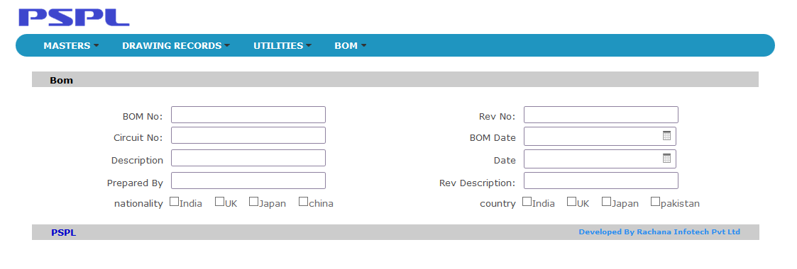

Fig 9: Display of CheckBox

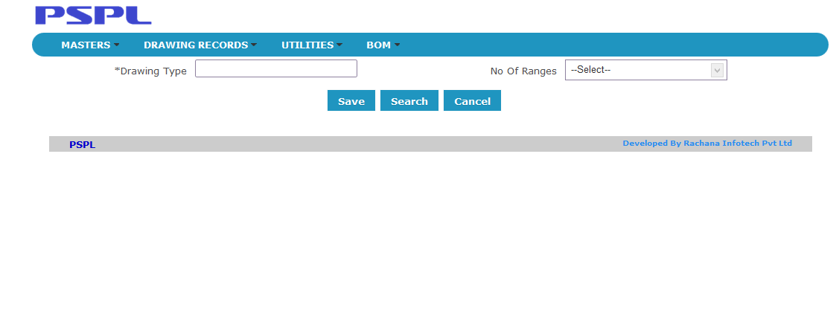

Fig 10 : Display of ComboBox

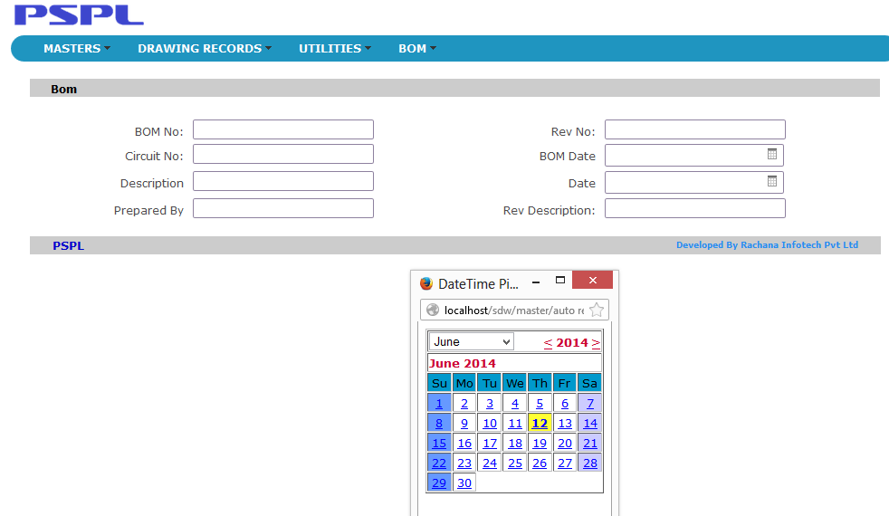

Fig 11 : Display of Date Time Picker

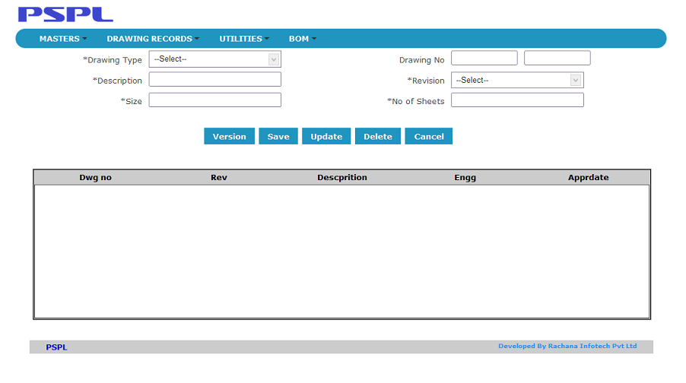

Fig 12 : Display of Double Text Box Component

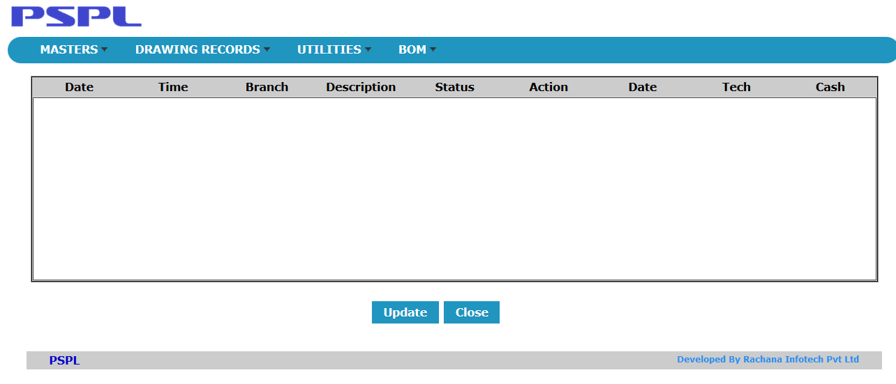

Fig 13 : Display of Table component

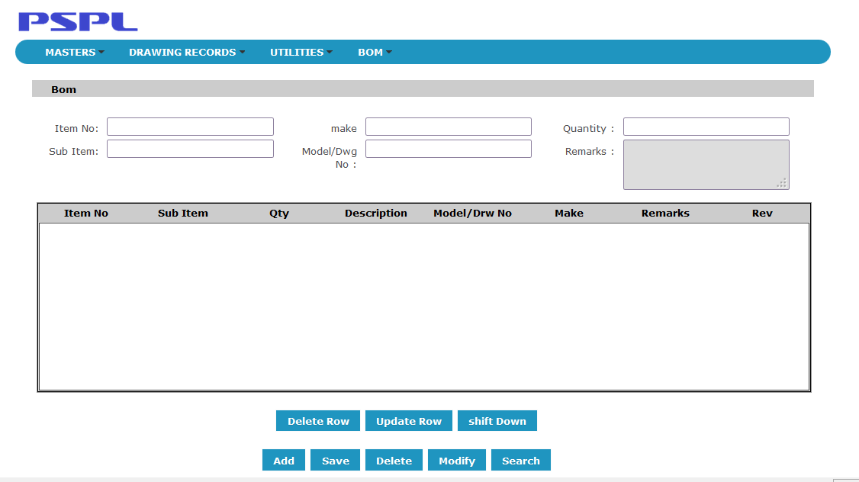

Fig 14 : Display of Text Area

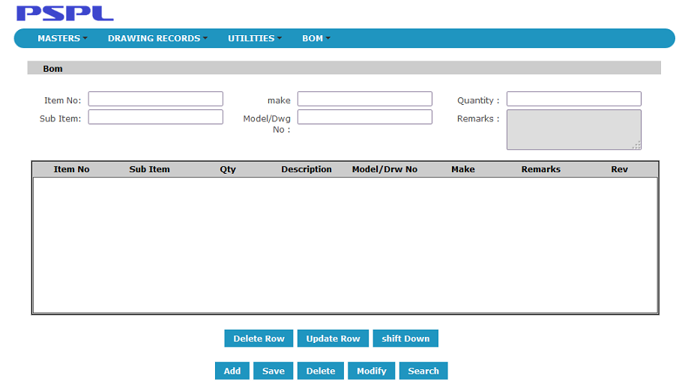

Fig 6

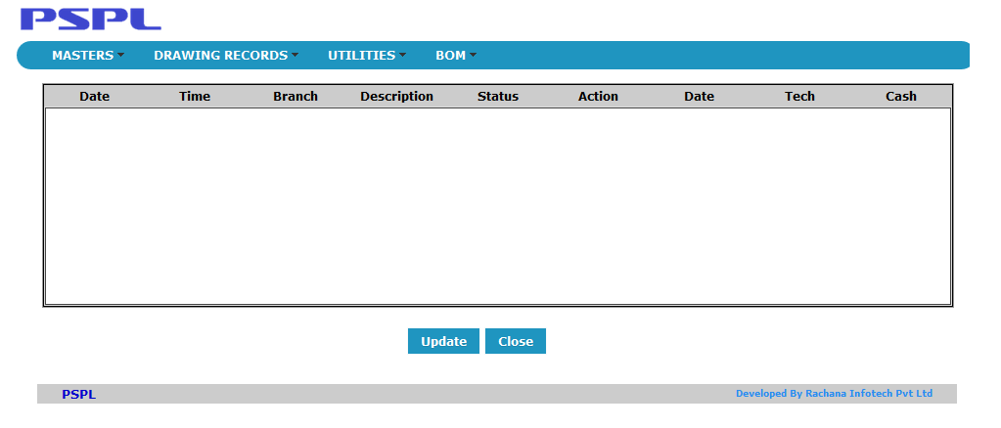

Fig 7

**APPENDIX B USER MANUAL**

***Menu Creation*** : Filling the Menu Items in the CSV file(Menu.csv)

|  |  |  |
| --- | --- | --- |
| Main Menu Name | Sub Menu Name | Inner Sub Menu Name |
| Masters | Component Description |  |
|  | Material Grade |  |
|  | Station Master |  |
| Transactions | Drawing Information | InnerSubMenu1 |
|  |  | InnerSubMenu2 |
|  |  | InnerSubMenu3 |
|  |  | InnerSubMenu4 |
|  | Process Planing | InnerSubMenu1 |
|  |  | InnerSubMenu2 |
|  |  | InnerSubMenu3 |
|  |  | InnerSubMenu4 |

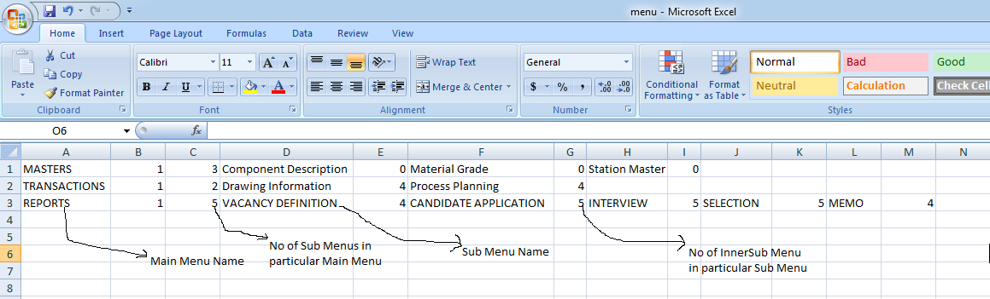

***Body Creation : Filling the body CSV files.***

Layout 1:

|  |  |
| --- | --- |
| Naming Conventions | Example |
| Textbox | 1layout,textbox,callno,1,clear. |
| Twotextbox | 1layout, twotextbox,Date,1,clear. |
| Threetextbox | 1layout, threetextbox,Date,1,clear. |
| Button | 1layout,button,2,Add,Delete,Clear |
| Listbox | 1layout,listbox,Designation,3,Manager,CEO,SoftwareEngg,clear. |
| Button | 1layout,button,2,save,close,clear. |
| Checkbox | 1layout, checkbox,nationality,4,India,UK,Japan,china |
| Rb | 1layout, rb,Gender,2,male,female |
| Textboxsearchicon | 1layout, textboxsearchicon,id,1,clear. |
| Textboxarrowicon | 1layout, textboxarrowicon,name,1,clear. |
| Textboxdateicon | 1layout, textboxdateicon,Date,1,clear. |
| Textarea | 1layout,textarea,Adress,1,clear. |
| Table | 1layout,table,4,Sno,Name,Address,Price,clear. |
| No of Tabs and Starting of tabs | 1layout,tabstart,2,clear |
| Adding tab1 components | 1layout,starttabenb,clear |
|  | 2layout,lefttextbox,1,righttextbox,1,clear |
|  | 2layout,lefttextbox,1,righttextbox,1,clear |
|  | 2layout,lefttextbox,1,righttextbox,1,clear. |
|  | 2layout,leftcheckbox,Course,3,MBA,MCA,BE |
| Ending tab1 | 1layout,endtabenb,clear |
| Adding tab 2 components | 1layout,starttabdis,clear |
|  | 2layout,lefttextbox,1,righttextbox,1,clear |
|  | 2layout,lefttextbox,1,righttextbox,1,clear |
|  | 2layout,lefttextbox,1,righttextbox,1 |
|  | 2layout,leftcheckbox,Course,3,MBA,MCA |
| Ending tab2 | 1layout,endtabenb,clear |
| Ending tab area | 1layout,tabend,clear |

Layout 2:

|  |  |
| --- | --- |
| Naming Conventions | Example |
| Lefttextbox | 2layout,lefttextbox,callno,1 |
| Righttextbox | 2layout, righttextbox,username,1,clear. |
| Button | 2layout,button,2,Add,Delete,Clear |
| Rightlistbox | 2layout,rightlistbox,Designation,3,Manager,CEO,SoftwareEngg |
| Leftlistbox | 2layout,leftlistbox,region,3,Belgaum,Dharwad,hubli, |
| Button | 2layout,button,2,save,close |
| Leftcheckbox | 2layout, leftcheckbox,nationality,4,India,UK,Japan,china |
| Rightcheckbox | 2layout, rightcheckbox,country,4,India,UK,Japan,pakistan |
| Leftrb | 2layout, leftrb,Gender,2,male,female |
| Rightrb | 2layout, rightrb,course,2,MCA,MTECH |
| lefttextboxsearchicon | 2layout, lefttextboxsearchicon,id,1 |
| righttextboxsearchicon | 2layout, righttextboxsearchicon,id,1 |
| lefttextboxarrowicon | 2layout, lefttextboxarrowicon,name,1 |
| righttextboxarrowicon | 2layout, righttextboxarrowicon,taxes,1 |
| Lefttextboxdateicon | 2layout, lefttextboxdateicon,Date,1,clear |
| Righttextboxdateicon | 2layout, righttextboxdateicon,Date,1,clear |
| Lefttextarea | 2layout,lefttextarea,Adress,1 |
| Righttextarea | 2layout, righttextarea,Address,1 |
| Table | 2layout,table,4,Sno,Name,Address,Price |
| No of Tabs and Starting of tabs | 2layout,tabstart,2,clear |
| Adding tab1 components | 2layout,starttabenb,clear |
|  | 2layout,lefttextbox,1,righttextbox,1,clear |
|  | 2layout,lefttextbox,1,righttextbox,1,clear |
|  | 2layout,lefttextbox,1,righttextbox,1 |
|  | 2layout,leftcheckbox,Course,3,MBA,MCA |
| Ending tab1 | 2layout,endtabenb,clear |
| Adding tab 2 components | 2layout,starttabdis,clear |
|  | 2layout,lefttextbox,1,righttextbox,1,clear |
|  | 2layout,lefttextbox,1,righttextbox,1,clear |
|  | 2layout,lefttextbox,1,righttextbox,1 |
|  | 2layout,leftcheckbox,Course,3,MBA,MCA |
| Ending tab2 | 2layout,endtabenb,clear |
| Ending tab area | 2layout,tabend,clear |

Layout 3:

|  |  |
| --- | --- |
| Naming Conventions | Example |
| Lefttextbox | 3layout,lefttextbox,callno,1 |
| Righttextbox | 3layout, righttextbox,username,1,clear. |
| Midtextbox | 3layout, midtextbox,username,1,clear. |
| Twotextbox | 3layout, twotextbox,Date,1,clear. |
| Threetextbox | 3layout, threetextbox,Date,1,clear. |
| Button | 3layout,button,2,Add,Delete,Clear |
| Rightlistbox | 3layout,rightlistbox,Designation,3,Manager,CEO,SoftwareEngg |
| Leftlistbox | 3layout,leftlistbox,region,3,Belgaum,Dharwad,hubli, |
| Midlistbox | 3layout, midlistbox,region,3,Belgaum,Dharwad,hubli, |
| Button | 3layout,button,2,save,close |
| Leftcheckbox | 3layout, leftcheckbox,nationality,4,India,UK,Japan,china |
| Rightcheckbox | 3layout, rightcheckbox,country,4,India,UK,Japan,pakistan |
| Midcheckbox | 3layout, midcheckbox,country,4,India,UK,Japan,pakistan |
| Leftrb | 3layout, leftrb,Gender,2,male,female |
| Rightrb | 3layout, rightrb,course,2,MCA,MTECH |
| Midrb | 3layout, midrb,course,2,MCA,MTECH |
| lefttextboxsearchicon | 3layout, lefttextboxsearchicon,id,1 |
| righttextboxsearchicon | 3layout, righttextboxsearchicon,id,1 |
| midtextboxsearchicon | 3layout, midtextboxsearchicon,id,1 |
| lefttextboxarrowicon | 3layout, lefttextboxarrowicon,name,1 |
| righttextboxarrowicon | 3layout, righttextboxarrowicon,taxes,1 |
| midtextboxarrowicon | 3layout, midtextboxarrowicon,taxes,1 |
| Lefttextboxdateicon | 3layout, lefttextboxdateicon,Date,1,clear |
| Righttextboxdateicon | 3layout, righttextboxdateicon,Date,1,clear |
| Midtextboxdateicon | 3layout, midtextboxdateicon,Date,1,clear |
| Lefttextarea | 3layout,lefttextarea,Adress,1 |
| Righttextarea | 3layout, righttextarea,Address,1 |
| Midtextarea | 3layout, midtextarea,Address,1 |
| Table | 3layout,table,4,Sno,Name,Address,Price |
| No of Tabs and Starting tab area | 3layout,tabstart,2,clear |
| Adding tab1 components | 3layout,starttabenb,clear |
|  | 3layout,lefttextbox,1,righttextbox,1,clear |
|  | 3layout,lefttextbox,1,righttextbox,1,clear |
|  | 3layout,lefttextbox,1,righttextbox,1 |
|  | 3layout,leftcheckbox,2,rightcheckbox,3,clear |
| Ending tab1 | 3layout,endtabenb,clear |
| Adding tab 2 components | 3layout,starttabdis,clear |
|  | 3layout,lefttextbox,1,righttextbox,1,clear |
|  | 3layout,lefttextbox,1,righttextbox,1,clear |
|  | 3layout,lefttextbox,1,righttextbox,1 |
|  | 3layout,leftcheckbox,2,rightcheckbox,3,clear |
| Ending tab2 | 3layout,endtabenb,clear |
| Ending tab area | 3layout,tabend,clear |

