Spacecraft Timekeeping Functional Flow
Version 0.2 - Ground Segment Validation and Failure Modes

Introduction
This document presents the functional flow of the spacecraft timekeeping system before converting it into a hardware block diagram. The system uses GNSS as an external time reference and a Rubidium atomic clock as a stable onboard clock source.
The Time Synchronization Engine combines GNSS time, GNSS 1PPS and Rubidium clock information to generate Master Spacecraft Time. The PPS Distribution System then distributes this timing reference to onboard subsystems. Version 0.2 also adds the ground segment as the reference used to validate whether spacecraft time is correct.

Level 1 - Functional Architecture
The functional architecture starts from GNSS constellations and ends with Ground UTC comparison. The TR-2S receiver provides GNSS time and 1PPS, while the Rubidium clock provides stable frequency and holdover support.
Master Spacecraft Time is distributed through the PPS Distribution System to TMTC, AOCS, Payload and OBC. Time telemetry is sent to the ground station, where it is compared with Ground UTC after correcting for propagation delay.
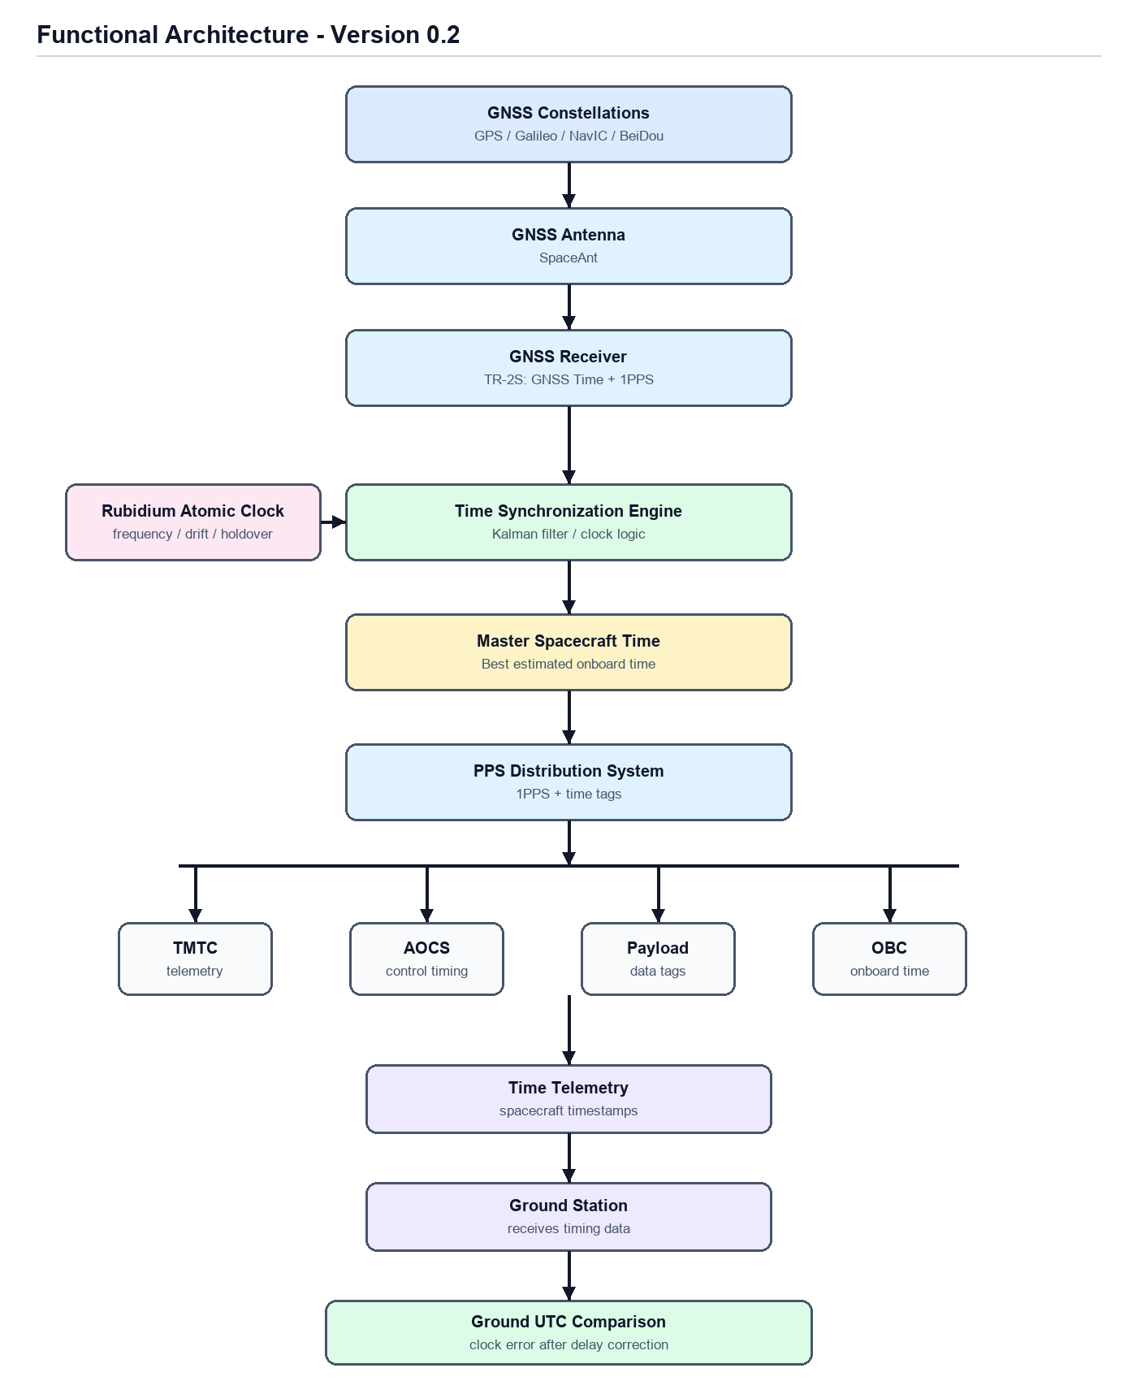

Detailed Timing Flow
The detailed timing flow separates the timing products used by the synchronization logic. The TR-2S receiver is treated as both a navigation source and a timing source because it provides position, velocity, UTC/GPS time and GNSS PPS.
The Rubidium atomic clock provides frequency stability, drift behaviour and holdover capability. A Kalman-filter-based estimator uses these inputs to estimate clock bias, drift and correction terms for the master time solution.

Ground Segment Time Validation
The ground segment acts as the referee for spacecraft time. The spacecraft has Master Spacecraft Time, and the ground station has Ground UTC. These two values cannot be compared directly unless signal propagation delay is considered.
For example, if the spacecraft is 500 km away, the signal travel time is approximately 1.7 ms. Therefore, the received spacecraft timestamp must be corrected before calculating clock error.
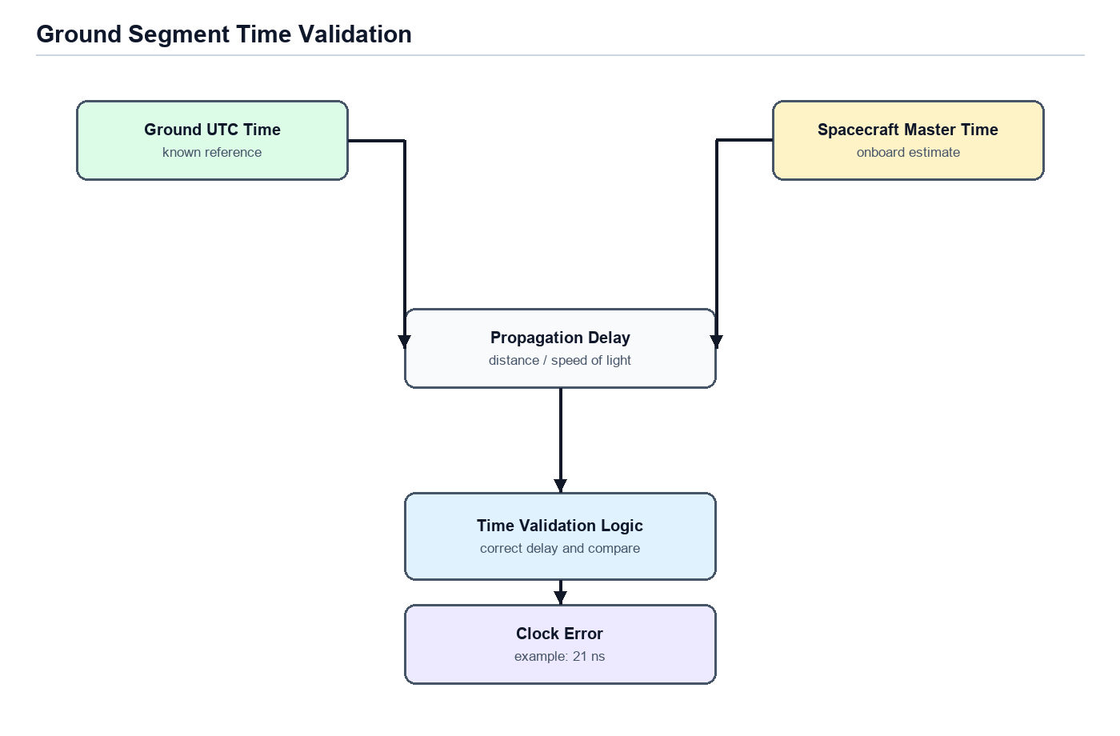

Failure Mode Flow
The failure mode flow shows how the timing system behaves in normal and degraded conditions. This makes the design stronger because the architecture does not depend on only one timing source.
In normal mode, GNSS and Rubidium are both available. If GNSS is lost, Rubidium holdover maintains spacecraft time while uncertainty increases. If Rubidium fails, GNSS time can still be used as the external reference.
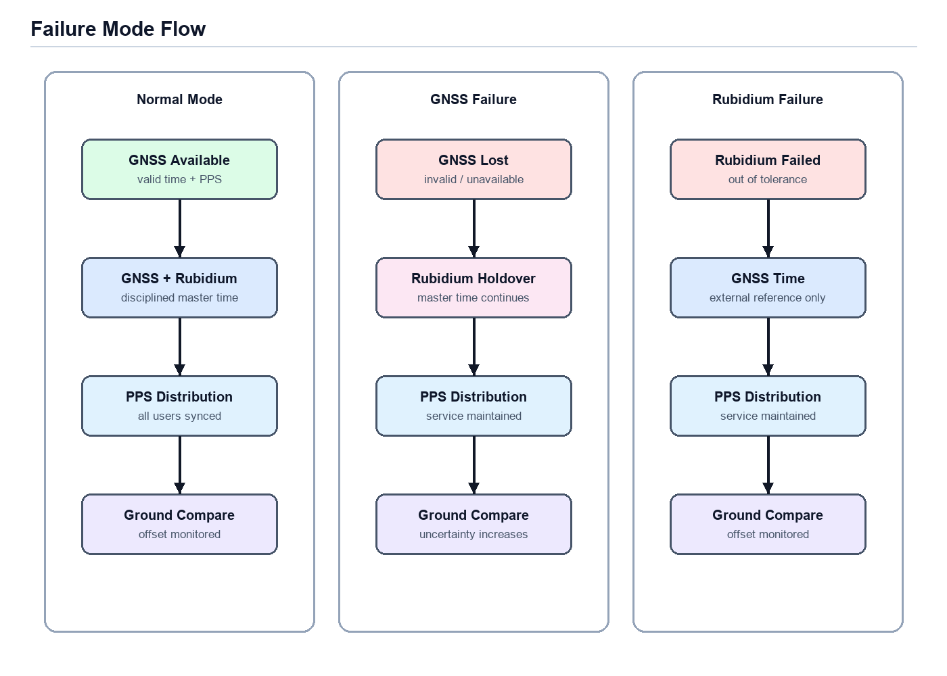

Simulation Architecture
The simulator starts with GNSS constellation modelling, TR-2S receiver modelling and Rubidium clock modelling. The synchronization engine then generates Master Spacecraft Time, and the PPS Distribution Simulator sends timing to the subsystem models.
Version 0.2 adds Ground UTC Reference and Clock Error Calculation modules. The first simulator version can treat Ground UTC as a known perfect reference. Later versions can add propagation delay, round-trip delay and two-way time transfer.
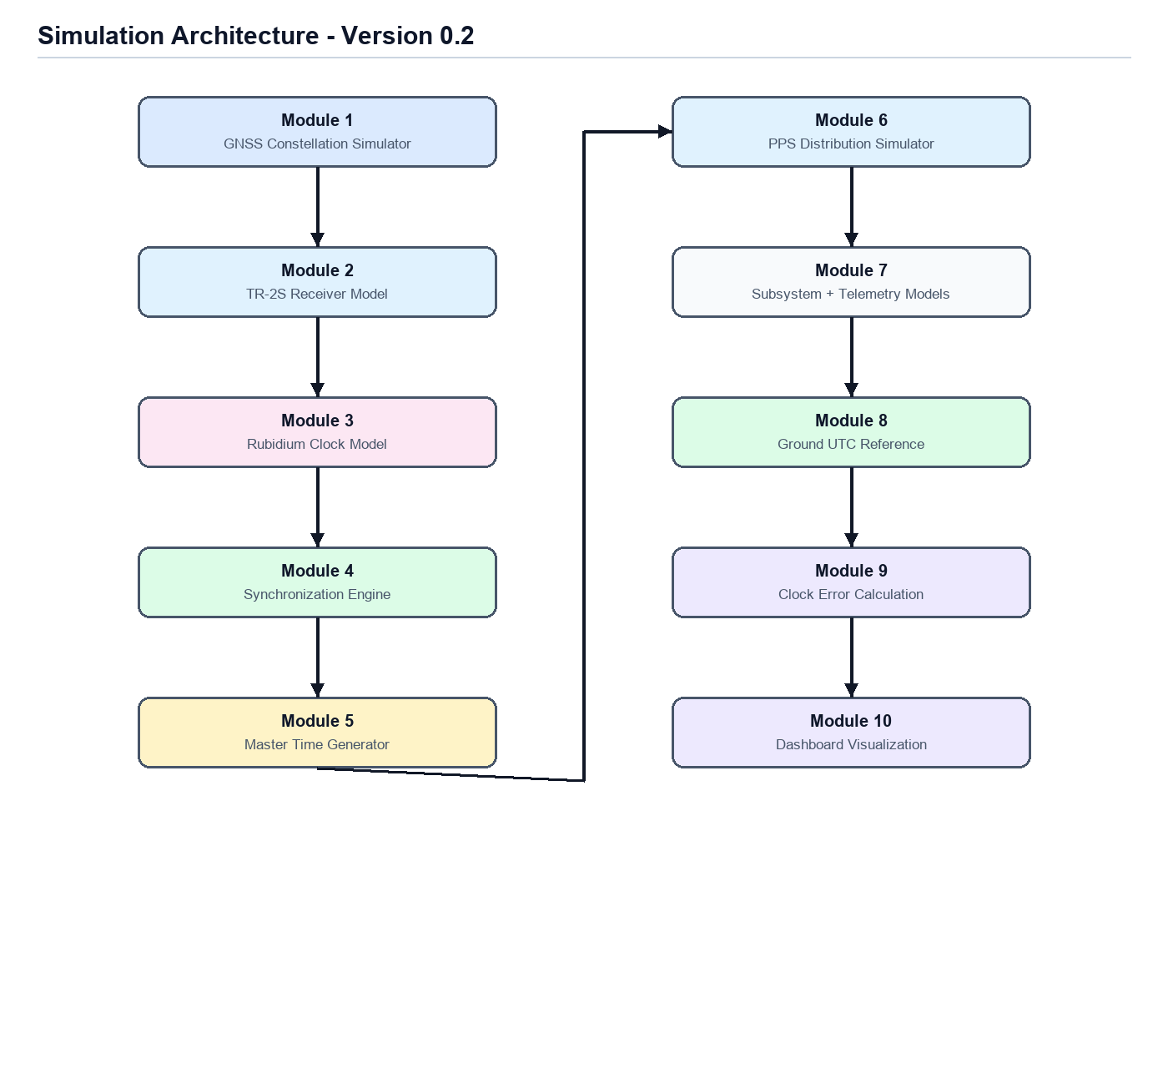

Dashboard Concept
The dashboard should look like a Mission Time Operations Center. It should show GNSS status, Rubidium health, PPS distribution status, Ground UTC, spacecraft time and live clock offset.
For example, if Ground UTC is 12:00:00.000000 and spacecraft time is 12:00:00.000008, the dashboard should show an offset of 8 ns.
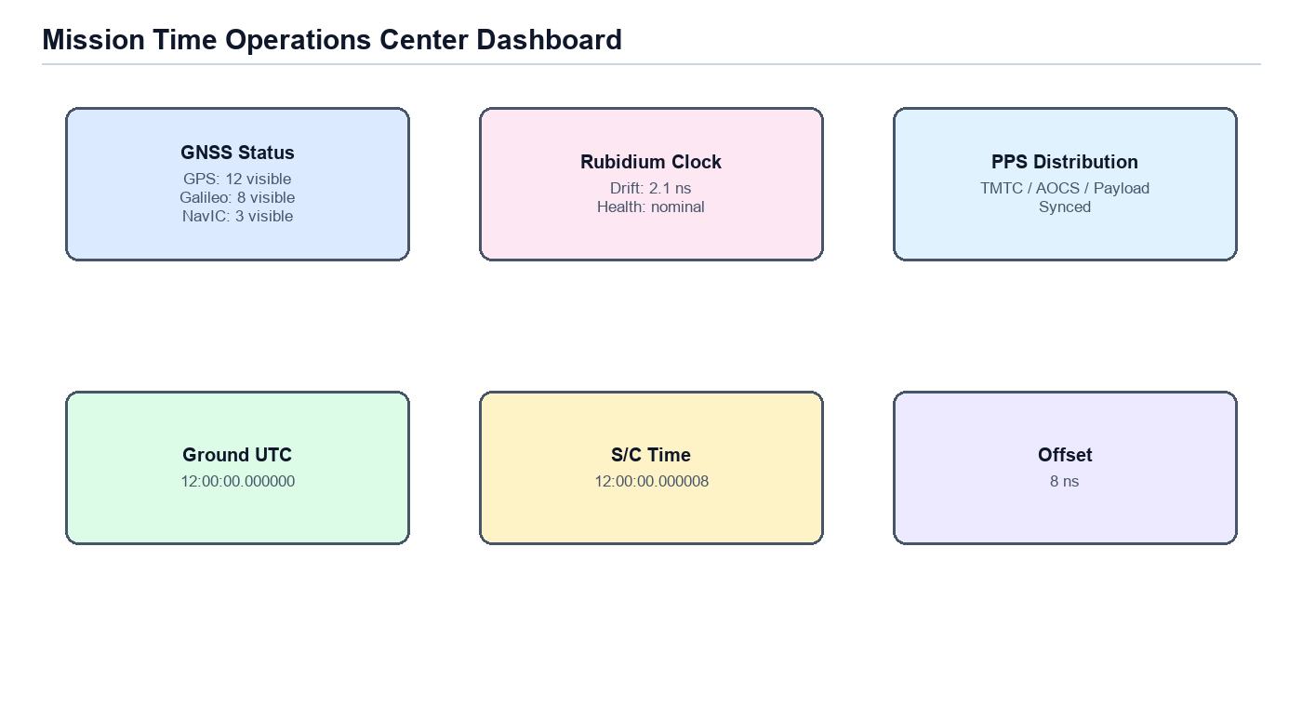

Important Design Points to Confirm
- Whether the receiver should use GPS only or multi-constellation GNSS.
- Whether the Rubidium clock is the primary onboard clock or mainly a holdover reference.
- The required timing accuracy between TMTC, AOCS, Payload and OBC.
- The assumed orbit, because GNSS visibility and propagation delay depend on orbit type.
- Whether the PPS Distribution System performs source selection and arbitration.
- Whether Version 0.2 should use simple Ground UTC comparison or include two-way time transfer.

Development Sequence
- Finalize the functional timing flow.
- Define timing sources and source selection logic.
- Build GNSS receiver and Rubidium clock models.
- Implement the Kalman-filter-based synchronization engine.
- Generate Master Spacecraft Time and PPS output.
- Add subsystem timing models and time telemetry.
- Add Ground UTC reference and clock error comparison.
- Add propagation delay and two-way time transfer in later versions.
- Build the Mission Time Operations Center dashboard.

Conclusion
The complete timing architecture includes GNSS, Rubidium, Master Spacecraft Time, PPS distribution, failure-mode handling and ground validation. The ground segment is essential because it confirms whether spacecraft time is actually correct.

