**Random Forest Metrics**

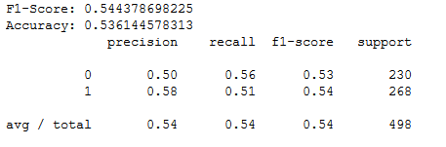

**Decision Tree**

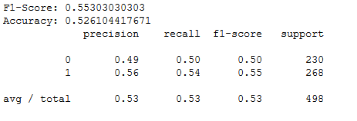

**Multinomial Logistic Regression Results**

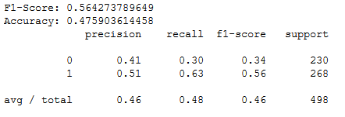

**The word tokens that affect the ‘High’ and ‘Low’ of the DJIA Stock prices**