White Space Health Call Center Text Classi cation November 12, 2015

* Project Scope

I analyzed 235,144 records from the WSH Phone Notes database table. As discussed with Hari, a number of these records spanned a signal phone conversation. Hence, I found that there were roughly 190,000 unique conversations and roughly 172,000 of those were populated with text appropriate for the classi cation. As Figure 1 below indicates, there are a total of eight class types contained in the database. For the purpose of the analysis, CONTINUED records were appended to their parent record and JUNK and OUTGOING records were ignored.

Table 1: Summary of WSH Phone Call Data Table

|  |  |  |  |
| --- | --- | --- | --- |
| Category | Count | Status | Share |
|  |  |  |  |
| APPOINTMENTS | 45,340 | Classi ed | 26.3 |
| ASK A DOCTOR | 29,607 | Classi ed | 17.2 |
| CONTINUED | 44,359 | Classi ed |  |
| JUNK | 17,237 | Ignored |  |
| LAB | 14,293 | Classi ed | 8.3 |
| MISCELLANEOUS | 34,384 | Classi ed | 19.9 |
| OUTGOING | 1,120 | Ignored |  |
| PRESCRIPTION | 48,804 | Classi ed | 28.3 |
| Total | 235,144 |  | 100.0 |
| w/o Continued | 190,785 |  |  |
| w/o JUNK & OUTGOING | 172,428 |  |  |

Figure 1: Word Distribution per Conversations

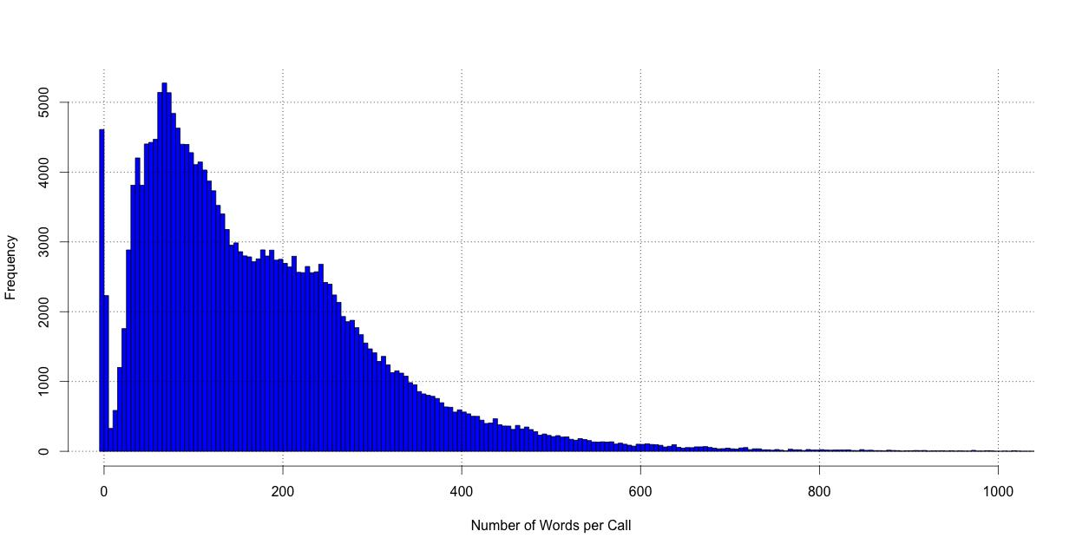

* Text Cleaning

The storage of the textual data in Rich Textual Format (RTF) presented some initial challenges, yet the conversion of the RTF into clean text in Python was fairly straightforward. However, I did make a number of adjustments, in order to make sure that the classi cation was being done in a manner consistent with the current WSH approach, including:

Ignoring the Reason for Call data in the free text eld.

Limiting the classi cation to the initial portion of the text prior to the Follow-up sections.

Client names and phone numbers were also excluded in the classi cation, as they did not represent desirable machine learning features.

Nick Waltner

White Space Health Call Center Text Classi cation November 12, 2015

* Feature Engineering

For the purpose of this Proof of Concept, the feature engineering of the textual data was rather limited using simple uni-gram and bi-gram approaches. Ideally, if this were to turn into a production system, I did notice a number of features, which could be valuable in improving accuracy further, including:

Standardizing common abbreviations such as pt for patient.

Expanding features such as date and time elds via regular expressions.

Adding tags for when speci c drugs and/or procedures are mentioned, in order to improve PRESCRIPTION accuracy.

Adding special tags for LAB speci c terms.

I examine making adjustments for the high frequency of documents with only a few words in them, as Figures 1 and 2 indicate, by excluding documents with less than 5 words, yet this did not make for a material di erence in the classi cation accuracy.

Figure 2: Word Distribution per Conversations - Cleaned Text

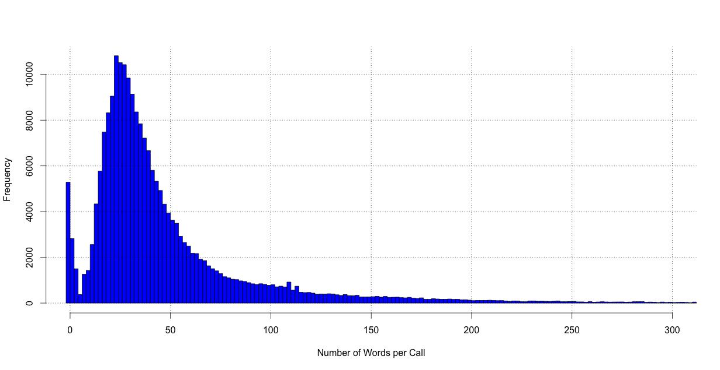

Nick Waltner

White Space Health Call Center Text Classi cation November 12, 2015

* Results

The data was broken into two datasets with roughly 84% of it for training and 16% for test purposes. Additionally, a number of tests were run to examine a number of two assumpitons with the data as detailed below in Table 2. The rst two rows labelled as Base Case for Features represent my best understanding of the current text being used to classify the WSH data. As such, the classi er was able to achieve roughly 75% accuracy using either uni- or bi-grams in the Test dataset. As is typical with higher n-grams models, in this case with a bi-gram approach, a much higher ac-curacies were achieved in the Training dataset, yet with roughly the same results in Test, as over tting tends to occur.

I then moved on to classify the data by testing two variations with the textual data. In the with Summary case, I have included the SUMMARY eld into the classi cation text, as it would seem logical to add it to the classi cation, much like using article titles in the nancial press to determine overall article content. Adding this text turns out to be quite useful in raising the Test accuracy to nearly 80%. Finally, I re-estimated the classi er allowing all text from the entry into the classi cation, even if it were of a follow-up nature. As one can see, adding more text actually worsens the results slightly, as the extra text does little to explain the reason for the call.

Table 2: Summary of WSH Phone Call Classi cation Results

|  |  |  |  |  |
| --- | --- | --- | --- | --- |
|  |  | Accuracy (%) | |  |
|  |  |  |  |  |
| N-Gram | Features | Train | Test |  |
|  |  |  |  |  |
| 1 | Base Case | 79.1 | 75.6 |  |
| 2 | Base Case | 96.2 | 74.4 |  |
| 1 | with Summary | 83.3 | 78.3 |  |
| 2 | with Summary | 98.4 | 78.0 |  |
| 1 | with Summary & Full Text | 84.1 | 78.4 |  |
| 2 | with Summary & Full Text | 99.0 | 77.5 |  |

Below, I provide the confusion matrix for the best model, namely the Uni-gram approach allowing the Summary Data to be used in the classi cation. As one can, there is strong clustering along the diagonal of the confusion matrix, which is to be expected for a robust model. The most accurate predictions are for Ask-A-Doctor and for Lab work, which seems intuitive. The Miscellaneous category seems to be causing the greatest number of false positives and false negatives especially with Appointments.

Table 3: WSH Phone Call Confusion Matrix for Using Unigrams and Summary Field Data

|  |  |  |  |  |  |  |
| --- | --- | --- | --- | --- | --- | --- |
| Class | APPTS | ASK A DR | LAB | MISCELL. | PRESCR. | Total |
|  |  |  |  |  |  |  |
| APPOINTMENTS | 7,701 | 503 | 112 | 625 | 112 | 9,053 |
| ASK A DOCTOR | 282 | 3,918 | 86 | 433 | 344 | 5,063 |
| LAB | 267 | 180 | 3,129 | 427 | 160 | 4,163 |
| MISCELLANEOUS | 596 | 663 | 231 | 4,716 | 348 | 6,554 |
| PRESCRIPTION | 153 | 480 | 83 | 431 | 2,989 | 4,136 |
| Class Accuracy | 85.1 | 77.4 | 87.5 | 72.0 | 72.3 |  |

* Conclusion

This basic analysis has established that a high degree of accuracy can be achieved without manual curation of the call center data. If there were interest in putting this system into production, I recommend that features previously discussed in this write-up be added to the classi cation model. With further feature engineering and error analysis on the confusion matrix, I believe that automated accuracy would reach into the low 80% range. Accuracy could be raised further with further manual curation for low probability classi cations, where there is confusion between the ve classes. Further, a topic model to re-evaluate the classes choices could be examined, especially with respect to the sub-classi cations, which I have left for future work.

Nick Waltner