Vinoth V

38120093

B. Tech Information Technology

2018 – 2022

Machine Learning {Cycle-1}

SCS4305 – Python Programming and Machine Learning Lab

## Exercise 1 (a):

# Handling Input and Output

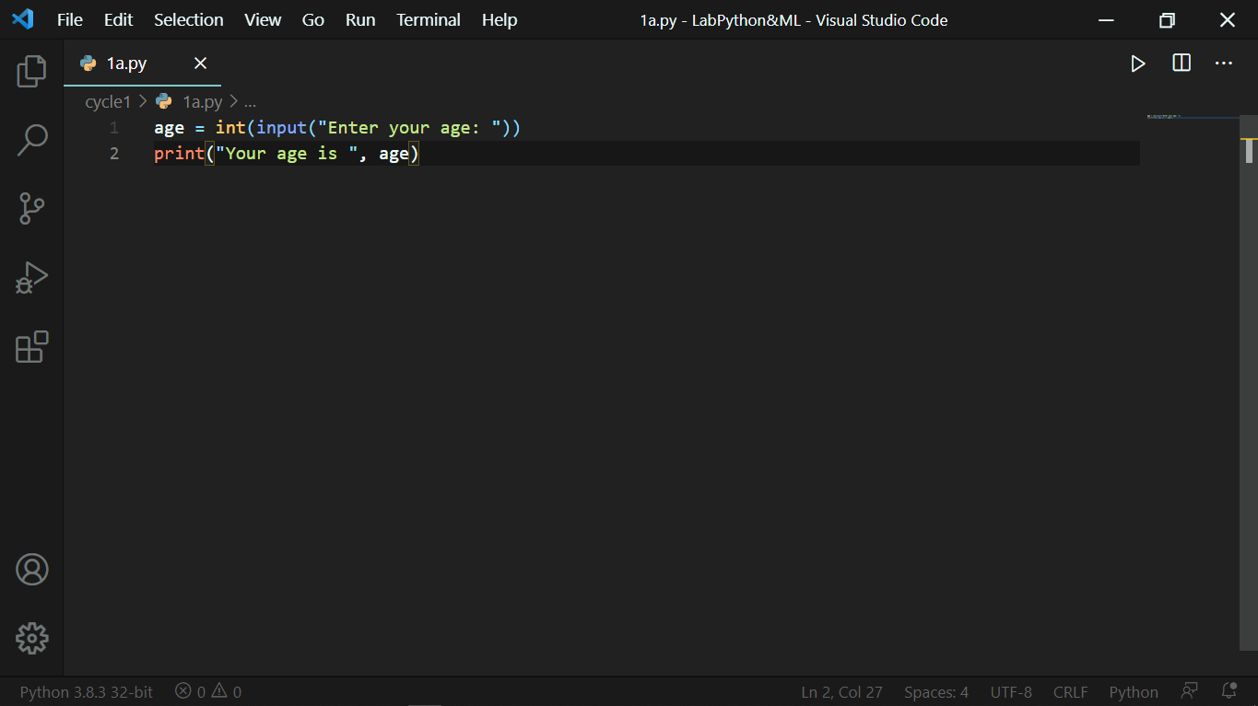

*Output:*

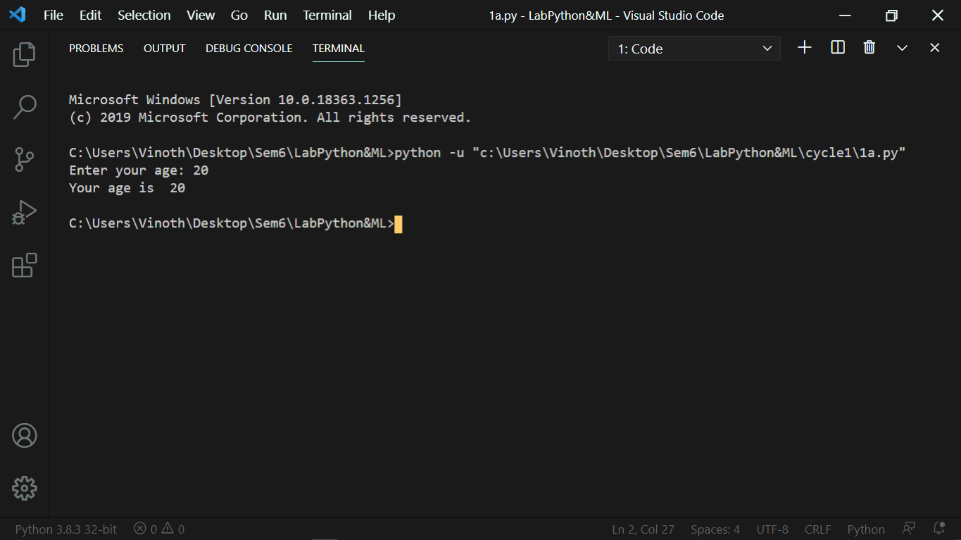

## Exercise 1 (b):

# Looping Constructs

*Output:*

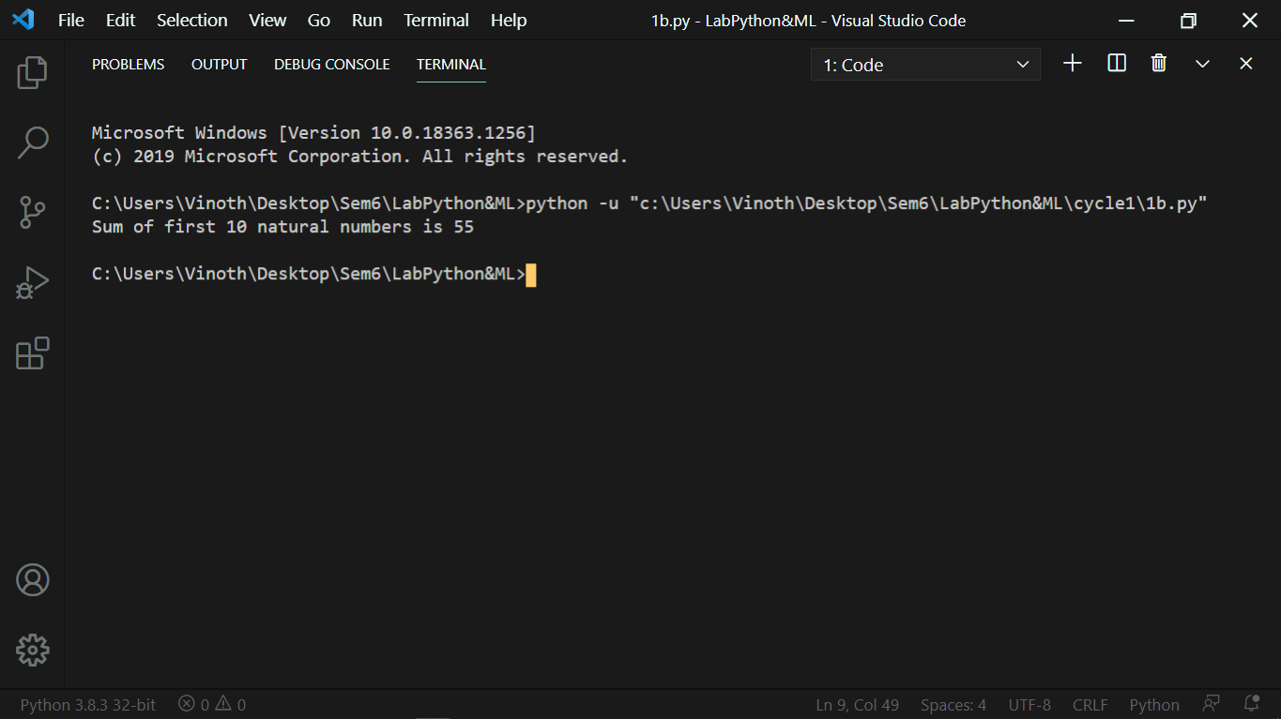

## Exercise 1 (c):

# Arrays, Lists and Sets in python.

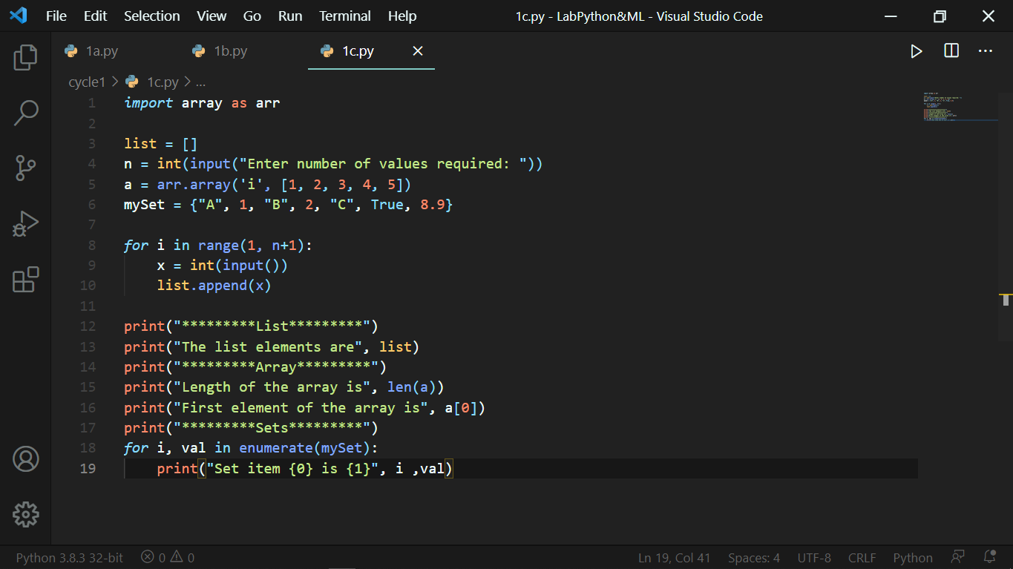

### Output:

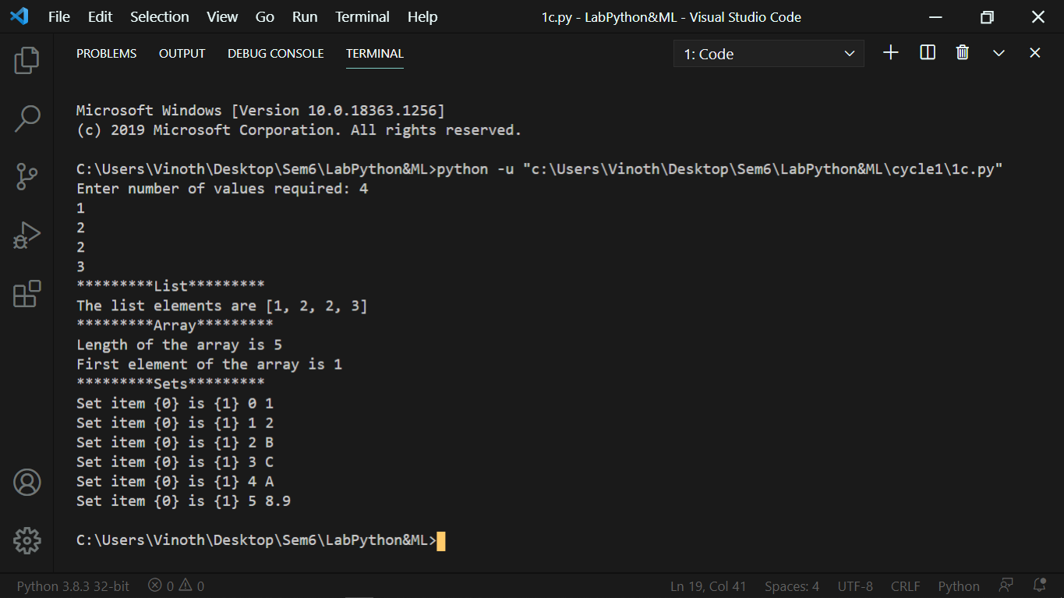

## Exercise 2 (a):

# Modules and Functions in Python.

## 

### Output:

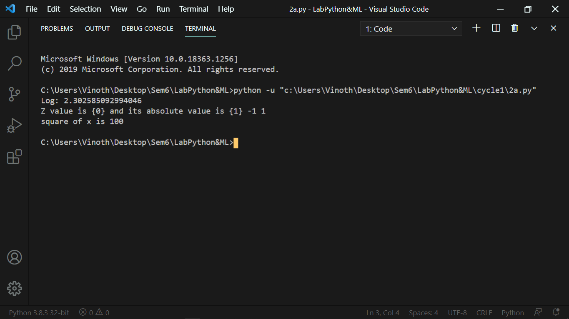

## Exercise 2 (b):

# File Handling in Python.

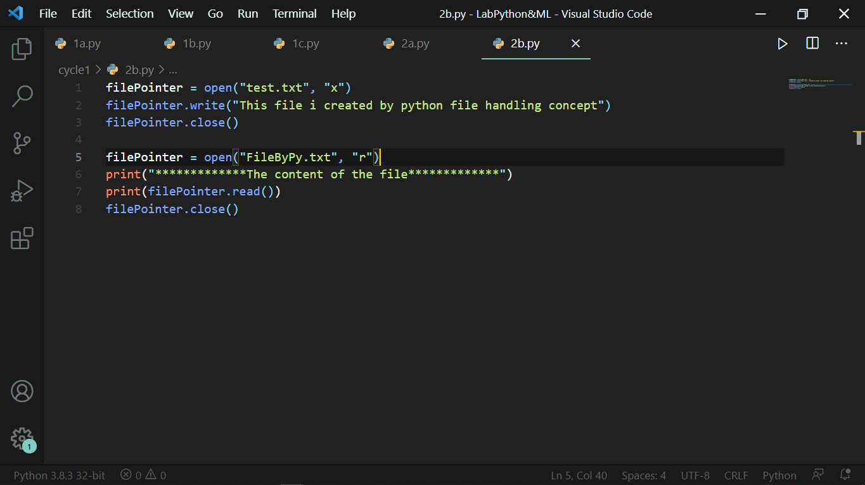

### Output:

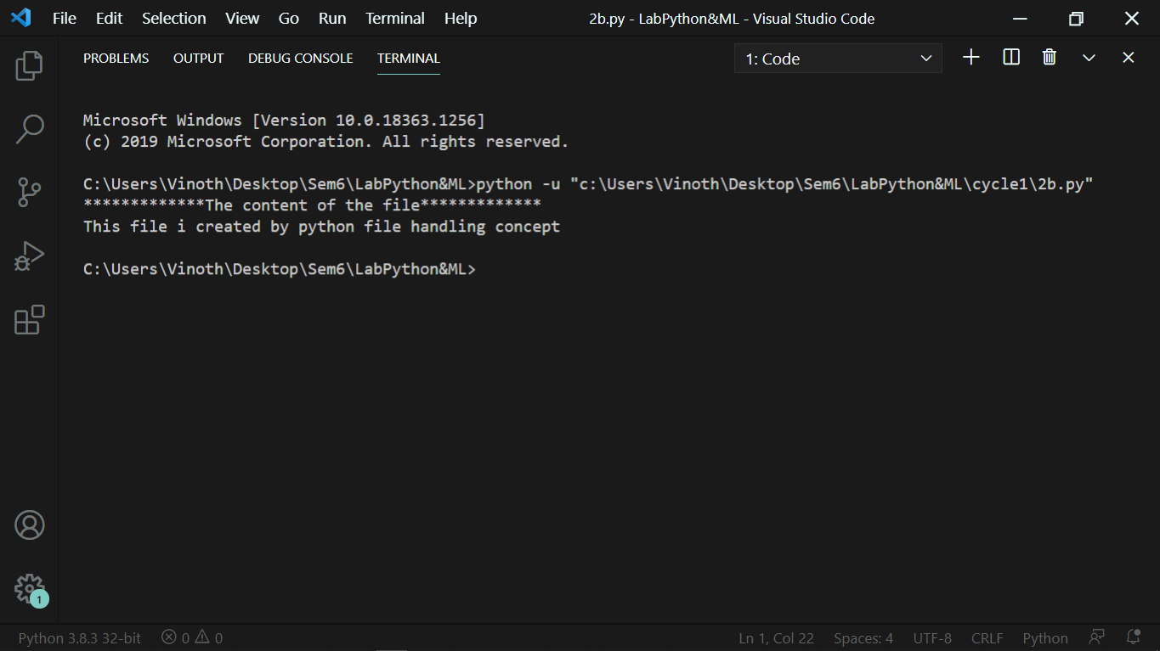

## Exercise 2 (c):

# Exception Handling in Python

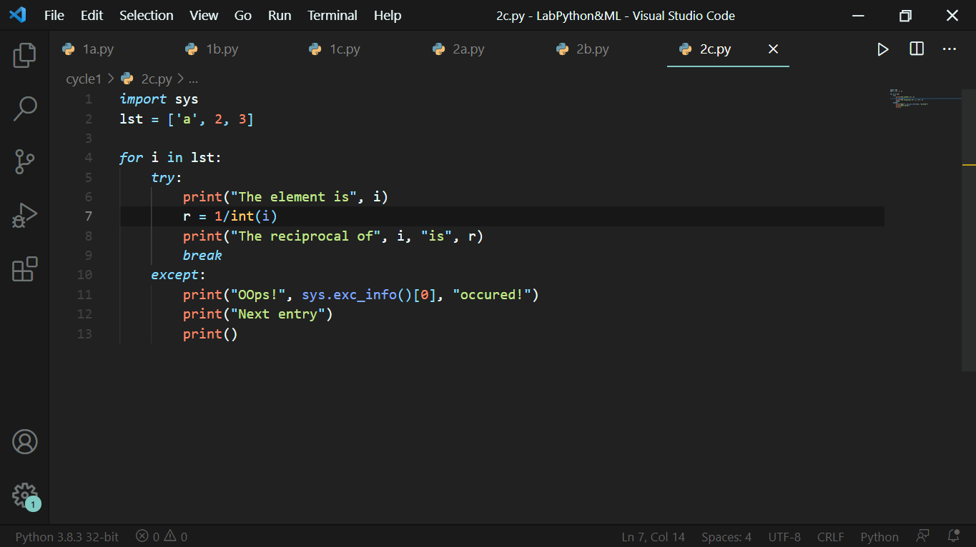

### Output:

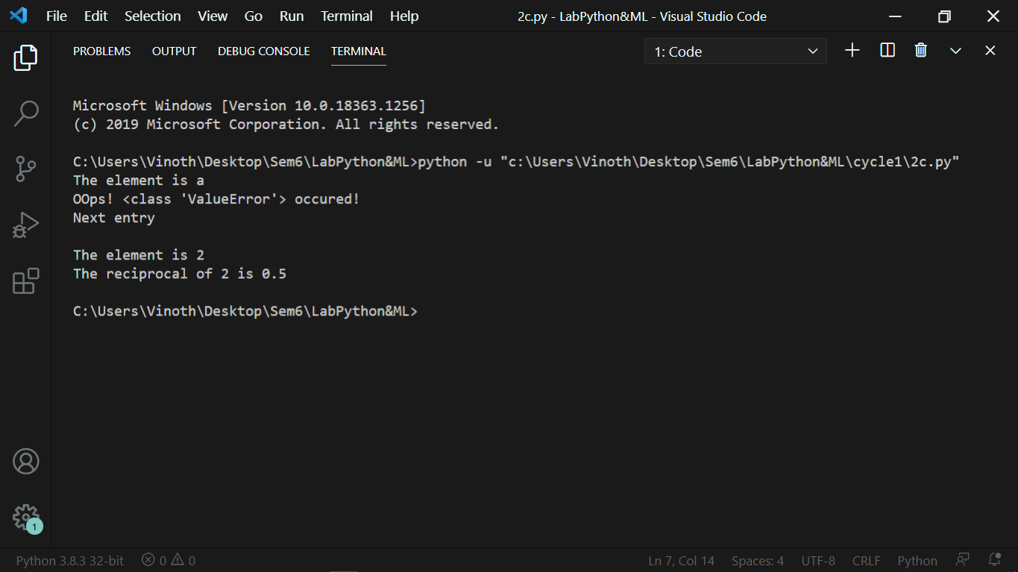

## Exercise 3:

# Finding the second highest value from the given list

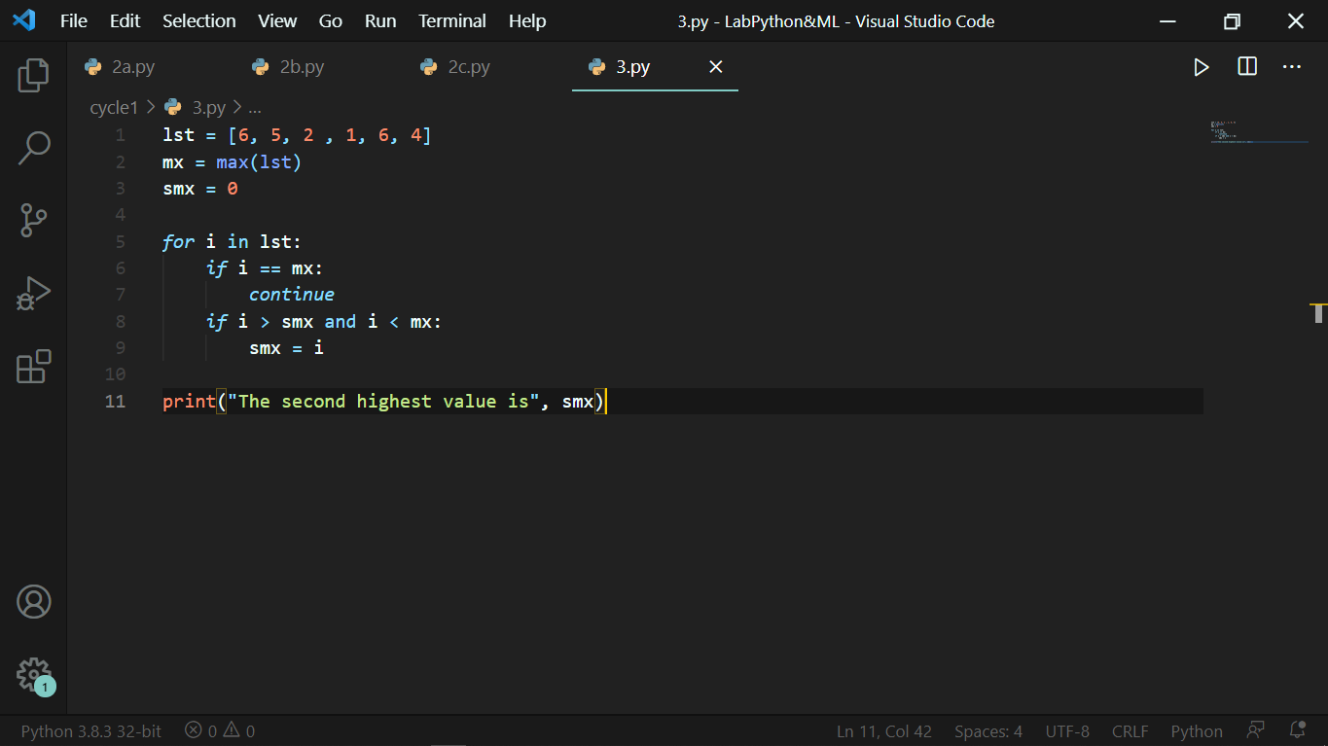

### Output:

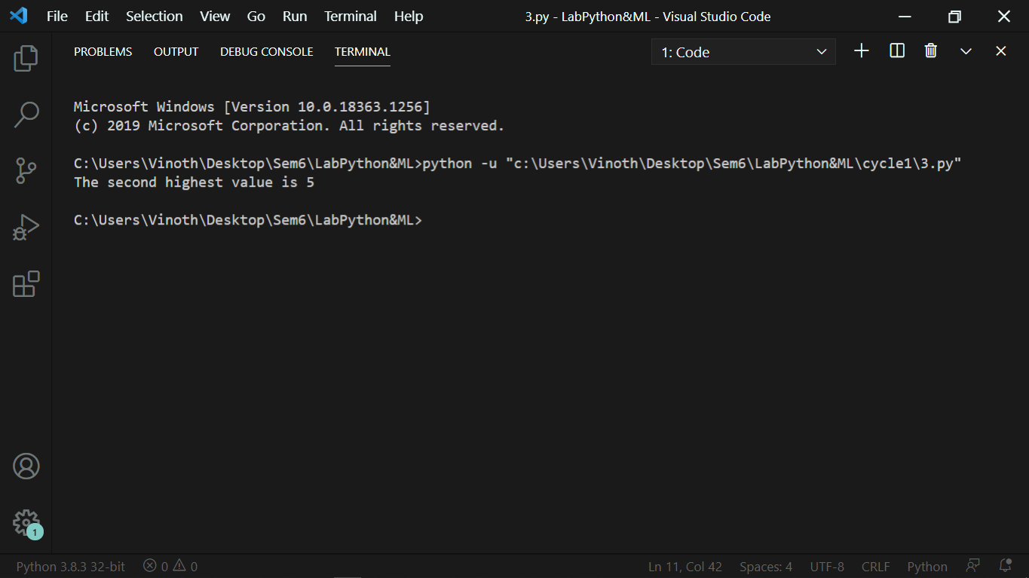

## Exercise 4:

# From the given string, find the number of special characters, numbers, alphabets, lower and upper case letters.

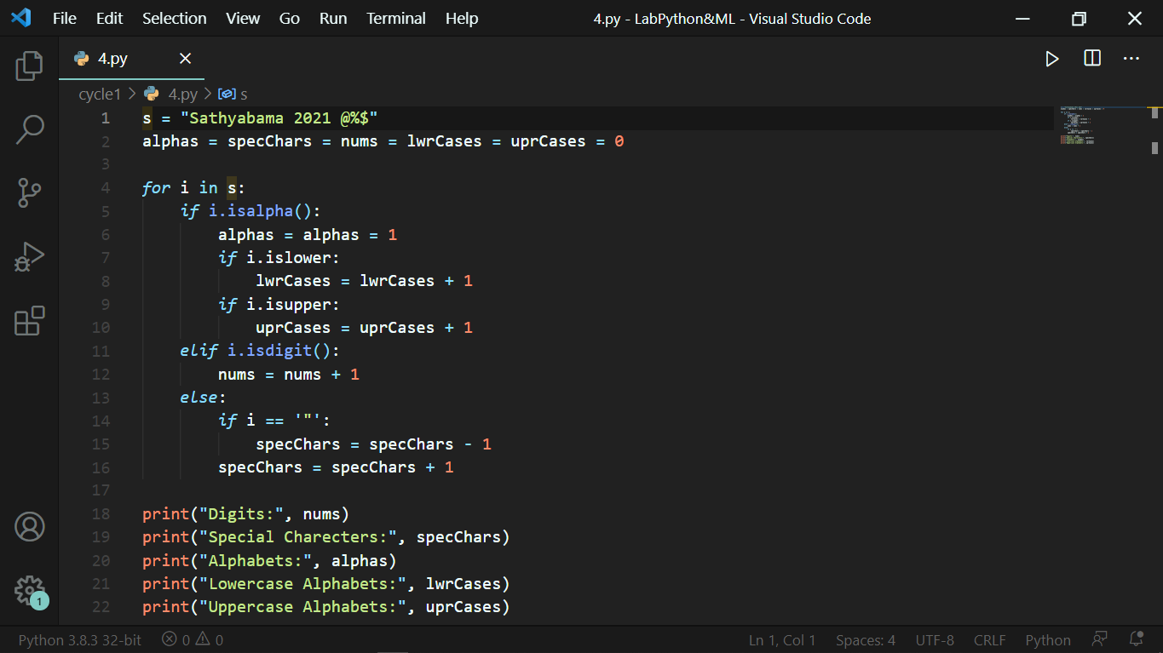

### Output:

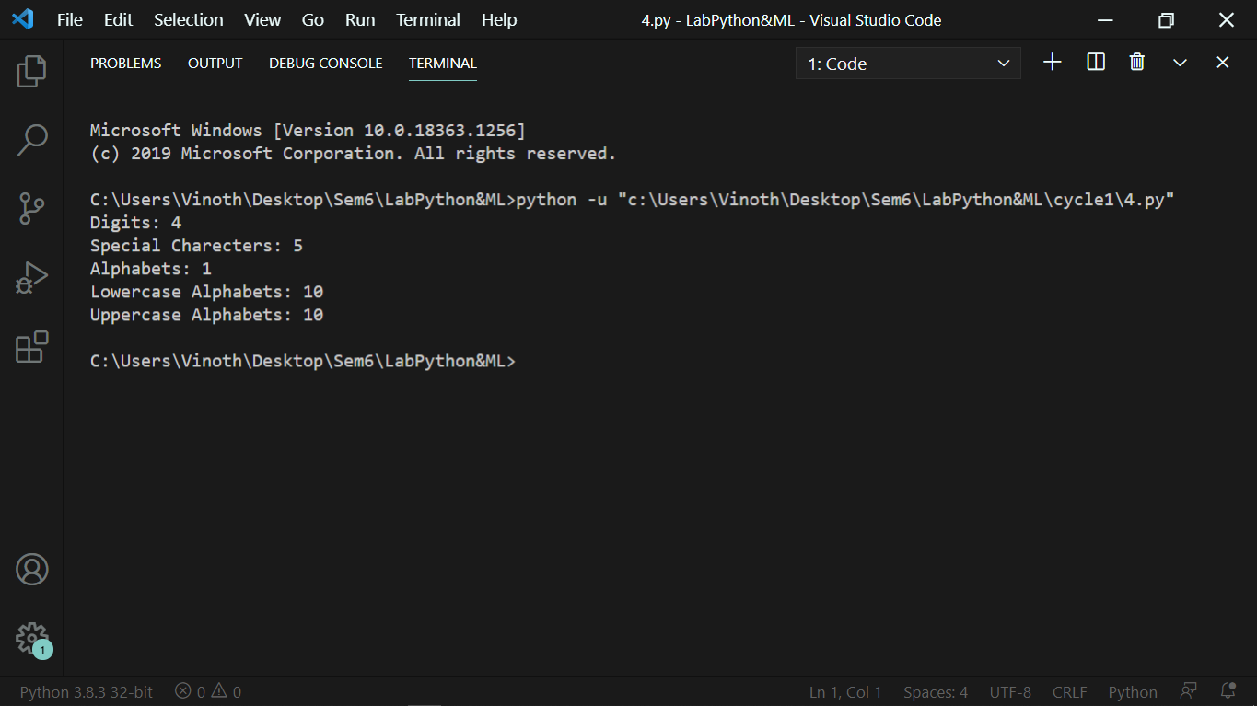

## Exercise 5:

# For the given input string(s) and width(w), Wrap the given text with the width.

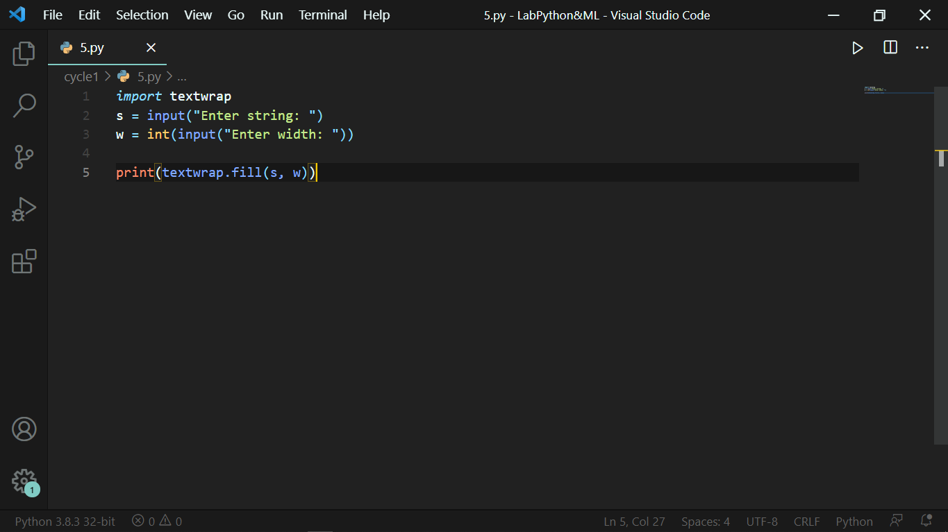

### Output:

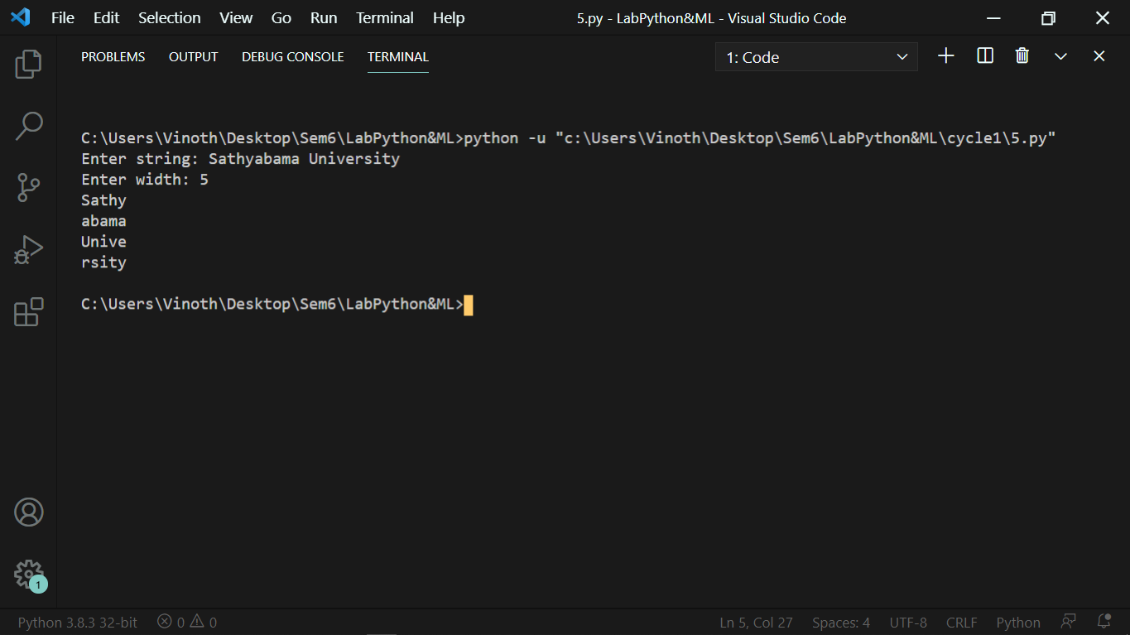

## Exercise 6:

# Print the string “Welcome”. Matrix size must be N X M ( N is an odd natural number and M is 3 times of N). The design should have “WELCOME” in the center. The design pattern should only use [ |, ., -]

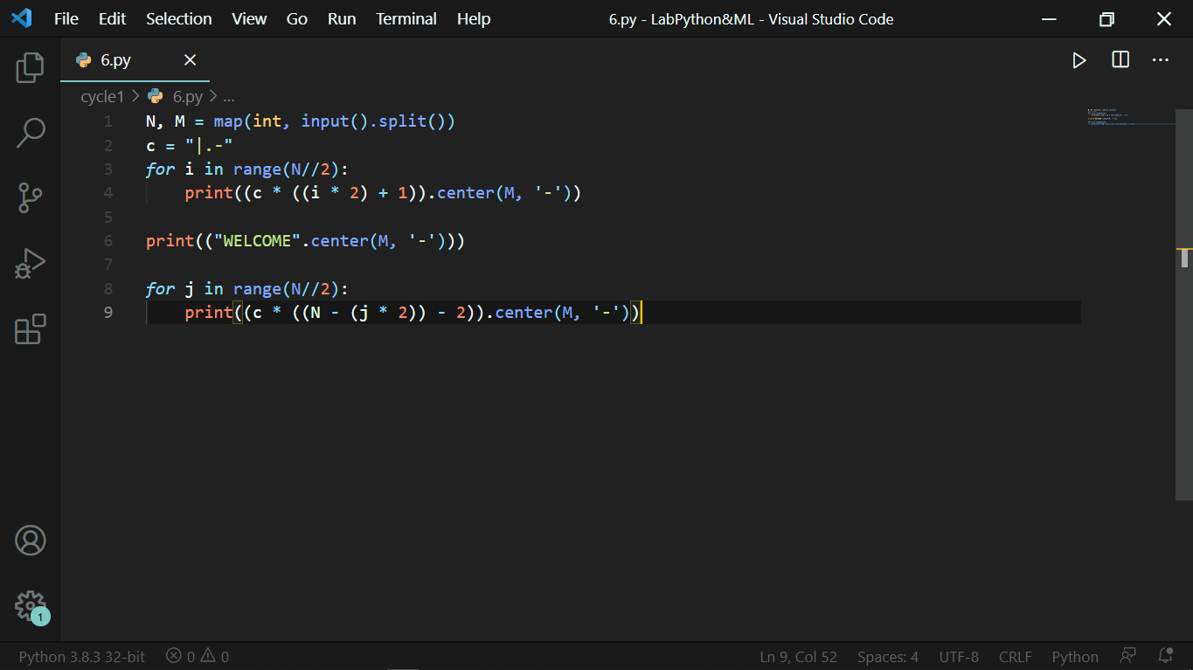

### Output:

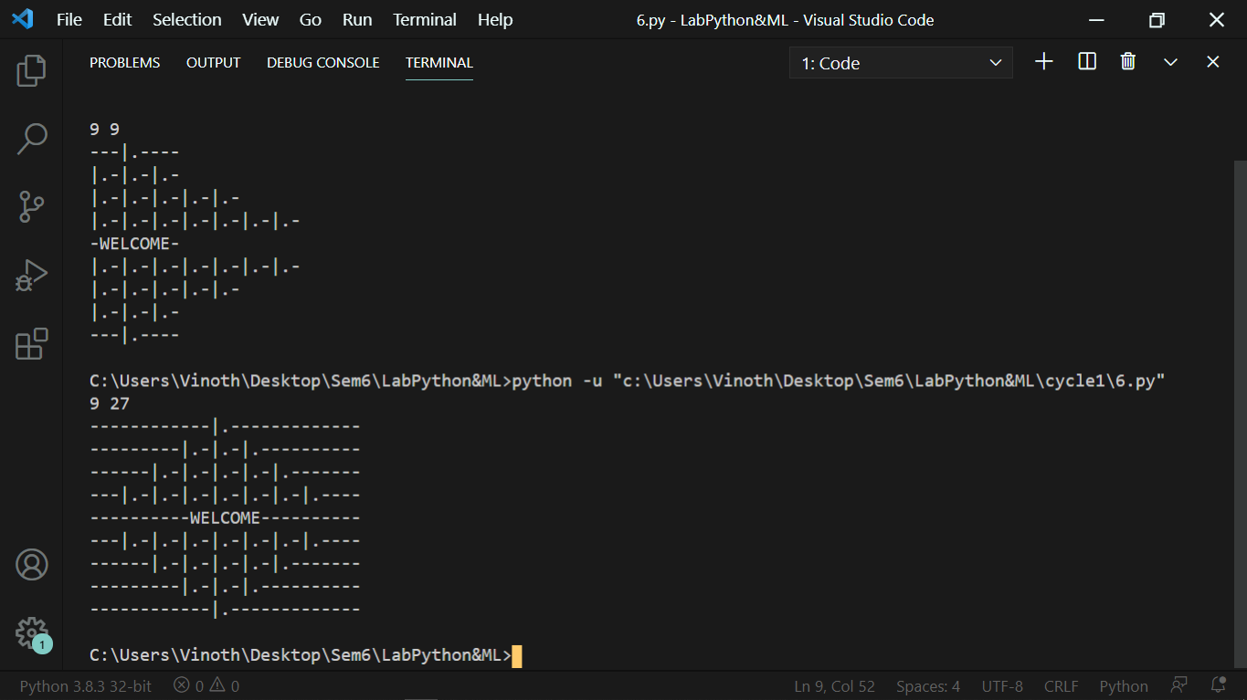

## Exercise 7:

# Consider a function f(X) = 3X. Input is ‘N’ lists. Each list contains ‘M’ Elements. From the lists, Find the maximum element. Also, compute:

# S = (f(X1) + f(X2) + … + f(Xn)) modulo Z

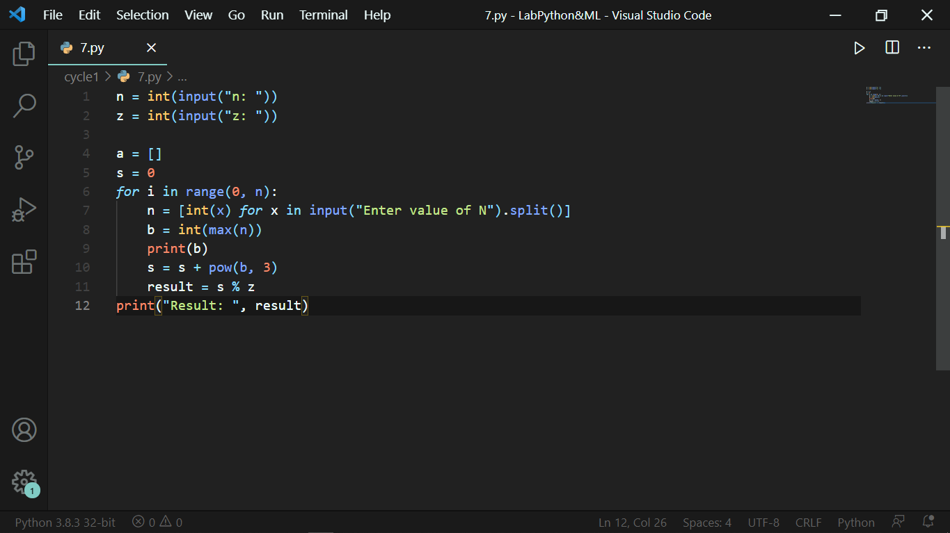

### Output:

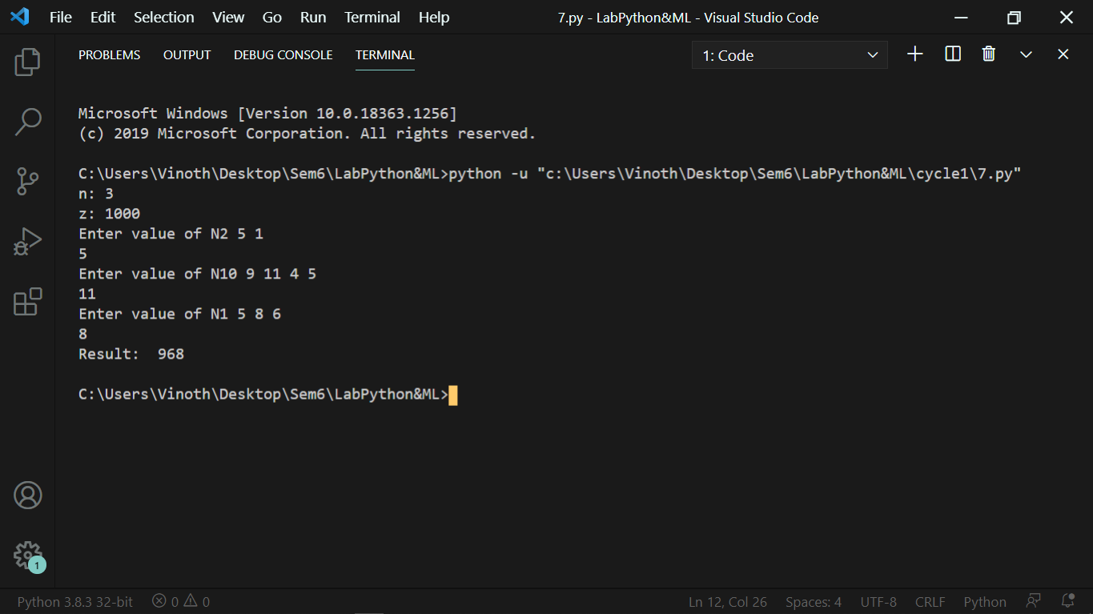

## Exercise 8:

# Validate the credit numbers based on the following:

# Begins with 4, 5, or 6

# Contains exactly 16 digits

# Contains only numbers ( 0 – 9 )

# For every 4 digits hyphen may be there ( Not mandatory )

# No Special characters are permitted

# Must not Have 4 or more consecutive same digits

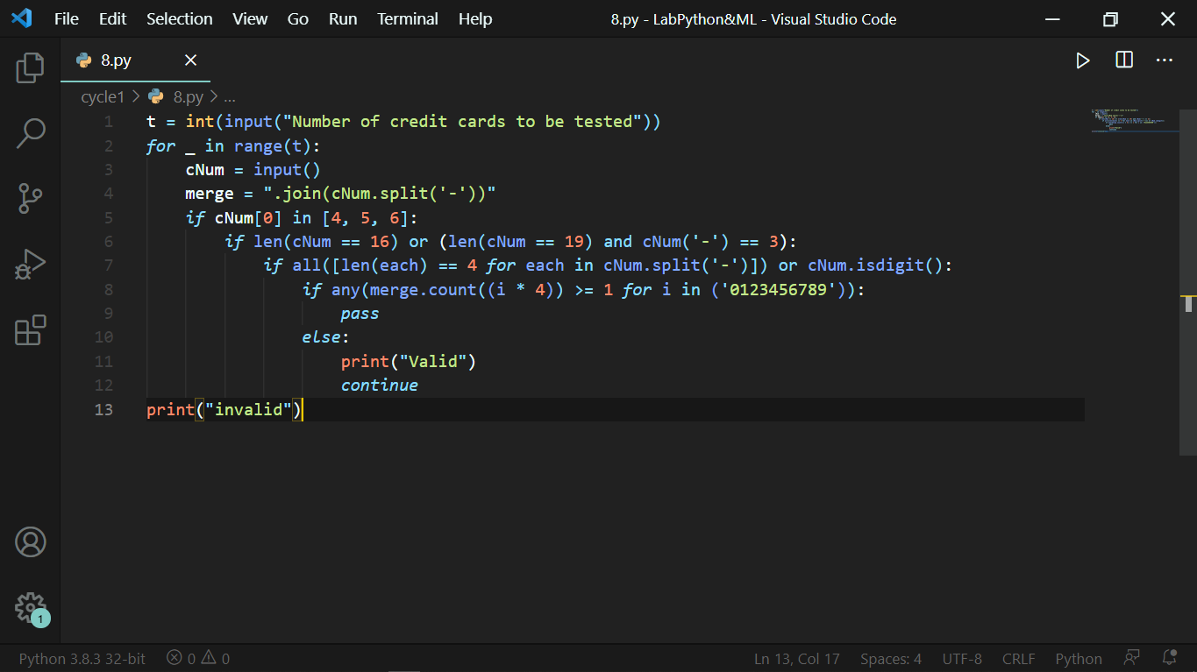

### Output:

