Vinoth V

38120093

(Cycle 2)

(Experiments 14, 15, 16)

Python Programming and Machine Learning Lab

Ex 14:

A robot moves in a plane starting from point (0, 0). The robot can move toward original point Up, Down, Left, Right. The trace is as follows,

Up 5

Down 3

Left 3

Right 2

Write a program to compute the distance from the current position after sequence of moves.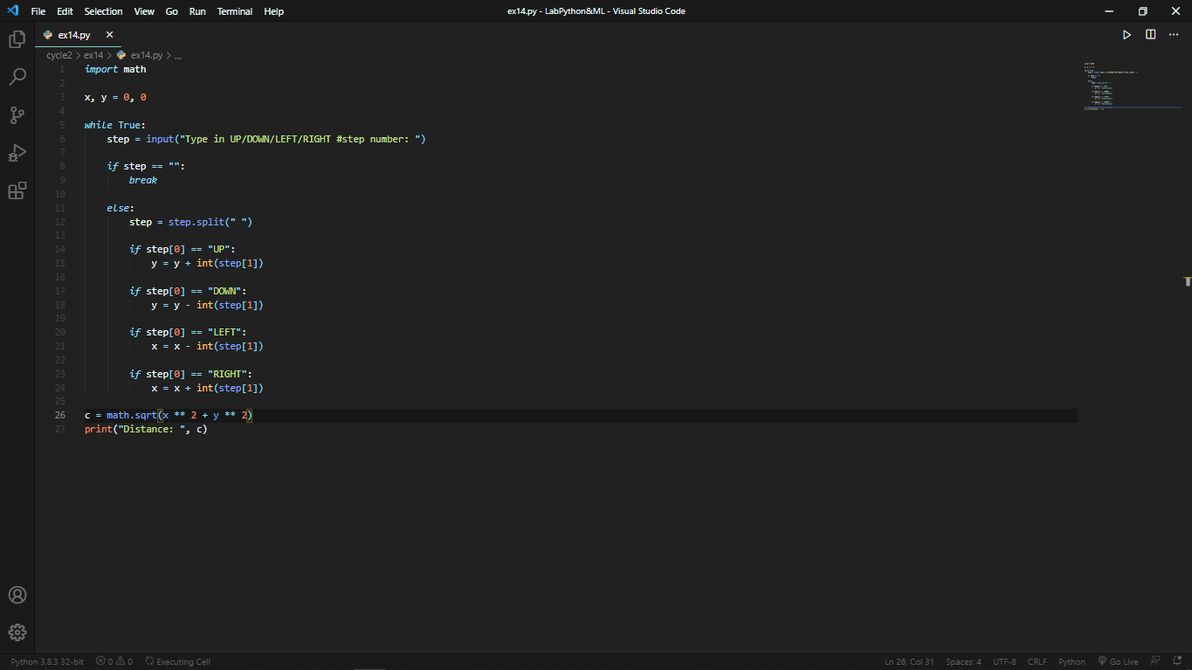

Output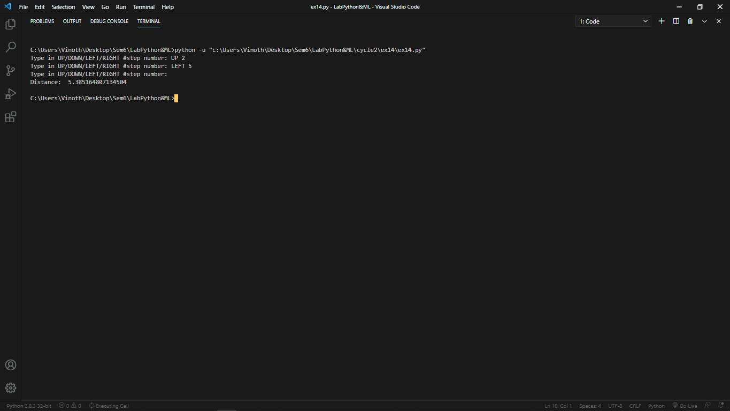

Ex 15:

Make a Grocery List for super market shopping with name, price and quantity; if the list already   contains an item then only update the price and quantity it should not append the item name again. Ask user his/her budget initially and minus the budget after adding a new item in the list. If budgets go zero/0 then no more item could be bought and if some money left and user add item greater than budget left then inform “over price” or any other message. After the list is made any money left in the budget it should show an item within the budget from the list made.

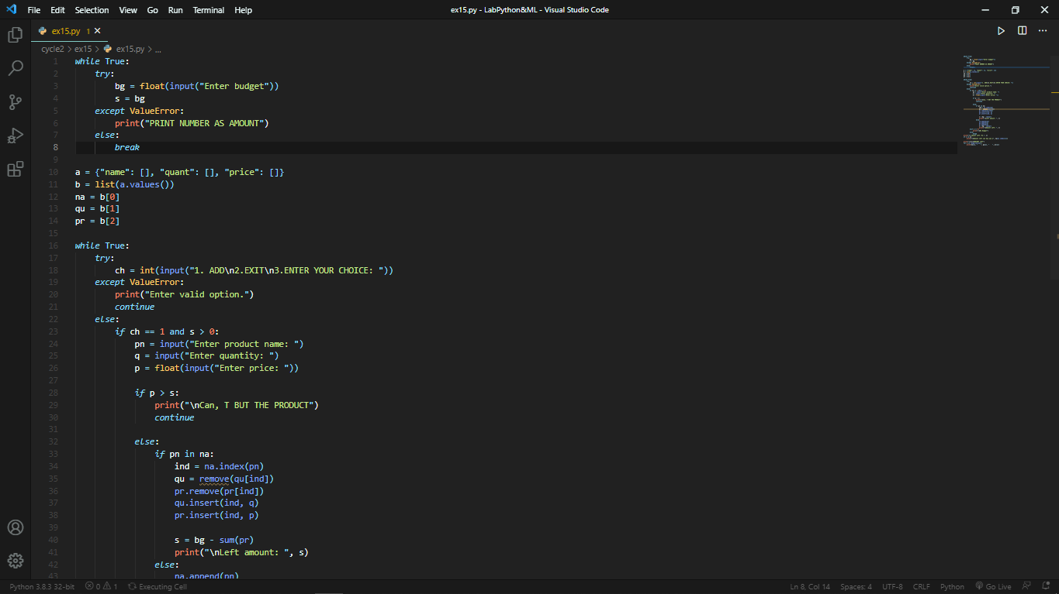

Output:

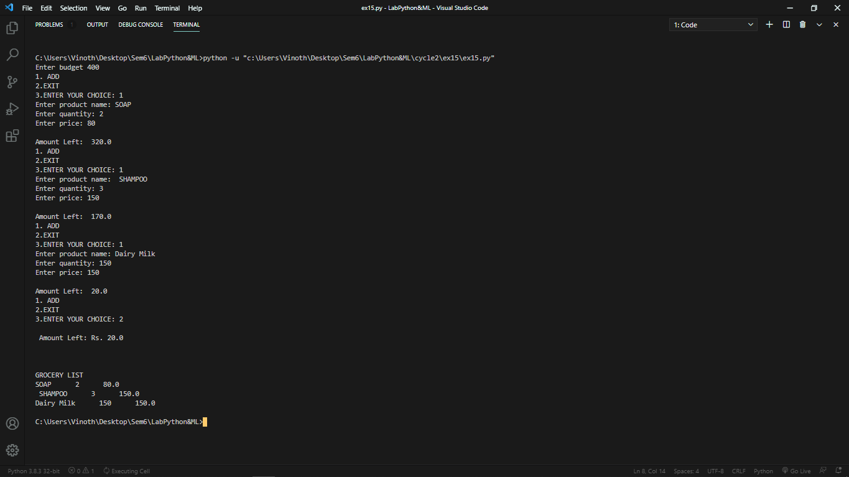

Ex 16:

Create a scatter plot using sepal length and petal width to separate the Species classes.

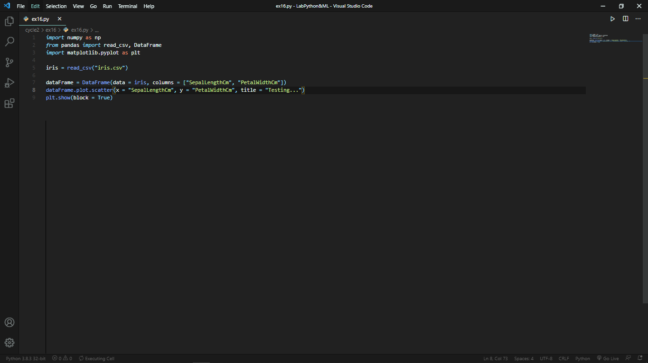

Output:

