Vinoth V

38120093

B. Tech Information Technology

2018 – 2022

Machine Learning {Cycle-1}

SCS4305 – Python Programming and Machine Learning Lab

## Exercise 01:

Printing the contents of the file as row into columns and columns into rows.

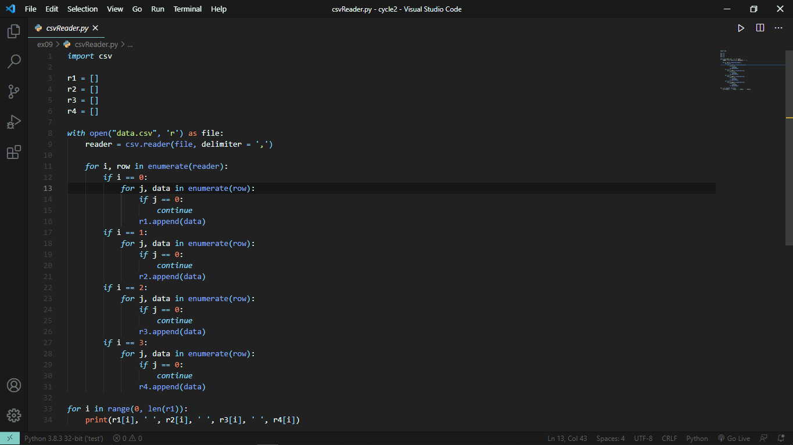

Output:

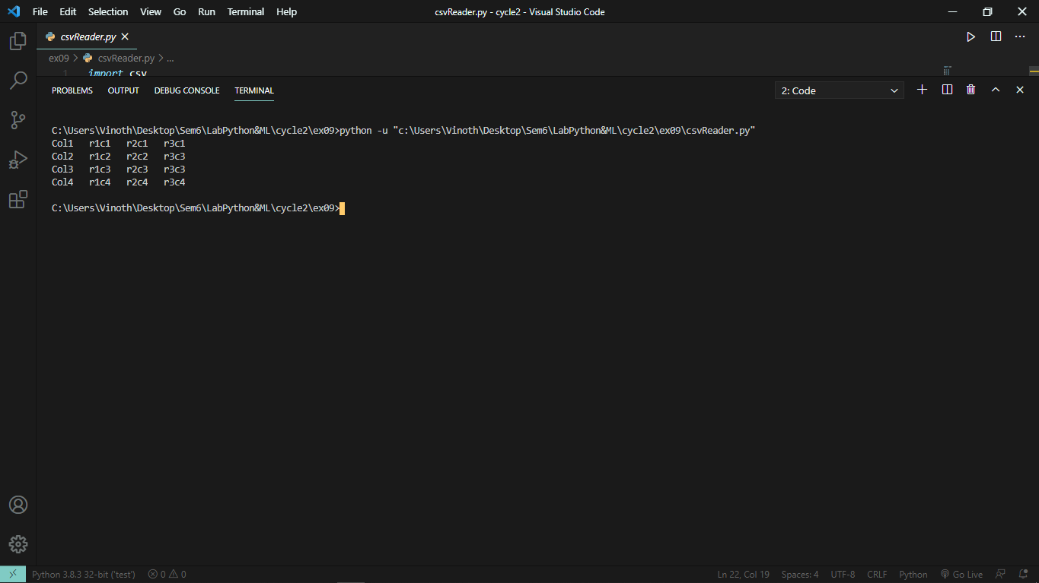

## Exercise 02:

Write a function evenDigits(lower, upper) which finds all numbers between those two (including those two) such that all the digits of the number is even.

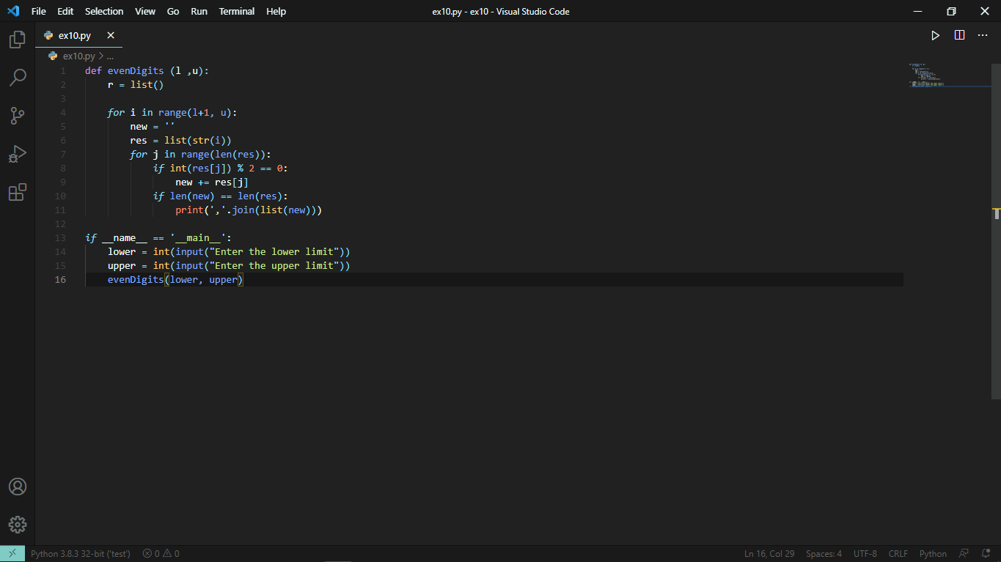

Output:

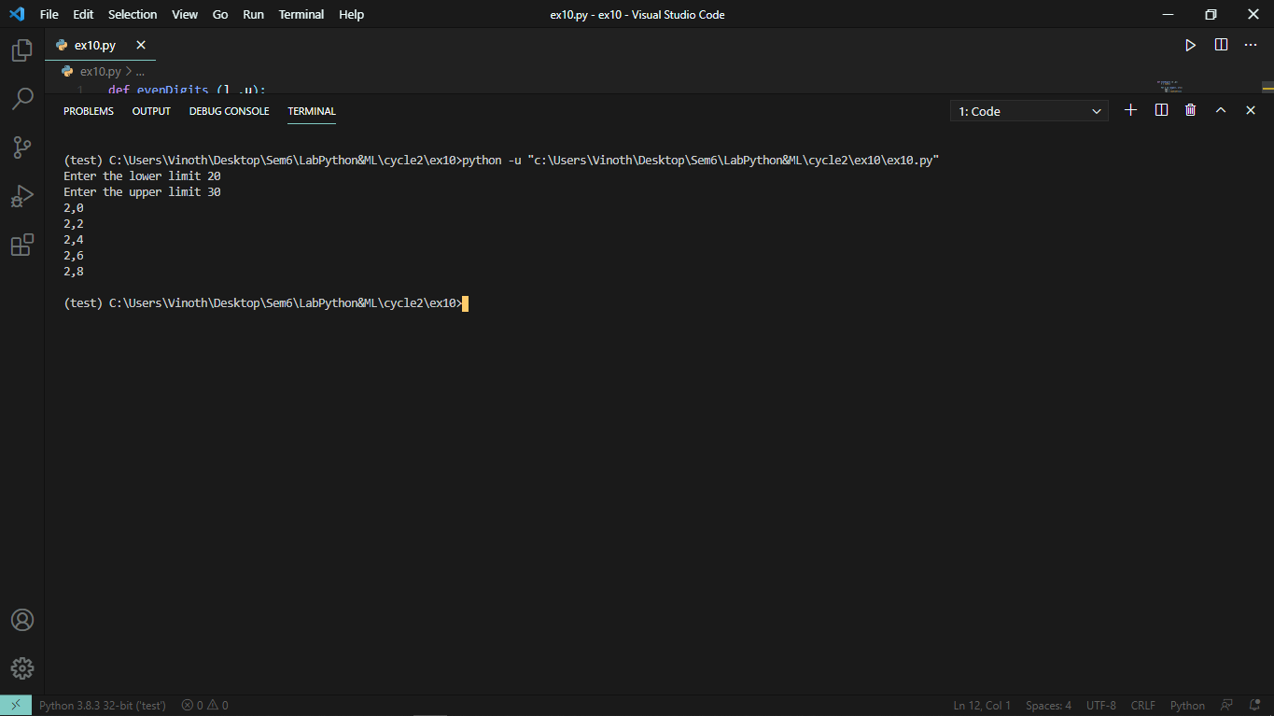

## Exercise 03:

Getting and Printing N number of lines from a file in python.

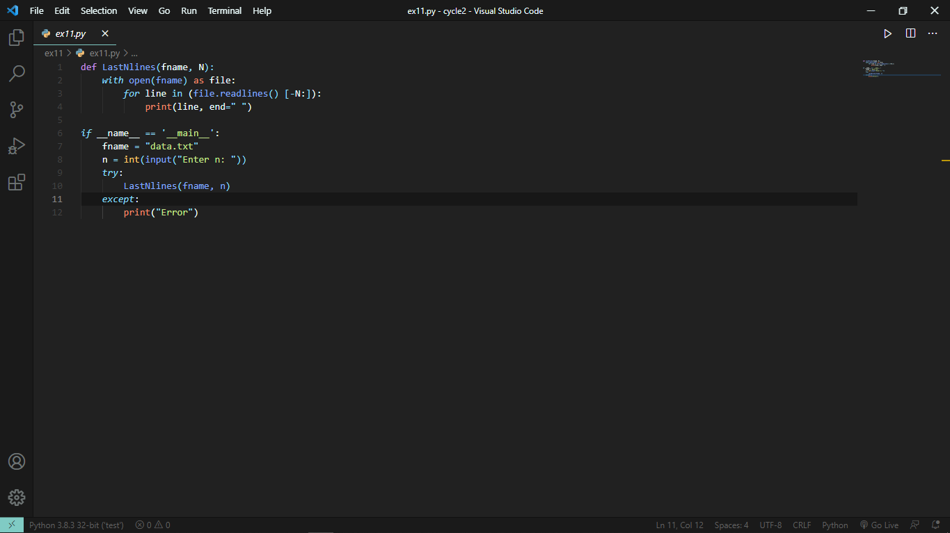

Output:

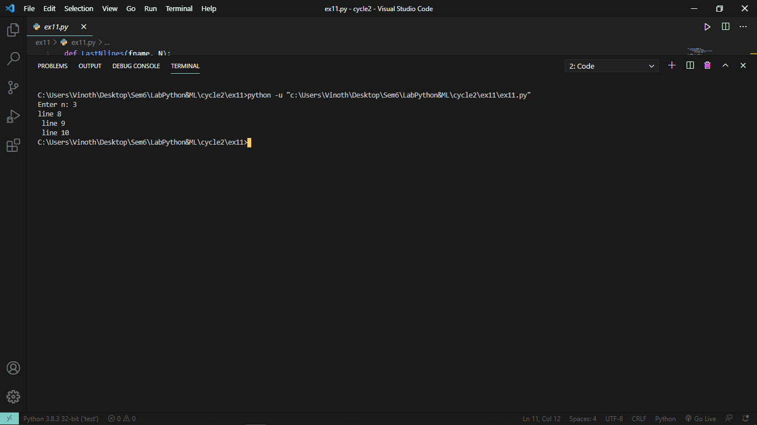

## Exercise 04:

Counting the frequency of words in an external file in python.

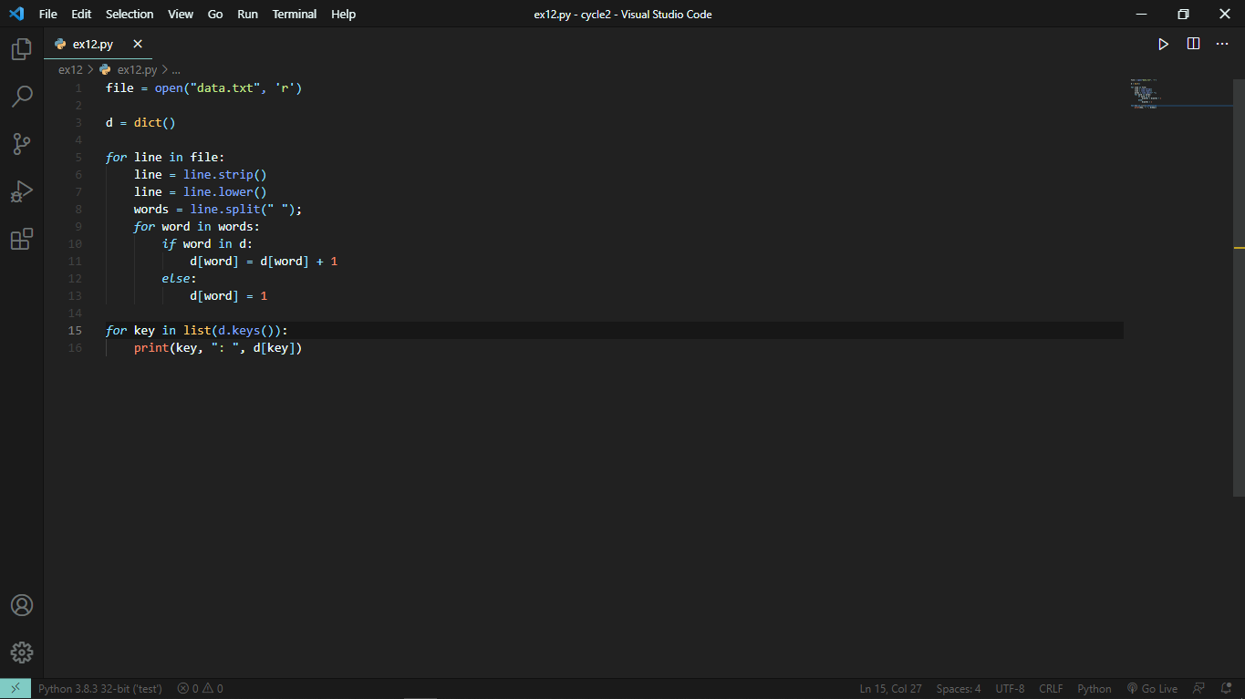

Output:

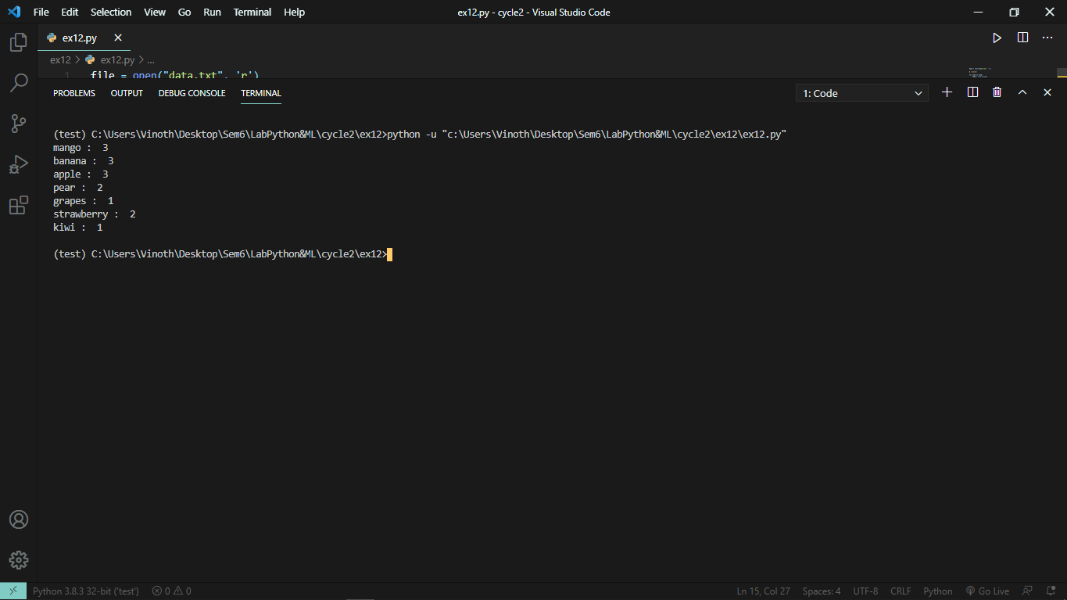

## Exercise 05:

Write a program that accepts sequence of comma separated sequence of 4 digit binaries and check whether are divisible by 5, If so, then print it in comma separated sequence.

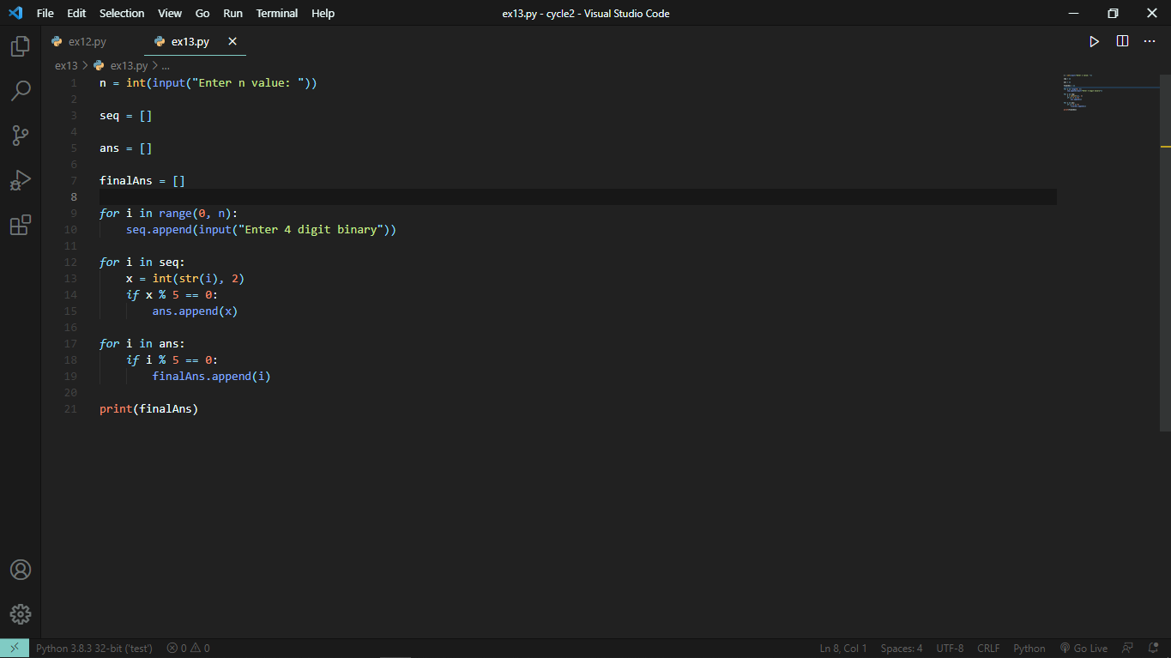

Output:

