Vinoth V

38120093

Machine Learning and Python Lab

Ex 18:

 Read the data set, Remove the Twitter Handles, Remove Punctuation, Numbers and Special Characters, Remove words of length less than or equal to three, Tokenize the Words, Process Word Stemming

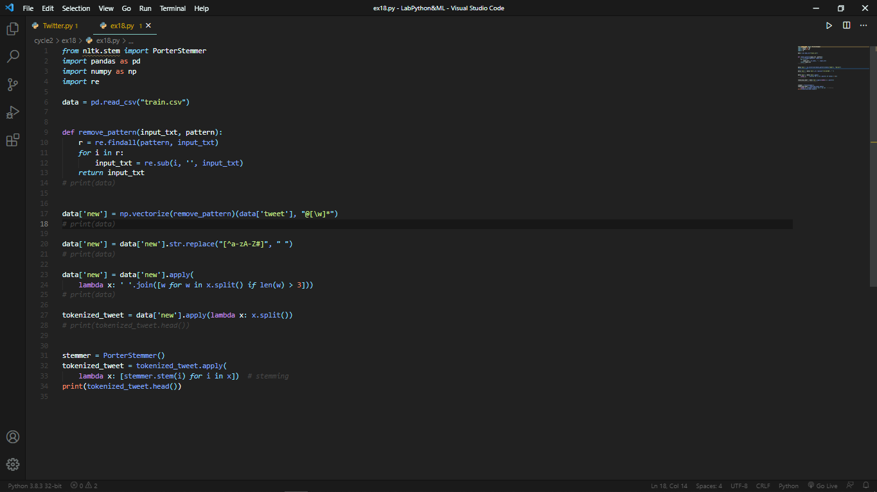

Output:

