**Vinoth V**

38120093

Python Programming and Machine Learning Lab

B. Tech IT

Ex 20:

Evaluating the results of machine learning algorithms. Calculating Confusion_matrix, Accuracy, Precision, Recall, Sensitivity, Specificity.

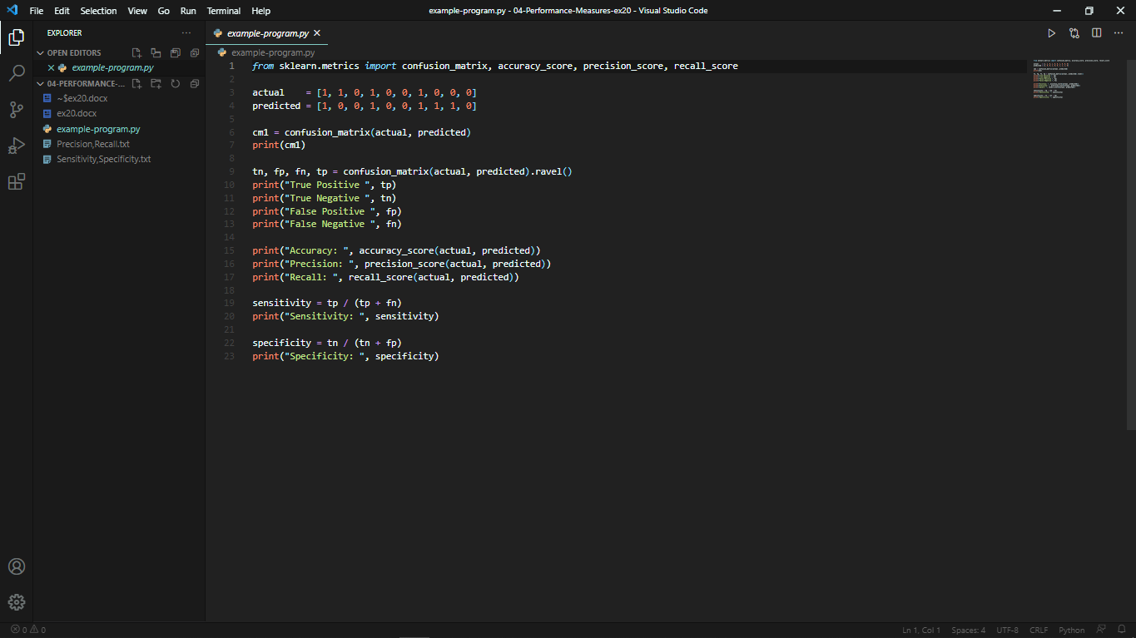

Output:

