Vinoth V

38120093

Python Programming and Machine Learning Lab

B. Tech IT

Ex 21:

*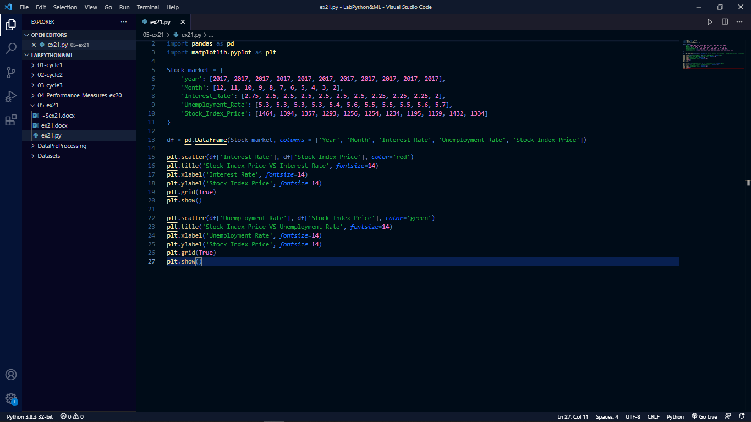*

Output:

*