# Vinoth V

38120093

IIIrd Year,

IT B sec.

Experiment 17

Data Preprocessing

## Python and Machine Learning Lab

Program:

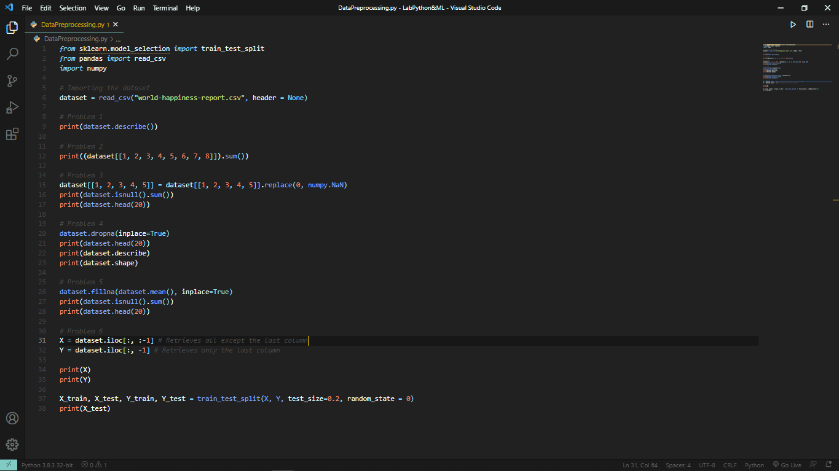

Output:

