**Indigo Enhancements**

**HOTAC**

**Revision History**

|  |  |  |  |
| --- | --- | --- | --- |
| **Revision Level** | **Date** | **Author** | **Changes Made**  **(Include Change Request # if applicable)** |
| 1 | 15-07-2021 | Yohapriya Vairaperumal |  |
|  |  |  |  |

**Table of Contents**

1. Problem Statement 4

2. Assumptions 4

3. Existing System and Design 4

4. Proposed Design 8

4.1 RLLH Configuration 8

4.2 Early Checkout 9

5. Component List 12

6. Messages 12

7. Configuration Changes 12

8. External Interfaces 12

9. Internal Interfaces 12

10. Technology Stack…….……………………………………………………………………………………………………………………………………………. 12

# Problem Statement

* **Current RLLH configuration is not more customizable.**
* Currently RLLH configuration has crew rank, crew qualification, from and to date, total nights for configuration.
* RLLH configuration to be enhanced to make it more customizable.
* **Early checkout option is available without date selection.**
  + - There is an option to define early check out for an individual crew member. User to be able to define whether entitlement is for consecutive nights or for total hotel nights (only count nights where crew are in the station and require hotel) at the relocation station

# Assumptions/Constraints

N/A

# Existing System and Design

* **Current RLLH configuration.**
* Currently RLLH configuration has crew rank, crew qualification, from and to date, total nights for configuration.

**Existing:**

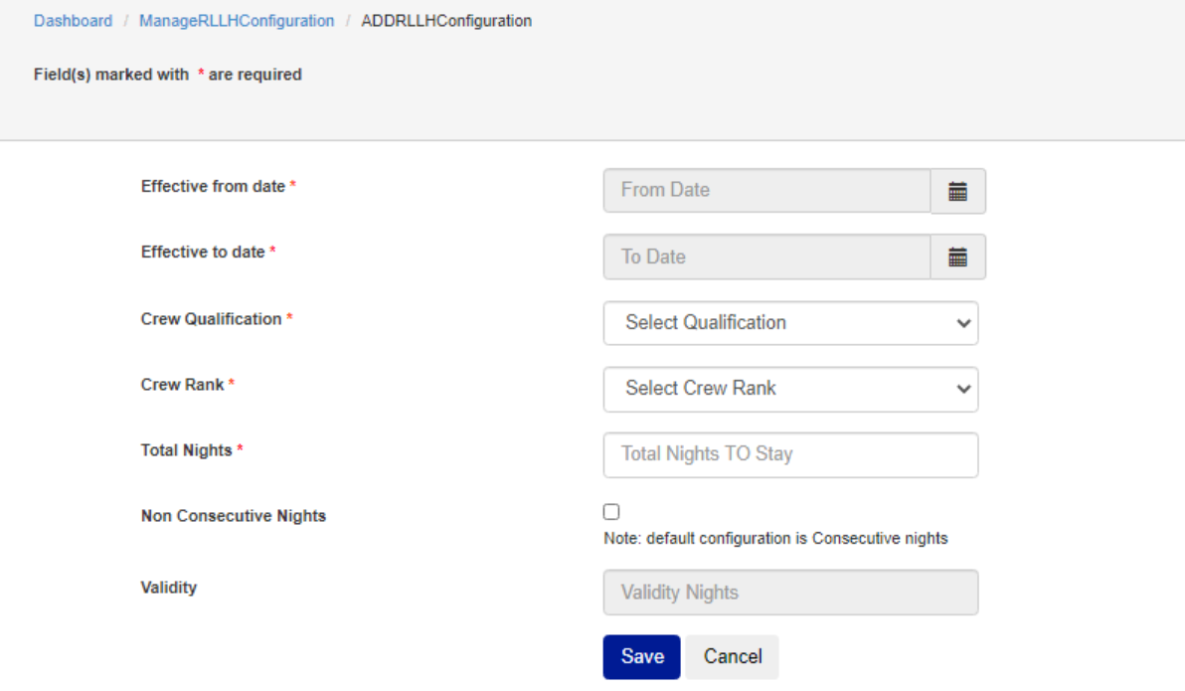

**Proposed Change:**

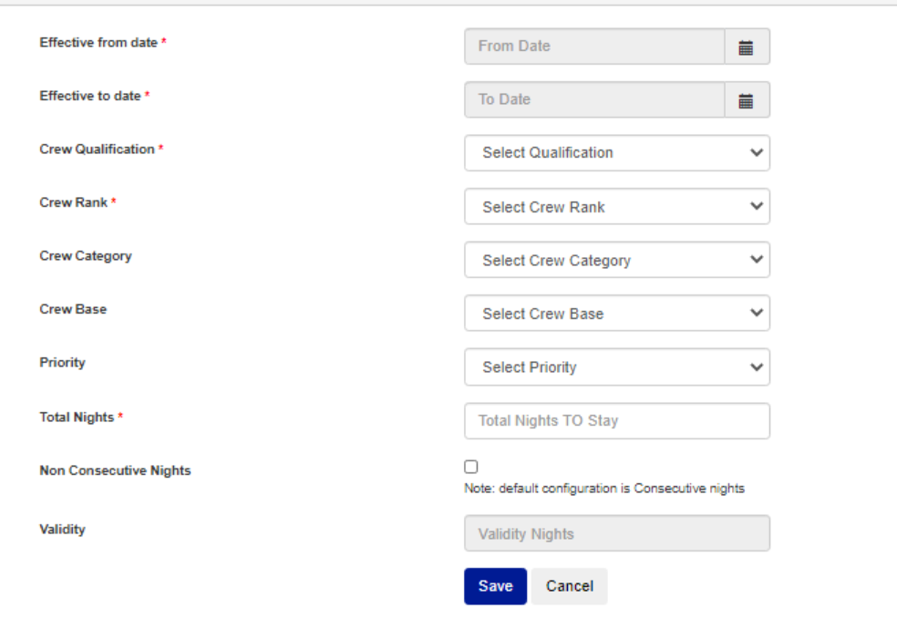

* **Early checkout option is available without date selection.**
  + - There is an option to define early check out for an individual crew member. User to be able to define whether entitlement is for consecutive nights or for total hotel nights (only count nights where crew are in the station and require hotel) at the relocation station

**Existing:**

**Proposed Change:**

**High Level Architecture Diagram:**

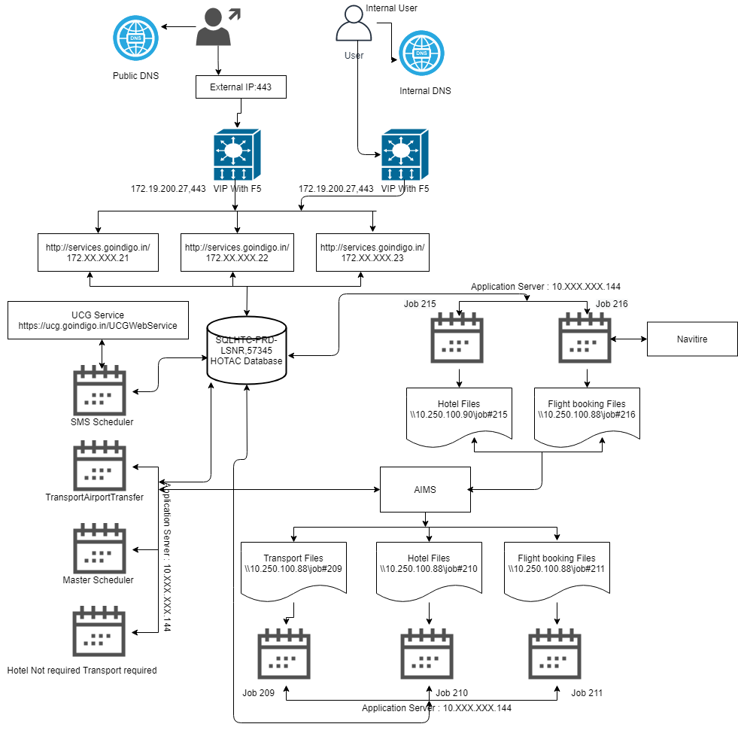

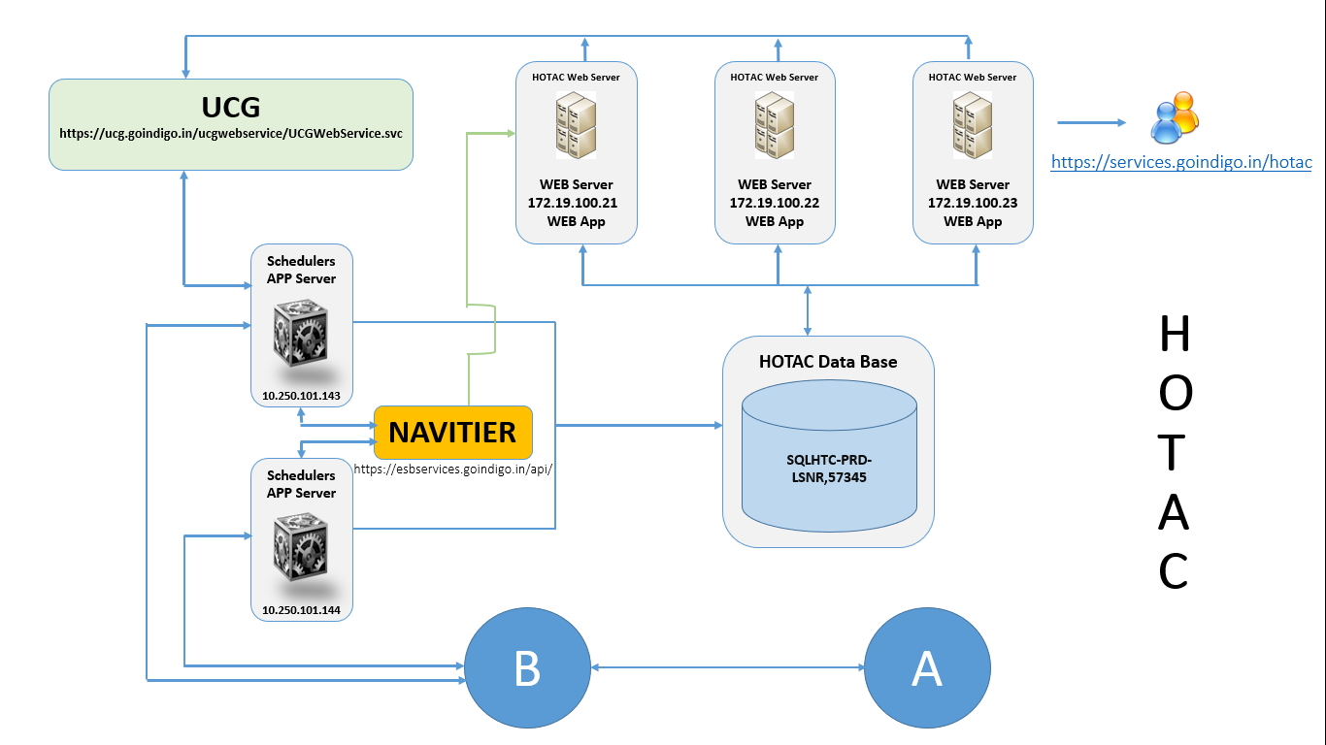

# Proposed Design

* **RLLH configuration with new parameters to make it more customizable**

Example : Proposed RLLH configuration

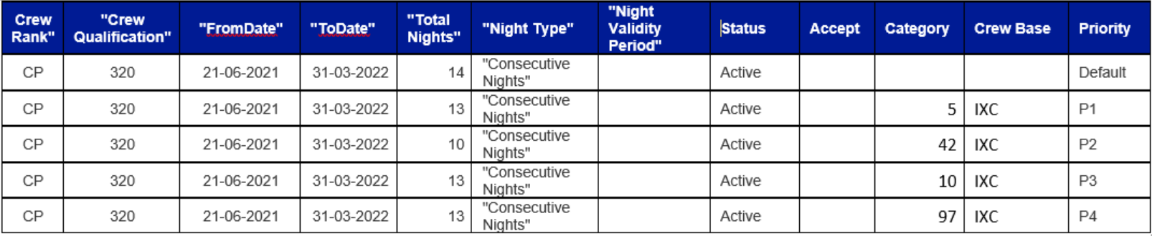

* In RLLH configuration, add crew category, crew base and priority to make it more customizable. In case when more than one rule is made by admin for same crew category then option of priority will be used to identify which one will be picked by system.
* Initially crew base and priority will be disabled mode, If crew category is chosen then crew base and crew priority will be enable and it will made mandatory.
* Crew base should have all the available bases and Select all option. In case if selected option is ‘select all’ then the configuration should be applicable to all the bases.
* The priority will be Default and P1 to P10.
* The default priority will be the one in which the configuration doesn’t have crew category, crew base and priority.
* P1 to P10 priority will be dropdown.
* Configuration with Priority should be created in the order of P1 to P10 without skipping any priorities in between.
* In priority dropdown we should show only the available priorities. In case if the available priorities are P8, P9, P10 user should create configuration for the priority P8. If user choose P9 or P10 as priority instead of P8, message will be shown as P8 priority needs to be created first.
* In case user wanted to update the priority to the existing priority, then message will be shown as the priority will be swapped and after the confirmation the priority will be updated.
* **Early checkout option is available date selection.**
  + - In existing design, a button is provided for early checkout through which crew can be checkout at same time. New feature will include date option where they can enter a future date & time and save it. On the saved checkout date crew should be checked. With this change OCC user will have option to override the date manually for relocation checkout. Also, user should be able to checkout for future 30 days manually by defining date.
    - Check out date selected by user will be final check out and no further changes in date can be applied.
* **Relocation schedular changes.**
  + - Initially schedular will look for crew rank and qualification. Now the changes to be made to consider crew category, crew base and priority.

**Deployment Details:**

|  |  |  |  |
| --- | --- | --- | --- |
| **Component** | **Name** | **IP** | **New/Old** |
| Scheduler | RelocationScheduler | 10.250.101.144 | Old |
| Scheduler | RLLHHotelMonthlyCount | 10.250.101.144 | Old |

* 1. MIS Functionality

NA

* 1. Database design

NA

**Table**

Modified

Existing : RLLH_Configuration:

Existing : TRN_HOTEL_Relocation:

**Stored Procedure**

New Created

* USP_GetBaseList
* USP_GETCREWRANKCATEGORYFORDDL
* USP_GetPriorityList

Modified

* Sp_GetRLLHCongfigByID
* Save_RLLHConfig
* Sp_CheckDateRangeForRLLH
* Sp_GetRLLHCongfigByID
* usp_EarlyCheckoutHotelBooking
* USP_GET_RELOCATION_TOUPDATE

# Component List

|  |  |  |
| --- | --- | --- |
| Component Name | Location | New / Existing |
|  |  |  |

# Messages

NA

# Changes

NA

# External Interfaces

NA

# Internal Interfaces

# Technology Stack

|  |  |
| --- | --- |
| **Technology Stack** | **Details** |
| Languages | C#, Javascript, jquery |
| Technologies | MVC 5, sql server, Jquery, |
| Development Tool / IDE | Visual studio |
| Databases | Sql Server |
| Persistence |  |
| Source Control | TFS |
| Web Servers / App. Servers(Installation and configuration) |  |
| Development Tools | Visual studio, sql server |
| Monitoring tools / methodology | AppDyanamics |
| Review tools |  |
| Built Tools | NA |
| Source Code Control Tools | TFS |
| Testing tools / methodology |  |
| ITSM Tool | Manual Testing |
| Methodologies /Frameworks |  |
| Change / Process  Management tools | BMC |
| Operating Systems | Window |