**Indigo Enhancements**

**MEL / CDL - Navblue integration**

**Revision History**

|  |  |  |  |
| --- | --- | --- | --- |
| **Revision Level** | **Date** | **Author** | **Changes Made**  **(Include Change Request # if applicable)** |
| 1 | 07-10-2021 | Yohapriya Vairaperumal |  |
|  |  |  |  |

**Table of Contents**

1. Problem Statement 4

2. Assumptions 4

3. Existing System and Design 4

4. Solution Design 5

4.1. Solution Approach 5

4.2. High level architecture diagram 6

4.3. Technology stack 7

4.4. Use Case diagram 8

5. Proposed Design 9

6. Integrations 13

7. WebServices 14

8. Component List 14

9. Messages 14

10. Changes 14

11. External Interfaces 14

12. Internal Interfaces 14

13. Technology Stack…….……………………………………………………………………………………………………………………………………………. 15

# Problem Statement

Currently, MEL/CDL numbers are coming in an excel sheet from MCC application. Which is then captured by inhouse application (Report Engine) which then is accessed by Stations to print and handover the Additional Information (AI) sheet when crew arrives at the airport for each flight.

With Crew based EFB live, there is no need to print Flight documents as Crew can check all required documents in EFB. However, EFB doesn’t have MEL/CDL information for day of Operations of specific aircraft. As it is important to send this information to crew so that they have specific reference number of MEL/CDL data, this integration is required. As a stop gap arrangement, we are providing it via Additional Information (AI) sheet. This is a manual task, where Stations provide a physical copies of AI sheets to the Crew

# Abbreviation

|  |  |
| --- | --- |
| **Abbreviation** | **Full Form** |
| MEL | Minimum Equipment List |
| CDL | Configuration Deviation List |
| AI | Additional Information |
| N-FP | N-Flight Planning |
| EFB | Electronic Flight Bag |

# Assumptions/Constraints

# MEL/CDL MCC application is updated with current MEL/CDL information.

* MCC application is updated with current MEL/CDL information with update cycles synced with NFP.
* All Information available in MCC Application cannot be replicated on FRC For e.g. Station Invoked at

# Existing System and Design

* **Current MEL/CDL information.**

MEL/CDL numbers are coming in an excel sheet from MCC application. Which is then captured by inhouse application (Report Engine) which then is accessed by Stations to print and handover the Additional Information (AI) sheet when crew arrives at the airport for each flight.

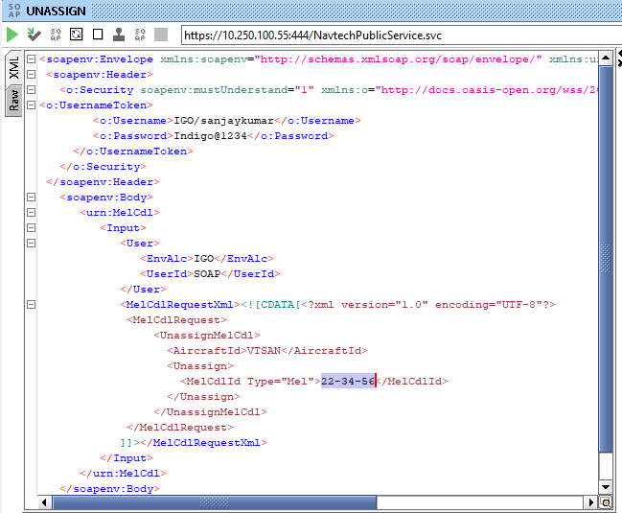

# 4.Solution Design

## 4.1 Solution Approach

* + 1. Get MEL/CDL data from MCC application.
    2. MEL/CDL data can be retrived by using XML entity encoding or CDATA enclosure.
    3. Navblue to be updated with latest MEL/CDL data
    4. Revoked MEL/CDL to be removed from FRC

## 4.2 High Level Architecture Diagram:

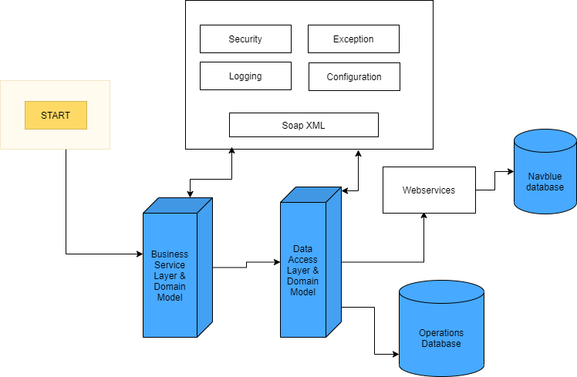

## 4.3 Technology Stack

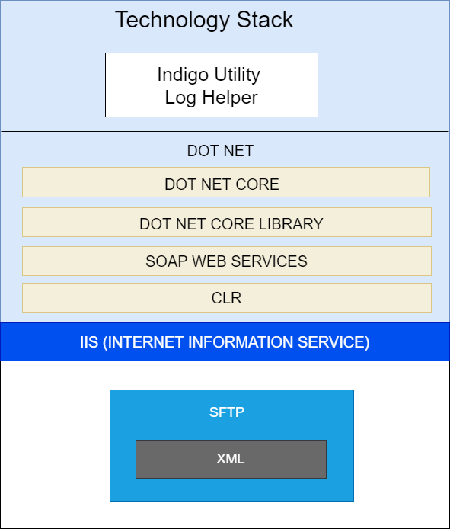

## 4.4 Use Case Diagram

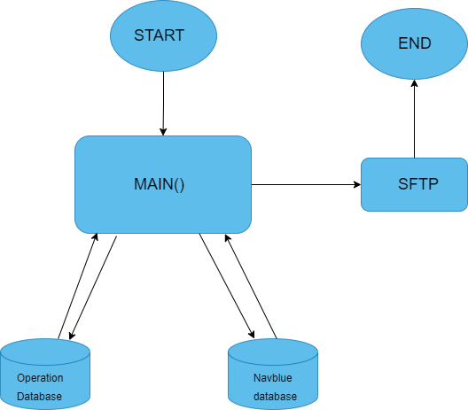

# 5.Proposed Design

1. On real time basis webservice will run which would capture the latest MEL/CDL information coming on aircrafts and push the data into the NavBlue system
2. Navblue will consume the webservice to reflect the latest MEL/CDL in their FRC page whenever the flight plan is computed and released.
3. The interface to send latest, MEL/CDL data from MCC application to NAVBLUE on real time basis as & when MEL/CDL are invoked/revoked. This activity will happen as and when a new data is released by MCC team, the same is updated in NavBlue.
4. Navblue to be updated with latest MEL/CDL data at least 2 hours 30 mins prior till D-45
5. Revoked MEL/CDL to be removed from FRC
6. The most recent MEL / CDL to be taken and pushed to Navblue FRC.
7. The Latest MEL/CDL data would be captured by interface and pushed to NavBlue.
8. MEL/CDL data can be retrived by using XML entity encoding or CDATA enclosure.

## XML Format:

## XML entity encoding

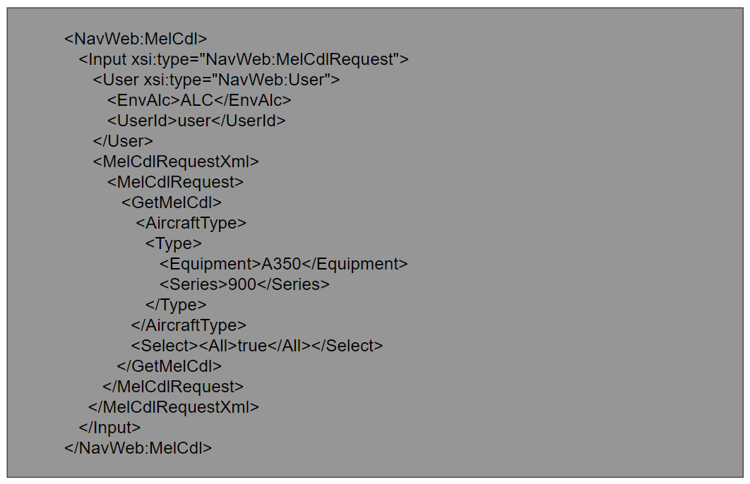

## CDATA enclosure:

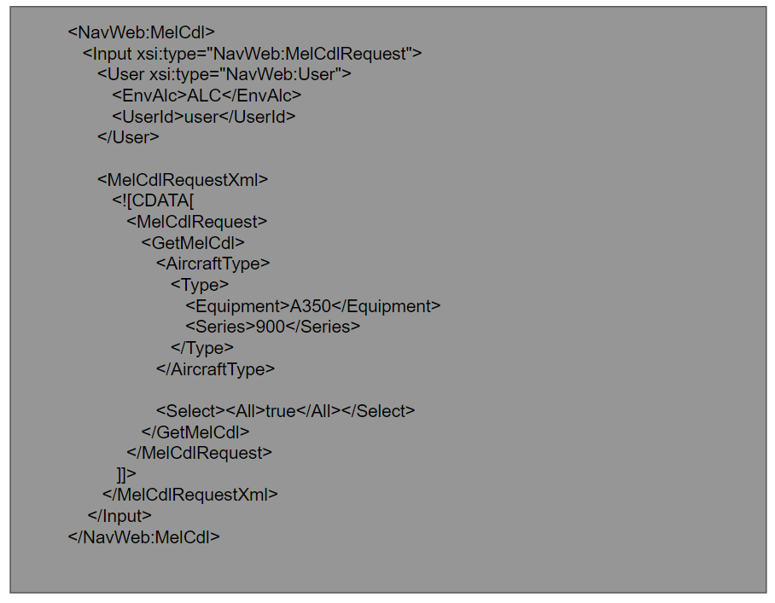

* 1. MIS Functionality

NA

* 1. Database design

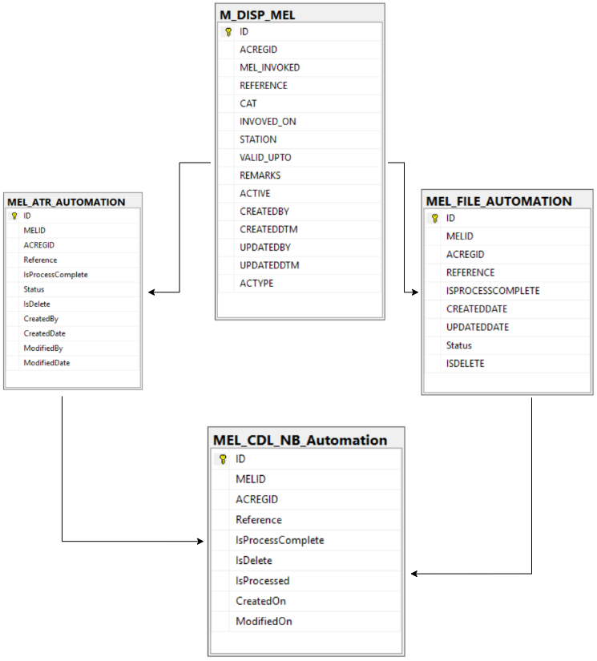

**Table**

**Created:**

New : MEL_CDL_NB_Automation

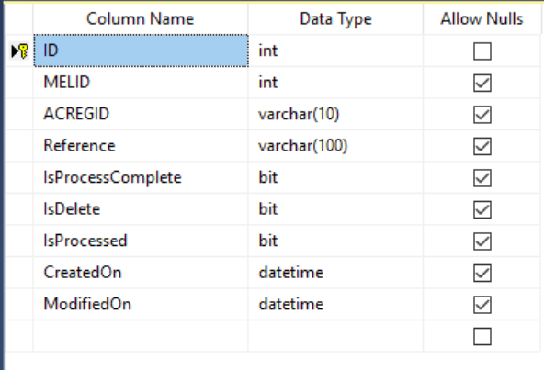

**Stored Procedure:**

New :

* Sp_MEL_GetMELCDLInfo
* SP_NB_InsertMEL_CDL_NB_AutomationData

## 6. Integrations

|  |  |  |  |  |
| --- | --- | --- | --- | --- |
| **Application Name** | **Type of Data** | **Frequency** | **One/Two way Transfer** | **Additional Notes** |
| MCC dashboard/EFRC | MEL/CDL reference numbers, tail no., | Near real time | One way |  |

## 7.WebServices

N-Flight planning Web services is used to get latest MEL/CDL information.

# 8.Component List

|  |  |  |
| --- | --- | --- |
| Component Name | Location | New / Existing |
|  |  |  |

# 9. Messages

NA

# 10. Changes

NA

# External Interfaces

Navblue

# Internal Interfaces

# Operations DB : SQLOCC-PRd-LSNR.indigo.in,55537

# Technology Stack

|  |  |
| --- | --- |
| **Technology Stack** | **Details** |
| Languages | C# |
| Technologies | .Net Core |
| Development Tool / IDE | Visual studio |
| Framework | .Net, Webservice |
| Databases | SQL SERVER |
| Persistence |  |
| Source Control | TFS |
| Web Servers / App. Servers(Installation and configuration) |  |
| Development Tools | Visual studio |
| Monitoring tools / methodology | AppDyanamics |
| Review tools |  |
| Built Tools | NA |
| Source Code Control Tools | TFS |
| Testing tools / methodology |  |
| ITSM Tool | Manual Testing |
| Methodologies /Frameworks | Web services |
| Change / Process  Management tools | BMC |
| Operating Systems | Window |