Assignment-Regression Algorithm

- Identify your problem statement

Stage 1 – Machine Learning -> Input majorities are numbers
Stage 2 – Supervised Learning -> Requirements are Clear
Stage 3 - Regression -> Output are Numerical values

- Tell basic info about the dataset (Total number of rows, columns)

Client wants to predict the insurance charges based on the given Inputs example age, sex, etc.
Input-> age, bmi, children, sex, smoker
Output-> charges

Total number of rows and columns (1338 rows × 6 columns) before pre-processing.
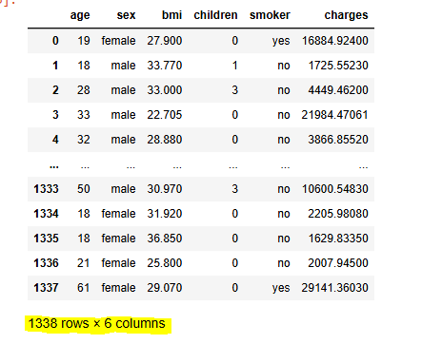
Total number of rows and columns (1338 rows × 6 columns) after pre-processing.
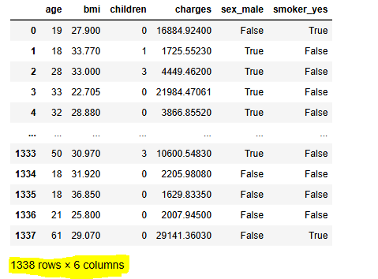

- Mention the pre-processing method if you’re doing any

Converting string (Sex, Smoker) to number – nominal data using get_dummies function

- R2 value
- Multiple Liner Regression R2 Value =0.78947903

- SUPPORT VECTOR MACHINE: -
S.NO | HYPER PARAMETER | LINEAR | POLY | RBF | SIGMOID
 |  | R2 value | R2 value | R2 value | R2 value
1 | C10 | 0.462468 | 0.038716 | -0.032273 | 0.039307
2 | C100 | 0.628879 | 0.617956 | 0.320031 | 0.52761
3 | C500 | 0.763105 | 0.826368 | 0.664298 | 0.444606
4 | C1000 | 0.764931 | 0.856648 | 0.810206 | 0.28747
5 | C2000 | 0.744041 | 0.860557 | 0.854776 | -0.59395
6 | C3000 | 0.741423 | 0.859893 | 0.866339 | -2.124419

The SVM Regression use R² Value (RBF and hyper parameter(C3000)) = 0.866339

- Decision Tree Regressor: -

S.No | criterion | max_features | splitter | R2 Value
1 | squared_error | sqrt | best | 0.5134345
2 | squared_error | sqrt | random | 0.696855
3 | squared_error | Log2 | best | 0.738349
4 | squared_error | Log2 | random | 0.652272
5 | friedman_mse | sqrt | best | 0.662422
6 | friedman_mse | sqrt | random | 0.72539
7 | friedman_mse | Log2 | best | 0.713697
8 | friedman_mse | Log2 | random | 0.632829
9 | absolute_error | sqrt | best | 0.605655
10 | absolute_error | sqrt | random | 0.711887
11 | absolute_error | Log2 | best | 0.758961
12 | absolute_error | Log2 | random | 0.720418
13 | poisson | sqrt | best | 0.687067
14 | poisson | sqrt | random | 0.635849
15 | poisson | Log2 | best | 0.721222
16 | poisson | Log2 | random | 0.703589

The Decision Tree Regression use R² Value (absolute_error, Log2, best) =0.758961

- Random Forest

S_No | criterion | max_features | n_estimators | R2 Value
1 | squared_error | sqrt | 10 | 0.851936
2 | squared_error | sqrt | 100 | 0.871984
3 | squared_error | Log2 | 10 | 0.852507
4 | squared_error | Log2 | 100 | 0.866981
5 | friedman_mse | sqrt | 10 | 0.863078
6 | friedman_mse | sqrt | 100 | 0.873748
7 | friedman_mse | Log2 | 10 | 0.865468
8 | friedman_mse | Log2 | 100 | 0.874149
9 | absolute_error | sqrt | 10 | 0.850794
10 | absolute_error | sqrt | 100 | 0.875751
11 | absolute_error | Log2 | 10 | 0.859094
12 | absolute_error | Log2 | 100 | 0.872328
13 | poisson | sqrt | 10 | 0.851107
14 | poisson | sqrt | 100 | 0.871667
15 | poisson | Log2 | 10 | 0.849682
16 | poisson | Log2 | 100 | 0.872961

Random Forest use R² Value (absolute_error, sqrt, n_estimators=100) = 0.875751

Final Model selected is Random Forest the output value which is nearest to 1 compare to other model.

