Sustainable Smart City Assistant Using IBM Granite LLM

Team Leader: k.Vinoth kumar

Team Members: L.A.Thennarasu, G. Vasanth, P. Anandha babu

# 1. Introduction

Project Title: Sustainable Smart City Assistant Using IBM Granite LLM  
  
This project leverages the capabilities of IBM Granite LLM to build an AI-powered   
assistant designed for sustainable smart cities. It aims to improve urban management,   
enhance citizen services, and promote sustainability by using advanced AI-driven insights.

# 2. Project Overview

Purpose:  
The Sustainable Smart City Assistant project is intended to provide intelligent,   
real-time solutions to urban challenges such as traffic management, waste disposal,   
energy optimization, and citizen engagement. By integrating with IoT devices,   
environmental sensors, and city infrastructure, the system ensures efficient resource   
utilization and sustainable urban growth.  
  
Features:  
- AI-powered decision support for smart governance  
- Real-time traffic and transport optimization  
- Smart energy monitoring and predictive consumption analysis  
- Waste management insights through data-driven predictions  
- Citizen engagement chatbot for queries and service requests  
- Integration with IoT devices and city-wide sensor networks  
- Secure and responsible data handling with role-based access

# 3. Architecture

The architecture of the Smart City Assistant is built on a layered framework:  
- Data Layer: Collects data from IoT sensors, cameras, environmental monitors,   
 and government records.  
- Preprocessing Layer: Cleans and transforms raw data for AI analysis.  
- AI/LLM Layer: Uses IBM Granite LLM for natural language understanding,   
 predictions, and smart recommendations.  
- API/Service Layer: Provides secure endpoints for city applications and dashboards.  
- Application Layer: Dashboards for administrators, mobile apps for citizens,   
 and control panels for city planners.  
- Security & Compliance Layer: Ensures encryption, authentication, and compliance   
 with smart city regulations.  
- Monitoring Layer: Continuous feedback and improvements for system performance.

# 4. Setup Instructions

- Install Python, AI libraries, and configure IBM Granite LLM API access.  
- Set up IoT/sensor data pipelines for real-time input.  
- Configure APIs with Flask/FastAPI for backend integration.  
- Build front-end dashboards with React or mobile apps for citizen interaction.  
- Containerize with Docker for deployment across city servers.  
- Use environment variables and secure authentication for data safety.

# 5. Folder Structure

- data/ : raw, processed, and external smart city datasets  
- notebooks/ : Jupyter notebooks for experiments and analysis  
- src/ : core source code (data_preprocessing, models, prediction, nlp, utils)  
- api/ : backend APIs for city services  
- models/ : trained AI and LLM models  
- tests/ : unit and integration testing  
- configs/ : environment and system configuration  
- logs/ : runtime and system logs  
- Dockerfile : containerization instructions  
- requirements.txt : dependencies  
- README.md : project overview  
- .env : environment variables and API keys

# 6. Running the Application

- Preprocess sensor and city datasets using preprocessing scripts.  
- Train or fine-tune AI/LLM models with available datasets.  
- Launch backend APIs with Flask/FastAPI to serve predictions.  
- Start dashboards or mobile frontends for citizens and administrators.  
- Deploy using Docker containers for scalability across servers.  
- Test APIs and monitor logs to ensure system reliability.

# 7. API Documentation

The API provides endpoints for:  
- Traffic and transport optimization requests  
- Energy usage analysis and predictions  
- Waste management recommendations  
- Citizen chatbot queries and responses  
- IoT sensor data integration  
  
APIs support authentication with keys or tokens and return structured JSON responses.

# 8. Authentication

The system uses OAuth2.0/JWT for authentication with role-based access.   
- Admins: Access to dashboards and configurations.  
- Citizens: Chatbot queries and service requests.  
- Operators: IoT device and infrastructure monitoring.  
All communications are secured with HTTPS encryption.

# 9. User Interface

The UI includes:  
- City administrator dashboards with insights and visualizations.  
- Citizen chatbot accessible via web and mobile apps.  
- Real-time maps for traffic and energy monitoring.  
- Notifications and alerts for city services.  
The interface is responsive, user-friendly, and multilingual.

# 10. Testing

Testing includes:  
- Unit testing for preprocessing and API logic.  
- Integration testing with IoT and city data sources.  
- Performance testing for scalability across servers.  
- Security testing for vulnerabilities.  
- User acceptance testing with city officials and citizens. 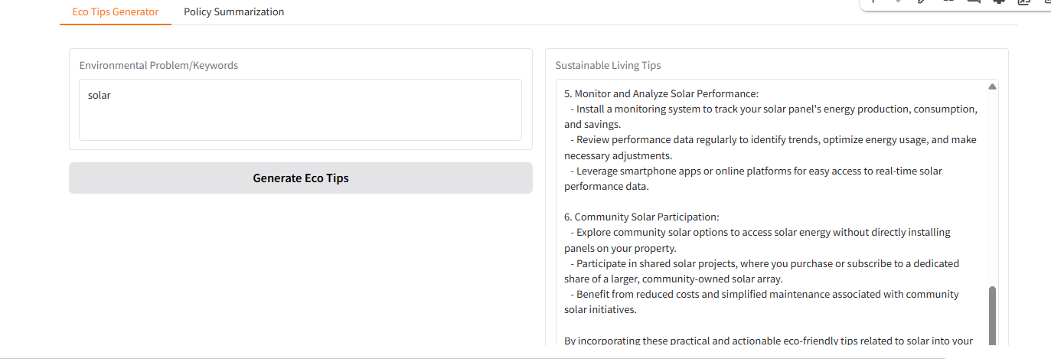

# Conclusion

The Sustainable Smart City Assistant project demonstrates how IBM Granite LLM   
can be harnessed to create a sustainable, efficient, and citizen-friendly urban ecosystem.   
By combining IoT data, AI-driven predictions, and user-centric interfaces, the system   
offers solutions for energy efficiency, waste management, traffic optimization,   
and citizen engagement. This project sets the foundation for future AI-powered smart cities.

# THANK YOU