Assignment-3

ZIGZAG

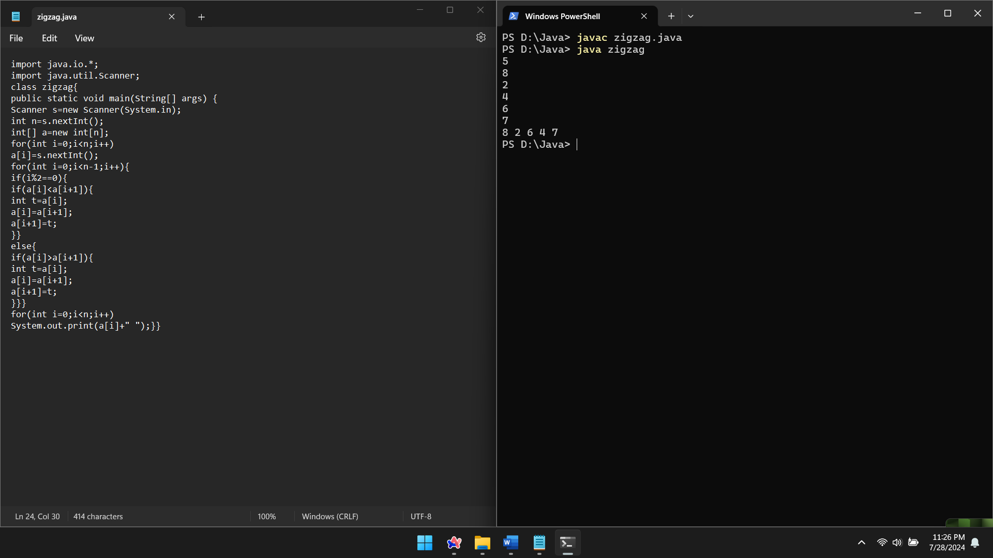

Peak element

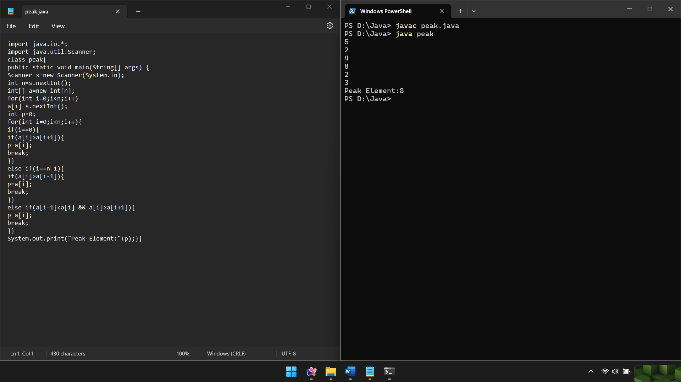

Continuous subarray maximum sum

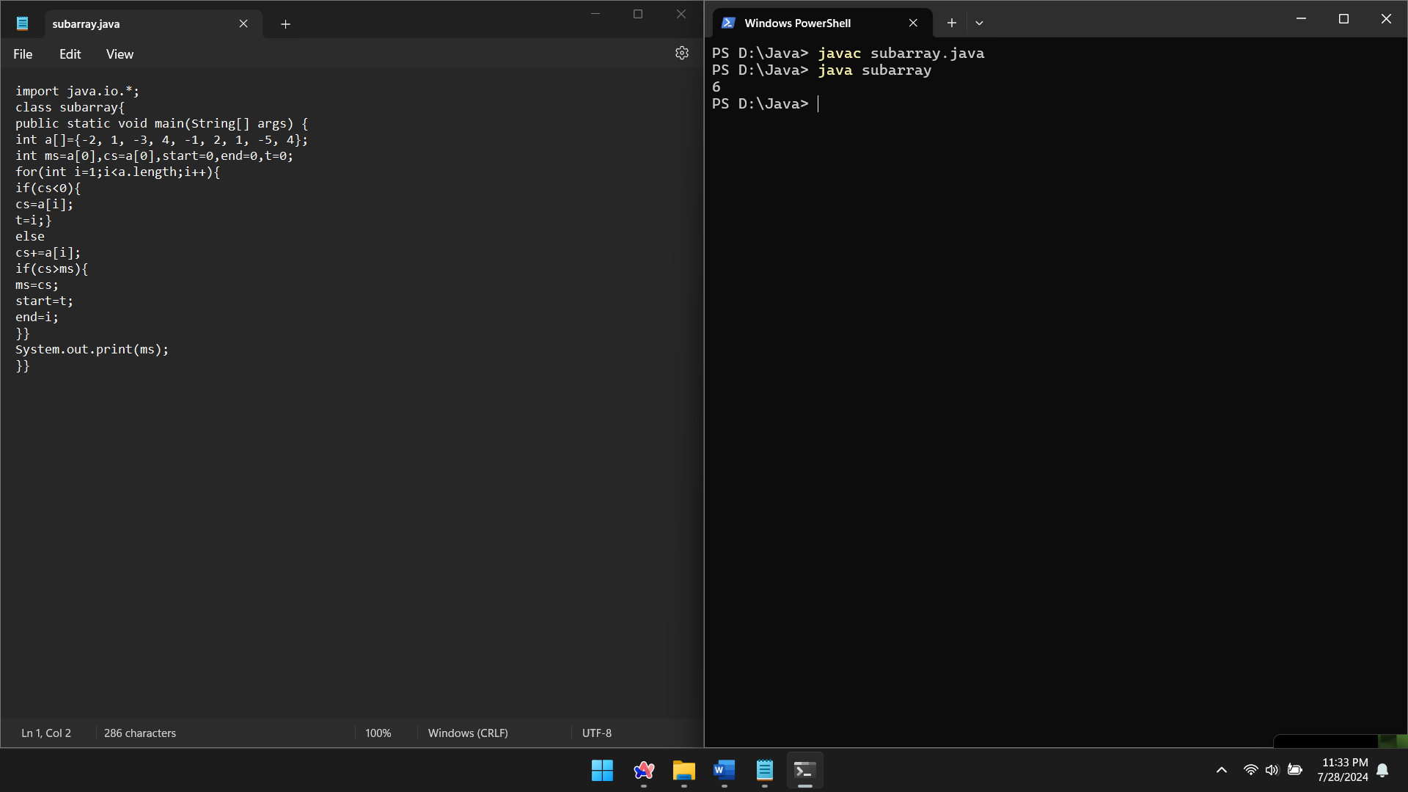

Given a string s consisting of words and spaces, return the length of the last word in the string. A word is a maximal substring consisting of non-space characters only. There will be at least one word, consists of only English letters and spaces ' '.

Example 1:

Input: s = "Hello World"

Output: 5

Explanation: The last word is "World" with length 5.

