S3 Bucket Creation:

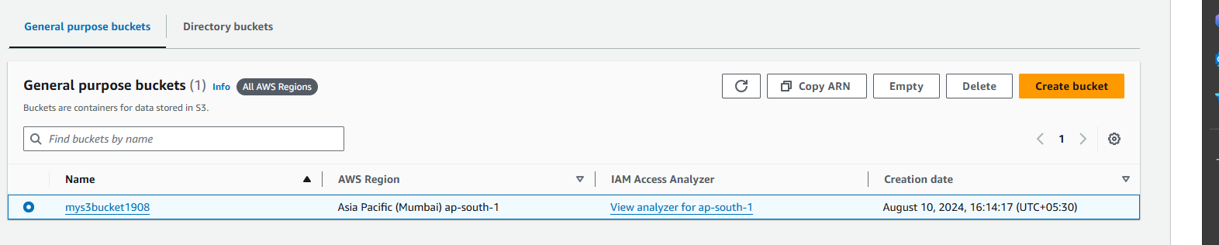

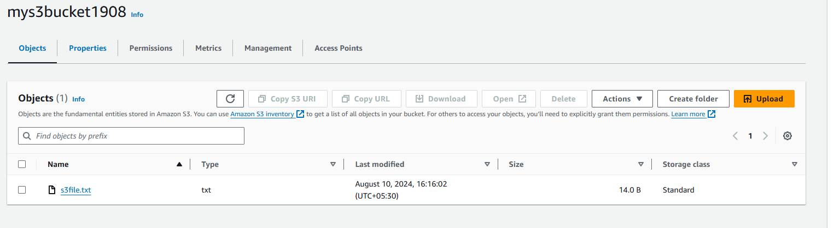

Launch 2 EC2:

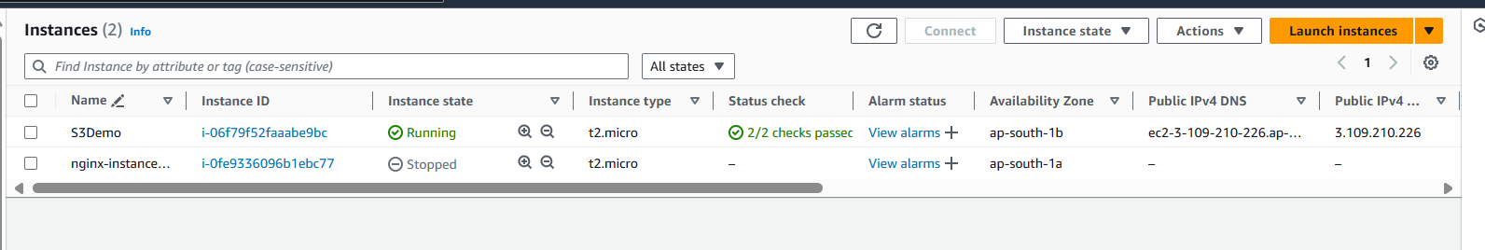

Create Load Balancers:

